Hw 4

2.6(a)
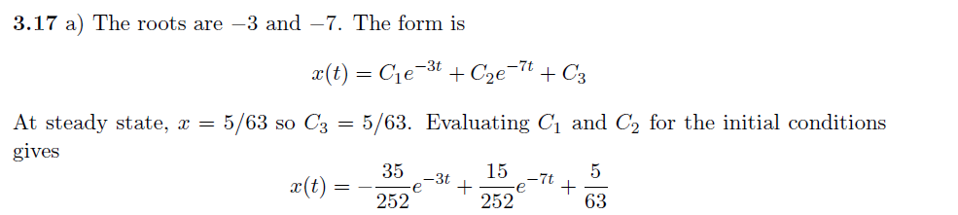

2.16 a
Roots are -3 and -5
There are 2 exponential terms for the transient part

2.35(f)

2.37(b),

2.40 d
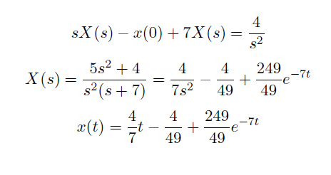

2.41(c)

