PHYS 262 Exam 2 Fall 2010

Name ____________________ November 1, 2010
Please Print

Mult choice (40 max) ________

Problems (60 max) ________

TOTAL: ________

$1/f=1/s+1/s'$ $f=r/2$ $m=h\text{'/}h=−s\text{'/}s$ $n=c/v$ $\text{sin}θ_{c}={n_{2}}/{n_{1}}$ $n_{1}\text{sin}θ_{1}=n_{2}\text{sin}θ_{2}$ $m=θ\text{'/}θ$ $Δr=2t={mλ}/n$ $Δr=2t=(m+0\text{.}5)λ/n$ $m={−f_{o}}/{f_{e}}$ $mλ=d\text{sin}θ$ $(m+0\text{.}5)λ=d\text{sin}θ$ $P=1/f$ $φ=2{πΔr}/λ$ $1/f=(n−1)(1/{R_{1}}+1/{R_{2}})$ $n=c/v$$I=I_{0}{\text{cos}}^{2}δ/2$ $m=h\text{'/}h=−s\text{'/}s$ $λ_{n}=λ/n$ $I=I_{0}{\text{cos}}^{2}θ$ $\text{sin}θ_{c}={n_{2}}/{n_{1}}$ $Δθ=1\text{.}\text{22}λ/a$ $\text{sin}θ={mλ}/a$
Good luck

BE SURE TO PUT ANSWERS ON THE LINE TO THE LEFT OR LOSE 2pts!

____D______1. A student is prescribed glasses having a power of -3.0 Diopters. This student has a _____ point of _______ cm.
(a) near, 30 (b) far, 30 (c) near, 33.3 (d) far, 33.3 (e) none of them

_____B______2. A certain lens yields a virtual image for an object placed closer the lens than 20 cm. If an object is placed 60 cm in front of the lens what would the image distance be? (a) 15 cm (b) 30 cm (c) 45 cm (d) 60 cm (e) none of them

_____D______3. A certain mirror yields an image of magnification -2 when an object is placed 10 cm in front of it. What is its focal length?
(a) 3.56 cm (b) 4.12 cm (c) 5.76 cm (d) 6.67 cm (e) none of them

______D______4. Of the following four, the one that travels at the slowest speed is:
(a) red light in air (b) red light in water (c) blue light in air (d) blue light in water

______A______5. A ray of light enters a medium from air at an incident angle of 30 degrees. What is the refracted angle if the speed of light in the medium is 2/3 that in air?
(a) 19.5⁰ (b) 15.5⁰ (c) 23.5⁰ (d) 27.5⁰ (e) none of them

______B______6. When light passes through a pair of slits separated by a distance d, an interference pattern is observed on a distant screen. The separation between the interference fringes increases whenever the wavelength ______ or d ______
(a) increases, increases (b) increases, decreases
(c) decreases, increases (d) decreases, decreases

______C_______7. Which of these always forms virtual images?
(a) converging lenses & convex mirrors (b) converging lenses & concave mirrors
(c) diverging lenses & convex mirrors (d) diverging lenses & concave mirrors

_______C______8. Find the sine of the largest angle between 0 and 90 degrees for which a maximum intensity is observed when microwaves of wavelength 2 cm are incident on a pair of slits separated by 5 cm.
(a) 0.6 (b) 0.7 (c) 0.8 (d) 0.9 (e) none of them

_______C______9. How many bright interference fringes would you observe within the central diffraction peak using light incident on a pair of slits of width 0.1 mm & separation 0.52 mm?
(a) 7 (b) 9 (c) 11 (d) 13 (e) none of them

_______C______10. To demonstrate the phenomenon of interference using two sources, they must be:
(a) in phase (b) out of phase (c) coherent (d) incoherent
Problems (10 pts each)

1. A spy satellite is at an altitude of 200 km, and it has a camera capable of resolving the numbers on license plates. Find the minimum diameter of the camera’s lens for it to do this. You will need to make estimates of several quantities in order to do the calculation.

Assume a wavelength of 600 nm
$Δθ=1\text{.}\text{22}λ/a=\frac{x}{L}$ where x = size of letters -= .05 m & L = 200 km = 2 x 10⁵ m
So: $Δθ=2\text{.}5×{\text{10}}^{−7}\text{rad}$ and
Thus, $a=\frac{1\text{.}\text{22}(\text{600}×{\text{10}}^{−9})}{2\text{.}5×{\text{10}}^{−7}}=3\text{.}0m$

2. How thick a coating should be placed on a camera lens if the coating is made of material whose index is 1.3 so as to minimize the amount of reflected light in the middle of the visible spectrum?

Two phase changes here
$Δr=2t=(m+\frac{1}{2})\frac{λ}{n}$. Using m = 0 gives thinnest coating of 120nm

3. Two sheets of glass are separated at one end by a piece of paper of thickness 0.1 mm so as to form a small angle wedge of air between them. When illuminated from above one sees bright fringes separated by 1 mm. What is the length of the wedge?

Let L be the length of the plate. The thickness of the wedge increases by $\frac{λ}{2}$ from one bright fringe to the next. Thus by similar triangles we have: $\frac{0\text{.}1\text{mm}}{L}=\frac{λ/2}{1\text{mm}}$ &
$L=\frac{0\text{.}2}{λ}$ (both quantities in mm)
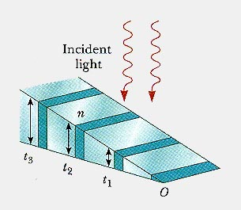
4. Consider two in-phase point sources of microwaves of wavelength 0.5 cm. One source is located at the origin and the other is on the y-axis 2cm above the origin. Find all points on the x-axis where the waves constructively interfere.

( 2,0)
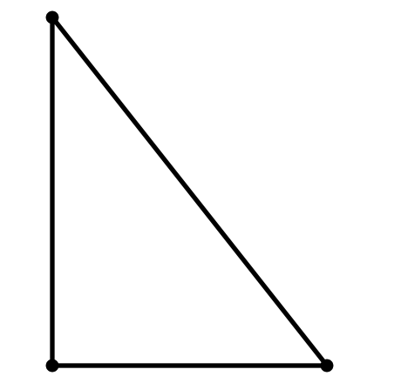
( 0,0) (x,0)

$Δr=\sqrt{x^{2}+2^{2}}−x=mλ$ Just solve this for $x$ & let m = 0,1,2,3,…

5. A sheet of glass (index 1.5) is in air. Consider a ray of light that originates inside the glass and strikes the boundary at 45 degrees angle of incidence. Will the ray of light be totally internally reflected? You must have a proper explanation using both a calculation and the appropriate words to receive any credit.

Using $\text{sin}θ_{c}=\frac{1}{n}=0\text{.}\text{667}$, we find the critical angle is 41 degrees, which is less than the ray angle so it will be totally internally reflected.

6. A screen is placed 100 cm behind a pair of slits separated by 0.1 mm. When the slits are illuminated by EM waves one observes a series of spots on the screen separated by 1 cm. What specifically can you conclude from this observation.

$$mλ=d\text{sin}θ≈d\text{tan}θ=d({Δy}/L)$$

Thus, the location on the screen of the mth fringe is: $y=\frac{mλL}{d}$& the distance between fringes on the screen is $Δy=\frac{λL}{d}$ This can be solved for the wavelength to find around 1000nm.

