

Iterative Redesign & Task Analysis

T/TAC Spring 2005

Tsehaye Habteselasie
Jennifer Okezie
Meredith Riddile
Aanal Sheth

Table of Contents

Introduction 3
Task Analysis 3
Task: Creating the Local Improvement Plan & Reports 4
Organizational Process of Local Improvement Plans & Reports 5
Redesign Phase 1 6
Expert Reviews 6
Results of the Expert Reviews and Implications on Design 6
Redesign Process 6
Task Analysis and Redesign Phase 1 8
Redesign Phase 2 9
Usability Testing 9
Results of the Usability Testing and Implications on Design 9
Redesign Process 9
Task Analysis and Redesign Phase 2 10
Redesign Phase 3 10
Client Meeting and VDOE Expert Review (Richmond Meeting) 10
Results of the Richmond Meeting and Implications on Design 11
Redesign Process 11
Conclusion 12
References 14

Introduction
A task analysis, in terms of instructional design, is a “process of analyzing and articulating the kind of learning that you expect the learners to know how to perform” (Jonassen, Tessmer, & Hannum, 1999, p.3). A detailed task analysis can be conducted to understand the current system and the process flow within it. Instructional designers perform a task analysis in order to make time predictions for how long a task will take and for spotting potential errors. To conduct a task analysis the design team defines the tasks and the goals for the tasks and further breaks the tasks down into sequential steps. It makes it possible to determine if the tasks are allocated appropriately within the system. It also helps to determine if all the functions are included in the system.
In other words, task analysis is an observation-based technique that elicits knowledge from the users for whom a product is intended. Initially, the design team has to familiarize themselves with the system so that they can determine user needs. The design team then interviews actual users of the system. All users are asked some questions so that users’ normal task flow is reflected rather than the design team’s preconceptions.
Some of the crucial information that a task analysis aims to uncover is:
- who the different groups of users are and how they differ
- which tasks are performed by each specific group of users
- which tasks they must perform
- which tasks they perform frequently
- what sequence they perform these tasks in
- which measures of user performance (accuracy, speed, etc.) are relevant

Task Analysis
For the T/TAC Online project, a task analysis or breakdown of the user’s tasks was conducted during the initial design phase. The design team used the process flowchart as a starting point to dissect the task into mini-tasks. The flowchart provided the framework needed to move into the design phase of the initial prototype. Once the prototype was finished, the design team started to evaluate the existing prototype for usability. During the evaluation phase, the team gathered feedback which was used to identify the redesigns needed in the system.

Task: Creating the Local Improvement Plan & Reports

The task analysis focused on describing, with specificity, the steps users must take to create a Local Improvement Plan¹ and its corresponding reports.

January-March
Writes LIP

Completes the seven sections of LIP.

Requests approval from VDOE Technical Assistant (TA)
TA provides approval or feedback to LEA contact

Edits the LIP based on TA’s feedback
LEA Contact

Formally submits finalized LIP
to VDOE

April
May
Formally submits finalized LIP in LEA Annual Plan
September – December
Creates a progress report to document LIP progress
April of following year
Submits an evaluation report, documenting outcomes of implemented LIP

¹ A Local Improvement Plan is a seven section proposal focused on the five goals which are part of the Virginia Special Education Improvement Plan and relates to three strategic directions of the Virginia Department of Education that determine the release of federal money to support schools in Virginia. Subsequent to the implementation of the proposal, a progress and evaluation report on the implementation of the proposal is created and added to the LIP in order to document outcomes of the LIP.

Organizational Process of Local Improvement Plans & Reports

The flowchart below depicts the overall organizational task of creating a LIP, including tasks that need to be completed by people other than our targeted users. It is imperative that the design team analyze the entire task to ensure that the system that is created will support the overall task by fitting into this overall task where needed.

A flowchart shows the main flow of the tasks. It also explains the paths that a user has to follow which helps to determine whether some potential problem exists. (Keller, 2004). The visual representation of the tasks in a linear form helps to identify if any tasks or sub-tasks are skipped.

This chart was created by the Fall 2003 T/TAC Group 2 and was modified slightly to demonstrate the areas that the design team focused on. The modifications to the diagram (the colored circles and arrows) specify the areas that the team analyzed. The red circle indicates the current system: someone outside the normal LIP development process is entering in the LIPs well after they have been submitted and/or implemented. The green circles indicate areas that were examined in order to determine where the solution would be most suitable within the writing/implementation/submission system.

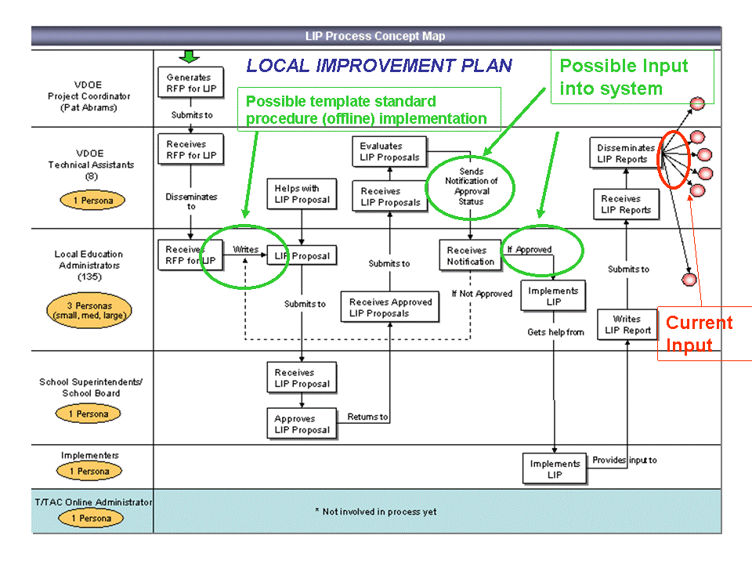
Created by T/TAC Online Project Team 2003-2004
http://immersion.gmu.edu/ttac/fall2003/group2/projectwork.htm
Redesign Phase 1

Expert Reviews

The expert review portion of the evaluation research allowed the team to predict tasks that the users would typically perform within the context of the online system. From expert reviews, the team was able to observe potential user behaviors when entering and exploring the online environment, particularly the main interface. Experts in the fields of instructional design, Local Improvement Plan content and technical functionality, provided feedback to the team about potential revisions and adjustments. From the data and feedback collected, the team underwent a major redesign of the online system.

Results of the Expert Reviews and Implications on Design

From the expert reviews, the team realized that the organization of the system was causing the most problems. During observations, users would enter the system and have to decide what process they wanted to begin within the main interface. At that point, the design team had assumed that users would be aware of the overall procedures for beginning and developing the Local Improvement Plans (LIPs), as well as the progress and evaluation reports. The process of moving past the main interface was too dependent on the user knowing the procedures and correctly implementing them. The design team decided that it would be necessary to lessen the cognitive burden on the user and provide them with an interface that would tell them the procedures and rules visually, making it friendly for all users: novice to veteran. This main redesign resulted in the team shifting the design from an action-oriented to object-oriented. The system would rely more on the database by showing users what options they have at any given time, depending on what document (object) they are working on.

The team also observed the “circular” nature of the system. During the expert reviews, the participants noted that they felt as if they were moving through the system in giant circles. The team decided to minimize the amount of clicking as much as possible by merging pages and relying more on the database to make decisions for users when possible.

Redesign Process

The team chose to redesign the visual design of the prototype in preparation for usability testing. The team made a master list of tasks to be done, divided work, ordered tasks and worked in a rapid redesign mode. The team was under an impending deadline—to complete the revisions within two days so the prototype redesign would be ready prior to the first usability test.

Our initial prototype design can be viewed at: http://immersion.gmu.edu/ttac/fall2004/visualdesign/lip_options.htm

The redesign can be viewed at:
http://immersion.gmu.edu/ttac/spring2005/2visualdesign/lip_options.htm

The redesign of the main interface was the most significant change and it resulted in transforming the interactions within the system as a whole.

Main Interface Before Main Interface After Redesign 1
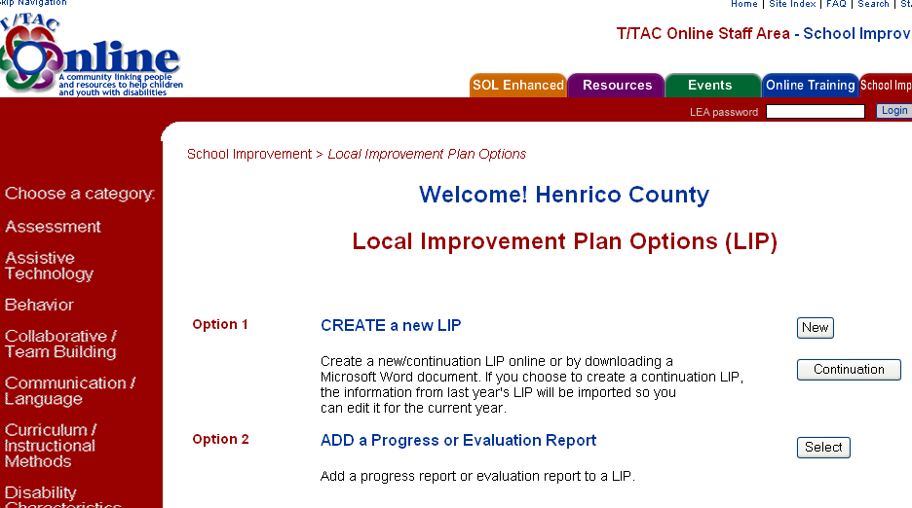
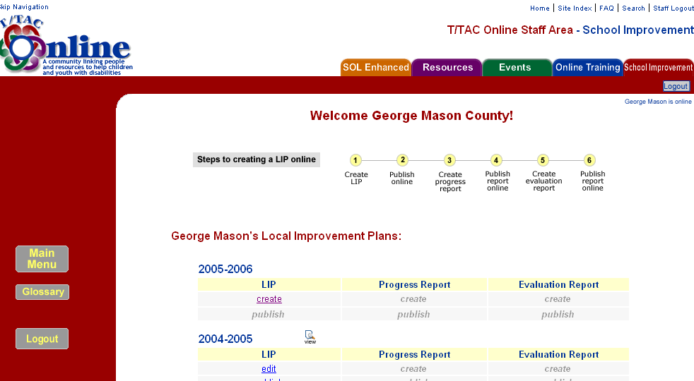

The interface became more intuitive. The user would enter the system and be presented with the options that were possible for their county at that time. Through this interface, the user does not have to worry about procedures and rules. The cognitive burden has been transferred from the user to the system.

Section 3 Interface Before Section 3 Interface After Redesign 1

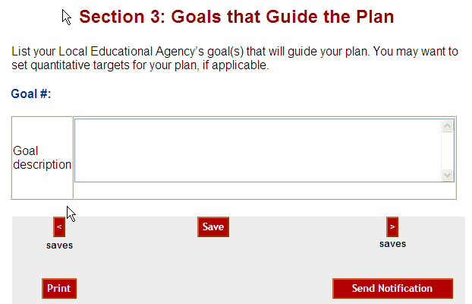
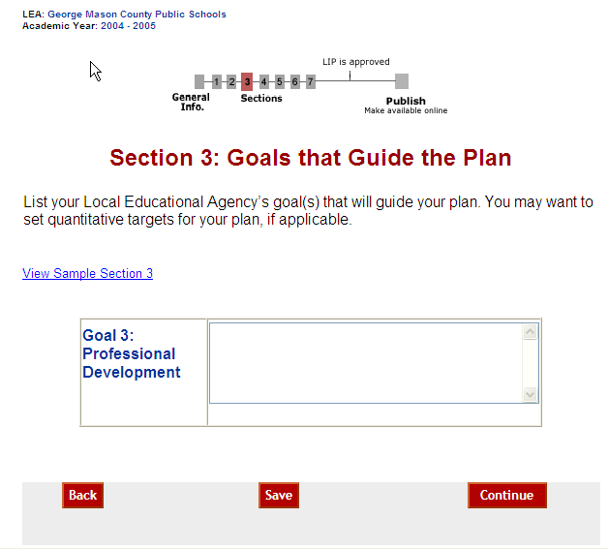

Overall navigation issues were also addressed. The team standardized button names, functions, layouts and set rules about when and where each button was appropriate. The team also cut down on the “circular” issues that were brought up in the expert reviews. The redesign of the main interface helped to correct many of these issues. A task bar was added at the top of each page within a process to guide users and indicate where they were within the process. Navigation buttons were reduced in number on each page to offer users only the choices that they would use at that point. The decision to make these changes was based on the information from the task analysis and expert review comments.

Task Analysis and Redesign Phase 1

In examining potential tasks that the user would perform, the team was primarily concerned with understanding the general user of an online system. The team, through expert reviews, attempted to predict potential user problems before testing the system with actual users. This was a critical step because it was the team’s first time designing a fully-functioning online system.

Redesign Phase 2

Usability Testing

The usability testing portion of the evaluation research allowed the team to observe actual users performing the tasks that they would typically perform within the context of the online system. From usability testing, the team was able to observe actual user behaviors while they entered the system and created the LIPs, progress reports and evaluation reports.

The team visited users from various counties in the state of Virginia at their actual offices, where they would perform the tasks. After observing the users test the system using the task scenarios provided, they provided the team with information as to how they currently create LIPs and their respective reports. Through observations and feedback, the team performed a basic task analysis in conjunction with the usability testing.

Results of the Usability Testing and Implications on Design

The team set usability goals to determine whether or not the system was: usable, efficient, useful and acceptable. The team set goals for each task scenario by determining the maximum number of help requests, errors, as well as, instances of satisfaction and confusion of frustration, to test whether or not the system was usable. The team observed participants performing the task scenarios, examining for congruency between user task performance and system interaction. Overall, usability goals were met.

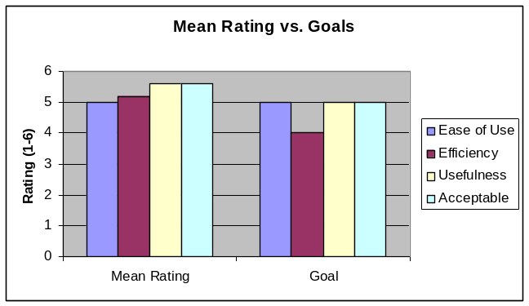

Redesign Process

Because the team’s programmer was engaged in the development of the actual system at the conclusion of usability testing, the team decided to begin creating lists of necessary changes along with visual examples at times. From analysis of the usability data, the team decided that the system was working very well for the users and that no major changes to the system were required.

The team decided that the following five items would need to be adjusted:

- Create explicit directions to explain location of login button.
- Make the taskbar active.
- Add a spell check feature.
- Clarify the “publish” and “request approval from VDOE” button features.
- Confirm with programmer that the “Edit” button will be seen by all users, regardless of screen resolution and browser settings.

Task Analysis and Redesign Phase 2

A basic task analysis was actually performed during the usability testing. The team was able to observe users interacting with the system, practicing creating the LIP documents with which they were familiar. The team received feedback from the users about how congruent the system was with their current methods for creating LIP documents.

Initially, the team’s goal was to transfer a job responsibility from the website administrator to those that created the LIP. The team expected the users to have difficulty adopting the new method and online system, but users actually responded in a surprising manner. Of the users tested and surveyed, they indicated this new system would be much easier and more efficient than their current method. In developing the online system, the design team attempted to model it as close to a performance support tool as possible; however, this was not the primary concern of the design because the team was under the impression that the system would actually hinder their performance instead of support it. Through usability testing, the team discovered that the system was actually working as a support tool, helping to the users to create their documents quickly and easily.

Redesign Phase 3

Client Meeting and VDOE Expert Review (Richmond Meeting)

The design team visited Richmond on Monday April 11th, 2005 to meet the client, Dr. Patricia Abrams and T/TAC Technical Assistants (TAs). The Technical Assistants would provide valuable feedback being that they oversee those persons that write the LIPs and are considered to be experts about the creation of the documents. The team presented the new system and gave Dr. Abrams and the TAs an opportunity to explore the system. The team then distributed a survey questionnaire to measure satisfaction and gather feedback.

Results of the Richmond Meeting and Implications on Design

The team received exceedingly positive responses from Dr. Abrams and the TAs. The team set the same goals for ease of use, efficiency, usefulness and acceptability as the usability testing, adding one additional goal for gauging the importance of the “Request Approval” feature. The team’s goals were exceeded in every category, with the client, Dr. Abrams giving the system the highest scores possible in every category but one.

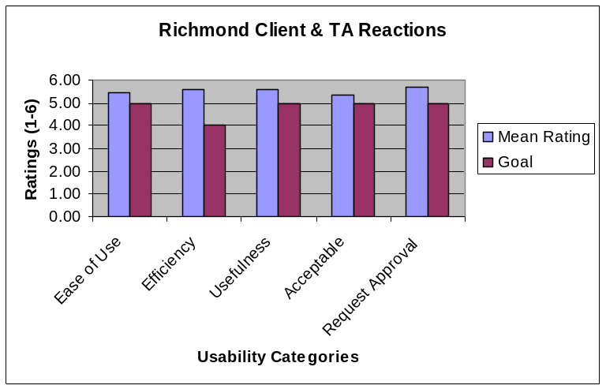

Dr. Patricia Abrams (Client) Reactions

 | Dr. Abrams’ Responses
Ease of Use | 6
Efficiency | 6
Usefulness | 6
Acceptable | 5
Request Approval | 6

The client gave the system the highest ratings possible with the exception of the “acceptable” category. The question was: Do you think that special education professionals will use this system to write their LIPs? Dr. Abrams had some doubts as to the overall acceptance of the system, rating it a 5 out of 6 (definitely).

The design team was extremely pleased with the client’s and TA’s reactions to the system.

Redesign Process

Because the team’s programmer was engaged in the development of the actual system at the conclusion of the Richmond meeting, the team decided to create lists of necessary changes along with visual examples, as had been done after usability testing. From analysis of the Richmond feedback, the team decided that the system would work very well for the users and that no major changes to the system were required.

The team made the following suggestions to the programmer and assigned priority:

 | Redesign tasks | Priority
1 | Create explicit directions to explain location of login button | Important
2 | Make taskbar active | Very Important
3 | Add spell check feature | Very Important
4 | Clarify two button features (Request Approval and Publish) | Important
5 | Confirm that Edit page will allow all users to see “edit” button located to the right of each section | Important
6 | Create an instructional manual for the whole LIP process | Very Important
7 | Add ‘School division’ word under Applicant 3 digit code | Important
8 | Look at the Publish directions and check if it explains that once the LIP is published it cannot be edited | Important
9 | On page that offers template option- make explanation link bigger( What does download a template mean?) and in pop-up be more explicit about how user doesn’t need to use a template first | Very Important
10 | Create a help pop-up page which explains who to contact if facing problems with the site | Important
11 | Talk to Dr. Wang about back button in the browser, will it lose data? | Very Important
12 | Read publish disclaimer | Very Important
13 | Search for a LIP for sample | Important

Conclusion

The design team has completed several iterations of this system based on gathering data via expert reviews, usability testing, and conducting a thorough task analysis. The resulting product is a system that models the users’ workflow by supporting them in the completion of a task. This performance support tool transfers part of the workload of creating the LIP documents onto the database-driven system which enables users to create LIP documents with ease.

While proceeding through this formative evaluation-redesign process the team learned several lessons about web design.

- The web design of the system must match the task at-hand. Navigation, page layout, and user interaction opportunities must be planned so that they support the users’ task completion process.
- Learning the users’ perspectives is critical. Designers should observe users interacting with the system and note difficulties users have with the web design.
- Programmers are knowledgeable about web design, but they do not know the users and task as the designers do. It is important to work with programmers and acknowledge their concerns or advice, but it is not always in the best interest of the users to implement ideas that have may be skewed to focus mostly on functional aspects.

The design team documented the entire formative evaluation and redesign processes on their project site, which can be viewed at:
http://immersion.gmu.edu/ttac/spring2005/project.html

References
Ergosoft Laboratories. (2003). What is Task Analysis? Retrieved on April 16, 2005
from http://www.ergolabs.com/task_analysis.htm
Keller, A. (2004). Task Analysis. Professional Writing 408, Web-Based
Documentation. Retrieved on April 16, 2005, from
http://web.uvic.ca/akeller/pw408/r_taskanal.html
Stanley, T. (2002). Hierarchical Task Analysis. Instructional Design Knowledge
Base. Retrieved on April 16, 2005, from http://classweb.gmu.edu/ndabbagh/Resources/Resources2/
hierarchical_analysis.htm

