
Staff Instructions for Using T/TAC Online

Website Address: http://ttac.gmu.edu/phase6

Contact Information: Lucinda D. Zimmermann
(703) 993-3670

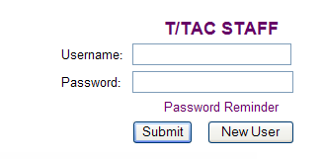
T/TAC Login

- Locate T/TAC Login area
  - Top right hand corner
- Enter username
- Enter password

Click “Submit button”

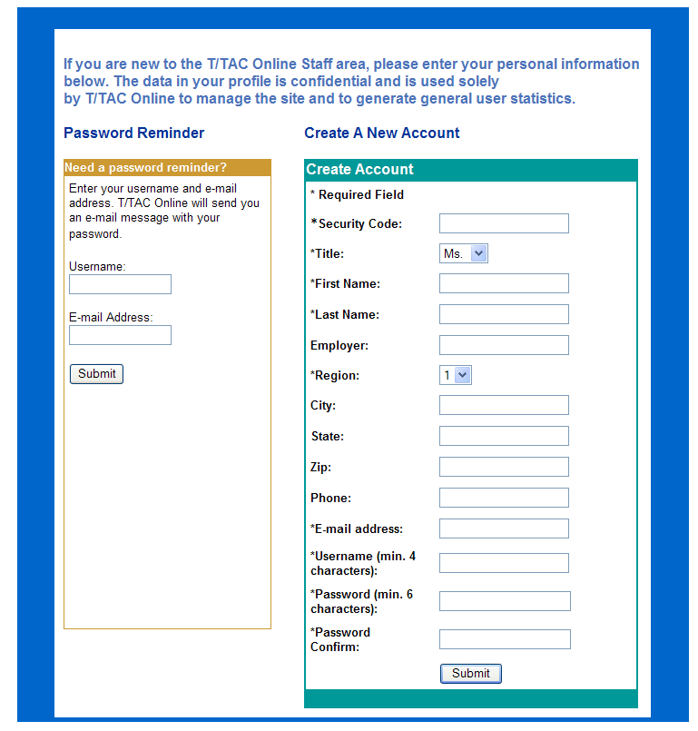

Create New User Account

1. Click on “New User” button
- On the initial page in the top right hand corner
2. Find “Create Account” form
3. Fill in the requested information
- Security Code: The security code can be requested from the T/TAC Online Administrator (lzimmer1@gmu.edu)
- Current Security Code:
- Fill in the personal information requested
- User name: Each person needs a unique name on T/TAC Online. For example, John K. Smith may choose JKSmith.
4. Click “Submit” button

RESOURCES
Resources include suggestions for books, articles, journals, relevant legislative initiatives, materials, and Web sites that support professionals, family members and others who help children and youth with disabilities.
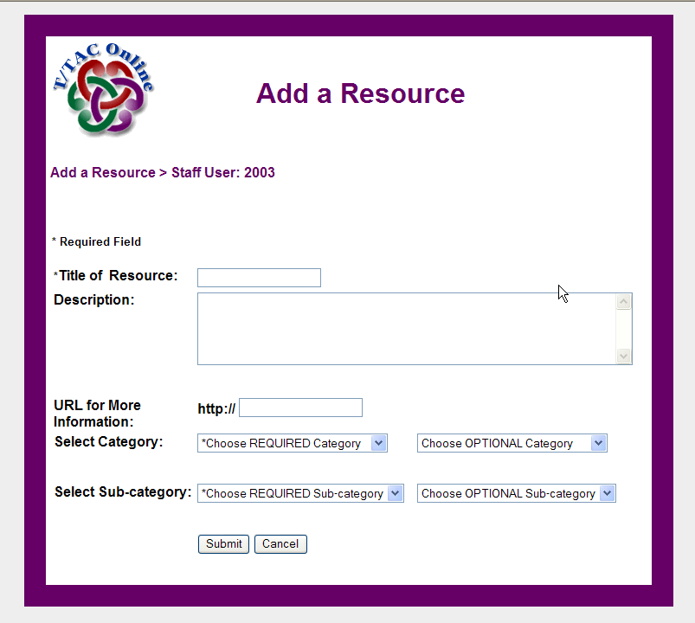

Add a Resource

You must be logged in as T/TAC Staff to add a Resource.

1. Click on the Resources tab
2. Click on “Add a Resource” button
3. Enter Resource information
- Enter a title and description for Resource
- Enter a URL (web address) if applicable
- Select Required Category and Subcategory
- Select Optional Category and Subcategory if desired
- Click “Submit” button

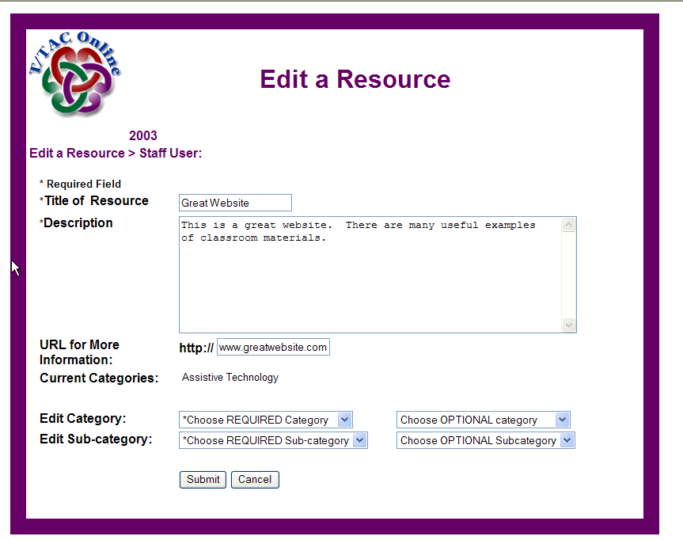
Edit a Resource

- Click on the “My Resources” button
- Find the Resource you would like to edit
- Click on the “Edit” button
- Edit the information you would like to change
- Click on the “Submit” button

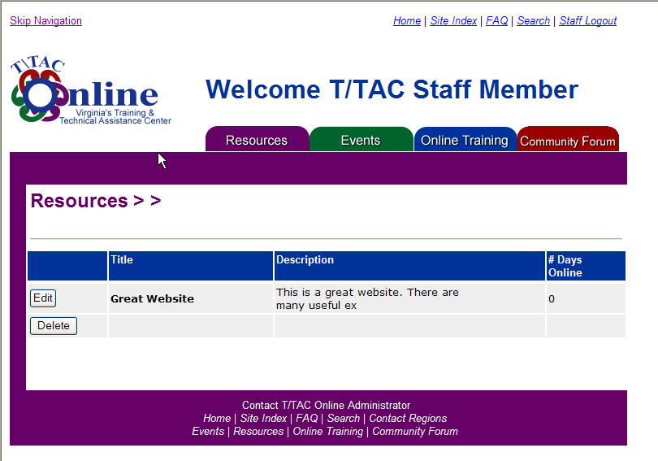
Delete a Resource

1. Click on the “My Resources” button
2. Find the Resource you would like to delete
3. Click on the “Delete” button
- A new window will appear. Select “Delete” to complete the deletion

EVENTS
Events include conferences, workshops, trainings and lectures across Virginia and the nation.

Add an Event

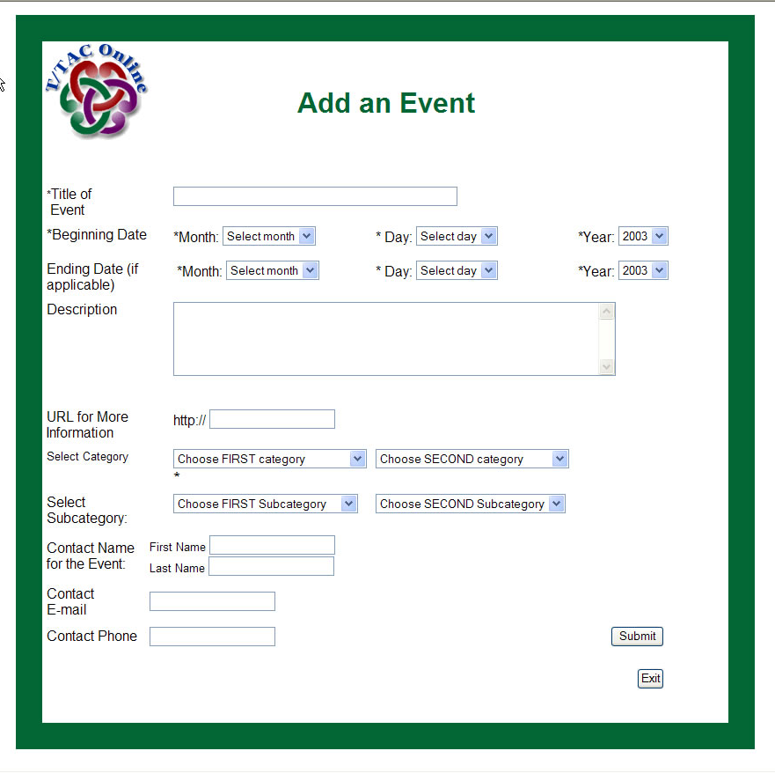
You must be logged in as T/TAC Staff to add an Event.

1. Click on the Events tab
2. Click on “Add an Event” button
3. Enter Event information
- Enter a title and description for the Event
- Enter the date of the Event (if a multi-day Event, enter Ending Date)
- Enter a URL (web address) if applicable
- Select Required Category and Subcategory
- Select Optional Category and Subcategory if desired
- Enter Contact Information:
If someone wants to attend the event, whom should they contact? Enter this information into the area. Only add your name and information if you are the contact for the event.
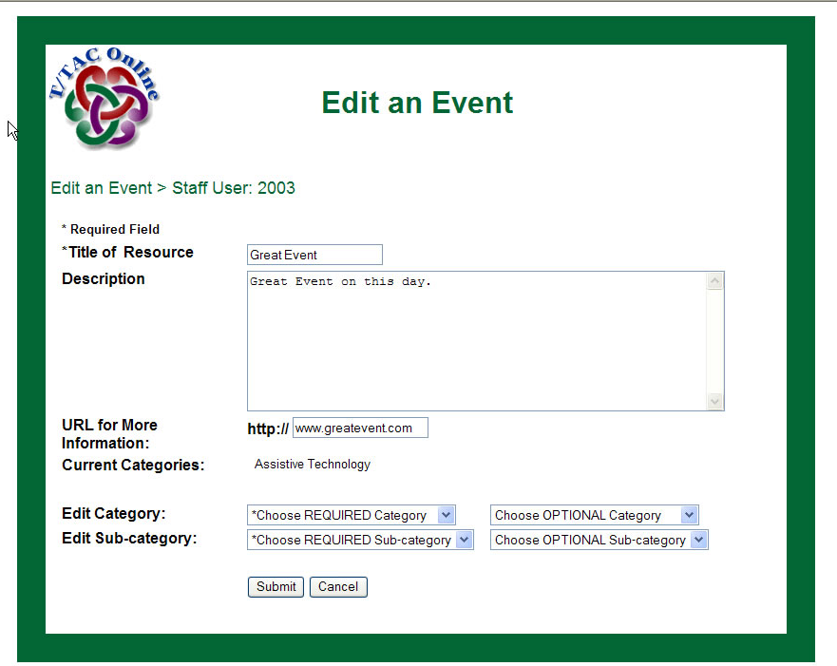
4. Click “Submit” button

Edit An Event

1. Click on the “My Events” button
2. Find the Event you would like to edit
3. Click on the “Edit” button
4. Edit the information you would like to change
5. Click on the “Submit” button

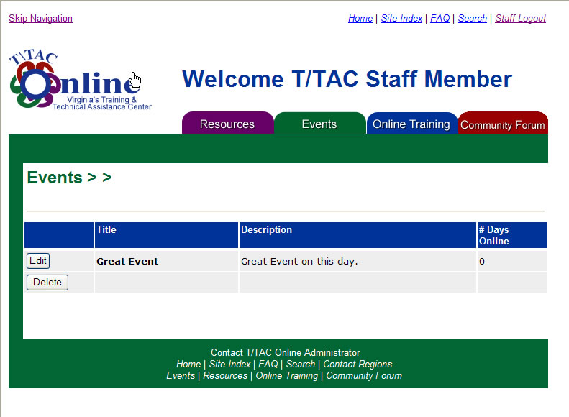

Delete an Event

1. Click on the “My Events” button
2. Find the Event you would like to delete
3. Click on the “Delete” button

4. A new window will appear. Select “Delete” to complete the deletion

WEBSHOPS (ONLINE TRAINNG)
Webshops are self-paced, online workshops designed by T/TAC Staff. They are a collection of 15-minute chunks of instruction (modules), which break the overall content down into smaller, more manageable pieces.

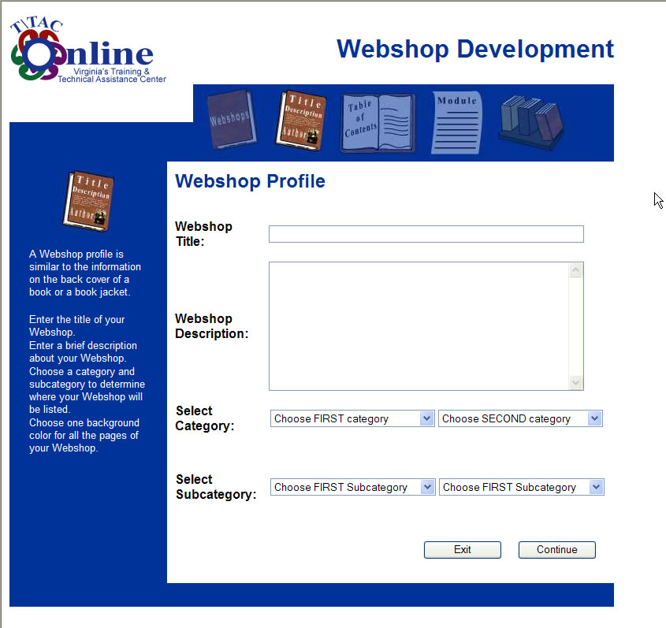

Add Webshop

You must be logged in as T/TAC Staff to add a Webshop.

- Click on the “Online Training” tab
- Click on the “Add a Webshop” button (“Add a Webshop” is also available in “My Webshops”).
- Read through the directions for adding a Webshop. Click Continue.
- Enter Webshop Profile. The information you submit applies to all Modules in the Webshop.
  - Enter title and description.
  - Select Required Category and Subcategory
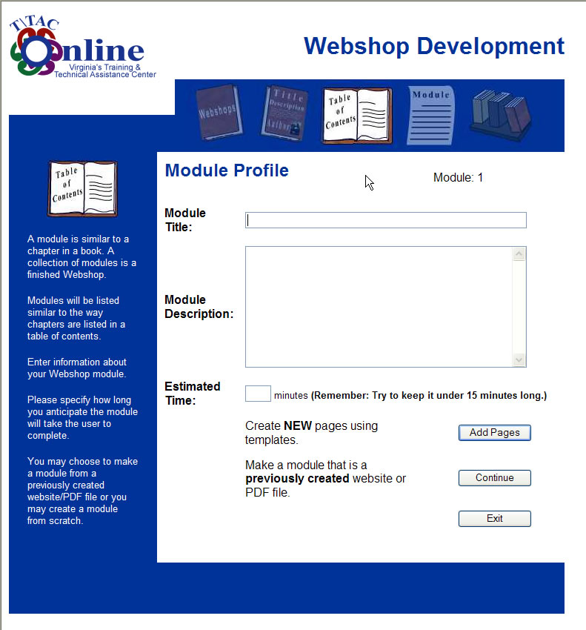
  - Select Optional Category and Subcategory if desired
  - Click “Continue”
5. Enter Module Profile information. Remember, this is one segment in the Webshop.
- Enter title and description.
- Enter estimated time for completion.
- Choose to either use the T/TAC Online templates or to Upload/Link to complete module.
  - T/TAC Online Templates: If you need to create a Webshop page by page, click the “Use Templates” button.
  - Upload/Link : If you have existing training materials on an outside website or you have an existing Webshop in a single PDF file, click the “Upload/Link” button.
6. Choose a template that matches the formatting you would like to use. The template gives you a general idea of how your page will look.
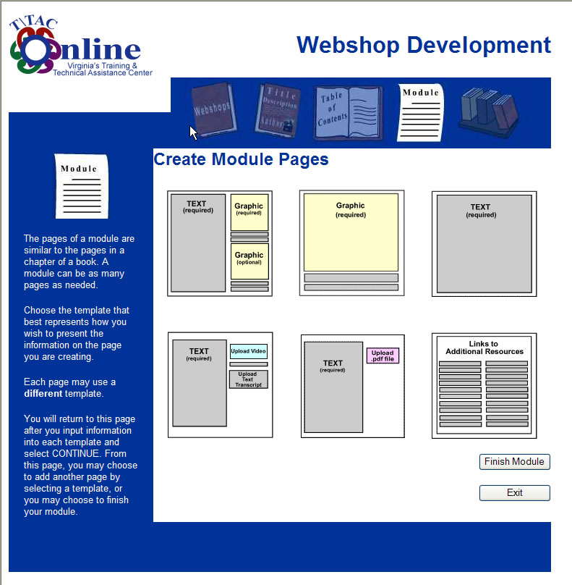
7. Add information to the templates as necessary.
- You may preview each template as you are creating your module.
8. Continuing adding pages as needed by clicking the “Add Another Page” button.
9. To finish and save the module, click “Finish Module”.
10.On the Publish Module page, you have four options.
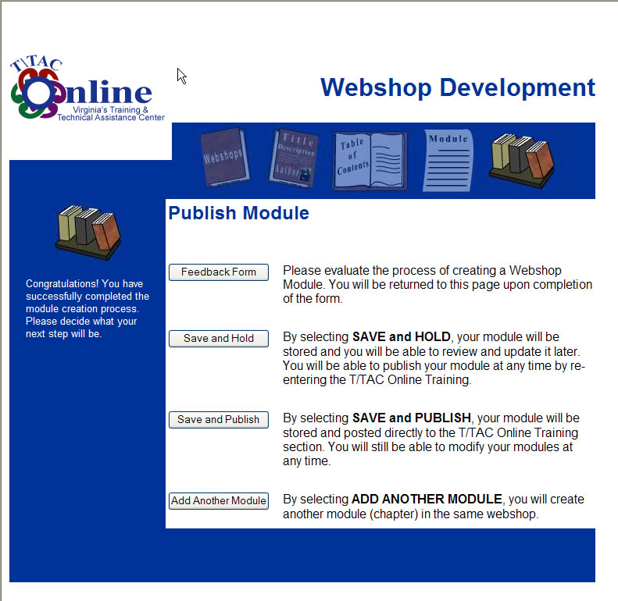
- Feedback Form: Choose this to send feedback to the T/TAC Administrator on the process of creating a Webshop. The information will be used to improve this process and ensure your satisfaction.
- Save and Hold: By selecting SAVE and HOLD, your module will be stored and you will be able to update it later. Your module will not be able to be viewed by others. You will be able to publish your module at any time by re-entering the T/TAC Online Training and clicking “My Webshops.”
- Save and Publish: By selecting SAVE and PUBLISH, your module will be stored and posted directly to the T/TAC Online Training section. You will still be able to modify your modules at any time.
- Add Another Module: By selecting ADD ANOTHER MODULE, you will create another module (chapter) in the same Webshop.

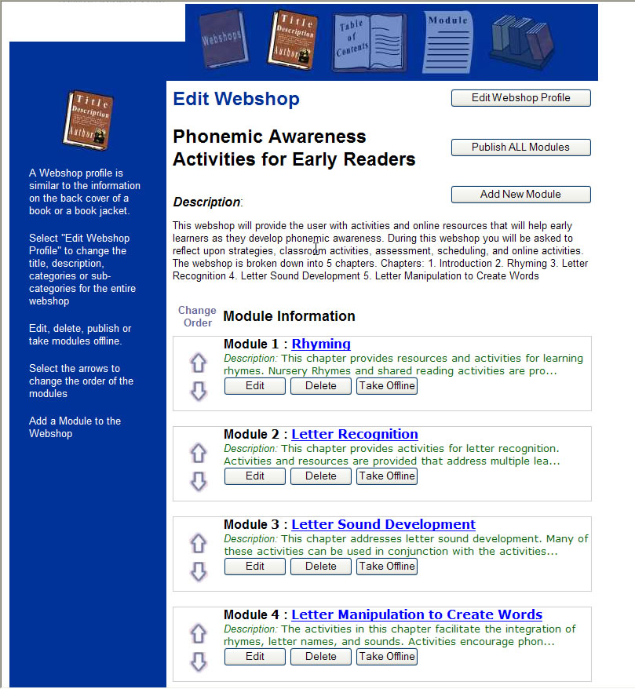
Edit a Webshop
My Webshops is an area that lists all Webshops you have created. Use this area to edit and delete Webshops, Modules, and Module pages.

- Click on “My Webshops”.
- To delete the entire Webshop, click on the delete button next to the Webshop.
- Click on the Edit/Publish button next to the Webshop you have selected.
- Edit Webshop Page: Several features are available for you to edit the Webshops you have created.
  - Edit Webshop Profile—this will allow you to change the overarching information about the entire Webshop
  - Publish All Modules—Any module you have on hold within this Webshop will be published online.
  - Add a New Module—This will take you back through the Module creation process to add a module to this Webshop.
  - Up/Down arrows—This will change the order of the modules within this Webshop.
  - Take Offline button—This will move the corresponding module to a holding area where only you can view it.
  - Publish—This will publish the corresponding module to the web.
  - Edit—This will allow you to edit the corresponding Module.
  - Delete—This will allow you to delete the entire Module
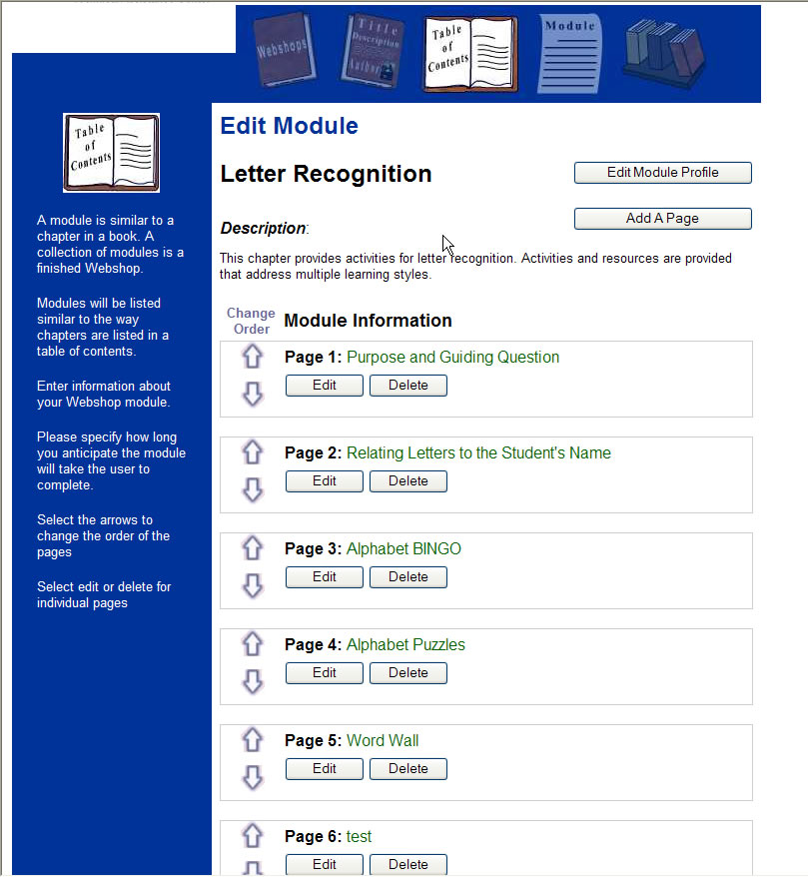
- Edit Module Page: Several features are available for you to edit the Modules you have created within a Webshop.
- Edit Module Profile—this will allow you to change information about the specific Module.
- Add a Page—This will take you back through the Module page creation process to add a new page to the Module.
- Up/Down arrows—This will change the order of the pages within the Module.
- Edit—This will allow you edit the corresponding page.
- Delete—This will allow you delete the page from the Module.

Save a PowerPoint for T/TAC Online

Remember to use larger (36+) fonts so the information can be clearly read.

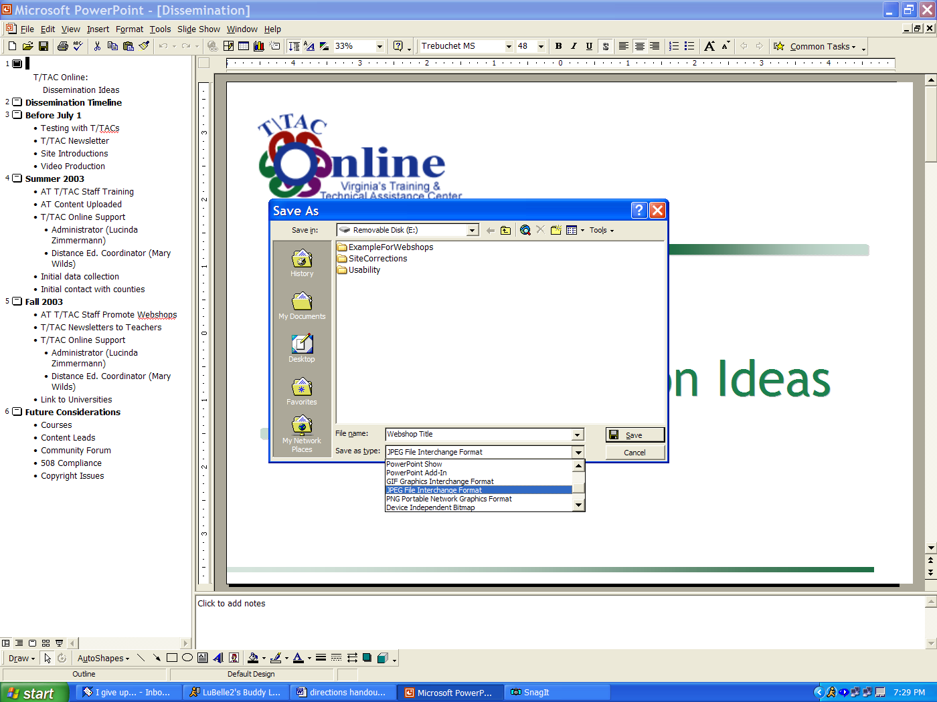
- Open the presentation in PowerPoint.
- The presentation needs to be in its final format; any changes completed after this process will not be saved properly. If you do make changes to the presentation, simply repeat this process.
- Go to File, Save As.
- In the Save As window, find “Save as type.”
  - Click the down arrow. Scroll down to select “JPEG File Interchange Format”.
  - Click Save.
  - The program will ask if you want to export every slide in the presentation. Select Yes.
  - Each slide will be saved as a separate image in a folder named the same as your presentations.
- Insert each slide (jpeg) into the One Graphic template. Hint: Look for the folder in the same location as the original presentation.

Converting Instructor-Led Training to T/TAC Online Webshops

Organizing and Writing Online Materials
- Reexamine the content you want to present. Divide the content into 10-25 minute logical sections that can stand independently, but fit into a larger webshop.
- Think about what content may need to be elaborated for learners who will not directly interact with you. Instructors often offer more detailed explanations once they are asked specific questions. Anticipate those questions and provide written explanations.
- Provide a clear organization for the entire Webshop. At the beginning of each module, refer back to this overarching organization. Provide transitions between modules (at the beginning and end) that remind learners where each fits into the whole.
- If your Webshop is composed of many modules, consider offering a summary module at the end.
- Write with a consistent style. Online learners tend to respond better to a more informal, conversational tone in writing than a formal one.
- Be as concise as possible while still explaining important points. Online readers often skim materials instead of reading as thoroughly as with a book or article

Designing the Learning Environment

Gain Attention
If you currently . . . | You might try to . . .
Tell a story at the beginning of the presentation. | Write a scenario or story to set the stage for the module. Think about ways to return to aspects of the scenario throughout or at the end of the module.
Ask the learners questions about situations pertinent to the module content; stimulate discussion at the beginning of the presentation. | Write questions to pose at the beginning of a module. You could spread them out on different pages to encourage learners to slow down and think.
Ask guiding questions that help the learners focus on important aspects of the information you present. | Present those same questions in written form at specific points throughout the entire module. You might provide more continuity to the entire webshop by referring back to the same guiding questions in several modules.
State Clear Objectives
If you currently . . . | You might try to . . .
Tell the learners the objectives of the presentation. | Write the objectives on the first page of the module. You might refer back to the objectives throughout or at the end of the module.
Write the objectives on a slide or handout. | Use that same format as a page in a module.
Give one presentation that includes all the information contained in several modules of a Webshop. | Write separate objectives for each module of the webshop. It might help the learners to see how the current module’s objectives connect to the objectives of other modules in the Webshop.
Expect learners to take notes on your presentation. | Upload a concept map or note-taking organizer for the module or entire Webshop as a PDF. Learners could download this and record thoughts and ideas throughout. Remind them that they can take notes either on paper or electronically.

Activate Prior Knowledge
If you currently . . . | You might try to . . .
Ask learners what they already know about the topic of your presentation. | Write a scenario and ask learners to think about how they might respond to the situation based their current knowledge.
Give learners an informal pretest to assess their knowledge. | Incorporate pretest type questions or an opinion survey into an introduction to the entire Webshop or to a specific module in the Webshop.
Present Information
If you currently . . . | You might try to . . .
Present content that follows specific steps or procedures. | Articulate those steps in a clear concise way and present each step on a separate page.
Demonstrate a procedure. | Take a series of pictures of the demonstration. You will need to write clear explanations for what is happening in each picture.
Rely on your speaking abilities to explain content without notes or visual aids. | Record yourself during a presentation and write the content based on what you say. This may help you to elaborate written explanations for learners who will hear you teach.
Use only a few slides to illustrate your points as you present. | Split the information into several pages including elements of your oral presentation. Be concise; try making bulleted lists to communicate information.
Use many slides to illustrate your points as you present. | Remove some slides with redundant or extraneous information. Learners will stay more focused if the relevance of the information is clear.
Rely on discussions as part of your presentation. | Ask questions and offer multiple opinions as possible answers. Consider quoting other T/TAC staff or country special education leaders.  Start a discussion thread on a topic in your Webshop. Direct learners to the Discussion Board to read and post other opinions.
Cue the learners to important information through your words. | Experiment with visual cues to highlight important information (i.e., all caps, asterisks). For example, create a consistent look for a page used to ask a question.
Rely on your ability to stimulate learner’s curiosity during your presentation. | Present questions that ask learners to predict the how information can be applied to new situations instead of just telling them.
Refer to online resources during your presentation. | Provide a link to those resources at the end of the module. Challenge learners to look for information online before the moving to the next module. Use this as a transition at the beginning of the next module.
Talk about how to implement information in the classroom. | Provide pictures that show examples of this happening. Be sure to maintain confidentiality by blurring the faces of children and omitting names.

Provide Practice and Feedback
If you currently . . . | You might try to . . .
Ask questions during your presentation to assess the learners’ level of understanding. | Present self-assessment questions on one page and feedback on the following page. The questions could be simple multiple-choice, but the feedback provided should explain why the answer is correct or incorrect. You might direct learners who answer incorrectly to the page number where the information was first presented.
Answer many questions from your learners throughout your presentation. | Keep track of the most common questions and introduce them as part of the module. This could be a consistent Question and Answer page format that you use throughout the Webshop or module.
Ask learners to summarize parts of the information learned for the whole group. | Ask learners to write a brief summary of what they have learned in the module.
Spend time during your presentation letting learners talk about their thoughts on the new information. | Ask questions that allow learners to reflect on the new information and how it might affect their work. You could prompt the learners to write some of their thoughts or to discuss them with a colleague (Perhaps one they have told about your Webshop on T/TAC Online!).
Answer very case-specific questions for learners at the end of the presentation. | Offer to answer questions through email or through the Discussion Board.
Enhance Retention
If you currently . . . | You might try to . . .
Provide opportunities during the presentation for learners to interact with each other. | Challenge the learners to ask a colleague about something they learned in your module. At the beginning of the next module, refer back to the challenge.
Give your learners a handout during the presentation. | Upload this as a PDF file so learners can download it for use.
Try to promote discussion of the new information at the end of the presentation. | Offer to lead an online discussion of a topic in the Webshop at a particular time. You might also simply start a discussion thread and encourage learners to post their new thoughts.

These are just a few of the possible tips for converting your training to T/TAC Online. To share other ideas you have or read ideas from others, add to the online discussion on the T/TAC Online Discussion Board.

