

Design Approach
T/TAC Online Project, Fall 2005 – VA Assessments

Matt Humphrey
Aala’a Mashaal
Pamela Sharpe
Tim Smith
Maria Washington

Graduate School of Education
George Mason University
December 1, 2005

Table of Contents

I. What is an Electronic Performance Support System (EPSS)? …………………... 3
II. Why is an EPSS the Best Solution for T/TAC? ……...………………………....... 4
III. How Teachers Will Use the EPSS ………………………………………………... 4

IV. The Types of Problems That Will Be Supported ……………………………...… 5

V. Prototype of Solution System ……………………………………………………... 8

VI. References …………………………………………………………………...…… 15

VII. Appendices
a. Flowchart 1: Searching the VAAP Manual ……………………………… 16
b. Database Schema 1: Searching the VAAP Manual …………………...… 17
c. Flowchart 2: Lesson Plan Document …………………………………...… 18
d. Database Schema 2: Lesson Plan Document …………………………….. 19

I. What is an Electronic Performance Support System (EPSS)?
In the ground-breaking book Electronic Performance Support Systems (EPSS) (1991), Gloria Gery defined EPSS as an integrated electronic environment that is available to and easily accessible by each employee and is structured to provide immediate, individualized on-line access to the full range of information, software, guidance, advice and assistance, data, images, tools, and assessment and monitoring systems to permit job performance with minimal support and intervention by others.
An electronic performance support system can also be described as any computer software program or component that improves employee performance by
- reducing the complexity or number of steps required to perform a task,
- providing the performance information an employee needs to perform a task, or
- providing a decision support system that enables an employee to identify the action that is appropriate for a particular set of conditions.
An EPSS helps employees perform tasks without additional training. The introduction of an EPSS system can help employees be more productive, accurate, efficient, learn new procedures and task, give them access to additional resources. An EPSS helps new employee get up and running faster, learn task, and get acclimated to the culture of the organization.
Key Characteristics of EPSS

Deborah Alpert Sleight (1993) states that an EPSS should contain these key characteristics:
- computer-based
- provide access to the discrete, specific information needed to perform a task at the time the task is to be performed
- used on the job, or in simulations or other practice of the job
- controlled by the user
- reduce the need for prior training in order to accomplish the task
Attributes
In her classic article “Attributes and Behaviors of Performance Centered Systems”, Gloria Gery delineated numerous elements of effective performance support systems including:
- Establishes and maintain a work context
- Aids in establishing the goal
- Structures the work process
- Reflects the natural flow of work
- Provides alternative views data, information, and knowledge
- Provides contextual feedback
- Provides support resources without breaking the task context
- Embeds knowledge into the interface
- Provides access to underlying logic
- Automates tasks
II. Why is an EPSS the Best Solution for T/TAC?
Based upon the results from data collection and needs analysis, the T/TAC Mission Six team determined that the vast majority of users will be new to the VAAP assessments and welcomed a system that would assist them in developing lesson plans aligned to the new SOL standards. Statistics showed that teachers indicated a need for a solution system that removed hindrances, was easy to use, decreased the amount of time needed to complete assessments and provided resources that helped select appropriate instructional strategies for students. Teachers indicated a need to interact with other special education teachers involved in the VAAP transition and a need to share lesson plans, and collaborate with other special education teachers.

III. How Teachers Will Use EPSS

During the performance analysis phase of the T/TAC Mission Six project the team learned that the state of Virginia implemented a new alternate assessment procedure called the Virginia Alternate Assessment Plan (VAAP). The VAAP was created for special education teachers of students with severe cognitive disabilities to use in assessing their students according to the mandates of the Individuals with Disabilities Education Improvement Act (IDEIA) and the No Child Left Behind Act (NCLB). Under these two pieces of legislation all students with disabilities must (with the consent of their parents) be considered for participation in the Standards of Learning (SOL) assessments. Recognizing the challenges faced by students with severe cognitive disabilities the authors of the VAAP manual compiled a list of SOLs they felt were accessible by these students, which they named the Aligned Standards of Learning (ASOL).

Prior to the implementation of the new VAAP procedures special education teachers of students participating in alternate assessments focused on teaching life skills with little if any consideration of SOLs, which focus on cognitive skills. Furthermore, the authors of the VAAP manual acknowledged that communication is the key to learning and point out that communication can be very difficult for individuals with severe disabilities. It was with this in mind that the authors stipulated that communication skills be incorporated into the lesson plans.

The Learner Analysis informed the T/TAC Mission Six team that special education teachers in the state of Virginia have varying levels of experience working with students with disabilities. It is important to note that due to the fact that the VAAP manual is new, none of the teachers in the state of Virginia have experience designing lesson plans that incorporate SOL and communication skills.

The T/TAC Mission Six team has considered that the task of writing the lesson plans that meet the new mandates of the VAAP may be easier for some special education teachers than others depending on their number of years of experience. Therefore, the T/TAC Mission Six team categorizes teachers in the state of Virginia as follows:

- Novice teachers -teachers that have little or no experience working with students with disabilities

- Intermediate teachers – teachers that have several months or years of experience working with students with disabilities

- Expert teachers – teachers that have many years of experience working with students with disabilities

With these factors in mind the T/TAC Mission Six Team envisions the EPSS as a job aid that will

- Assist teachers in making the transition from designing life skill centered lesson plans to SOL centered lesson plans

- Assist teachers in incorporating communication skills into their lesson plans

- Provide just in time support for teachers requiring different degrees of assistance

For example, a novice teacher may use more of the scaffolding provided by the site than an intermediate teacher would in designing a lesson plan. Whereas, an expert teacher may only use the site to search for ideas without utilizing any of the scaffolding provided.

IV. Types of Problems That Will Be Supported

In this design approach the teachers completing the lesson plans will be using a combination of Gagne’s Intellectual Skills or procedural knowledge consisting of relational rule using and problem solving. There are seven different sections a teacher must complete in order to produce a lesson plan for instruction of a VAAP student (student’s with significant cognitive disabilities).

In the first section the teacher will clarify the Theme or Event of the instruction. The teacher will apply a relational rule to this section because they must consider prerequisite factors in terms of the student(s) skill set and apply an “if then” process to complete the task (Smith & Ragan 2005). In this section of the lesson plan the teacher might be provided with a checklist and/or prompt questions for a support mechanism.

1. THEME/EVENT:

DATE:

In the second section the teacher will select the student task or learning activity. They complete this by relational rule using. The teacher will select the student task or activity based on the theme or event from the prior section. The support provided for this section might also be a checklist and question prompt system.
2. STUDENT TASKS/ACTIVITIES:
1.

2.

3.

4.
.

In the third section the teacher will support the Virginia Align Standards of Learning (ASOLs) with math or English. This will be completed using problem solving. The teacher will solve problems in a situation never encountered (aligning ASOLs to instruction) and will incorporate a trial and error until a correct selection is made. The teacher must also use multiple rules to solve a problem (Smith & Ragan, 2005). In this section the teacher could be supported with a case study scenario, for example.

3. ALIGNED STANDARDS OF LEARNING: MATH ENGLISH
Organizing Topic: Standard: Student(s):
Organizing Topic: Standard: Student(s):
Organizing Topic: Standard: Student(s):
Organizing Topic: Standard: Student(s):
Organizing Topic: Standard: Student(s):
Organizing Topic: Standard: Student(s):

In the fourth section the teacher will be using problem solving to select the correct communication skill suited for instruction to the particular student(s). Teaching communication skills are a new requirement for teachers instructing VAAP students. The teachers will have to learn new information to select the skill level the fit the student(s) in different skill categories. The support system in this section could also be a case study or a scenario.
4. COMMUNICATION SKILLS ADDRESSED:

__C1 __ C2 __ C3 __ C4 __ C5 __ C6 __ C7

__ C8 __C9 __C10 __ C11 __ C12 __ C13 __ C14

For the fifth section the teachers will use relational rule using to complete the material list for the learning activity. The teachers are familiar with what materials to use for certain learning activities and will list the items from prior knowledge. The support system used here could be a checklist and question prompt system.
5. MATERIALS:

In the sixth section the teacher must select assistive technologies to enhance or assist in the student(s) in instruction. The teacher will use the relational rule using to apply assistive technology to the student(s) instruction. They will develop a list of assistive technologies from prior knowledge that best suits the instructional goals. The supports given for this section could be a checklist and question prompt.

6. ASSISTIVE TECHNOLOGY:

The seventh and final section applies the evidence collection section to a problem solving intellectual skill. The teacher will use resources for collection of student(s) completion of the target tasks and use this evidence to prove skills in communication, ASOLs, and cognitive skills never produced in past skill discovery. This section could provide support for the teachers in the form of a case study or a scenario.
EVIDENCE COLLECTING TOOLS: ______ Audiotape ____ Videotape
Student(s): Student(s):
_____ Work Samples
Student(s): ______ Anecdotal Records _____ Interviews
Student(s): Student(s
_____ Photographs
Student(s): ______ Charts/Graphs
Student(s):

V. Prototype

At this point, the EPSS will include three main features. The first feature gives the user the ability to search the VAAP manual for topics, ASOLs, and sample activities for use when creating lesson plans. The second feature gives the user the ability to search existing lesson plans that have been submitted by teachers and approved by the Department of Education for use within this expert system. The third feature assists the user in creating the lesson plan by walking them through the process by each step with proper supports and coaching.

The following is an overview of the initial prototype development for this EPSS.

Search VAAP Manual Screen
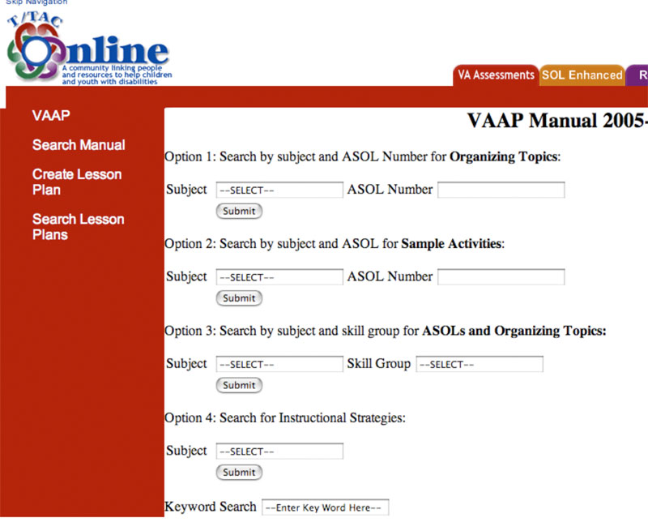

Search Option 1: Users may search by subjects [English, Math, History, and Science]. The result of the search will be organizing topics documents (from the enhanced scope and sequence section of the manual).
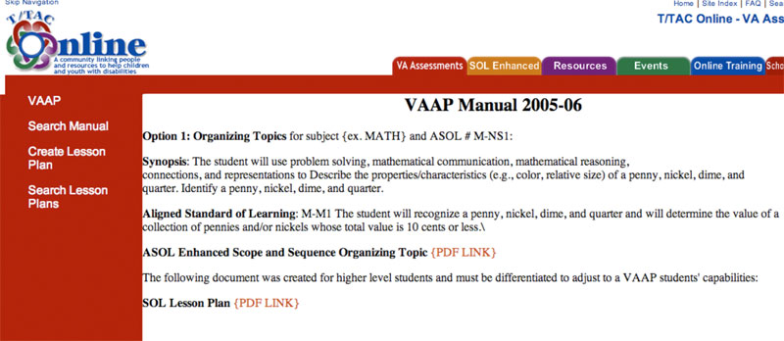

Search Option 2: The user will search by subjects and ASOL number (i.e. Math and ASOL Number M-NS1. The result of the search will be sample activities.
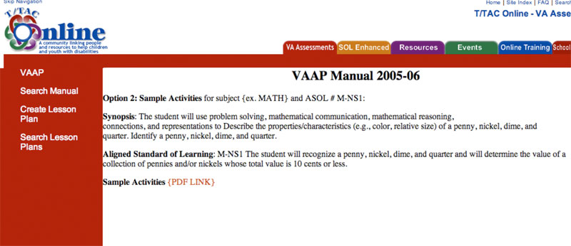

Search Option 3: Users will search by subjects (i.e. English) and skill group (i.e. 2). The result will be the ASOLs that fall in the particular skill group. Then they will choose one ASOL to find the organizing topics.
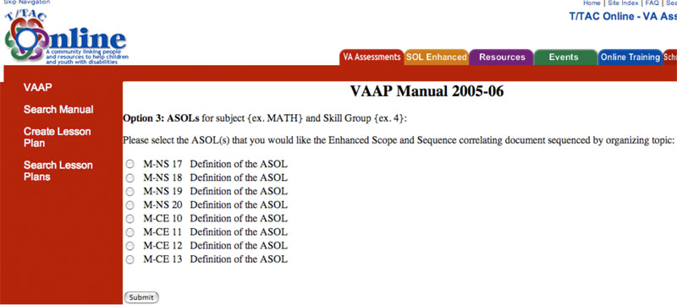

Search Option 4: Users will search by subjects only and the result will be instructional strategies.
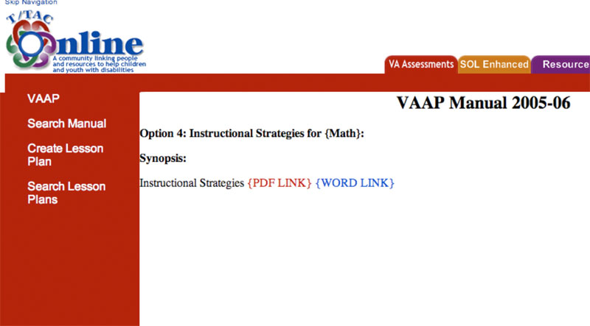

Lesson Plan Design System

Each of the following screen designs is based on the lesson plan document that is explained in section 4 of this document.

Screen 1 – General Information
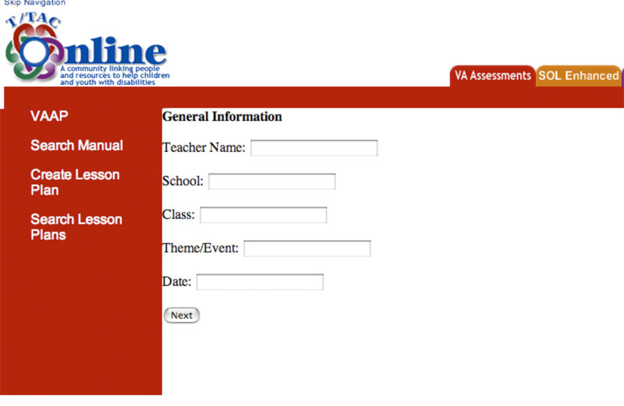

Screen 2 – Student Tasks/Activities
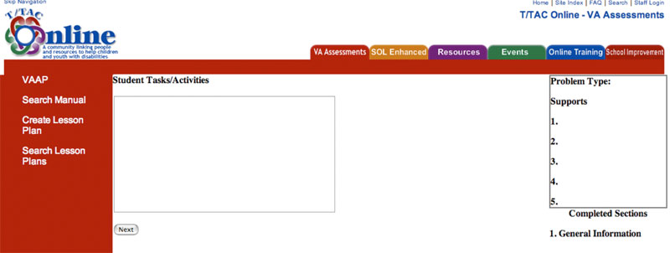
Screen 3 – Aligned Standards of Learning
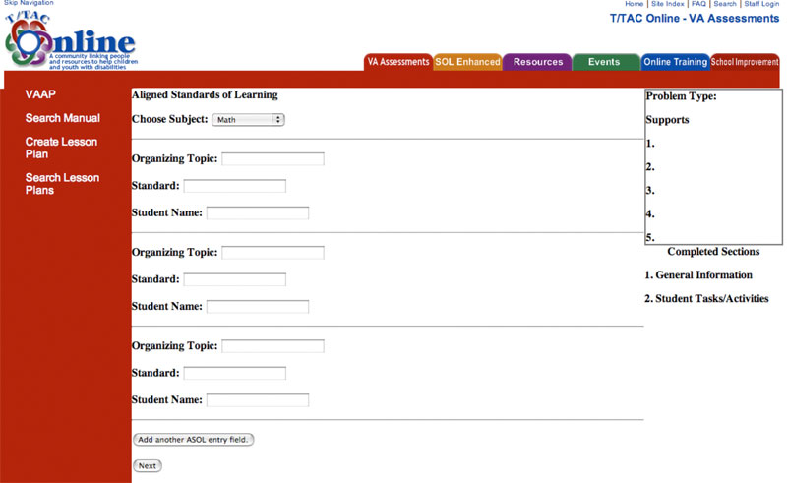

Screen 4 – Communication Skills
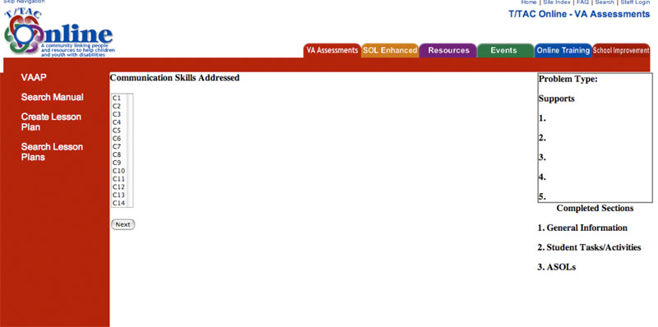
Screen 5 – Materials Used
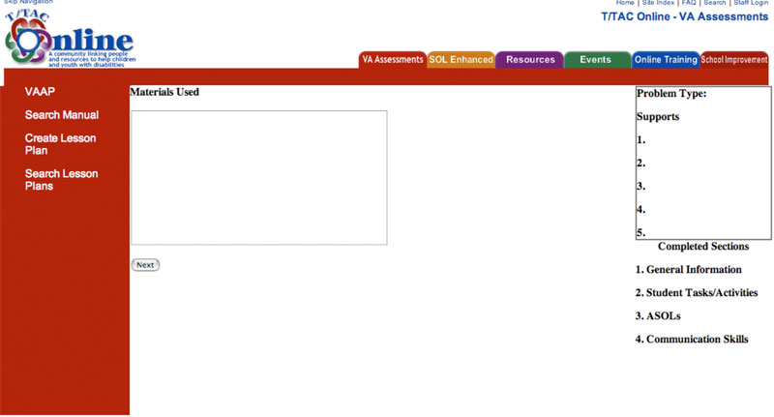

Screen 6 – Assistive Technology
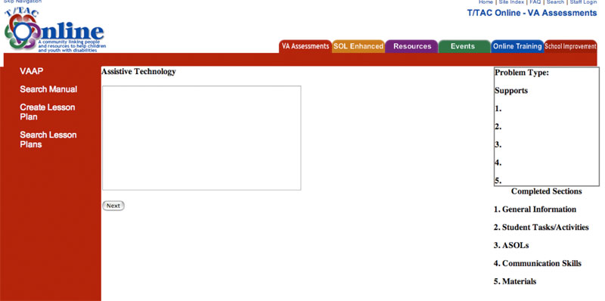

Screen 7 – Evidence Collection Tools
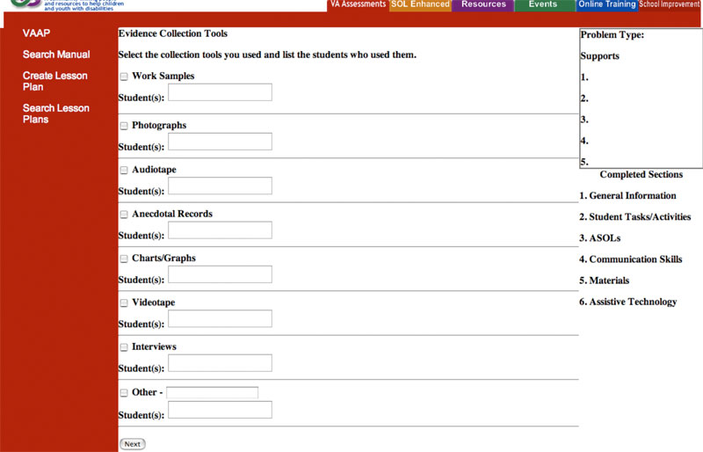

Screen 8 – Additional Comments
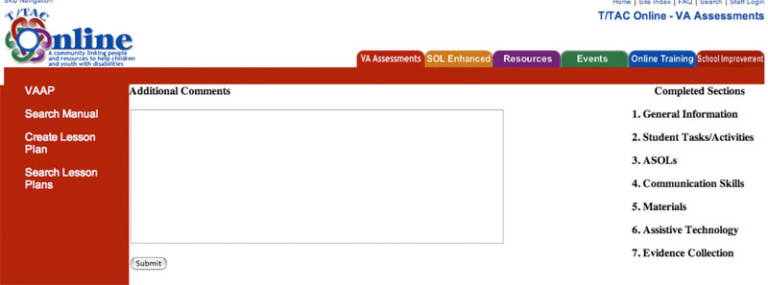

VI. References

Gery, G. (1991). Electronic Performance Support Systems. Tolland, MA: Gery Associates.

Gery, G. (1995). Attributes and Behaviors of Performance-Centered Systems. Performance Improvement Quarterly, 8(1), 47-93.

Smith, Patricia L. & Ragan, Tillman J. (2005). Instructional Design. Hoboken, NJ: John Wiley & Sons, Inc.
VII. Appendices

a. Flowchart 1: Searching the VAAP Manual

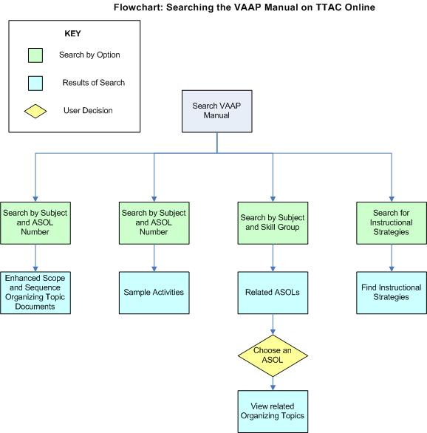

b. Database Schema 1: Searching the VAAP Manual

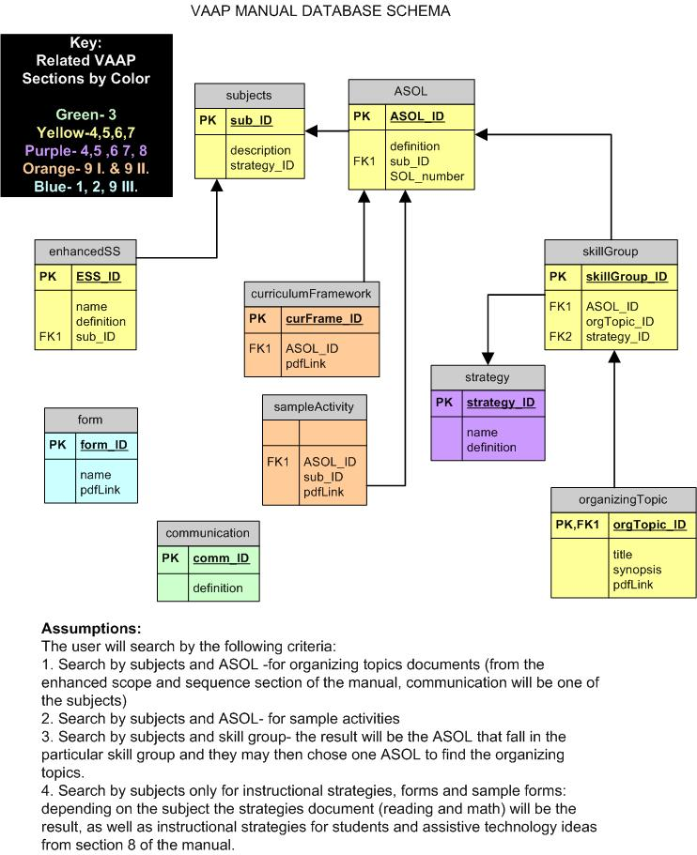

c. Flowchart 2: Lesson Plan Document

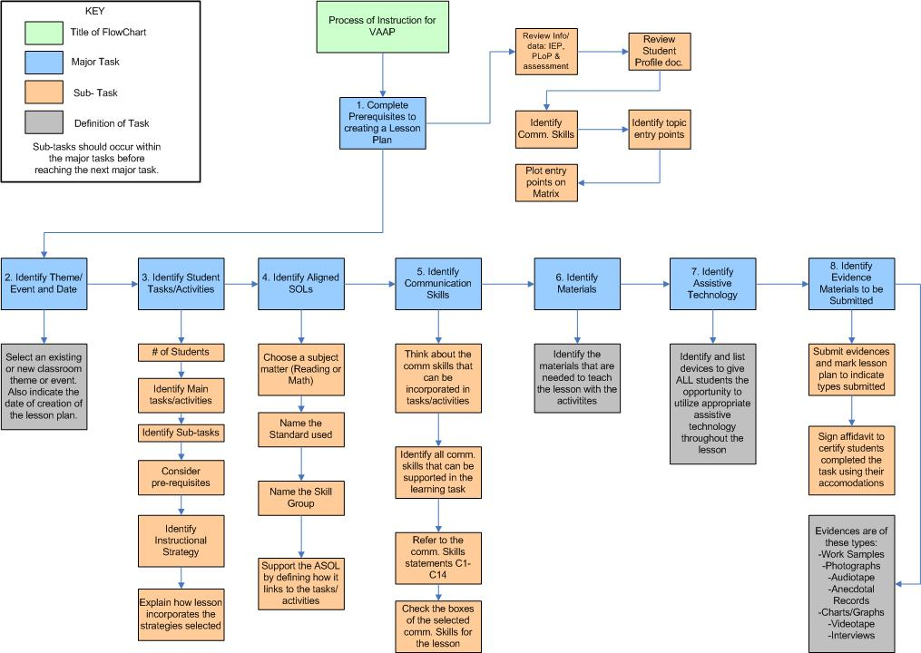

d. Database Schema 2: Lesson Plan Document


