Design Document

The Development of the
Manager’s Community of Practice
A
Training Module
For
Mine Safety and Health Administration

Table of Contents

PROJECT INFORMATION 3

INTRODUCTION 4

VISION STATEMENT 7

PROJECT GOALS 7

PROJECT OVERVIEW 7

RESOURCES 8

DRIVERS & BARRIERS 9

NEEDS ASSESSMENT 10

AUDIENCE ANALYSIS 11

OPTIMALS, ACTUALS, & GAP 13

DESIGN REQUIREMENTS 14

COURSE DESCRIPTION 17

OBJECTIVES 18

TASK ANALYSIS 19

INSTRUCTIONAL STRATEGIES MATRIX 19

DESIGN APPROACH 22

MEASUREMENT 24

DELIVERY SYSTEM DESCRIPTION 24

DESIGN SPECIFICATIONS 26

CONTENT OUTLINE 28

FLOWCHART 31

REFERENCES 36

APPENDICES 37

PROJECT INFORMATION

Client Information

Organization: Mine Safety and Health Administration
Client Contact: James M. Baugher
Title: Management Program Analyst
Educational Policy Analyst
Address: 1100 Wilson Boulevard
Room 2142
City, State, Zip: Arlington, VA 22209-3939
Phone: (202) 693-9570
Fax: (202) 693-9571
Email: Baugher-James@msha.gov

GMU Design Team Members

Lisa-Marie Aird: Objectives, Measurement, Task Analysis, Storyboard Image, Interface Description, Tutorial Storyboard (Appendix G)
Tammi Fritz: Editor, Contact, Additional Questions, Needs Assessment, Audience Analysis, Optimals, Actuals, & Gap, Task Analysis, Content Outline and Outline Introduction, Flowchart Images
Lisa Knudson: Editor, Consolidated Document, Introduction, Vision Statement, Project Goals, Task Analysis, Priorities for Development, Drivers & Barriers, Potential Solutions, Recommendations, Design Requirements, Instructional Strategies Matrix, Design Approach, Content Outline, Storyboard Layout, Design Specifications, References, Appendices, and Website Example (Appendix H),
Irene Montano: Contact, Course Description, Delivery System Description and Rationale, Task Analysis, Tutorial Script (Appendix F).

Schedule

The implementation of the MSHA Haulage Truck Operator Training Program Tutorial is projected for spring 2003. All documentation deliverables and prototype will be completed by December, 2002.
Project Deliverables include:

October 2, 2002 Performance Analysis Briefing Report
October 14, 2002 Briefing Report (Needs Assessment, Audience and Task Analysis, Objectives and Measurement)
November 1, 2002 Design Treatment
November 13, 2002 Storyboards or Wireframes, Sitemaps or Flowcharts
December 2, 2002 Prototype, Production and Usability Testing.

INTRODUCTION

The Mine Safety and Health Administration (MSHA) was created in 1978, when the 1977 Act transferred the Federal mine safety program from the Department of the Interior to the Department of Labor. MSHA is required by Congress to enforce mandatory safety and health standards for both surface and underground coal and metal/nonmetal mines in the United States as a way of eliminating fatal injuries. MSHA works toward a reduction of serious accidents by promoting proper safety and health conditions in the mining industry.

To drastically lower health hazards, the Mine Act (of 1977) requires MSHA to visit and inspect every mining and mineral processing operation in the US regardless of size and location. Other provisions call for issuing detailed regulations on basic safety and health training for miners, upgrading and strengthening many existing mine safety and health laws, making changes in the civil penalty system applying to rules violators, and increasing participation of miners or their representatives in lawful safety activities. MSHA strives for improved working conditions by encouraging the education of our Nations miners, as well as MSHA personnel.

MSHA has concluded through collected data that safety and health in the mining industry has improved greatly since the early 20th Century. The following chart shows the number of mining deaths in the United States from 1910 to 2001.

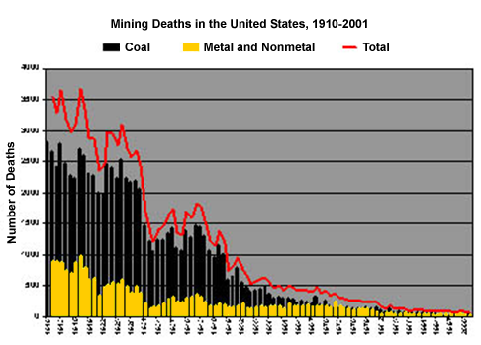

Total mining fatalities reached the lowest level in history in 2001; the Mine Safety and Health Administration reported 72 mining deaths in 2001, the lowest figure since official record keeping began in 1910 and 13 fewer than in calendar 2000. At the same time, a plateau has appeared in recent years. Therefore, the top two of five MSHA’s Goals are:

- Reduce fatal accidents by 15 percent per year
- Reduce Nonfatal Days-Lost due to injuries by 50 percent over four years?
“According to the Bureau of Labor Statistics, the fatality rate for coal miners is more than seven times higher than for the industry as a whole, making it one of the most dangerous jobs in America. In addition, coal-mining fatalities have increased while fatalities in other below-ground mining are on a decline” (Denver Post.com editorial - http://www.denverpost.com/Stories/0,1413,36%257E73%257E762074,00.html ). Although U.S. coal mine production is at its highest level in history and mining fatalities are much lower than in the past, coal mining deaths have increased for the past three years. “The number of coal mine fatalities nationally fell each year from 1990 through 1998, when they reached an all-time low of 29. In 1999, 35 coal miners died on the job” (Courier Journal.com – Louisville, KY – http://www.courier-journal.com/localnews/2002/01/04/ke010402s132294.htm ). The metal and non-metal mining sector, however, has set a historic low with 30 fatalities during 2001, compared with 47 in 2000 and the previous low of 40 in 1994.
Although coal mines have a higher fatality rate than metal/nonmetal mines, both types of mines report that the highest incidents of fatalities occur due to powered haulage in either underground or surface mines. This can be viewed by the following charts that show the number and type of fatalities in coal mines and metal/nonmetal mines for the past five years.

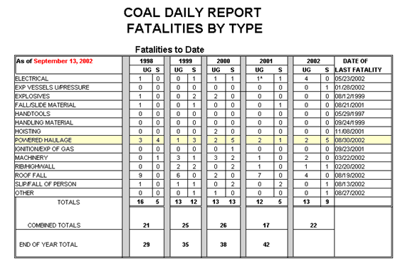
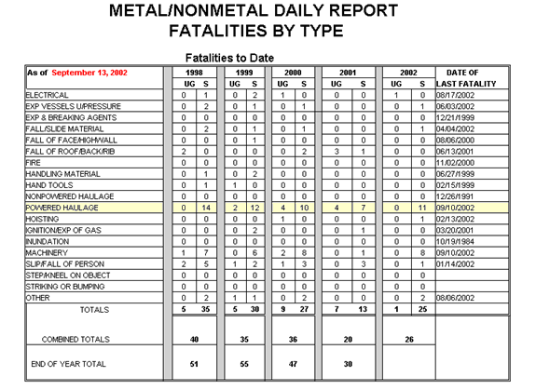

In the last five years, there have been 114 fatalities in the mining industry involving surface haulage. Seventy-Three of the fatalities, or 64 percent, involved trucks. Some of the causes of truck accidents have been caused by: loss of control of the vehicle; faulty brakes or other defective equipment; driving too fast for conditions; overloading the truck; use of unsafe dumping practices; and use of parking procedures which did not hold the truck. Other causes of fatalities have been persons on foot getting run over by trucks or pinned between two vehicles. These types of accidents can occur if an operator is not familiar with the capabilities and limitations of the truck or doesn't perform a proper preoperational examination.
Safety Directors and Mine Managers have no efficient method of providing “Haulage Truck Operator Training” at this time. Our client, Mr. Baugher, has a vision to improve the mining industry by teaching people how to do their job better. He feels that training could help miners have better safety practices which would lead to less maintenance and ultimately a more productive mine. The overarching goal of this project is to increase the number of mine managers who are skilled at customizing safety training for the mines. This goal will be achieved by providing training to the mine and safety managers, which assists them in tailoring a task analysis template for haulage drivers provided by MSHA. This process should guarantee ownership of the training and task worksheets, and ultimately provide a safer environment.

VISION STATEMENT

To develop a technology-based prototype Community of Practice for MSHA to provide to mine and safety managers at the individual mines; the Job Task Analysis (JTA) CoP will enhance manager’s communication with one another and offer further preparation for their role as a facilitator of job task analysis workshops.

PROJECT GOALS

After Mr. Baugher’s request for technology-based job training and an analysis of the provided information, the instructional design team chose the following goals for this project:

- Quotes from persons involved in previous groups (Testimonials)
- A message board where employees can post their ideas
- Graphics to illustrate the process
- A tutorial on the facilitating process
- A database of completed task lists.

PROJECT OVERVIEW

The purpose of this tutorial is to demonstrate to the safety directors and mine managers the process of how to properly provide on-the-job training through one-day, on-site workshops. The workshops will be made up of various mine employees; truck drivers, mechanics, and managers that work with the haulers. At the completion of the workshop the team will have produced a comprehensive task worksheet that lists the sequential job steps.

Originally, MSHA organized a week-long workshop developed and conducted by the Navy. The national joint committee, comprised of manufacturers, maintenance people, truck operators, safety staff, haulage supervisors and MSHA, were organized to proceed through the process of developing a systematic task worksheet. The process began with a brainstorming session where all team members silently jotted individual haul truck operating tasks on post-it notes. Then, the still non-verbal group arranged job steps in the order that they are normally accomplished.

Once the group concluded the organization of the tasks, the facilitator developed the results into a Spider, or visual mind map, using MindManager, a mind mapping and brainstorming software tool. The Spider was then converted into a final worksheet document, using MSWord, which provides a comprehensive list of job duties that can be used by the trainer to check his own knowledge before he trains other employees and ultimately provides a safer mine.

Since this initial workshop, MSHA has piloted a few one-day individual mine workshops. During these workshops, the mine employees involved with haul trucks proceed through a series of steps to revise the previously developed worksheet and customize it to meet the specific needs of their mine. The participants of these pilot programs have felt that the workshops are productive and worthwhile; the overall comments have been exceptionally positive. MSHA feels that there is a shift in the attitudes and actual safety behaviors of the participants, since the mine employees are now playing a constructive role in developing their own job aides.

These pilot programs have been led and facilitated by MSHA employees. However, MSHA would like to train safety directors and mine and maintenance managers to become facilitators so that all training would be at the local mine level. This would allow faster expansion of this process and completed task worksheets to all mines, which should produce a higher degree of ownership among the mines and ensure the follow-through of the job aide. Also, this would lighten MSHA’s responsibilities with working at every workshop and allow time to be spent in other productive areas. Furthermore, once the process is introduced and familiar at a mine, the process of developing the task worksheet can be applied toward other specific jobs.

RESOURCES

Human Resources

Stakeholder/Subject Matter Expert

Jim Baugher, MSHA’s Management Program Analyst and Educational Policy Analyst, is both the primary stakeholder and subject matter expert for this project. Mr. Baugher is the original requestor of assistance in developing a Web-based Instructional Tutorial. Mr. Baugher approached the GMU instructional design team with materials and a computer-based instructional idea for training mine managers to become facilitators of the task analysis workshop. As a further reference, Mr. Baugher’s content knowledge is one of the most valuable resources to the team. Mr. Baugher was asked six questions as a combined effort of both teams; the summary of his responses are included as a chart in Appendix A.

Additional Sources

Shannon Robinson, an MSHA intern, has provided valuable insight and assistance into the culture and operations of MSHA and the mines, as well as essential documents and additional sources. Don Conrad and Cathy Matchett, MSHA employees, were provided as additional human resources available to the instructional design team. Their responses provided the instructional design team with further information; the summary of their responses to the six questions is provided as a chart in Appendix B.

Non-Human Resources

General Information

The instructional design team obtained demographic information and statistical data for the current mines and mine employee population from the Internet. Additional documentation was provided by Mr. Baugher and Shannon Robinson and includes:

- Instructions to Pilot Users of Haulage Truck Operator Training;
- Haulage Truck Operator Training and Assessment Worksheet;
- Task Worksheet Completion Instructions;
- Haulage Truck Pilot Follow-up;
- Post Workshop Truck Pilot Feedback;
- Post Workshop Pilot Team Member’s Feedback;
- Example of Task/Checklist;
- Packet for Pilot Facilitators;
- Packet for Pilot Participants;
- Recommendations & Suggestions;
- Haul Truck Spider.

On-line Resources

The MSHA website, accessed at http://www.msha.gov, is a good source of information about the agency and mine data. The instructional design team has also been compiling a list of other online resources that will be useful to both the team and Mr. Baugher. The list includes other organizations, statistical data, articles, safety training, and injury prevention. The compilation of the Website’s URL and a description of its contents of what has been collected to date are provided in Appendix C. The instructional design team will continue to refine this list during the remainder of the semester and will deliver a final list to Mr. Baugher at the end of the project.

DRIVERS & BARRIERS

Our team has identified the following drivers and barriers that will assist or hinder us in completing the MSHA haul truck Project. The following is a list of the aligned drivers and barriers:

Drivers | Barriers
Federally mandated occupational safety regulations exist. | Attitude of mine employees (haul truck drivers) is that government is adversarial.
Federally mandated employee training regulations exist. | Need buy-in of target audience to provide on-the-job-training (OJT) to drivers of haulers.
MSHA's goal is to reduce fatal accidents and non-fatal, days-lost injuries. | Target audience (Safety Directors, Mine Managers and Maintenance Managers) has little time to read large amounts of training material and attend training that would take them away from their jobs.
MSHA personnel cannot provide training to all of the nation's mines. | MSHA employees, Safety Inspectors, and Mine Managers can only be reached because all other participants (haul truck drivers and mine employees) have limited access to computers.
Most fatalities are the result of haul truck accidents. | Time is generally scarce for workers; they only receive 30 minutes of haul operator training.

NEEDS ASSESSMENT

Definition of the Problem

The purpose of this tutorial is to demonstrate to the safety directors and mine managers the process of how to properly provide on-the-job training through one-day, on-site workshops. The workshops will be made up of various mine employees; truck drivers, mechanics, and managers that work with the haulers. The workshop engages the mine employees in a process that breaks down each task a worker must perform in order to safely and effectively operate a piece of machinery. At the completion of the workshop the team will have produced a comprehensive task worksheet that lists the sequential job steps.

Originally, MSHA organized a week-long workshop, developed and conducted by the Navy, to guarantee that all employees’ ideas and expertise are heard. The national joint committee, comprised of manufacturers, maintenance people, truck operators, safety staff, haulage supervisors and MSHA, were organized to proceed through the process of developing a systematic task worksheet. The process began with a brainstorming session where all team members silently jotted individual haul truck operating tasks on post-it notes and affixed them to the workshop wall. Then, once each member felt they broke the job down as far as they could, the still non-verbal group arranged the job steps in the order that they are normally accomplished.

Once the group concluded the organization of the tasks, the facilitator developed the results into a Spider, or visual mind map, using MindManager, a mind mapping and brainstorming software tool. The Spider was then converted into a final worksheet document, using MSWord, which provides a comprehensive list of job duties that can be used by the trainer to check his own knowledge before he trains other employees and ultimately provides a safer mine.

Since this initial workshop, MSHA has piloted a few one-day individual Job Task Analysis (JTA) workshops. During these workshops, the mine employees involved with haul trucks proceed through a series of steps to create a detailed task list worksheet, customized to meet the specific needs of their mine. During this training session the mine employees broke down the task of driving a haul truck and ultimately created a very detailed task list for the drivers to follow.

The workshops are felt to be so successful that MSHA decided the process should be applied to many disciplines and customized for each individual mine. In order to reach every mine, however, a different approach is needed; MSHA does not have the resources to train people nation wide. MSHA also feels that there is a shift in the attitudes and actual safety behaviors of the participants, since the mine employees are now playing a constructive role in developing their own job aides. For these reasons, MSHA would like to teach the process of facilitating these workshops to safety and mine managers at mines all over the country. Jim Baugher approached the GMU Instructional Design program to seek possible web-based or computer-based solutions for training. In addition, he recognizes a need to convince managers to use this training; therefore, another task of the instructional design team will be to devise a way to market this training as a tool for creating a safer and more productive mine.

AUDIENCE ANALYSIS

Target Audience Demographics

Target audience data was collected by Jim Baugher, our MSHA subject matter expert; his responses were compiled to provide the narrative description below and the detailed questions and responses are provided in Appendix B (Group Two) and Appendix C (Group One).
In order to effectively plan the best course of action for this project, there are two target audiences to consider. The primary target audience is identified as the mine and safety managers, who after successful completion of the training will become training facilitators. The secondary audience, who will in turn be trained by the mine and safety managers are the haul truck drivers. Both groups will be impacted by the training that is designed therefore a description of each is provided.
The mine and safety managers are described as persons who are respected in their communities and earn above average wages. Most have a 10th - 12th grade reading level, but do not have time nor do they like to read a great deal on the job. Many have graduated from Vocational Technical schools while others are college graduates with engineering degrees. Most managers have 10+ years on the job. Everything that occurs at the mine falls within their job description.
The haul truck operators are described as being upper blue collar workers who have approximately a 6th grade reading level. Most are high school graduates who have experience in construction, mining or trucking. Haul truck operators can generally be expected to have 5+ years on the job. Their primary role at work is to show up each day, produce as much as possible, adjust to the changing conditions of the mine, and to prevent machinery accidents by operating equipment safely.
The mine managers generally perceive training as beneficial and recognize that there is a need to improve. The need for improvement is driven by their desire to see an increase in production, a decrease in maintenance needs, and a decrease in injuries and days lost at the workplace. They are not always clear how cost effective this training will be.
Haul truck operators have a different attitude toward training. Experienced drivers are described as thinking they already know what they need to know and therefore do not have a need for training. The newer drivers recognize they need training, but are reluctant to express this need.
Mine and safety managers are motivated by having a mine with a high rate of production, few problems on site, and a high salary. The haul truck drivers are motivated by personal pride, competition with others, their families, and a high salary.

Job Environment

The miners work primarily outdoors in all weather. The equipment is large, powerful, noisy, and dusty. The overall scene is one of organized chaos. Large and small machines travel in all directions and are intermixed with people on foot. There are extensive dirt roads connecting a work face (high wall) or pit (large hole in ground) to a dumping ramp or pile. High walls can be hundreds of feet high, pits hundreds of feet deep (large mines thousands), equipment several stories high, and roads miles long.

Rock is blasted for in situ rock, broken out by large shovels or front end loaders from looser gravel formations, and then dredged up from under water sand and gravel deposits. Mined material is either stock piled if the consistency is correct, screened if size differential is small or crushed in large mechanical crushers if the size needs to be reduced. Material is transported using belt lines and often stock piled by larger elevated belt stackers. Some stages of the processes use haulage trucks to move material. Material from the pit is almost always moved by trucks that are loaded by front end loaders and shovels.

If customers buy material from the site there are scales that can weigh large trucks and customer roadways that are sometimes used by both customers and mining equipment. Some mines have railroad spurs.

Computer Skills Data

Most mine and safety managers are said to have a computer that sits on their desk. They can generally use the Internet, search engines, and often input data into spreadsheets. They know how to download information. Most know how to modify documents and files.
The haul truck drivers may use their personal family computer, but generally do not have access to a computer in the work place. Most have at least “surfed” the Internet with the help of their children and can follow on-screen instructions if “user friendly”.

Training Environment
The mine/safety mangers are described as receiving little to no training. Generally the little training they receive is at a conference away from the mine, or at a contractor’s location. However, most mine managers have a computer with Internet access on their desk, making this a possible vehicle to deliver training.
The haul truck operators usually have access to a training room that has access to a video tape set up. There are tables and chairs and simple surroundings. These training rooms are often located in a trailer at the mines.

OPTIMALS, ACTUALS, & GAP

Through correspondence with Jim Baugher, the following statements and conclusions were drawn with regards to the performance of the mine and safety managers. The suggested Community of Practice and Facilitator training would address the gaps listed below.

Optimal Performance | Actual Performance | Gap
Plan, implement, and oversee operations as a system. | Some managers cannot see how all processes are interdependent. | Training is needed to teach mine workers how all jobs are interdependent.
Consider cause and effect in decision making. | Putting out fires, not proactive | Training is needed to teach mine workers how all jobs are interdependent.
Utilize expertise and experience of staff in planning and decision making. | Mine managers are not currently facilitators of group decision making. | Mine managers need training in facilitating the use of all workers ideas and expertise.
Hold group discussions whenever there is a significant change in work procedures- at least every few weeks. | Discussions are held as the worker is supposed to begin the job. They either agree or “argue it out.” | Managers need to be proactive having group discussions prior to the worker beginning the change.
Invite other work groups to the group discussions if it will affect their job. | Staff meetings are usually held weekly, and some group discussion takes place, although all groups may not be included. | Managers need to include all work groups affected by decisions by inviting them to participate in group discussions.
Provide regular feedback to employees based on performance. | Generally they only receive negative feedback when things go wrong. Some additional feedback is given through MSHA inspections. | Managers need training to understand the importance of regular positive and negative feedback.
Coach and enable employees to succeed. | Little training is provided to individual mines. | Include workers in discussions and decisions to give them a sense of ownership in the mine. Provide feedback regularly.

DESIGN REQUIREMENTS

Potential Solutions

Based on answers from Mr. Jim Baugher, our client; Mr. Don Conrad and Ms. Cathy Matchett, additional sources; and the information collected from the MSHA Websites and other electronic resources, the instructional design team recognizes the need to provide a Haul Truck Web-Based Training Tutorial. The design team suggests the online tutorial include areas for:

- Quotes from persons involved in previous groups (Testimonials)
- A message board where employees can post their ideas
- Graphics to illustrate the process
- A tutorial on the facilitating process
- A database of completed task lists.

The following chart illustrates the solutions and justifications to their corresponding drivers and barriers:

Drivers | Barriers | Solutions | Justifications
Federally mandated occupational safety regulations exist. | Attitude of mine employees (haul truck drivers) is that government is adversarial. | Include quotes from persons involved in previous groups to illustrate how well this process works. | Developing own task lists will show that they are “in-charge” of process and overall safety, not MSHA.
Federally mandated employee training regulations exist. | Need buy-in of target audience to provide on-the-job-training (OJT) to drivers of haulers. | Include a message board where employees can post their ideas, questions, and concerns of the training process. | A support system for the managers will encourage them and guarantee them that they are not in this alone.
MSHA's goal is to reduce fatal accidents and non-fatal, days-lost injuries. | Target audience (Safety Directors, Mine Managers and Maintenance Managers) has little time to read large amounts of training material and attend training that would take them away from their jobs. | Use very little text, and more white space and graphics so that the users won’t have as much to read and will be motivated to precede though the program. | Simple, clean-cut pages will not overwhelm the managers and help ensure that they continue through the tutorial.

Drivers | Barriers | Solutions | Justifications
MSHA personnel cannot provide training to all of the nation's mines. | MSHA employees, Safety Inspectors, and Mine Managers can only be reached because all other participants (haul truck drivers and mine employees) have limited access to computers. | Provide a tutorial on how to facilitate the process of developing a task list; this will be the main portion of the site. (Include a template to organize their completed task list). | Providing a step-by-step process of facilitator training will ensure that the managers will be properly trained and can utilize materials if need be in the future.
Most fatalities are the result of haul truck accidents. | Time is generally scarce for workers; they only receive 30 minutes of haul operator training. | Develop a database where companies can post their completed task list for others to see and to compare their task lists with those developed by similar mines. | A database should show that other mines are successfully going through the process and that this training is impacting safety practices.

Recommended Solution

Based on answers from Mr. Jim Baugher, our client; Mr. Don Conrad and Ms. Cathy Matchett, additional source; and the information collected from the MSHA Websites and other electronic resources, the instructional design team recognizes the need to provide a Haul Truck Web-Based Training Tutorial. The design team suggests the online Community of Practice include areas for:

Solutions | Justifications
1. Include quotes from persons involved in previous groups to illustrate how well this process works. | Developing own task lists will show that they are “in-charge” of process and overall safety, not MSHA.
2. Include a message board where employees can post their ideas, questions, and concerns of the training process. | A support system for the managers will encourage them and guarantee them that they are not in this alone.
3. Use very little text, and more white space and graphics so that the users won’t have as much to read and will be motivated to precede though the program. | Simple, clean-cut pages will not overwhelm the managers and help ensure that they continue through the tutorial.
4. Provide a tutorial on how to facilitate the process of developing a task list; this will be the main portion of the site. (Include a template to organize their completed task list). | Providing a step-by-step process of facilitator training will ensure that the managers will be properly trained and can utilize materials if need be in the future.
5. Develop a database where companies can post their completed task list for others to see and to compare their task lists with those developed by similar mines. | A database should show that other mines are successfully going through the process and that this training is impacting safety practices.
Recommendations

In addition to the recommended solutions to provide a haul truck tutorial, the following is a list of future recommendations to MSHA for further developing the site that goes beyond the scope of this project:

  - Provide a video of the facilitation process to those mines who can’t access the web due to lack of technology.
  - Include video tape of all participants working together, perhaps at different stages of the workshop (post-it section with no talking, then working together – to show how the team building should be done correctly)
  - Include a training database which would be used to track and make accessible information, such as the name of the mine, number of participants, training date, and after training evaluation and feedback
  - Provide incentives to mine companies that participated and/or mines that have gone through the training and have improved safety records, such as a MSHA Seal of Approval certificate
  - Provide a section that includes a concept mapping tool (Mind Manager), so that the users can practice organizing their thoughts and steps and share this with the drivers
  - Make process available in Spanish
  - Make site 508 compliant.

Delivery System Description and Rationale

Transitioning to web based training may be the only way MSHA can meet its expanding education and training mission requirements while still providing timely and quality experiences.

Web-based training has many benefits for the workforce, including:

- It increases the availability of training and offers students control over the location and timing of their training.
- It provides an avenue for communication among mine managers and safety managers to share ideas and support one another.
- Forms and other support resources for the training can be downloaded directly from the web.
- Centralized documentation providing verification when training is completed and workshops are implemented.
- Worksheets created by other mines can easily be stored and accessed through an online database.
- It ensures the consistency of the material presented.
- Use of multi-media packages that include text, graphics, sound and interactivity appeals to multiple learning styles.
- It can drastically reduce training costs, effort, and complexity, while providing a cutting-edge, interactive, learning experience.
- Training can be easily updated through one central location.
- Gathering and presenting information that individual mines produced offers encouragement to mine managers and safety managers to produce a higher quality of work.
- It encourages employee centered information skill development rather than exclusively leader directed.

Web-based technologies provide MSHA with the ability to increase access to its training while promoting effective learning experiences for individuals. Through training, MSHA can better help the mines to meet its current safety goals. In the past training pilot programs have been led and facilitated by MSHA employees. However, if MSHA could train safety directors and mine and maintenance managers to become facilitators through web-based training so that all training would be at the local mine level, then this would allow for faster expansion of this process and should produce a higher degree of ownership among the mines and ensure the follow-through of the safety training. This would change MSHA’s responsibilities from presenting at every workshop and allow time to be spent in other productive areas.

COURSE DESCRIPTION

This online course has been designed to increase the number of facilitators who are skilled at customizing safety training for the mines. The website contains five components designed to meet the mine managers and mine safety managers training needs. The first section is a tutorial with step-by-step directions on how to facilitate a workshop. The message board component is designed to encourage communication and peer support among the facilitators. A database has been included for facilitators to search as a resource and to document trainings that have taken place. The resource section contains all of the documents needed for the facilitator, recorder and participants in the workshop as well as other support documents for the facilitator. A section containing testimonials given by participants shows the safety benefits of the facilitator training resulting from workshops that have been conducted. This multifaceted approach will help MSHA’s meet it training and safety goals of the future.

OBJECTIVES

Course Goal | The overarching goal of this project is to increase the number of mine managers who are skilled at customizing safety training for the mines.
Terminal Objectives | - Given the tutorial, mine managers and safety directors are able to demonstrate the process of properly providing on-the-job training through one-day, on-site workshops successfully.  - Given the tutorial, mine managers and safety directors are able to facilitate the process of team communication by enabling group members to recognize the contribution and interdependency of all mine employees.  - Given the CoP environment, mine managers and safety directors’ gain an avenue of communication to obtain and provide feedback and support from similar mines.
Enabling Objectives 1
- Given the necessary step to prepare for the workshop, (approvals from managers and organizations) proceed to selecting a date, schedule and location for the workshop. Decide on participants (subject matter experts, administrators, and workers) who will be involved in the Table Top Job Task Analysis (TTJTA.) and who will take the role of the recorder. Prepare invitational letters and send "read ahead" material to all participants. Confirm attendance of participants then proceed to gather materials needed for the training and create an agenda.
- Given the procedure to follow to introduce the workshop, complete the task of introducing the participants and explain the agenda to the participants.
- Given the explanation of the process, the participants and the recorder will revise a previous worksheet (TTJTA).
- Given the necessary materials, prepare the final results of the workshop.
- Given a list of all participants of the workshop, mail out thank you letters.

Enabling Objectives 2
- When the necessary steps of good team building are demonstrated, mine employees will recognize the contribution and interdependency of all mine employees.

Enabling Objectives 3
- Given the CoP environment mine managers and safety directors successfully communicate, reflect and become proactive in their environments.

TASK ANALYSIS

As this is a Community of Practice website that will primarily be “owned” and run by the mine and safety managers themselves, it does not contain direct instruction. However, the following area does contain instructional information or tutorial-based instructional sections.

- Describe the tutorial procedures performed by the mine and safety managers in order for them to successfully become facilitators of the Job Task Analysis (JTA) workshop process.

The completely detailed task analysis is provided at the end of this document in Appendix E.

INSTRUCTIONAL STRATEGIES MATRIX

The following chart provides a detailed description of the learning objectives with their corresponding level of Bloom’s taxonomy and type of instructional strategy that will support the objective. The Bloom’s taxonomy level is supplied to show that this CoP will present the users with opportunities for a reciprocal exchange of ideas, data, and opinions at a higher level thinking; which will stimulate their thought process, in turn providing them with an additional attitude of ownership to the program. The instructional strategies offer additional support for the use of the CoP Instructional model of learning; these strategies are summarized below:

The goal in collaboration and social negotiation is to share different viewpoints and ideas and to collaborate on problem-solving and knowledge building activities. Groups are formed to provide variation in activity (face-to-face or virtual), share workloads, and promote peer tutoring. Interaction with other people via online telecommunications technologies allow students to distribute information and interact with information resources in a joint space, prompting conceptual progress

Authentic learning activities anchor learners in a realistic environment, where the focus is put on learning a process and solving problems rather than learning a body of content. Current knowledge is adapted and applied to new situations and problems, thereby extending their body of knowledge and seeing the direct implications of actions. Authentic learning activities blend well with adult learning theory, which stipulates that in order for a student to want to learn something, it must be meaningful to them.

Cognitive reflexivity, also known as metacognition, is the ability of students to be aware of their own role in the knowledge construction process. Beyond metacognition, reflexivity refers to the learner's attitude, which cues them to be knowledgeable about how and what structures create meaning for them.

Self-directed learning is a process in which learners take the initiative, with or without help from others, to analyze their learning needs, state learning goals, identify resources for learning, choose and implement learning strategies, and evaluate learning outcomes.

Articulation involves students making tacit knowledge explicit by explaining to others what they know. As students articulate their knowledge to one another, they share multiple perspectives and generalize their knowledge so that it is applicable in different contexts.

Reflection involves students reviewing what they have done, analyzing their performance, and comparing it to that of experts and peers.

Terminal Learning Objective | Enabling Learning Objective | Item | Bloom’s Level of Taxonomy | Instructional Strategy
Course Level - Terminal Learning Objective |  | The overarching goal of this project is to increase the number of mine managers who are skilled at customizing safety training for the mines. | Evaluation (judge, critique, justify, evaluate, review, assess)
1:
1.1 |  | Given the tutorial, mine managers and safety directors are able to demonstrate the process of properly providing on-the-job training through one-day, on-site workshops successfully. | Synthesis (combine, organize, integrate, create, produce, blend, design) | Authentic Learning,  Cognitive Reflexivity,  Articulation
 | 1.1.1 | Given the necessary step to prepare for the workshop, proceed to selecting a date, schedule and location for the workshop. Decide on participants who will be involved in the Table Top Job Task Analysis and who will take the role of the recorder. Prepare invitational letters and send "read ahead" material to all participants. Confirm attendance of participants then proceed to gather materials needed for the training and create an agenda. | Analysis (separate into parts, analyze, categorize, compare and contrast, determine relationships, examine, classify, infer) | Authentic Learning, Self-directed Learning, and Articulation
 | 1.1.2 | Given the procedure to follow to introduce the workshop, complete the task of introducing the participants and explain the agenda to the participants. | Application (use, solve, demonstrate the use of, apply, prepare, build, operate, develop) | Collaboration & Social Negotiation,  Authentic Learning, and Articulation
 | 1.1.3 | Given the explanation of the process, the participants and the recorder will revise a previous worksheet (TTJTA). | Synthesis (combine, organize, integrate, create, produce, blend, design) | Collaboration & Social Negotiation,  Authentic Learning,  Cognitive Reflexivity, and Articulation
 | 1.1.4 | Given the necessary materials, prepare the final results of the workshop. | Comprehension (paraphrase, explain in your own words, sort examples from non-examples, summarize, relate, restate, sum up, identify, state a generalization) | Reflection
 | 1.1.5 | Given a list of all participants of the workshop, mail out thank you letters. | Knowledge (write, list, name, state, tell, define, describe, recite, copy, locate) | Self-directed Learning
2:
2.1 |  | Given the tutorial, mine managers and safety directors are able to facilitate the process of team communication by enabling group members to recognize the contribution and interdependency of all mine employees. | Evaluation (judge, critique, justify, evaluate, review, assess) | Collaboration & Social Negotiation, Authentic Learning, Cognitive Reflexivity, Self-directed Learning, Articulation, and Reflection
 | 2.1.1 | When the necessary steps of good team building are demonstrated, mine employees will recognize the contribution and interdependency of all mine employees. | Synthesis (combine, organize, integrate, create, produce, blend, design) | Collaboration & Social Negotiation, Authentic Learning, Cognitive Reflexivity, Self-directed Learning, Articulation, and Reflection
3:
3.1 |  | Given the CoP environment, mine managers and safety directors’ gain an avenue of communication to obtain and provide feedback and support from similar mines. | Evaluation (judge, critique, justify, evaluate, review, assess) | Collaboration & Social Negotiation, Authentic Learning, Cognitive Reflexivity, Self-directed Learning, Articulation, and Reflection
 | 3.1.1 | Given the CoP environment mine managers and safety directors successfully communicate, reflect and become proactive in their environments. | Synthesis (combine, organize, integrate, create, produce, blend, design) | Collaboration & Social Negotiation, Authentic Learning, Cognitive Reflexivity, Self-directed Learning, Articulation, and Reflection

DESIGN APPROACH

“No database or technology system can fully capture and distribute all the knowledge that floats around a company–nor should it. If we respect the way knowledge naturally happens, then we support the communities in which it grows” (Allee, 2000). A community of practice (CoP) is an informal group of individuals that share knowledge on common concerns while pursuing joint solutions. CoPs contribute to a more informed dialogue often leading to improved developmental outcomes. They also facilitate problem-solving among individual members, stimulate learning, promote professional development, address individual questions, and generate knowledge needed in daily work. CoPs also utilize a complementary mix of tools and activities to facilitate sustained interaction among members.

In the global, knowledge-based, modern organization, communities create a channel for knowledge to cross boundaries created by workflow, functions, geography, and time.
Communities provide the means to move local know-how to collective information and promote standardization of practices across division and regions. “A less tangible feature of communities is that they strengthen the social fabric of the organization, a fabric that may have been worn thin by geography and size. People share a common interest, legitimized by business intent, and form relationships that provide social support, excitement, and personal validation. Members collaborate, use one another as sounding boards, teach each other, and strike out together to explore new subject matter” (Building and Sustaining Communities of Practice, 2001).

Communities of practice are beneficial for the entire business, for the community itself and for the employees involved in the community. CoPs are powerful vehicles both for sharing knowledge and achieving business results. “John Seely Brown, VP and Chief Scientist at Parc Xerox describes such communities as "peers in the execution of real work. What holds them together is a common sense of purpose and a real need to know what each other knows." What sets these apart from teams, however, is that communities are defined by knowledge rather than task. Further, a community life cycle is determined by the value it creates for its members, not by project deadlines” (Allee, 2002).

The following is a list of benefits of Communities of Practice in each of these areas (business, community, and individual). The list came from Verna Allee’s article, Knowledge Networks and Communities of Practice, from OD Practicioner:

For the Business
- Help drive strategy
- Support faster problem solving both locally and organization wide
- Aid in developing, recruiting and retaining talent
- Build core capabilities and knowledge competencies
- More rapidly diffuse practices for operational excellence
- Cross fertilize ideas and increase opportunities for innovation
For the Community
- Help build common language, methods and models around specific competencies
- Embed knowledge and expertise in a larger population
- Aid retention of knowledge when employees leave the company
- Increase access to expertise across the company
- Provide a means to share power and influence with the formal parts of the organization
For the Individual
- Help people do their jobs
- Provide a stable sense of community with other internal colleagues and with the company
- Foster a learning-focused sense of identity
- Help develop individual skills and competencies
- Help a knowledge worker stay current
- Provide challenges and opportunities to contribute

“As organizations grow in size, geographical scope, and complexity, it is increasingly apparent that sponsorship and support of communities of practice—groups whose members regularly engage in sharing and learning, based on common interests—can improve organizational performance” (Lesser, 2001). Four areas of organizational performance that were impacted by the ongoing activities of communities of practice, as identified by IBM’s Lesser and Storck research includes:

- Decreasing the learning curve of new employees
- Responding more rapidly to customer needs and inquiries
- Reducing rework and preventing “reinvention of the wheel”
- Spawning new ideas for products and services

Characteristics of a Community of Practice | Project Justification
Small groups that find time to meet and discuss their specialties, their work environments and training practices. | Through informal interaction mine and safety managers will expand their understanding of the facilitation process.
People are informally invited to join and stay on in an informal group because they have something to learn and to contribute. | Online discussions allow the dialogue to continue beyond geographic barriers, thus giving everyone the opportunity to participate with more opportunity to reflect and less feeling of intimidation.
The group concentrates on learning that emerges only though working, or actually practicing one's craft. | Using an online discussion board, the managers will be able to have discussions with other managers that they normally wouldn’t be able to.
The group itself sets its own goals (understanding their specialty and its applications), membership, personal relationships, and generalized reciprocity (a sense of mutual commitment to the community). | The managers will be allowed opportunities to decide on topics that are important to them. In addition, the archives of past discussions will continue to be available for reference.
They are not defined by organizational mandate, but rather by the ways people actually work together. | A support system for the managers will encourage them and guarantee them that they are not in this alone. It will make them feel that they are personally involved and important.
They involve many different "roles", as opposed to a flat structure. | The website has the ability to extend mentorship roles to other leaders in the field who are not physically located near a mine.

MEASUREMENT

Based on what has been provided in the Performance Analysis, the assessment method will be conducted using asynchronous methods of communication, i.e., testimonial from persons involved in previous groups, a message board where employees can log-on and post their ideas and the database of completed task list provided as examples.
To measure the usage a brief and simple survey will appear at the end of the tutorial. The survey questions are targeted to the reaction of the user.
Assessment will also be measured after the completion of the workshop, by the actual performance of the mine managers and safety directors as the train others using a task analysis tailored for their mine.

DELIVERY SYSTEM DESCRIPTION

Interface Description

The title of the CoP “Building Blocks to Safe Mines” was created by the team with the understanding that the resources provided are to guide the safety directors, mine managers and other miner worker to develop a safer working environment. This web site is to be used as the foundation, the step by step instruction, to move forward with their task. Therefore we decided that each step of the procedure to creating a safer working environment builds on the next, hence the theme and name “Building Blocks.”

The thought process behind the design of the user interface of the web site plays on the theme of “building blocks”. The design of the logo consists of 5 individually colored blocks. The blocks have also been arranged to look like steps representing an upward movement towards progress. The colors used in the design are strong earth tone colors that could possibly be representative of the strength of the workers and their association with the natural contents of the earth. The concept of the interface is meant to be visually simple and easy on the eye, navigation is designed to clear and direct. The idea is to keep the text to a minimum, relying on graphics, video and audio cues.

Sample Storyboard

COURSE: | MSHA CoP | SCREEN ID:
SECTION: | Message Board | - A000101
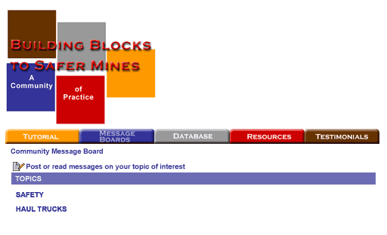
Navigation
Button | Go to
Tutorial | Tutorial Page
Message Board | Message Board Page
Database | Database Page
Resources | Resources Page
Testimonials | Testimonials Page

Branching
# | Selection or Hotspot | Go-To
1 |  | MSHA Home Page
2
3

Graphics/Animations
# | Filename | Description
1 |  | MSHA Logo
2 |  | MSHA Name
3
4

Programming Notes
# | Action | Result
1
2
3

DESIGN SPECIFICATIONS

Technical Specifications

Component | Specifications
Writing Style | The writing style will be simple and clear to convey the content effectively.
Screen Format | Each text screen will carry the pre-designed Mine CoP logo with colored navigation tabs at the top of the page. Each text screen will be no larger than three-fourths of the whole computer screen.
Grammar | Each sentence will ensure subject/verb agreement and be written in the present tense.
Numbering | Both bullets and numbering styles will be used.
Abbreviations | Abbreviations will be used sparingly. If necessary, they will be spelled the first time used on each page and abbreviated after that on the same page.
Acronyms | The first time an acronym is needed, the entire phrase will be completely presented to the learner followed by the acronym inside parentheses. Subsequent references to the phrase will only contain the acronym.

Instructional Specifications

Component | Specifications
Strategy | The Building Blocks Mine Community of Practice will consist of five main categories: tutorial, message board, database, resources, and frequently asked questions (FAQ’s).
Menu Organization | Each menu item may be accessed in any order via the main tabs at the top of the screen. Each section tab will have a different “earth tone” color, which will help to identify where the user is at all times on the site.
Reading Level | Textual material will be appropriate for high school students.

Design Specifications

Component | Design Specifications
Screen Text | Text Font: Arial, Helvetica, sans-serif.  Justify: Left justification.
Screen Text | Style | Font | Size | Color | Alignment | Attribute
Screen Text | Main Title | Arial | 14p | Black (#000000) | Default | Bold
Screen Text | Subtitle | Arial | 12p | Black (#000000) | Default | Bold, italic
Screen Text | Content | Arial | 12p | Black (#000000) | Default | Default
Screen Text | Navigation | Arial | 10p | Dark red (#8B0000) | Default | Bold
Screen Text | Direction | Arial | 12p | Black (#000000) | Default | Bold
Screen Text | Pop-up | Arial | 12p | Blue (#000099) | Default | Default
Screen Text | Pop-up, reference, glossary rollover | Arial | 12p | Blue (#000099) | Default | Underlined
Screen Text | Link | Arial | 12p | Dark blue (#00008B) | Default | Underlined
Screen Text | Link on rollover | Arial | 12p | Light blue (#0000ff) | Default | Underlined
Spacing | Paragraphs: Double space between paragraphs.  Punctuation: One space between the end of one sentence and the beginning of another; single space following commas, colons, or semicolons; no spaces around a hyphen.
Bullets | Bullets: Used for listing, capitalize the first letter of a bulleted item, no end punctuation.
Page Elements | Body Background Color: #FFFFFF  Top Border: Color = #FFFFFF Image = BuildBlock.jpg  Bottom Border: none.

CONTENT OUTLINE

I. Tutorial

A. Team Member Roles

1. Facilitator

2. Recorder

a) Place a link to the How to use MS word worksheet

3. Participants

a) Representatives from all mine departments

b) SME's

B. Step by Step Directions

1. Training Preparation

a) Introduction

(1) Explain the workshop is to determine the best way to conduct their own on the job training

(2) Explain the process of developing the worksheet

(3) Emphasize the work they do today will develop their own training program

b) Choosing participants

(1) Explain that the team they choose should include a representative from each group affected by the chosen task

(2) Identify potential participants (SME’s and administrators)

(3) Secure management approval

c) Choose a date and location

d) Establish a workshop schedule

e) Contact team members

f) Prepare and send read ahead material

g) Confirm arrangements and schedules with participants

h) Gather workshop supplies

i) Coordinate the workshop

j) Prepare the final results

k) Explain what the workshop involves, how it is conducted, and the expected final result

2. Train the operators/miners

a) Group Interaction

(1) Control pace and keep on schedule

(2) Limit unnecessary discussion while keeping a friendly tone

(3) Encourage everyone to participate

(4) Summarize what was said on each discussion point

(i) Guide the group to reach a consensus

b) Customizing the Task Worksheet

(1) Explain the 3 final worksheet uses

(i) Instructor Self Analysis and Preparation

(ii) Teaching Outline

(iii) Trainee Evaluation Guide

(2) Discuss the purpose and use of each column of the worksheet

(3) Identify job steps on task worksheet that do not apply to the job or the mine

(4) Have group discussion on what steps need to be added (recorder to maintain those that have reached group consensus)

(5) Consider the importance of each job step

c) Importance field may be left blank if step is self explanatory

(1) Ways to consider importance

(i) Production

(ii) Maintenance

(iii) Safety

(2) Consider the job step in two ways

(i) Performing step under normal conditions

(ii) Performing the step if the equipment or process changed or if there was an emergency

(3) Rate each job step for overall performance on a scale of 1-3

(i) 1=important

(ii) 2=very important

(iii) 3=critical

(4) List additional information for a job step if needed in the Notes/Comments section

(5) Recorder should provide copy of new worksheet to each participant on disk and paper

3. Assess trainee performance

C. Glossary

1. Job task analysis glossary

II. Message Board

A. (Organized by topic area)

III. Testimonials

IV. Database

A. Completed task lists

B. Record of trainings already held

1. Mine name

2. Mine location

3. Number of participants

C. Workshop assessment data

1. Online participant survey that feeds into the database

V. Resources

A. How-To's

1. How to Modify the Task Worksheet

B. Session Day Handouts

1. Pre-reading documents

2. Task Attribute Rating Definitions

C. Forms

1. Facilitators checklist

2. Recorders checklist

3. Supply checklist

4. Final day checklist

5. Master planning checklist

6. Participant Data Sheet

D. Pre-reading documents

1. Job analysis glossary

2. Example worksheet page

3. Explanation of relationship between job, duties, and job steps

4. Task attribute rating definitions

E. Task worksheet

1. Completed Task Worksheet

2. Blank task worksheet

F. Workshop session supplies

1. Overhead projector

2. Flipchart

3. Flipchart paper

4. Pencil

5. Paper

6. Calculator

7. Laptop for recorder

8. Access to printer

G. Sample documents

1. Sample thank you letter

2. Sample invitation letter

3. Sample agenda

4. Sample room set up

FLOWCHART

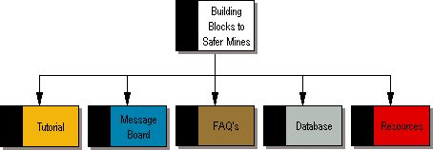

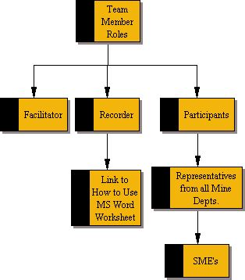

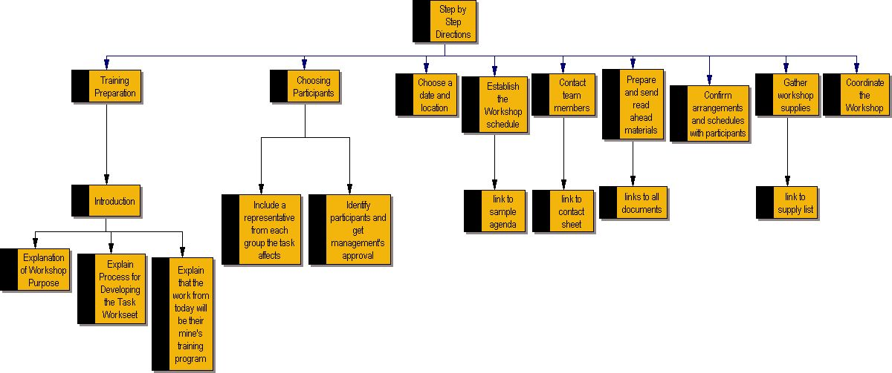
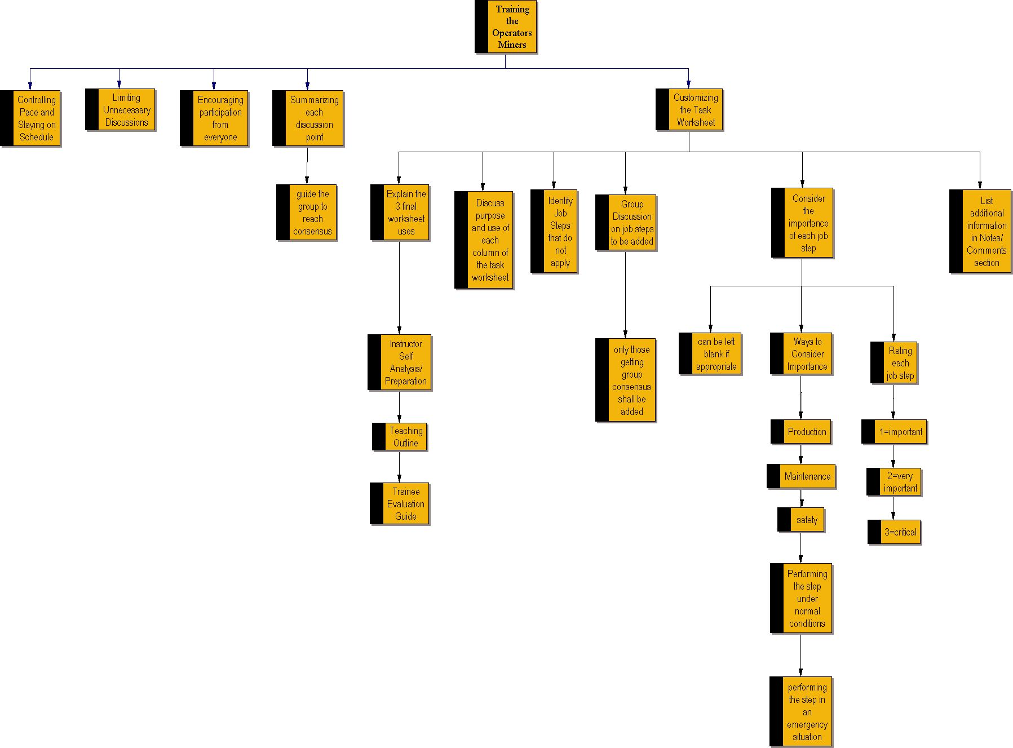

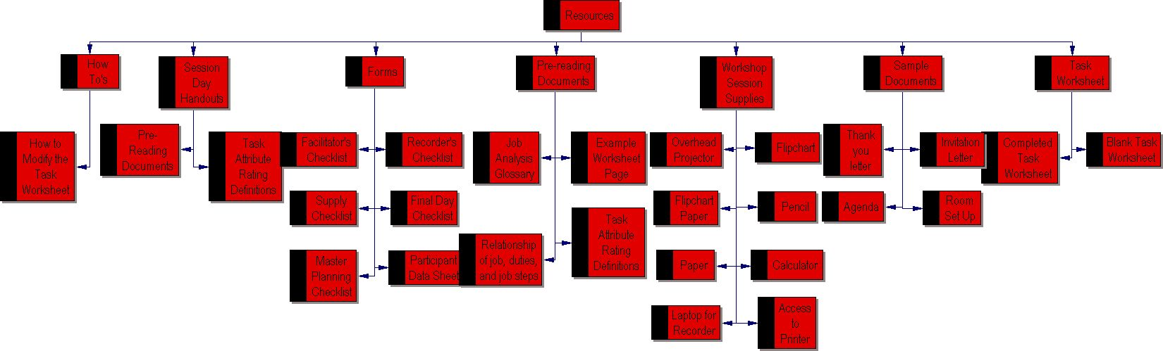

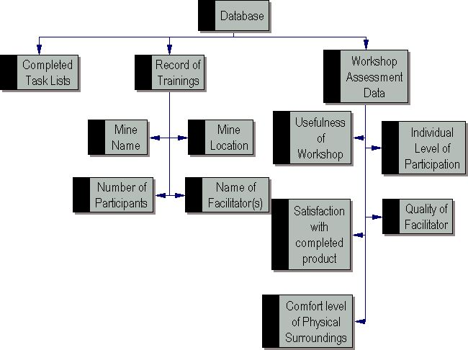

REFERENCES

Alford, Roger (Associated Press). (January 4, 2002). Kentucky ties its record low with five
mine deaths in 2001. Courier-Journal.com. Retrieved September 14, 2002, from
http://www.courier-journal.com/localnews/2002/01/04/ke010402s132294.htm

Allee, Verna. (2000). Knowledge Networks and Communities of Practice. OD Practitioner,
Vol. 32, No. 4. Retrieved October 10, 2002, from http://www.odnetwork.org/odponline/vol32n4/knowledgenets.html

Building and Sustaining Communities of Practice: Continuing Success in Knowledge
Managemet. (2001). American Productivity & Quality Center (APQC) International Benchmarking Clearinghouse. Consortium Learning Forum, Best-Practice Report. Retrieved October 10, 2002, from http://www.apqc.org/pubs/summaries/CMKMCOP.pdf

Heroes rescue Heroes. (July 30, 2002). DenverPost.com. Retrieved September 14, 2002, from
http://www.denverpost.com/Stories/0,1413,36%257E73%257E762074,00.html

Lesser, E. L. and Storck, J. (2001). Communities of Practice and Organizational Performance.

IBM Systems Journal, Knowledge Management, Volume 40, Number 4. Retrieved October 10, 2002, from http://www.research.ibm.com/journal/sj/404/lesser.html

APPENDIX A

The following chart is a summary of Mr. Baugher’s responses:

Question | Response
1. When you spoke to the class, you discussed a connection between productivity, safety, and maintenance - is this documented? If so, can we get a copy of this documentation? | - Not in a form that is readily available.  - We could do a computer analysis that would select the most productive mines and relate general accident rates. This research would produce numbers.  - The concept is more a "common sense" view; to be productive machinery must:  - Stay in operation a high percentage of time.  - Cycle operations in an efficient manner reducing cycle time.  - These goals are best accomplished by an operator:  - That makes few mistakes.  - Coordinates job steps in the most effective manner.  - Coordinates his machine's operation efficiently with other machines and operations.  - That has few accidents.  - To reduce maintenance cost:  - The operator must operate the machine in a smooth manner and only uses the controls and machine for the intended purpose.  - The machine is not operated beyond is rated capacity worn or failing parts must are replaced before they fail (preventive maintenance).  - Proper communication occurs between operator and maintenance personnel.  - Responsibility for regular checks is clear between the operator and maintenance crew.  - To avoid accidents all of the above must take place so the machine does not fail and the operator does not place himself or others in "harm's way."  - Each need is mutually dependent.  - If one or more of these concepts fail the others suffer.
2. Is it conclusive that the mines with the strongest safety record have such because of training, or might there be other conditions/drivers that contribute to their records? If in fact there is a correlation between training and the strong safety records, are these training processes documented? If so, can we get a copy of this documentation? | - Yes. There are ways of engineering out some of the of the human input, placing the operators in a safer position, guarding hazardous locations, designing better processes, etc. but the human beings often find ways and reasons for circumventing these safeguards.  - Reporting infractions and putting people on "light duty" work can affect records.  - Each of the above examples requires that the individual understand how to do it right, what his responsibilities are, and recognize potential hazards that still remain.  - Other than the above common sense logic good numbers are hard to come by. Some reasons for this are the quality and content of the training is not effectively measured in the industry. .  - Whether the safe guards or the training they received to use them is the cause for the reduction is virtually impossible to determine.  - All of the Fortune 500 companies have training programs.  - When we evaluate mine training programs the ones with the better programs usually have a better accident rate and production efficiency.  - The documentation is anecdotal and mine specific. There has not been much agency work and national data because we have historically been limited and focused on just the safety aspect.  - We have worked the production and maintenance into the training but there has not been particular documentation or analysis work on the relationships.  - If will do some looking around next week to see what might be available.
3. How did mine managers and safety directors who participated in the Field Tests describe the strengths and benefits of the workshop process? In what way was it relevant to them? | - Comments have been brief but the general reactions have been the:  - Thoroughness of the analysis.  - Application to their individual mine and particular equipment.  - Economy of time required to develop. The enthusiasm and "buy in" of the participants. Usefulness of the material to their front line training.  - The potential for other uses.  - Confidence that they could do something similar for other jobs themselves.  - I have the results from the first Field Test, but not the second and third.  - I will check my E-mail next week and share any comments I have received.  - They have not been compiled in any standardized form; not been in the office to do it yet.  - The above comments were given to me and other team members verbally.
4. Must facilitator-training be completed at a set time, or can it truly be "any time, any place"? | - No. Facilitator training design has not been started yet.  - The mines that are trying it themselves have participated in the process and used us for questions or start up help on site.  - I suspect the training will be simple and not particularly time consuming but we need an instruction guide.
5. Will the facilitators be accessing the training at work or at home? If at work, what technologies are available to them (PCs, connection speed, printers)? Are PCs with Internet access the norm both at work and at home? | - The facilitator's role is to run the workshop.  - At a mine the facilitator may also be a trainer or safely director and how he uses the workshop's template (outline) is beyond the scope of this project.  - It is a probably a good idea to make some suggestions as to how to use the template to do other activities or use it to begin the teaching.  - Hard to say where they will work but in general it will be done in the office.
6. How many hours of training are equipment operators required annually to have? What are the rewards? | - There is no required number of hours for task training but there are general requirements for demonstrated practice and performance.  - The language and application of the rule is very lax because the industry and our inspectors lack of ability to determine quality of training.  - There are generally not rewards other than some companies serve snacks or lunch. And it is easier the take training than to mine.  - The company does not receive a citation and fine from MSHA.  - Some enlightened mines appreciate training for its intrinsic value.  - Miners appreciate good training if they a benefit to themselves.  - To sell the improved approach it will probably need to be on the merits of the idea to the effect production, maintenance, and safety.  - The lack of validated research and data continues to haunt us.  - Keep the faith. Our experience has shown in other projects that our industry is not too impressed with scientific data and impressive numbers.  - If it "makes sense" to them personally they will do it and often become a disciple for it.

APPENDIX B

The following chart summarizes Don Conrad and Cathy Matchett‘s responses to the six questions asked to them by Shannon Robinson:

Question | Response
1. The project we are being asked to take on is training for the facilitators of the workshops. From your perspective, are there penalties/rewards (perceived or real) associated with participation in facilitator-training? | Don  - As far as I am concerned there are both, the reward is that any time I am doing a job I want to know as much about it as possible, this is a reward.  - The negative side or punishment side of that is when you get real good at something you are likely to be called upon to do this often.  - This means more travel, less time to do routine work that does not go away.  Cathy  - I have not had the facilitator training but there have been some areas in the workshops (as at Fishkill) which I think could be improved.  - Possibly with facilitator training, some of the organizational/leadership problems would be minimized (or disappear?).  - For the same reason, I think the reward for facilitator training for the initial workshop (where we developed the Spider) would be a more smoothly run workshop.
2. Will the facilitators be accessing the training at work or at home? If at work, what technologies are available to them (PCs, connection speed, printers) If at home, are PCs with Internet access the norm? | Don  - Most of our people that take the training will be again doing both , the major part of the assessment will be at work, but you always carry some of the thought process home or to the room etc.  - I guess most of the selected people have access to technology at home and work.  Cathy  - I don't know where the training would take place.  - I assumed it would be in a classroom setting.  - In EFS, we all have access to laptops which we can use (including internet access) at work, home and during travel.
3. Are mine managers and safety directors in all locations aware of mines with strong safety records - do they know how to find that information? If so, are these people motivated to seek out this information and is it easy to access? Is this information relevant to them (considering the vast differences between each type of mine)? | Don  - Most mine managers are concerned with this own operations some may look at safety info on neighbors or competitors, the info you talk about has been fairly difficult to get in the past.  - Now with the web page the info is easy to obtain, but many people have never looked at it.  - In my estimation about five percent of the mining community is currently utilizing the Mt or state web pages.  Cathy  - I believe they are not generally aware of other mines with strong safety records...unless they have friends or associates at those other mines.  - The information is accessible with internet access to the MSHA homepage under Data Retrieval, as long as they have the name(s) of the mines/operators they wish to check on.  - However, using Data Retrieval and their own mine ID permits them to compare their incident rate to the national average for similar mines.
4. Do mine managers and safety directors see the connection between safety record and productivity as well as MSHA does? Also, is it conclusive that the mines with strongest safety record have such because of training, or might there be other conditions/drivers that contribute to their record? | Don  - I do not think that mine manager in general really see the connection between safety and productivity, they care that injuries and incidents do not get to the point where the agencies are looking at them hard.  - Now by this I don't mean that they are totally uncaring but some rationalize that the events are not happening at the mine, others don't think any thing really bad will happen to their people.  - There are other factors to the occurrence of injuries at mines, physical conditions, attitude of management and workers and luck or chance.  - The mines with the best safety attitude for the most part are no longer in business, i.e. Bethlehem republic steel.  - I think most of the mines today see the need for safety and do take care of the major safety things that are why disasters are rare.  - But the either don't know how or don't want to deal with people problems.
5. How did mine managers and safety directors who participated in the Field Tests describe the strengths and benefits of the workshop process? In what way was it relevant to them? | Don  - I have only gotten feed back from the one manager and you were there, I think some of the participation is because this is something different, they do like the process especially the hourly workers because it gives them some input, we have not been formally ask back to do a second machine at any operation, so the jury is still out as far as I am concerned.  Cathy  - I have the results from the first Field Test, but not the second and third. I have the evaluations from the second field test (Cortez Gold in NV) but there were not eval's done at the third one (Twenty Mile Coal in CO).  - Here are some of the comments from the Cortez workshop:  - Planned very well.  - Will be useful.  - Good mix of participants...any more might create road blocks.  - With the information worked on, a 2 day workshop would be perfect.  - This was great...very god format to actually get something done.  - Practical for our operation with tweaking.  - Might be better with more people involved.
6. Jim mentioned that a barrier to training the mining personnel is "not wanting to read". Are there other barriers that you are aware of? Would it be a major problem for mine managers and safety directors to get operators to use a web based tutorial? | Don  - It depends, I do not have the same opinion as Jim on the not wanting to read, they do not have the luxury of doing this on the job so they don't read in that in stance, there is in most cases no reward for reading and learning today, in my area at least, there is no place to be promoted to, you do not have to read to learn how to run the machines.  - When I started in the coal mines these were tangible rewards for being safe, learning more and working hard.  - Today at least in coal the rewards for these guys are workers comp or retirement, and the rewards for the few young guys is too far down the road.  - In the stone industry the pay scale is not very high. So mining is a transient job.  - Web based training I just don't know. If it could be done on the job I think most miners with some minimal training could and would do it.  Cathy  - Most would probably not use a web based tutorial, but that's just my opinion.  - I didn't notice a problem with mining personnel "not wanting to read" in fact, at Twenty Mile last week I had a hard time getting them to follow along on the screen because they wanted to keep using the printed version (which, of course, we were in the process of changing!)  - Maybe it had to do more with if they could see the image on the screen...or had their glasses...or something other extraneous reason.  - But they do seem to like the interaction and being asked for their opinions/expertise.  - The real evaluation will only be done once someone has used the resultant worksheet and gives feedback on results/changes/etc.  - We haven't dealt much with follow-up yet but plan to over some period of time.
APPENDIX C

The following chart is Mr. Baugher’s responses to follow-up questions from MSHA Group Two:

Question | Response
1. How would you characterize the target learner audience (describe both the mine/safety managers as well as the haul truck operators? | Average level of education?  - Mine/Safety Manager: Vo-tech or college (often engineer) 10-12 grade reading level.  - Haul truck operator: High School graduate; sixth grade reading level.  Average years on the job?  - Mine/Safety Manager: 10+ years.  - Haul truck operator: 5 years.  Level of computer skills?  - Mine/Safety Manager: Computer on desk; can use Internet; can use search engines; inputs data into spread sheets; can down load and copy; probably modify documents and files.  - Haul truck operator: Kid’s Computer at home; probably “surf Internet with kids’ help; can follow on screen instructions if "user friendly"; print from screen.
2. How relevant will they perceive this training to be? | - Mine/Safety Manager: Probably has an innate understanding job training needs improved; needs to see benefit to his production, maintenance needs; not always clear on the direct benefit or cost benefit analysis of training versus performance probably due to poor training experience he has had or used.  - Haul truck operator: Experienced persons probably think they know it all; new drivers realize need but reluctant to show it.
3. What is their work environment/learning environment like? | - Mine/Safety Manager: these guys receive little training; what training they get is at a conference or at a contractor.  - Haul truck operator: There is usually a conference or training room; often has a video tape set up; table and chairs; simple surroundings; often a trailer. All receive mandatory federal training of 8 hours of annual refresher training. New miner training. New task training usually on the job unstructured.
4. What motivates them to do well in their job? | - Mine/Safety Manager: Production; lack of problems; high salary.  - Haul truck operator: Personal pride; competition with others; wife; high salary.
5. What are their roles and responsibilities? | - Mine/Safety Manager: "everything" within their responsibility; a list of duties fills several pages; problem solving.  - Haul truck operator: production; be there; adjusting to changing situations at the mine; machinery accidents.
6. What is their general background and educational profile of the population? | - Mine/Safety Manager: Engineering; extensive mining experience; doesn’t like to read extensively; want things abbreviated or homogenized, Reader’s Digest; respected in community; above average wages.  - Haul truck operator: construction, mining or trucking; upper blue collar.
7. Describe the skills and traits of an optimal mine/safety manager as their job relates to training facilitation | - Wow!! This could be a dissertation!  - Mine/Safety Manager: Plan, implement, and oversee operations as a system; consider “cause and effect” in decision making; utilize expertise and experience of staff in planning and decision making; provide regular feed back to employees based on performance; enable persons to succeed; coach.  - Haul truck operator: eye hand coordination; reactive knowledge of job steps so they can respond to emergencies; recognize role in the system and their effect on others; knowledge of most effective procedures.
8. Describe current performance levels, compared to the optimal. | - Mine/Safety Manager: “Fire fighting” versus proactive.  - Haul truck operator: basically pretty good considering; room to improve; learns by trial and error and observation; if errors weren’t catastrophic he plods on.
9. Is there any data (statistics, test data, feedback forms, evaluations, anecdotal) that might provide a detailed picture of current performance)? | - No there is no requirement for reporting and in house information is shared only during special projects and usually not mine specific.
10. What are some of the factors that might influence success of the training? | - Recognizing: the practicality of the approach; the efficiency of the approach; magnitude and quality of information.
11. Will this training be mandated? | - No. But it can be applied to the required task training.
12. Do employees receive CE credits? | - No.
13. How will this training benefit employees? Are there incentives (inherent or tangible) for them to increase their skills/performance in this area? | - Other than offered by the employer no. The personal satisfaction of being considered a subject matter expert, a task trainer; recognized top driver, a top producer.
14. Do you anticipate any resistance to the training? Are there any disincentives? | - Other than the normal new idea shyness there doesn't seem to be. Once they have participated they are enthusiastic.
15. Will other work groups be affected by this groups' change in performance? If so, how? | - Yes. Particularly the maintenance department. Less down time, better communication between drivers and maintenance. Safety department. Better communication. Improved safety procedures. Fewer accidents.
16. Describe the training context. | - The workshop is an analysis tool in which participants learn as well. The product will be used in an "on-job-job" format. Instructor demonstrates and explains; student demonstrates and explains; instructor corrects and provides practice.
17. Where do you envision employees be taking the training? In a lab environment? At their desktop? Explain. | - At or on the machine or worksite.
18. When do you envision employees taking the training? Would there be a set time, or do they complete it on their own time as they find time? | - Before they are assigned work. Required by law.

APPENDIX D

The following chart is Mr. Baugher’s responses to follow-up questions from MSHA Group One:

Question | Response
1. At what level of proficiency must potential facilitators be able to demonstrate or apply their skills and knowledge gained from this training? | - Not sure I know a quantifiable term or expression.  - Descriptive measures would include:  - Participation by all workshop members.  - Minimum of or quickly resolved conflicts.  - Efficient use SME and workshop time.  - Correct completion of the worksheets.  - Effective content level of the worksheets.  - Client acceptance of the final product.  - Continued use of the product by the client.  - Addition requests for the service.  - Facilitator as a minimum must achieve goals 1-6 Goals 7, 8 optimal.
2. What operating systems (PC: 486, Pentium 1, etc; MAC: OS#) do the potential facilitators use? Also, generally, what browser version (Netscape: 4.0 etc.; Internet Explorer: 4.0, 5.0 etc.; AOL: v4, v5, v6 etc.) do they use to access the Internet? | - Mostly a guess on my part.  - 486 or better Pentiums are growing as costs have come down.  - A few MACS.  - Netscape and AOL on version back.  - Internet at work is hard to guess.  - But the use of the MSHA home page is growing rapidly, indicating they have access somewhere.  - We have to assume they have access for this project.
3. Regarding the Internet connection, what are the bandwidth restrictions? Does  MSHA have any security requirements regarding Java, cookies, or ActiveX? What are MSHA's restrictions on email files? | Security:  - Read and execute only.  JAVA:  - Yes can use.  Cookies:  - NO  Active X:  - Yes can use.  E-mail:  - None (SMTP) Simple Mail Transfer Protocol.
4. If we plan to use audio/video, are the potential facilitators equipped with appropriate plug-ins (i.e. Windows media player), sound card and speakers? What about additional general plug-ins - do they have access to Adobe Acrobat Reader? | - Assume yes for sound card and speakers, media player, adobe reader (down load version).  - Plug IN’s that come with basic computer purchase.
5. What reporting or record-keeping functions are needed for the training of these facilitators? | - Most government agencies have a requirement for keeping records regarding who was trained and when.
6. What are MSHA's requirements? | - If the mine chooses to apply the training to their required training.  - There is a required 5000-23 form.  - An approved alternate form (must contain as a minimum the same info) can be computerized.  - These forms only require title of training and the hours.  - For task training this information must include demonstrated, practice and performance observation.

APPENDIX E

The following chart is the detailed task analysis for the tutorial section of the JTA Community of Practice.

Preparation
  - Secure approval from all managers for the training
    - Explain why job analysis is beneficial and how it produces fast results
    - Explain the purpose of the workshop
    - Present and explain and agenda for the training
  - Get all managers to suggest possible participants in the job analysis workshop
  - Secure management approval from organizations that supply the subject matter experts.
  - Establish dates and a schedule for a workshop.
  - Secure a location for the workshop
  - Identify the potential participants (subject matter experts, administrators, and workers) who will be involved in the Table Top Job Task Analysis (TTJTA.)
    - Send letter to chosen participants and include the following:
      - Explain to chosen people why they were chosen
      - Explain their role as a team member
      - Provide the date and time of the workshop
      - Explain attendance requirements
  - Identify who will take the role of recorder
    - Decide who will best be able to modify the task analysis which is a word document. This person should be the recorder.
    - Be sure recorder understands ahead of time how to use the template and how to modify the items in the sample job analysis
  - Prepare and send "read ahead" material to all participants.
    - Job analysis glossary
    - Example worksheet page
    - The explanation of the relationship between job, duty, and job step
    - Task attribute rating definitions
  - Confirm arrangements and schedule with participants.
  - Gather/ensure supplies are available for the workshop.
    - Overhead projector with screen
    - Two flipchart stands with 4 pads of paper
    - Markers for charts
    - Pencils/pens
    - One small calculator
    - Laptop for facilitator and access to a printer
  - Prepare the agenda

Introduction
  - Breakfast (ex. Fruit, donuts, juice and coffee) with informal conversation.
  - Introduce each other
  - Agenda
    - Provide copy of agenda
    - Overall goal of day
    - Explain purpose
    - Background of problem to be addressed
    - Explain process (steps going to go through/directions)
    - Explain the task worksheet and the purposes of each column
    - Explain that they are there to customize the sheet to a specific task (ex. Haul truck job analysis)
    - Explain the three final ways to use the task worksheet
    - Handout the job aide for selecting action verbs
- Workshop Activity
- Revision of a previous worksheet (done concurrently by the group and recorder)
  - Explain the process
  - Identify steps which do not apply to their mine and eliminate them
  - Pencil in missing steps
  - Group discussion on changes
  - Recorder will include revisions that obtain a group consensus
  - Rate the importance of each job step
a) Consider production, maintenance and safety
b) Do not rate if they feel it is unnecessary
  - Add additional information under the Notes/Comments section if necessary for complex tasks
  - Recorder should provide a copy of the new job worksheet to all participants.

Post Workshop Tasks

Prepare final results of the workshop.

Send thank you letters to all participants.

APPENDIX F

The following is a collection of scripts for the introduction to the Community of Practice:

Site Introduction

- This website contains materials describing the process for initiating and conducting a mine site Job Task Analysis that provides a training outline (worksheet) for conducting On-The-Job Training for persons assigned to perform that job.

- The website also contains a Resources section that provide aids and addition materials such as checks sheets, glossary, possible participant “read ahead” materials, sample correspondence, etc. that you may wish to use depending on the circumstances.

- A surface haulage truck is used in the examples.

Site Introduction

- The program is designed to flexible and scalable to meet individual client needs and requests.

- The worksheet is in MS WORD and additional columns can be added to identify additional factors such as difficulty of the tasks, frequency of the tasks, and procedure for accomplishing the tasks.

- The program as presented can usually be accomplished in a working day. Additional factors will generally require more time to develop.

- It is possible that the final product may be evolutionary and be developed over a series of working sessions. Available time is the main governing factor.

- The goal is to leave the mine with a modified worksheet (training outline) that is tailored to their individual training situation within an abbreviated time.

- It is anticipated that follow up meetings will be necessary to assist with implementation or perhaps train their OJT instructors on how to use the worksheet.

The following is a collection of scripts for the tutorial section:

Introduction
- This tutorial provides team facilitation procedures to conduct and record a mine specific job analysis and OJT training program. These procedures can be used as a guide or to train new facilitators.

- The following job training material, developed by a national joint committee comprised of manufacturers, maintenance people, truck operators, safety staff, haulage supervisors and MSHA, has been designed to assist on-the-job trainers. The core of the material is an in depth job analysis. This analysis is presented in a worksheet that presents job steps in the order they are normally accomplished.

- Remember your job is to facilitate the mine teams deliberations and record their decisions. Do not “take over” the discussion or interject your opinions even if you disagree with some of their decisions. Remain “neutral.”

Building Blocks to Safer Mines

utorial

How to Conduct the Workshop

Team Member Roles

The workshop is made up of a team of people that directly influence the job. This team is comprised of:
- Manufacturers
- Maintenance people
- Truck operators
- Safety staff
- Supervisors/managers

Each workshop will employ three types of participants:
- A facilitator
- A recorder
- The participants

All of these roles are described next.

Facilitator

The facilitator should be someone familiar with the overall task being analyzed. During the workshop, the facilitator is responsible for reviewing the job list with the group and facilitating discussion regarding each job or duty.

The facilitator’s role is to:
- Keep the subject-matter experts (SME’s) focused
- Supervise in cases of disagreement
- Use inter-personal skills and knowledge of the group to keep the workshop moving
- Propose suggestions to initiate discussion

Recorder

It is the responsibility of the recorder to make the modifications on the worksheet as the SMEs provide insight.

These modifications include:
Any changes to the job and duty lists
Decisions on the importance ratings and rationale
Any additional notes and comments from the participants

The recorder should be familiar with working in MS Word tables and, ideally, using pre-defined styles (additional information on using styles is provided later in this document for those who do not have familiarity with it).

Participants

The participants are representatives from all involved mine departments. Because these individuals know their particular job better than anyone else, they will serve as subject matter experts (SMEs).

This team is comprised of:
- Manufacturers
- Maintenance people
- Truck operators
- Safety staff
- Supervisors/managers

Their input will help modify the worksheet.

Step-by-Step Workshop Directions



Introduction

In the introduction to the workshop, the facilitator should:

- Explain that this is a workshop to determine the best way for them to conduct their on-the-job training
- Explain the process used to develop the worksheet
- Emphasize that the process was developed by a group of participants just like this group. “The work you do here today is your program.”
- Explain that the team includes subject matter experts (SME) representing everyone that directly influences the job. Each SME will contribute their intimate knowledge of the job and offer their perspective. (Optional)
- Introduce the spider, but do not spend too much time on it – the participants are more interested in the worksheet. (Spider) or briefly discuss that the worksheet will be modified in Word
- Explain what the workshop will involve, how it will be conducted, and the expected final result.

Introduction continued

Discuss the purpose and use of each column (importance, importance level, satisfactory/needs work, notes/comments) See procedure steps below.
Explain the three uses of the final worksheet.

Instructor Self analysis and preparation aid
Teaching outline
Trainee evaluation guide

Group Discussion

During the group interactions, the facilitator should remember the following issues:

Control the pace and keep on schedule. Keep the session focused. Some issues could be put in the “parking lot” and discussed if there is time at the end.
Limit unnecessary or excessive discussion while keeping the tone friendly.
Encourage everyone to participate. Examples: Ask individual questions or ask for an opinion. Go “around the table” to hear from everyone.
At the end of each discussion point, quickly summarize and lead the group towards a consensus.

Discussing the Worksheet

During the workshop you will revise the previously developed worksheet to meet the needs of the mine.

Conduct Ground/Walk-Around Inspection as they work on modifying the worksheet.

The following steps outline the procedure that will be used by the participants to modify the worksheet.

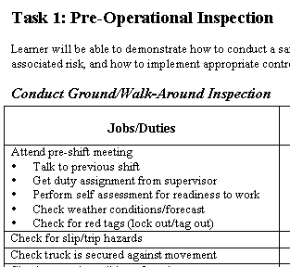
Category
Jobs & Duties

Individually read through each job and duty found within the overall task category (pre-operational inspection, operations, post-operational inspection). Identify any steps that do not apply to the mine and pencil-in any missing steps.
As a group, discuss which steps apply and any new steps that need to be added. The recorder will maintain the revisions determined by group consensus either on the page or, preferably, on a computer.

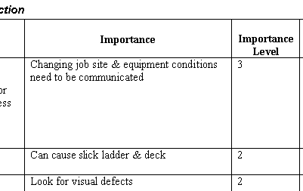
Identify & list importance of each step
Rank the importance level – 1 is the lowest and 3 is the highest

In the “Importance” field, identify the importance of conducting the job/duty step(s) that they identified. Importance can include production, maintenance, and safety. The SME’s can consider one, all, or any combination of these factors. Now is the time to consider all possibilities. The Importance field can be left blank if the group feels the importance of the step is self-explanatory.
Consider the job step in two ways:
- Performing that job step in normal operations
- What if that part of the equipment or process changed unexpectedly or failed or an emergency occurred?
Rate each job step for its overall importance of completing the job on a 1-3 scale. 1 is important 2 very important and 3 is critical. You will use this rating to make decisions such as which tasks need extra emphasis during training and how much practice is necessary to ensure good performance and that an accident doesn’t happen.

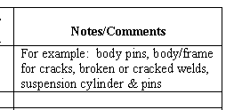
Any additional information that may be necessary

If the group feels additional information needs to be provided to the trainer or trainee, this can be listed under the Notes/Comments section. If a job step has unique or complex requirements it is recommended to record them here.
The recorder will provide a copy of the job worksheet (both on computer disk and in printed format) to the participants.

APPENDIX G

The following is a sample of storyboards created for the tutorial section:

STORY BOARD LAYOUT FOR TUTORIAL

(pages 1-6)

1. 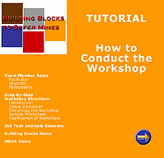 2. 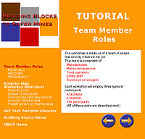

3. 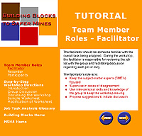 4. 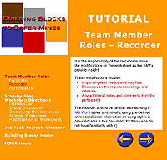

5. 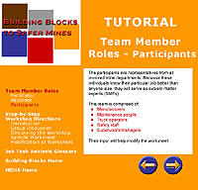 6. 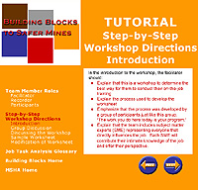

STORY BOARD LAYOUT FOR TUTORIAL

(pages 7-12)

7. 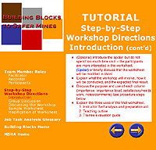 8. 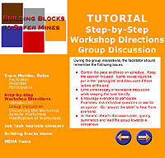

9. 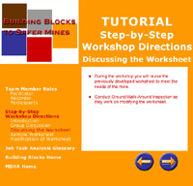 10. 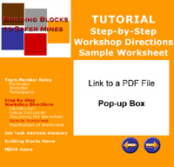

11. 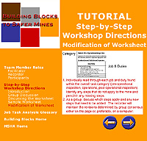 12. 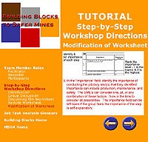

STORY BOARD LAYOUT FOR TUTORIAL

(pages 13-16)

13. 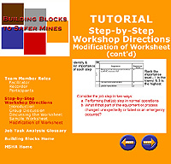 14. 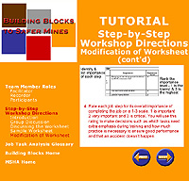

15. 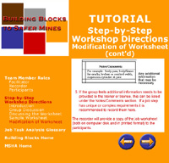 16. 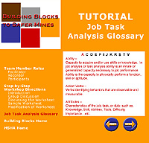

APPENDIX H

The following is another sample of screen shots created as an example of what the Community of Practice could look like; the current URL for this example is: http://mason.gmu.edu/~lfernand/Education/EDIT730/MSHAProject.htm

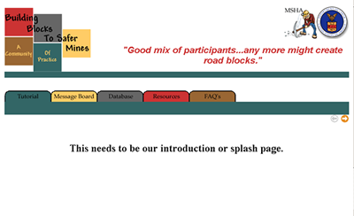
This would be turned into a splash page with an introduction and perhaps the overarching goal of the Community of Practice.

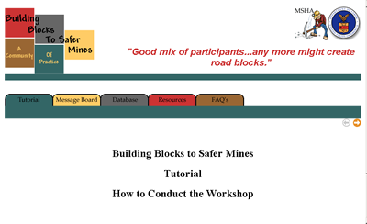
The first or title page of the tutorial section.
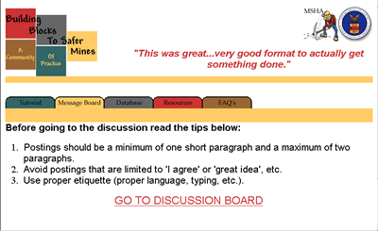
This would be the first or introduction page to the message board section with some general rules or tips; there would be a link to continue on to the message board.

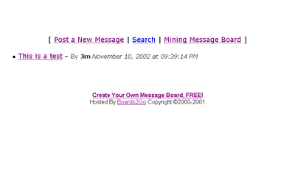
A sample of the (free) message board used as an example.

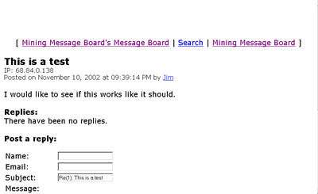
A sample of a message that was posted on the “Mining Message Board”.

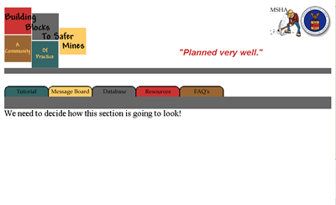
A sample of the first page of the Database.

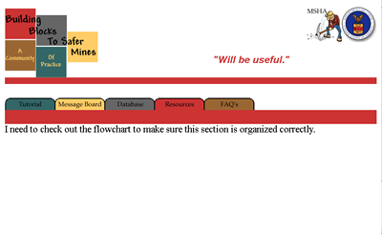
A sample of the resources first page.

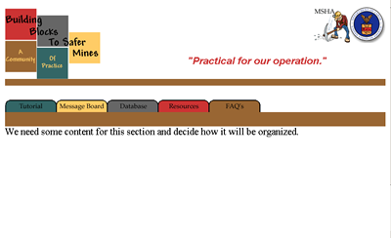
A sample of the first page in the FAQ’s section.

APPENDIX I

The following is a compilation of the Website’s URL and a description of its contents of what has been collected to date.

Website URL | Description
www.msha.gov | MSHA Homepage
http://www.msha.gov/MSHAINFO/STRAPLAN/STRAPLAN.PDF | Strategic Plan - Fiscal Years 1999-2004
http://www.msha.gov/training/surfhaul/index.htm | Surface Powered Haulage Safety
http://www.msha.gov/training/surfhaul/index.htm | Haul Truck Pre-operational Hazards
http://www.msha.gov/Accident_Prevention/Tips/forklift.htm | Hazards caused by Haul Trucks
http://www.msha.gov/ACCINJ/accinj.htm | Mining Industry Accident, Injuries, Employment, and Production Statistics
http://www.msha.gov/stats/charts/chartshome.htm | MSHA Fatality Statistics
http://www.msha.gov/fatals/fab.htm | Fatal Alert Bulletins, Fatalgrams, and Fatal Investigation Reports
http://www.msha.gov/TRAINING/CATALOG/traincat2001.pdf | Training Catalog
http://www.msha.gov/S&HINFO/SAFETY/HAZpwrh.PDF | MSHA Hazard Alert
http://www.msha.gov/S&HINFO/SAFETY/HCARD/ATTITUDE.HTM | Haulage Safety Attitude
http://www.msha.gov/S&HINFO/SAFETY/HCARD/100TLESS.HTM | 100-Ton or Less Truck Preoperation Inspection
http://www.msha.gov/S&HINFO/SAFETY/HCARD/TRUCKSAF.HTM | Truck Drivers - Safe Operating Procedures
http://www.msha.gov/S&HINFO/SAFETY/HCARD/TRAINING.HTM | Training Checklist
http://www.umwa.org/homepage.shtml | United Mine Workers of America
http://www.fmshrc.gov/ | Federal Mine Safety and Health Review Commission
http://www.usmra.com/ | United States Mine Rescue Association
http://www.bls.gov/oco/cg/cgs004.htm | Career Guide to Industries - Mining and Quarrying
http://www.caterpillar.com/industry_solutions/mining/support_solutions/02_communications/_pdfs/human_element.pdf | Trainers Guide – The Human Element, Mine Safety and You
http://behavioural-safety.com/articles/Improving_Safety_Attitudes_with_Computer_Based_Training/ | Improving Safety Attitudes with CBT article
http://www.coalage.com/ar/coal_miner_training_turns/ | Miner Training Turns to Technology
http://www.caterpillar.com/about_cat/news/03_products_n_services/_attachment/797_update.html | Hauler Pictures
http://www.mine-safety.mtu.edu/newslets/mms961.txt | Michigan State Grants Mine Safety Training
http://www.nhtsa.dot.gov/nhtsa/whatis/regions/Region05/05SafeComList.html | Injury Prevention Resources on the Internet
http://www.safetyperformance.com/acmodel.doc | An Actively Caring Model for Occupational Safety: A Field Test
http://www.umwa.org/journal/VOL111NO2/marlmpcp.shtml | LMPCP: A Continuing Success Story
http://www.qmc.com.au/docs/speeches/jonson.html | Unsafe Attitudes and Acts - A Psychological Explanation
http://www.minerals.nsw.gov.au/safety/msn4/msn4_10.pdf | National Mine Safety Culture Survey (assess attitudes in Australia)
http://216.239.51.100/search?q=cache:vQtoTy9-9WIC:www.minesite.aust.com/RefLib/PDF_Papers/Psychology_of_Mine_Safety.pdf+attitudes+mine+safety&hl=en&ie=UTF-8 | Psychological and Sociological Aspects of Safety Related Behaviour by Mine Workers and the Implications for Improving Safety Performance (Australia article)
http://www.courier-journal.com/localnews/2000/0012/22/ky_coal_train.html | Safety-training fraud article
http://www.minerals.nsw.gov.au/safety/msn5/msn_05_4.pdf | mining article (Australia)

