

MSHA Task Analysis
Mine Supervisor Training

Presented by:
GMU Immersion Design Team
Jennifer Cochran
Hong Li
Shawn Sullivan
Craig Wiggins
Betty Wilkins
Paula Johnson Williams

November 17, 2005
Table of Contents

Overview 1
The New Generic JTA 1
Cognitive Task Analysis 6
Learning Hierarchy 8
Conclusion 8
Appendix A: Generic JTA Diagrams 11
Duty 1: Self-Assessment and Personal Fitness 12
Duty 2: Start of Shift Activities 14
Duty 3: Prior to Entering the Mine 15
Duty 4: Entering the Mine 16
Duty 5: Traveling to the Section 17
Duty 6: Arrive on the Section 18
Duty 7: Section Observation 19
Duty 8: Conduct On-shift Examination 20
Duty 9: Conduct Pre-shift Examination 21
Duty 10: End of Shift 22
Duty 11: Emergency and Unusual Situations 23
Duty 12: Training Responsibilities 24
Appendix B: Generic JTA Worksheets 25
Duty 1: Self-Assessment and Personal Fitness 26
Duty 2: Start-of-shift Activities 27
Duty 3: Prior to entering the mine 29
Duty 4: Entering the mine 33
Duty 5: Travelling to the section 35
Duty 6: Arrive on the section 39
Duty 7: Section observation 44
Duty 8: Conduct On-Shift Examination 49
Duty 9: Conduct Pre-Shift Examination (for the next shift) 55
Duty 10: End-of-Shift Examination 62
Duty 11: Emergency or Unusual Situations 64
Duty 12: Training Responsibilities 69

Overview

A task analysis is a description of the breakdown of a job duty into its component tasks, which are then further divided into the steps and sub-steps required to complete the job.
In addition, the task analysis documents the knowledge and information needed by the performer to carry out the job effectively.
The purpose of a task analysis is to answer the questions, “What does the person performing the job in question actually do?” and “What does the person need to know in order to perform the tasks that define that job?” The answers to these questions help determine the instructional goals and objectives of the project, and consequently, identify effective instructional strategies needed to train someone to perform the job.
To find the answers to the questions above, the MSHA project team analyzed the diagrams, called the job task analysis spiders (JTAs), created by CONSOL Energy and Excel Mining that identify and describe the duties performed by coal mine supervisors at the respective companies. Based upon our analysis, a generic set of JTAs was developed. A cognitive task analysis (explained later in this document) was performed on these generic duties to categorize them according to their associated intellectual skill domains. As a result, learning hierarchies were formulated.

The New Generic JTA

The JTAs created by CONSOL Energy and Excel Mining differed in their breakdown of the duties performed by mine supervisors. For example, CONSOL determined that there were thirteen duties, whereas Excel Mining identified fifteen supervisory duties. The MSHA subject matter expert determined that some duties described by the two mines were company-specific and would not necessarily translate to operations within smaller mines with fewer resources.

Using both sets of JTA spiders as a foundation, the team (with assistance from subject matter expert), developed a set of generic JTAs that represent the high-level duties performed by mine supervisors in general (See Appendix A). The job was categorized into twelve top duties, and each top duty is completed by sequential steps/tasks. Further, the duties were assigned a rating which was used to prioritize the most significant in regard to safety factors. The ratings include:

- 1 = Important
- 2 = Very Important
- 3 = Critical

A task labeled as “1” would have marginal safety effect if not properly completed. A level “2” task may cause significant, but non-fatal effects if not properly completed. A “3” or critical task may cause fatalities or have a catastrophic effect if not completed properly.

For the purposes of developing a training strategy, the important (2) and critical (3) tasks will receive primary consideration for development. A companion worksheet was submitted to an MSHA subject matter expert for further review and comment (See Appendix B). Table 1 below represents a summary of job-related tasks.

Table 1: Job-Related Duties

Duty/High-Level Task | Description | Tasks | Importance  Rating
- Self Assessment and Personal Fitness | Preparing for a safe and healthful work shift for himself/herself and crew through self-assessment and personal fitness determinations prior to start of shift | - Conduct self-assessment | 2
- Self Assessment and Personal Fitness |  | - Be prepared to deal with employee problems/concerns | 2
- Start of Shift Activities | Conducting start-of-shift activities | - Arrive on time to review reports and records
- Start of Shift Activities | Conducting start-of-shift activities | - Review records and reports at mine office | 3
- Start of Shift Activities | Conducting start-of-shift activities | - Talk to previous shift foreman | 2
- Start of Shift Activities | Conducting start-of-shift activities | - Take pre-shift phone call | 3
- Prior to Entering the Mine | Conducting the required activities prior to entering the mine | - Check for and/or obtain necessary safety equipment | 3
- Prior to Entering the Mine |  | - Obtain necessary tools and equipment | 2*
- Prior to Entering the Mine |  | - Check crew | 3
- Prior to Entering the Mine |  | - Perform check-in at the mine | 3
- Entering the Mine | Properly boarding and traveling into the mine by slope car and/or elevator | - Conduct smoke search | 3
- Entering the Mine |  | - Board slope car
- Entering the Mine |  | - Board elevator
- Entering the Mine |  | - Board mantrip
- Travel to the Section | Properly traveling to the section by rail and rubber-tired mantrip | - Board mantrips | 3*
- Travel to the Section |  | - Observe conditions while traveling | 3*
- Travel to the Section |  | - Park mantrip | 3*
- Arrive on the Section | Conducting the appropriate activities upon arrival on the section. | - Meet with previous shift foreman for switch-off discussion | 2
- Arrive on the Section |  | - Monitor equipment operators pre-op examination
- Arrive on the Section |  | - Verify hot seating procedures | 1
- Arrive on the Section |  | - Proceed to the section feeder
- Section Observation | Conducting a safe and thorough section observation | - Monitor start-up | 2
- Section Observation | Conducting a safe and thorough section observation | - Check for hazardous conditions and methane | 3
- Section Observation | Conducting a safe and thorough section observation | - Monitor employee activities | 3
- Section Observation | Conducting a safe and thorough section observation | - Monitor equipment | 2
- Section Observation | Conducting a safe and thorough section observation | - Assure supplies and tools are available to complete assigned tasks | 2
- Section Observation | Conducting a safe and thorough section observation | - Assure center lines are installed prior to a place being mined | 2
- Section Observation | Conducting a safe and thorough section observation | - Coordinate anticipated downtime | 1
- Conduct On-shift Examination | Conducting a proper and thorough on-shift examination | - Examine faces | 3
- Conduct On-shift Examination | Conducting a proper and thorough on-shift examination | - Examine other areas of section | 3
- Conduct On-shift Examination | Conducting a proper and thorough on-shift examination | - Observe location and physical conditions of cables | 2
- Conduct On-shift Examination | Conducting a proper and thorough on-shift examination | - Check for first aid equipment | 2
- Conduct Pre-shift Examination | Conducting a proper and thorough pre-shift examination | - Examine section tail piece and perform checks | 2*
- Conduct Pre-shift Examination | Conducting a proper and thorough pre-shift examination | - Examine haulway | 2*
- Conduct Pre-shift Examination | Conducting a proper and thorough pre-shift examination | - Conduct dust parameter examination | 2
- Conduct Pre-shift Examination | Conducting a proper and thorough pre-shift examination | - Examine battery charging station | 2*
- Conduct Pre-shift Examination | Conducting a proper and thorough pre-shift examination | - Examine faces and immediate returns | 2
- Conduct Pre-shift Examination | Conducting a proper and thorough pre-shift examination | - Monitor roof control requirements | 2
- Conduct Pre-shift Examination | Conducting a proper and thorough pre-shift examination | - Examine power center | 2
- Conduct Pre-shift Examination | Conducting a proper and thorough pre-shift examination | - Call results out to the oncoming shift | 3
- End of Shift | Conducting a proper and thorough end-of-shift examination | - Talk to oncoming section foreman | 3
- End of Shift | Conducting a proper and thorough end-of-shift examination | - Ensure that all employees have checked out of the mine | 2
- End of Shift | Conducting a proper and thorough end-of-shift examination | - Order immediately needed supplies | 2
- End of Shift | Conducting a proper and thorough end-of-shift examination | - Communicate with shift foreman and chief electrician | 2
- End of Shift | Conducting a proper and thorough end-of-shift examination | - Charge methane detectors according to shift | 2
- End of Shift | Conducting a proper and thorough end-of-shift examination | - Review and sign pre-shift books | 3
- End of Shift | Conducting a proper and thorough end-of-shift examination | - Complete production and delay report | 2
- Emergency and Unusual Situations | Effectively handling emergency or unusual situations | - Account for all personnel | 3
- Emergency and Unusual Situations | Effectively handling emergency or unusual situations | - Ensure communications | 3
- Emergency and Unusual Situations | Effectively handling emergency or unusual situations | - Make sure that all SCSRs are gathered and available | 3
- Emergency and Unusual Situations | Effectively handling emergency or unusual situations | - Assess situation | 3
- Emergency and Unusual Situations | Effectively handling emergency or unusual situations | - Address fire/explosion | 3
- Emergency and Unusual Situations | Effectively handling emergency or unusual situations | - Address inundations | 3
- Emergency and Unusual Situations | Effectively handling emergency or unusual situations | - Address serious injury
- Emergency and Unusual Situations | Effectively handling emergency or unusual situations | - Address unintentional roof falls
- Emergency and Unusual Situations | Effectively handling emergency or unusual situations | - Conduct or schedule training
- Training Responsibilities | Conducting and monitoring required training | - Conduct escape and evacuation training | 3
- Training Responsibilities | Conducting and monitoring required training | - Conduct or monitor task training | 3
- Training Responsibilities | Conducting and monitoring required training | - Conduct or monitor hazard training | 3
- Training Responsibilities | Conducting and monitoring required training | - Conduct “Introduction to the Work Environment” tour | 3
* Indicates tasks containing subtasks with rating shown.

Cognitive Task Analysis

The goal of a cognitive task analysis is to identify the cognitive skills that are needed for task performance. More specifically, it is used to identify and take into account the cognitive requirements inherent in performing tasks. This includes the knowledge, mental processes, and decisions that are required to execute tasks.

In examining the JTAs, the primary objective of the cognitive task analysis was to provide an overview of mine supervisor decision-making tasks, the sources of complexity contained within those tasks, and the knowledge and skills required to properly complete tasks.

Using the CONSOL Energy and Excel mining JTAs, the MSHA project team conducted a cognitive task analysis of the all the duties performed by supervisors. Using a learning taxonomy, the analysis included an examination of the intellectual skills used in the execution of supervisory tasks. The project team found that a small number of mid and lower-level tasks required verbal information, the citing of facts in verbal or written form, which is represented in Gagnés Five Learned Capabilities. However, the majority of tasks performed by supervisors required rule-using skills, while the overall job performed by a supervisor encompassed problem-solving skills. Rule-using is defined as applying a rule to a given situation or condition by responding to a class of inputs with a class of actions (Gagné, R.M. and Briggs, L.J., 1974). In addition, problem-solving is defined as combining lower level rules to solve problems in a situation never encountered by the person solving the problem (Gagné, R.M. and Briggs, L.J., 1974). Figure 1 is a hierarchical representation of the learning taxonomy used in the analysis process.

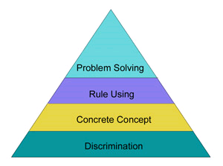
Tasks performed by supervisors
Overall job performed by supervisors
Figure 1: Gagne´s Intellectual Skills Domain

With cognitive task analysis method, the project team was able to separate the high-level duties performed by supervisors into two rule-using categories, procedural and principle. Procedural rule-using tasks (1-10) are those that follow a set of predefined steps to ensure that all components of that task are completed properly. This requires recalling a large body of interconnected facts. Principle rule-using tasks (11-12) are actions that can be converted into “if-then” situations; these include emergency and unusual situations and training responsibilities. As stated above, it was determined that the overall job of a supervisor requires problem-solving skills.

OVERALL JOB PERFORMED BY SUPERVISORS (Requires problem-solving skills)
Requires rule-using  (procedural) skills | Duty 1: Self-Assessment and Personal Fitness
Requires rule-using  (procedural) skills | Duty 2: Start-of-Shift Activities
Requires rule-using  (procedural) skills | Duty 3: Prior to Entering the Mine
Requires rule-using  (procedural) skills | Duty 4: Entering the Mine
Requires rule-using  (procedural) skills | Duty 5: Traveling to the Section
Requires rule-using  (procedural) skills | Duty 6: Arrive on the Section
Requires rule-using  (procedural) skills | Duty 7: Section Observation
Requires rule-using  (procedural) skills | Duty 8: Conduct On-Shift Examination
Requires rule-using  (procedural) skills | Duty 9: Conduct Pre-Shift Examination (for the next shift)
Requires rule-using  (procedural) skills | Duty 10: End-of-Shift Examination
Requires rule-using  (principle) skills | Duty 11: Emergency or Unusual Situations
Requires rule-using  (principle) skills | Duty 12: Training Responsibilities

For each of the duties listed above, the mine supervisor must be able to explain the job duties, why they are conducted, any associated risk, and how to implement appropriate controls. The first ten duties describe steps in the normal work day of a supervisor. The final two duties describe necessary elements of a supervisor’s knowledge base and responsibilities that are not necessarily everyday occurrences.

Learning Hierarchy

- For instructional purposes, the outcome of the cognitive task analysis of the generic JTA is to determine the learning hierarchy, which is composed of the learning objectives and the pre-requisite skills in a hierarchical order. The learning objectives are defined based on the optimal performance of the supervisory job duties that were identified during the job task analysis. The overall supervisory job, which is identified at the problem solving level, is the terminal objective of the learning hierarchy. The twelve duties in the JTA are identified as the rule using, procedural or principle level. Figure 2 presents the highest level of the learning hierarchy. It shows that a supervisor must know how to accurately perform the twelve duties before being qualified to carry out the supervisory job.

- The twelve duties form the next level of the learning hierarchy. These duties show the prerequisite knowledge that a supervisor must have. For example, Duty 2 identifies the knowledge needed in order to conduct start-of-shift activities. Figure 3 shows the learning hierarchy of the prerequisite skills.

The learning hierarchy helps the MSHA team to identify and order the learning objectives according to the intellectual skill domain and their prerequisites. Based on the learning hierarchy, the team will apply the appropriate instructional strategies and methods to teach the tasks according to their intellectual skill domains.

Conclusion

The original JTAs were created by two commercial coal mining companies to reflect what a section foreman would do in a workday. The design team converted the individual mines’ interpretations of coal mine supervisor’s duties to pertinent generic duties and aligned these duties and tasks to valid instructional design taxonomies.

Our next steps will include selecting the tasks rated in the generic JTA and to narrow the scope of possible learning strategies. Using the learning hierarchy as determined by the cognitive task analysis, the design team will construct the learning objectives, determine the instructional sequence and apply the appropriate instructional strategies and methods.

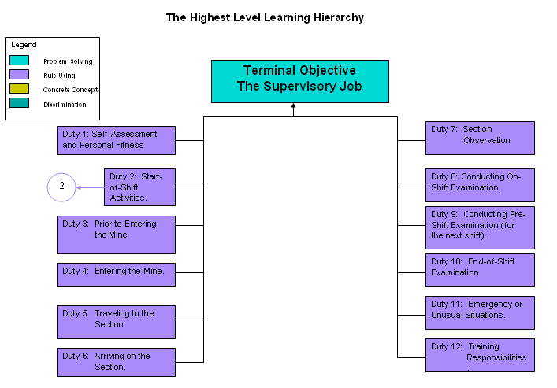

Figure 2: Highest Level Learning Hierarchy

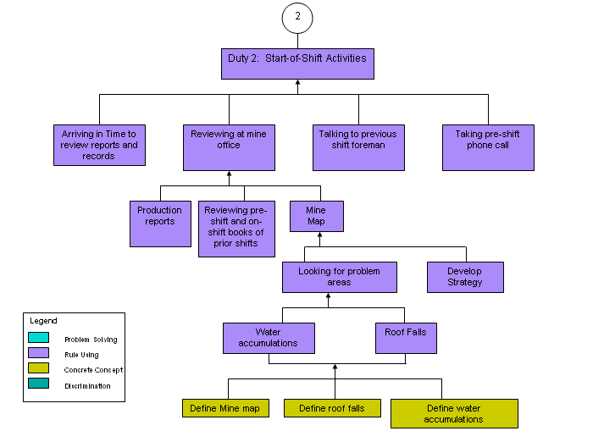
Figure 3: Learning Hierarchy - Duty 2

Appendix A: Generic JTA Diagrams

Duty 1: Self-Assessment and Personal Fitness

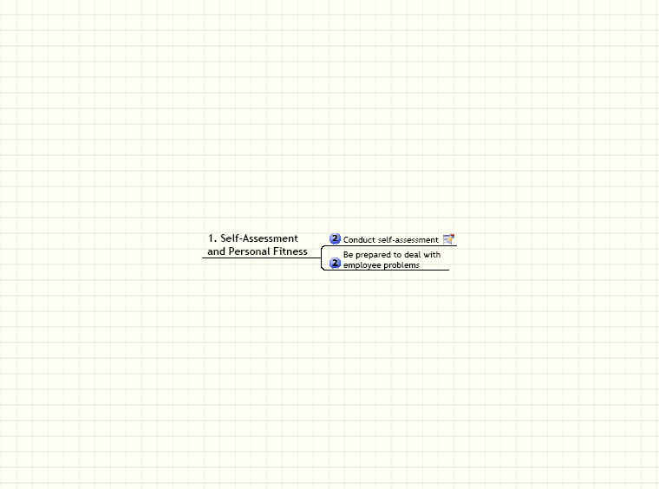

Duty 2: Start of Shift Activities

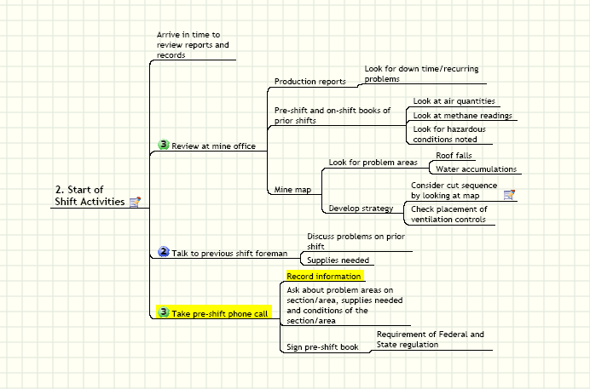

Duty 3: Prior to Entering the Mine

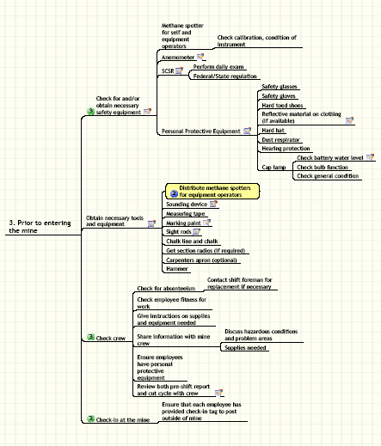

Duty 4: Entering the Mine

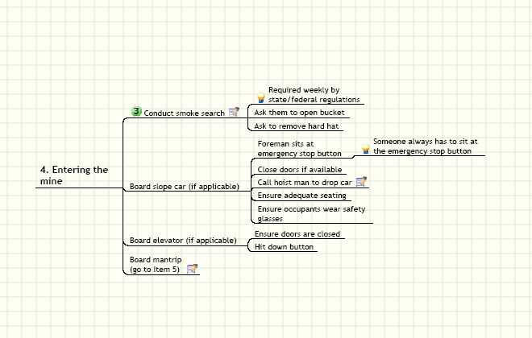

Duty 5: Traveling to the Section

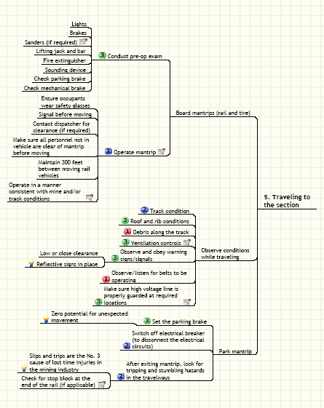

Duty 6: Arrive on the Section

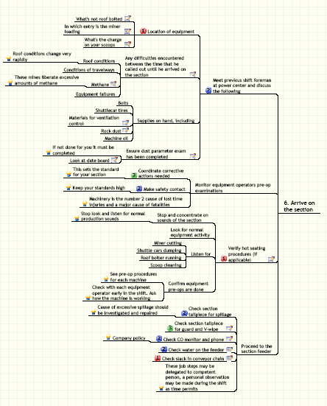

Duty 7: Section Observation

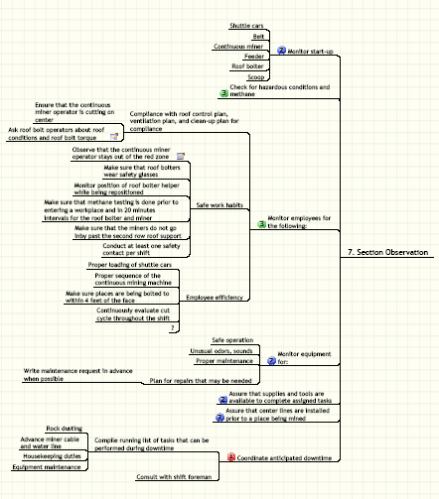

Duty 8: Conduct On-shift Examination

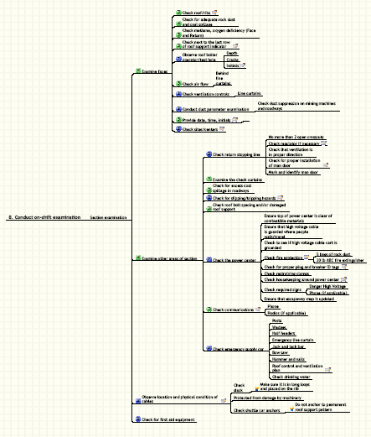

Duty 9: Conduct Pre-shift Examination

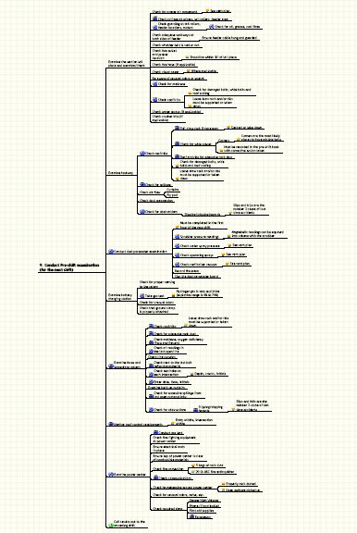

Duty 10: End of Shift

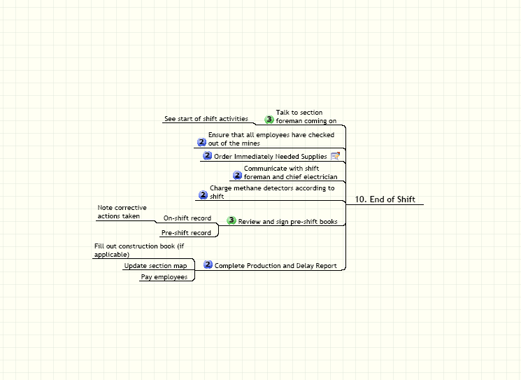

Duty 11: Emergency and Unusual Situations

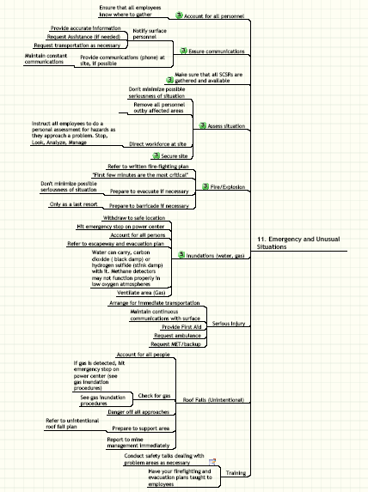

Duty 12: Training Responsibilities

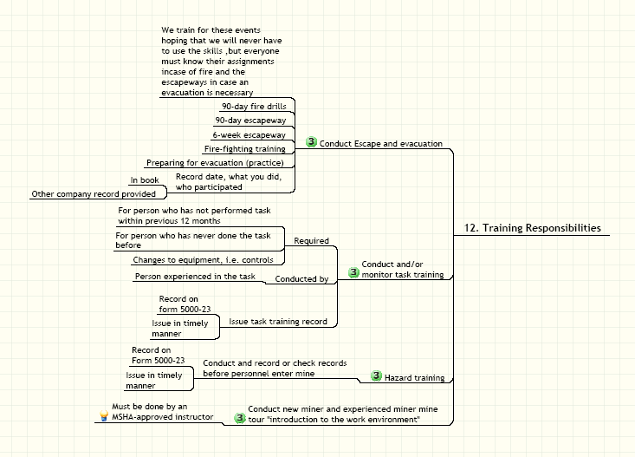

Appendix B: Generic JTA Worksheets

Duty 1: Self-Assessment and Personal Fitness

Learner will explain how to prepare for a safe and healthful work shift for himself/herself and crew through self-assessment and personal fitness determinations prior to start of shift. Learner will explain the job duties, why they are conducted, any associated risk, and how to implement appropriate controls. Self-assessment and personal fitness activities include the following job steps:

Job Steps | Importance Narrative  (Consider Safety, Production, Maintenance) | Importance Ranking  1=Important  2= Very Important  3=Critical | Reserved | Procedures/Risk Resolution/Notes/Comments
- Conduct self-assessment |  | 2 |  | The crux of this section. Soft skills aspects previously included (e.g. “be friendly”) are not as important.
- Be prepared to deal with employee problems/concerns |  | 2

Duty 2: Start-of-shift Activities
(break down into written info, face-to-face time with the previous shift foreman and a phone call)
Learner will demonstrate proper procedures for conducting start-of-shift activities. Learner will explain the job duties, why they are conducted, any associated risk, and how to implement appropriate controls.
Job Steps | Importance Narrative  (Consider Safety, Production, Maintenance) | Importance Ranking  1=Important  2= Very Important  3=Critical | Reserved | Procedures/Risk Resolution/Notes/Comments
- Arrive in time to review reports and records |  | ?
- Review at mine office |  | 3
- Production Reports
  - Look for downtime/recurring problems
  - Look at mine production runs
- Pre-shift and on-shift books of prior shifts
  - Look at air quantities
  - Look at methane readings
  - Look for hazardous conditions noted
- Mine map
- Look for problem areas
- Roof falls
- Water accumulation
- Develop strategy
- Consider cuts sequence by looking at the map |  |  |  | Sequence of mining cuts (who's behind, ahead, etc.); 'cut' is shorthand for the mining process.
- Check placement of ventilation controls
- Talk to previous shift foreman |  | 2
- Discuss problems on prior shift
- Supplies needed
- Take pre-shift phone call |  | 3
- Record information
- Ask about problem areas on section, supplies needed and conditions of the the section
- Sign pre-shift book |  |  |  | Requirement of state and federal regulations

Duty 3: Prior to entering the mine
Learner will demonstrate proper procedures required prior to entering the mine. Learner will explain the job duties, why they are conducted, any associated risk, and how to implement appropriate controls. Activites conducted prior to entering the mine will include the following:
Job Steps | Importance Narrative  (Consider Safety, Production, Maintenance) | Importance Ranking  1=Important  2= Very Important  3=Critical | Reserved | Procedures/Risk Resolution/Notes/Comments
- Check for and/or obtain necessary safety equipment |  | 3 |  | Inventory
- Methane spotter for self and equipment operators
- Check calibration, condition of instrument
- Anemometer |  |  |  | Measure linear feet of air that passes through the instrument. Used to determine cubic feet of air available.
- SCSR |  |  |  | Self-contained safety respirator. Good for one hour of breathing. Used in emergency situations.
- Perform daily exam
- Federal/state regulation
- Personal Protective Equipment |  |  |  | Observe crews to make sure that they have these materials.
- Safety glasses
- Safety gloves
- Hard toed shoes
- Reflective material on clothing (if available) |  |  |  | Not all mines provide reflective material on clothing.
- Hard hat
- Dust respirator
- Hearing protection
- Cap lamp
- Check battery water level |  |  |  | Acid-filled batteries need certain amount of water to function.
- Check bulb function
- Check general condition
- Obtain necessary tools and equipment |  |  |  | Best to keep tools in one bag (tote?)
- Distribute methane spotters for equipment operators |  | 2
- Sounding device |  |  |  | Hammer, walking stick – used to bang on the roof of the shaft to determine its integrity. The sound that you get from hitting the ceiling will tell.
- Measuring tape
- Marking paint |  |  |  | Can of paint
- Sight rods |  |  |  | Rods hung from the ceiling to identify position in shaft.
- Chalk line and chalk
- Get section radios (if required)
- Carpenters apron (optional)
- Hammer
- Check crew |  | 3
- Check for absenteeism
- Contact shift foreman for replacements if necessary
- Check employee fitness for work
- Give instructions on supplies and equipment needed
- Share information with mine crew
- Discuss hazardous conditions and problem areas
- Supplies needed
- Ensure employees have personal protective equipment
- Review both pre-shift report and cut cycle with crew |  |  |  | Most important to review pre-shift report; cut cycle review is optional.
- Check-in at the mine |  | 3
- Ensure that each employee has provided check-in tag to post outside of mine

Duty 4: Entering the mine
Learner will demonstrate the proper procedures for boarding and traveling into the mine by slope car and elevator. Learner will explain the job duties, why they are conducted, any associated risk, and how to implement appropriate controls.
Job Steps | Importance Narrative  (Consider Safety, Production, Maintenance) | Importance Ranking  1=Important  2= Very Important  3=Critical | Reserved | Procedures/Risk Resolution/Notes/Comments
- Conduct smoke search |  | 3 |  | Checking employees for cigarettes, lighters
- Required weekly by state/federal regulations
- Ask them to bucket
- Ask them to remove hard hat
- Board slope car (f applicable)
- Foreman sits at emergency stop button |  |  |  | Someone always has to sit at the emergency stop button
- Close doors if available
- Call hoist man to drop car |  |  |  | Hoist man is the guy that controls the slope/shaft car from the surface (pushes the buttons to lower and raise the miners to and from surface)
- Ensure adequate seating
- Ensure occupants wear safety glasses
- Board elevator (if applicable)
- Ensure doors are closed
- Hit down button
- Board mantrip (go to item 5) |  |  |  | Full explanation of mantrip issues under “Travelling to the Section”

Duty 5: Travelling to the section
Learner will demonstrate the proper procedures for traveling to the section by rail and rubber-tired mantrip. Learner will explain the job duties, why they are conducted, any associated risk, and how to implement appropriate controls.
Job Steps | Importance Narrative  (Consider Safety, Production, Maintenance) | Importance Ranking  1=Important  2= Very Important  3=Critical | Reserved | Procedures/Risk Resolution/Notes/Comments
- Board mantrips (rail and tire)
- Conduct pre-op exam
- Lights
- Brakes
- Sanders (if required) |  |  |  | Literally to drop sand on the track (for traction).
- Lifting jack and bar
- Fire extinguisher
- Sounding device
- Check parking brake
- Check mechanical brake
- Operate mantrip |  |  |  | Supervisor may not always operate mantrip; this may be delegated.
- Ensure occupants wear safety glasses
- Signal before moving
- Contact dispatcher for clearance (if required)
- Make sure all personnel not in vehicle are clear of mantrip before moving
- Maintain 300 feet between moving rail vehicles
- Operate in a manner consistent with mine and/or track conditions |  |  |  | Water, clay on track, etc.
- Observe conditions while travelling
- Track condition |  | 2
- Roof and rib condition |  | 3
- Debris along the track |  | 1
- Ventilation controls |  | 3 |  | Stoppings between entries/airways, overcasts/undercasts, curtains.
- Observe and obey warning signs/signals |  | 3
- Low or close clearance
- Reflective lights in place
- Observe/listen for belts to be operating |  | 1
- Make sure high voltage line is properly guarded at required locations |  | 3 |  | Regulations dictate that there be additional guarding if the area is 6 ft or above. Safety breakers on lines at regular intervals.
- Park mantrip
- Set parking brake |  | 3
- Zero potential for unexpected movement
- Switch off electrical breaker (to disconnect the electrical circuits) |  | 2
- After exiting matrip, look for tripping and stumbling hazards in the travelways |  | 2
- Slips and trips are the #3 cause of lost time injuries in the mining industry
- Check for stop block at the end of the rail (if applicable) |  |  |  | To keep rail equipment from coming off the rail onto the section.

Duty 6: Arrive on the section
Learner will demonstrate proper procedures for conducting activities upon arrival on the section. Learner will explain the job duties, why they are conducted, any associated risk, and how to implement appropriate controls.
Job Steps | Importance Narrative  (Consider Safety, Production, Maintenance) | Importance Ranking  1=Important  2= Very Important  3=Critical | Reserved | Procedures/Risk Resolution/Notes/Comments
- Meet previous shift foreman at power center and discuss the following |  | 2
- Location of equipment |  | 1
- What’s not roof bolted |  |  |  | Bolting are the metal rods set into the roof to keep it from collapsing (not the same as ribs)
- In which entry is the miner loading |  |  |  | Loading coal into the shuttlecars. Location would be the face number.
- What’s the charge on your scoops |  |  |  | Battery charge on scoop machines – basically, how much power is left to these machines. Charge usually lasts as long as a shift.
- Any difficulties encountered between the time that he called out until he arrived on the section |  |  |  | The call out of his report.
- Roof conditions |  |  |  | Roof conditions change very rapidly.
- Conditions of travelways
- Methane |  |  |  | CH₄
- These mines liberate excessive amounts of methane.
- Equipment failures
- Supplies on hand, including
- Bolts
- Shuttlecar tires
- Materials for verification control |  |  |  | Blocks, metal-fabricated panels, curtains. The check curtain is a swath of material used to cordon off the cut face (to contain CH₄).
- Rock dust |  |  |  | Limestone dust put on the roof, ribs and floor to keep the coal from catching on fire. The dust was sprayed on manually or by machine.
- Machine oil
- Ensure dust parameter exam has been completed |  |  |  | Dust parameter exam measures the amount of dust in a work area. If not done for you, it must be completed.
- Look at date board |  |  |  | Usually located at power center. The date board would note dust parameter exam results.
- Monitor equipment operators
- Coordinate corrective actions needed |  |  |  | This sets the standard from your section.
- Make safety contact |  |  |  | Keep your standards high.
- Machinery is the #2 cause of lost time injuries and a major cause of fatalities.
- Verify hot seating procedures (if applicable) |  | 1 |  | Hot seating: operaters switching control of a machine without pausing machine operation.
- Stop and concentrate on sounds of the section
- Stop look and listen for normal production sounds
- Look for normal equipment activity
- Listen for:
- Miner cutting
- Shuttle cars dumping
- Roof bolter running
- Scoop cleaning
- Confirm equipment pre-ops are done
- See pre-op procedures for each machine
- Check with each equipment operator early in the shift. Ask how the machine is working.
- Proceed to the section feeder | These job steps may be delegated to a competent person, a personal observation may be made during the shift as time permits.
- Check section tailpiece for spillage |  | 2
- Cause of excessive spillage should be investigated and repaired
- Check section tailpiece for guard and V-wipe |  | 3 |  | Guard around the belt roller and V-wipe (used to clean the belt of excess coal dust). The guard existence is crucial.
- Check CO monitor and phone |  | 2 |  | Company policy. Phone is connected to CO monitor. Alarm sounds if CP rises to unacceptable levels.
- Check water on the feeder |  | 2 |  | To suppress dust content in the workspace air.
- Check slack in conveyor chain |  | 1 |  | Must have right amount of slack to operate properly.

Duty 7: Section observation
Learner will demonstrate how to conduct a safe and thorough section observation. Learner will explain the job duties, why they are conducted, any associated risk, and how to implement appropriate controls.

Job Steps | Importance Narrative  (Consider Safety, Production, Maintenance) | Importance Ranking  1=Important  2= Very Important  3=Critical | Reserved | Procedures/Risk Resolution/Notes/Comments
- Monitor start-up |  | 2
- Shuttle cars
- Belt
- Continuous miner
- Feeder
- Roof bolter
- Scoop
- Check for hazardous conditions and methane |  | 3
- Monitor employees for the following |  | 3
- Compliance with roof control plan, ventilation plan, and clean up plan for compliance
- Ensure that the continuous miner is cutting on center
- Ask roof bolt operators about roof conditions and roof blot torque
- Safe work habits
- Observe that the continuous miner operator stays out of the red zone |  |  |  | The red zone is anyehere under an unsupported roof, where an operator could be crushed by a collapse. A supported roof is bolted.
- Make sure that roof bolters wear safety glasses
- Monitor position of your roof bolter helper while being repositioned
- Make sure that methane testing is done prior to entering a workplace and in 20 minutes intervals for the roof bolter and miner
- Make sure that the miners do not go inby past the second row roof support
- Conduct at least one safety contact per shift
- Employee efficiency
- Proper loading of the shuttlecars
- Proper sequence of the continuous mining machine
- Caution operators and helpers to stay out of red zones while moving
- Make sure places are bolted to within 4 feet of the face
- Continuously evaluate cut cycle through the shift
- Monitor equipment for: |  | 2
- Safe operation
- Unusual odors, sounds
- Proper maintenance
- Refer to service plans (written or verbal)
- See lube diagrams
- Chain tension
- Plan for repairs that may be needed
- Write maintenance request in advance when possible
- Assure that supplies and tools are available to complete assigned tasks |  | 2
- Assure that center lines are installed prior to a place being mined |  | 2
- Coordinate anticipated downtime |  | 1
- Compile running list of tasks that can be performed during downtime
- Rock dusting
- Advance miner cable and water line
- Equipment maintenance
- Consult with shift foreman
- End-of-shift responsibilities (production) |  | ?
- Make a list of needed supplies
- Equipment condition
- Note equipment problems during shift
- Note location of mining
- Note air quality and quantities
- Note unusual conditions
- Note progress of construction work
- Call out after pre-shift completed

Duty 8: Conduct On-Shift Examination

Learner will demonstrate how to conduct a proper and thorough on-shift examination. The learner will explain the job steps listed, why they are conducted, any associated risk, and how to implement appropriate controls.

Job Steps | Importance Narrative  (Consider Safety, Production, Maintenance) | Importance Ranking  1=Important  2= Very Important  3=Critical | Reserved | Procedures/Risk Resolution/Notes/Comments
- Examine faces
- Check roof/ribs |  |  |  | Loose draw rocks and/or ribs must be supported or taken down
- Check for adequate rock dust and coal spillage
- Check methane, oxygen deficiency (face and return)
- Check curtains
- Check next to the last row of roof support indicator |  |  |  | Roof falls are a leading cause of fatal and serious injury accidents
- Observe roof bolter operator/test hole
- Depth
- Cracks
- Initials |  |  |  | Company policy – many mines do not do this.
- Check roof/ribs
- Loose draw rock and/or ribs must be supported or taken down
- Pull draw rock if necessary
- Check for wide places
- Corners
- Wide bolts
- Roof and ribs for adequate rock dust
- Check for coal spillage
- Check air flow
- Behind line curtains
- Check ventilation controls
- Line curtains
- Conduct dust parameter examiantion
- Conduct during pre-shift for on-coming shift
- Check dust suppression on mining machines and roadways
- Monitor roof control requirements
- Provide date, time, initials |  |  |  | Federal/state requirement; protects you.
- Check sites/centers |  |  |  | Making sure that face is straight.
- Check coal seam height
- Check cable slack
- Examine other areas of section
- Check return stopping line
- No more than 2 open crosscuts
- Check regulator if necessary |  |  |  | Regulator controls airflow on the station.
- Check that ventilation is in proper direction
- Check for proper installation of man door |  |  |  | Man door is 30”x30” door inside center blocks that allow passage between areas.
- Mark and identify man door
- Examine the check curtains
- Check for excess coal spillage in roadways
- Check for slipping/tripping hazards |  |  |  | Slips and falls are the #3 cause of lost time injuries.
- Check for obstructions for workers or machinery
- Check roof bolt spacing and/or damaged roof support
- Check the power center
- Check highline guarding at man doors, charging stations
- Ensure electrical mats in place
- Ensure top of power center is clear of combustible materials
- Ensure that high voltage cable is guarded where people walk/travel
- Check to see if high voltage cable cart is grounded
- Check fire protection |  |  |  | Firefighting materials can become crucial in case of a fire. Be sure there materials are on the intake side.
- 5 bags of rock dust
- 20 lb ABC fire extinguisher
- Check for proper plug and breaker ID tags |  |  |  | Breaker must match plug that is intended to enter it. Lock out/tag out rules apply.
- Check plugs and cables for compliance
- Check restraining clamps
- Check housekeeping around power center |  |  |  | Properly rock dusted, keep garbage picked up.
- Check for unusual odors, noise, etc.
- Check required signs
- Danger High Voltage
- Phone (if applicable)
- First-aid supplies
- Ensure that escapeway map is updated
- Check communications |  |  |  | State laws: communication systems must work.
- Phone
- Radios (if applicable)
- Check emergency supply car
- Posts
- Wedges
- Half headers
- Emergency line curtain
- Jack and jack bar
- Bow saw
- Hammer and nails
- Roof control and ventilation plan |  |  |  | Update escapeway map on a regular basis (when moving feeder or belting up, etc.)
- Check drinking water
- Observe location and physical condition of cables |  |  |  | Handling cables is a major cause of back and shoulder injuries.
- Check slack | Make sure it is in long loops and placed on the rib.
- Protected from damage by machinery
- Check shuttle car anchors | Do not anchor to permanent roof support pattern.
- Check for first-aid equipment

Duty 9: Conduct Pre-Shift Examination (for the next shift)
Learner will demonstrate how to conduct a proper and thorough pre-shift examination. The learner will explain the job steps listed, why they are conducted, any associated risk, and how to implement appropriate controls.

Job Steps | Importance Narrative  (Consider Safety, Production, Maintenance) | Importance Ranking  1=Important  2= Very Important  3=Critical | Reserved | Procedures/Risk Resolution/Notes/Comments
- Examine the section tail piece
- Check for proper air movement
- See vent plan
- Check spillage at wipers, tail rollers, feeder area |  | 2
- Check guarding at tail rollers, feeder locations, motors |  | 2
- Check for oil, grease, coal fines
- Check adequate walkways at both sides of feeder
- Ensure feeder cable hung and guarded
- Check whether belt is wet or not
- Check fire outlet and proper location | Should be within 30’ of tail piece
- Check fire hose (if applicable)
- Check visual pager (if applicable)
- Be aware of unusual odors or sounds
- Check for methane |  | 2
- Check roof/ribs |  | 2
- Check for damaged bolts, wide bolts and roof scaling
- Loose draw rock and/or ribs must be supported or taken down
- Check water sprays (if applicable)
- Check crusher bits (if applicable)
- Examine haulway
- Check roof/ribs |  | 2
- Pull draw rock if necessary
- Support or take down
- Check for wide places
- Corners | Corners are the most likely places to have missing bolts.
- Must be recorded in the pre-shift book with corrective action taken
- Roof and ribs for adequate rock dust
- Check for damaged bolts, wide bolts and roof scaling
- Loose draw rock and/or ribs must be supported or taken down
- Check for spillage |  | 2
- Check for air flow
- Curtains
- Fly pad
- Check dust suppression
- Check for obstructions |  | 2
- Slipping/tripping hazards |  |  |  | Slips and trips are the #3 cause of lost time accidents.
- Conduct dust parameter examination |  |  |  | Must be completed in the first hour of the new shift.
- Scrubber pressure readings |  | 2 |  | Magnahelic readings can be equated into volume with the scrubber.
- See water pressure | See vent plan. | 2
- Check operating sprays | See vent plan. | 2
- Check roof bolter vacuum | See vent plan. | 2
- Record the exam
- Sign the dust parameter board
- Examine battery charging station
- Check for proper venting to the retun
- Take gas test |  | 2 |  | Hydrogen gas is very explosive (explosive range is 4% to 74%)
- Check for unusual odors
- Check that ground clamp is properly attached
- Examine faces and immediate returns
- Check roof/ribs |  | 2 |  | Loose draw rock and/or ribs must be supported or taken down.
- Check for adequate rock dust
- Check methane, oxygen deficiency (face and return) |  | 2
- Check air readings in the last open line |  | 2
- Check line curtains
- Check next to the last bolt reflective materials |  | 2
- Check test holes at each intersection |  | 2 |  | Depth, cracks, initials
- Enter date, time, initials |  | 2
- Examine back-up curtains
- Check for excessive spillage from last open crosscut inby |  | 2
- Check for obstructions |  | 2
- Slipping and tripping hazards |  |  |  | Slips and falls are the #3 cause of lost time accidents.
- Monitor roof control requirements |  | 2
- Entry widths, intersection widths
- Examine power center |  | 2
- Conduct gas test |  | 2
- Check firefighting equipment at power center
- Ensure electrical mats in place
- Ensure top of power center is clear of combustible materials
- Check fire protection
- 5 bags of rock dust
- 20 lb ABC fire extinguisher
- Check communications |  | 2
- Check housekeeping around power center
- Properly rock dusted
- Keep garbage picked up
- Check for unusual odors, noise, etc.
- Check required signs
- Danger High Voltage
- Phone (if applicable)
- First aid supplies
- Escapeway |  | 2
- Call results out to the oncoming shift |  | 3

Duty 10: End-of-Shift Examination
Learner will demonstrate how to conduct a proper and thorough end-of-shift examination. The learner will explain the job steps listed, why they are conducted, any associated risk, and how to implement appropriate controls.

Job Steps | Importance Narrative  (Consider Safety, Production, Maintenance) | Importance Ranking  1=Important  2= Very Important  3=Critical | Reserved | Procedures/Risk Resolution/Notes/Comments
- Talk to section foreman coming on |  | 3
- See start of shift activities
- Ensure that all employees have checked out of the mines |  | 2
- Order immediately needed supplies |  | 2 |  | Order critically needed parts, have part numbers and description, if possible.
- Communicate with shift foreman and chief electrician |  | 2
- Review and sign pre-shift books |  | 3
- On-shift record
- Note corrective actions taken
- Pre-shift record
- Complete production and delay report
- Fill out construction book (if applicable)
- Update section map
- Pay employees

Duty 11: Emergency or Unusual Situations
Learner will demonstrate proper procedures for handling emergency or unusual situations. Learner will also explain job steps listed, why they are conducted, any associated risk, and how to implement appropriate controls.
Job Steps | Importance Narrative  (Consider Safety, Production, Maintenance) | Importance Ranking  1=Important  2= Very Important  3=Critical | Reserved | Procedures/Risk Resolution/Notes/Comments
- Account for all personnel |  | 3
- Ensure that employees know where to gather
- Ensure communications |  | 3
- Notify surface personnel
- Provide accurate information
- Request assistance if needed
- Request transportation as necessary
- Provide communications (phone) at site, if possible
- Maintain constant communications
- Make sure that all SCSRs are gathered and available |  | 3
- Assess situation |  | 3
- Don’t minimize possible seriousness of situation
- Remove all personnel outby affected areas
- Direct workforce at site
- Instruct all employees to do a personal assessment for hazards, as they approach a problem. Stop, Look, Analyze, Manage
- Secure site |  | 3
- Fire/Explosion |  | 3
- Refr to written firefighting plan
- “First few minutes are the most critical”
- Prepare to evacuate if necessary
- Don’t minimize possible seriousness of the situation
- Prepare to barricade if necessary
- Only as a last resort
- Inundations (water, gas) |  | 3
- Withdraw to a safe location
- Hit emergency stop on power center
- Account for all persons
- Refer to escapeway and evacuation plan
- Water can carry CO₂ (black damp) or hydrogen sulfide (stink damp) with it. Methane detectors may not function properly in low oxygen atmospheres
- Ventilate area (in case of gas)
- Serious Injury
- Arrange for immediate transportation
- Maintain continuous communications with surface
- Provide first aid
- Request ambulance
- Request MET/backup
- Roof Falls (unintentional)
- Account for all people
- Check for gas
- If gas is detected, hit emergency stop on power center (see gas inundation procedures)
- See gas inundation procedures
- Danger off all approaches
- Prepare to support area
- Refer to unintentional roof fall plan
- Report to mine management immediately
- Training
- Conduct safety talks dealing with problem areas as necessary |  |  |  | Awareness is half the battle in preventing injuries and deaths.
- Have your firefighting and evacuation plans taught to employees

Duty 12: Training Responsibilities
Learner will demonstrate how to conduct and monitor required training. Learner will explain the job duties, why they are conducted, any associated risk, and how to implement appropriate controls.
Job Steps | Importance Narrative  (Consider Safety, Production, Maintenance) | Importance Ranking  1=Important  2= Very Important  3=Critical | Reserved | Procedures/Risk Resolution/Notes/Comments
- Conduct escape and evacuation | We train for these events hoping that we will never have to use these skills, but everyone must know their assignments in case of fire and the escapeways in case an evacuation is necessary. | 3
- 90-day fire drills
- 90-day escapeway
- 6-week escapeway
- Firefighting training
- Preparing for evacuation (practice)
- Record date, what you did, who participated
- In book
- Other company record provided
Conduct and/or monitor task training |  | 3
- Required
- For person who has not performed task within previous 12 months
- For person who ha never done the task before
- Changes to equipment, i.e. controls
- Conducted by
- Person experienced in the task
- Issue task training record
- Record on form 5000-23
- Issue in timely manner
Hazard training |  | 3
- Conduct and record or check records before personnel enter mine
- Record on form 5000-23
- Issue in timely manner
Conduct new miner and experienced miner mine tour “introduction to the work environment” |  | 3 |  | Must be done by an MSHA-approved instructor.

