RUNNING HEAD: HOLY SMOKE, BAT MAN! I MIGHT BE CRITICAL, TOO!

Holy Smoke, Bat Man! I Might Be Critical, Too!
Multiple Ways of Knowing Clear the Smoke

Holy Smoke, Bat Man! I Might Be Critical, Too!
Multiple Ways of Knowing Clear the Smoke
I suppose taking the critical stance could have been a sort of alter ego—one that I knowingly or unknowingly hid with the super hero suit in the Bat Cave. The key to connecting with that ego (not the hero) is to get rid of the suit all together and come out of the cave as I am to do what I intend to do.
At the onset of the semester I was aware that I wanted to be part of a learning organization that engaged in helping individuals reach their own self actualization within the “connected whole.” Reading Peter Senge’s book, The Fifth Discipline, helped to define this goal and to put it into a system that would guide me through the growing process necessary to becoming that sort of scholar. This system is a balancing system that serves as a place holder for the following variables or characteristics: personal mastery, relationships and patience, knowledge building and sharing, and coherence making. Ways of Knowing has touched on each of these attributes, bringing me further along the epistemological models outlined by Hofer and Pintrich (1997).
Personal mastery continues to be a focus for my development as it pertains to the self and the group. It involves a personal vision and understanding your current reality. A person needs to understand his or her deep purpose, as well as the group’s goal, in order to maintain creative tension within the group. If my intent is to serve the greater good by striving to ensure equitable educational opportunities in the classroom, then how can I deny the critical lens? I certainly was doing just that after reading Kincheloe. I was taken back by the tone and what I perceived as aggression that came with his message of the power struggles between the heard and unheard. If you were to put me on a linear continuum between rational thought and critical theory at that point, then I would be standing in the middle. However, I would be facing Descartes, with my back to Kincheloe, in denial. I was guilty of thinking in the two dimensional and I was not holding on to my personal vision, therefore my level of personal mastery in the system had to be in a delay of sorts.
There I am, standing between Descartes and Kincheloe, thinking either/or, black/white, yes/no, and looking left and right. Then I am told to look up and what do I learn? A feminist, collaborative lens could lift me from this two dimensional dilemma, creating a new, but connected angle on my personal vision.
Part of my vision involves the learning organization, which is collaborative and has been difficult to infuse into how schools function in recent history. The teachers choosing to teach in isolation is particularly troubling because it is thought that women have natural propensity for harnessing the power of collaboration. It has also been said that teachers value trust more than competence. Could it be that teachers value trust more than competence because this was all the human connectedness offered to teachers since most knowledge historically surrounding teaching and learning has been “received” in the form of manuals and mandates? Could this quality assurance, top down view of education have been due to cultural norms in defining women, in marginalizing their voice? If so, then it could be said that the “education debt” outlined by Ladson-Billings during the presidential address at the AERA conference could also be used to describe the lack of collaboration, change, and openness in many schools. The debt then stretches to include the teaching profession.
I begin to worry how I would be able to project my new, three dimensional self. Reason, critical theory, the feminist connections to the whole—they all help to clarify my personal vision and seem to enhance my personal mastery. However, my development as a leader or scholar also depends on relationships and patience, knowledge and sharing, and coherence making. Projecting myself must also depend on these three elements.
Arts based inquiry brought me back to a personal tendency towards viewing images and story as a way of knowing and feeling. Images and narratives bring in the heart in a way that connects the objective to something more meaningful and useful. It puts the objective knowledge into context. It builds relationships and eases tensions, as well as internal struggles like, “Am I really a critical feminist?” I learned here, that I can use what I enjoy, photography and music, in my way of knowing as I work with others toward decreasing the “education debt.” I am no longer on a two dimensional continuum and I am beginning to see the whole picture of education research.
Action research as a way of knowing is critical and includes methods from the tool boxes of all the varied ways of knowing. This seems perfect as it situates itself at the intersection of the ways of knowing for parents, scholars, and policy makers. This is where I want to be and this particular Ways of Knowing class has brought me closer as it guided me further along the epistemological model described by Brinkley.
I note my position after the third essay, as I was standing on the Descartes-Kincheloe continuum, as being subjective knowledge—still dualistic in nature. Once I looked up, as I learned more about the feminist way of knowing, I began to assimilate and accommodate the feminist lens, action research methodology, paradigm shifts, and arts based ways of knowing. I think I may have reached the level of procedural knowledge at this stage. I am able to be both separate and connected, to be objective and caring. This is a comfortable place and it does help connect with the leadership characteristics of relationships and patience.
Now, I am standing in the field of education research, under my mighty oak that is action research, peering further out to the current horizon. I see a spectacular picture. I see constructed knowledge through conceptual conflict and complementarily. I am not there yet, but I can see myself there. I am not wearing a super hero suit. I am just me in my community of knowers—collaborating, synthesizing, and overlaying knowledge to create a clearer picture of teaching and learning.

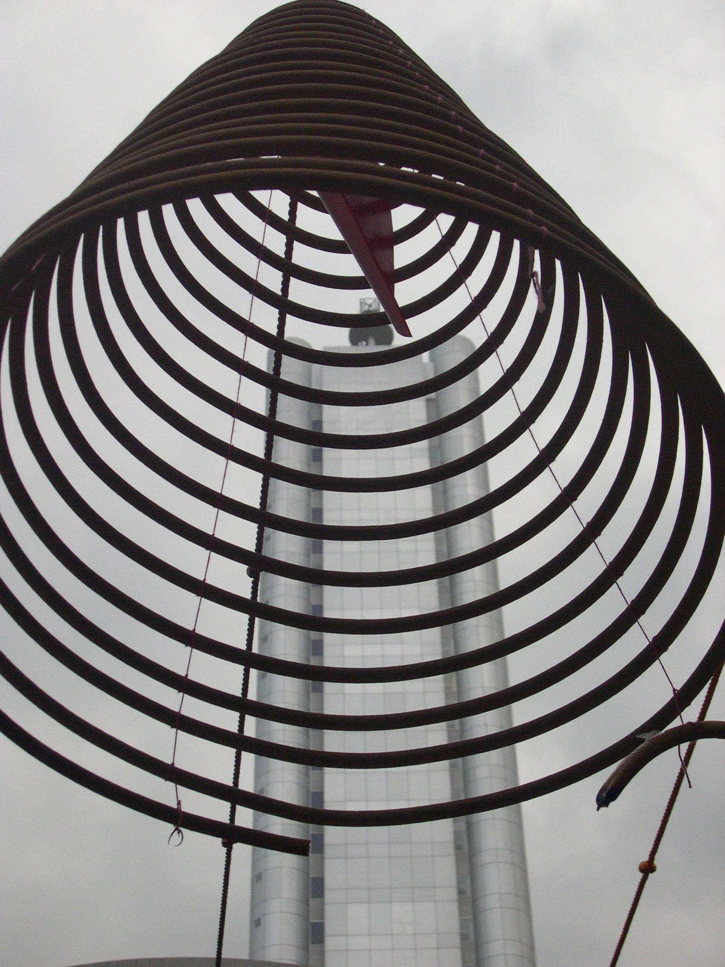

Singapore, 2006
Buddhist traditions
carry on as is, but still
add to growth and
understanding—overlay.

