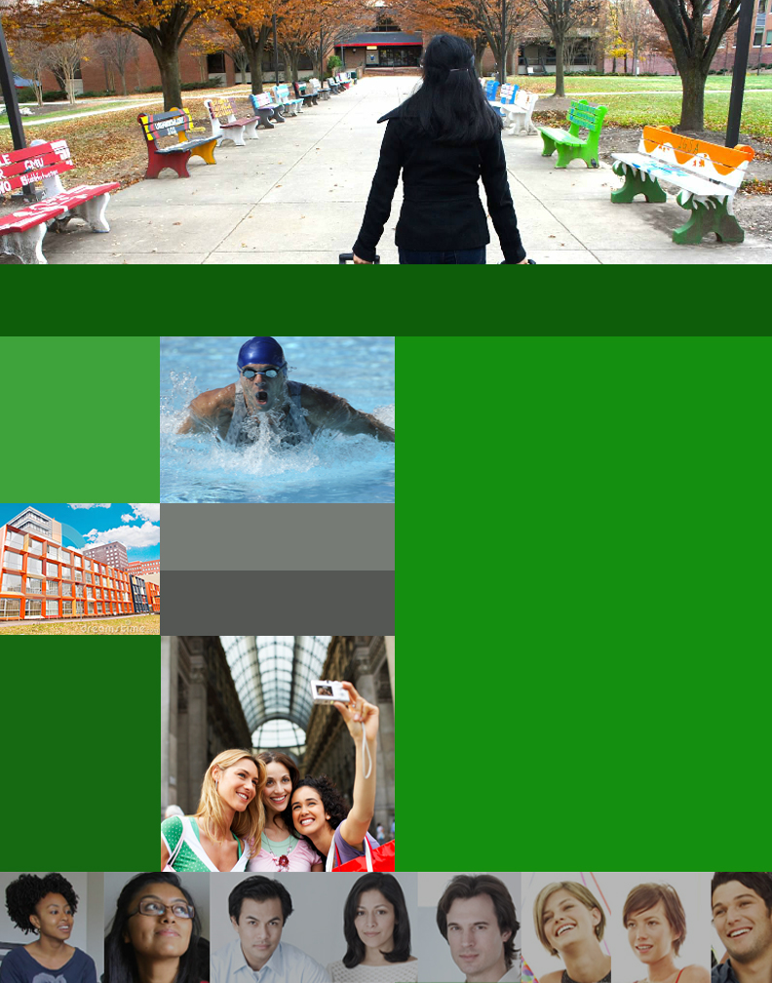
EDIT 752: Analysis and Design of Technology-Based Learning Environments
Spring 2014
Group C:
Melinda Babione
Gary Bushrod
Audrey Mascarenhas
Katherine Maye
Matthew Rufe
by
For
George Mason University
Office of International Programs and Services

ACQUAINT
Round One Usability Report

TABLE OF CONTENTS
Introduction 2
1: project BACKGROUND 2
1.1 USER EXPERIENCE RESEARCH SCOPE 2
1.2 assumptions 2
1.3 THE RESEARCH TEAM 2
1.4 SUCCESS CRITERIA 3
2: Goals 3
2.1 round one research goals 3
3: Target audience 3
3.1 target audience description 3
3.2 Tester Data 3
4: testing method 5
4.1 procedures 5
4.2 survey questions 5

5: results 5
5.1 perceived value for the user 6
5.2 menu link expectations 6
5.3 clarity of wording and design 8
5.4 quest game 8
5.5 recomendations 9

6: implications for design 10
6.1 prototype revisions 10
6.2 implications for round 2 12

Introduction
This report summarizes the methods, participants, and findings of Round 1 usability testing of the ACQUAINT website prototype for pre-arrival international students at George Mason University. The prototype is being developed on behalf of the Office of International Programs and Services to fulfill an unmet need of consolidating information that is helpful for international students who are preparing to come to campus to study.

1: Project Background

1.1 User Experience Research Scope
The scope of this project is limited to a User Experience Rapid Research Cycle. Resources (especially time) will not allow any significant redesign of the ACQUAINT prototype. The research cycle will allow the project team to make tweaks to the prototype for our initial and subsequent round of testing based on the data we gather from testing.

1.2 Assumptions
The project team assumes that by testing our prototype with students and university colleagues who are already living in this country, we will identify issues which might arise for pre-arrival international students in their home countries.

1.3 The Research Team

Melinda Babione
- Pal-Tech
- Over 15 years experience with training and development including instructor led training and eLearning.
- Lead: Round 2 testing via Solidify
Gary Bushrod
- Senior Consultant at Booz Allen Hamilton
- 5 years experience in Instructor Lead Training
- Designs, maintains, and provides end-user support for web-based training courses for the Department of Defense
- Lead: Synthesis and Presentation
Audrey Mascarenhas
- Associate at Booz Allen Hamilton.
- Previously spent over 15 years developing training and multimedia products for several companies.
- Lead: Prototype Development, including interface and navigation design.
Katherine Maye
- Senior Consultant at Booz Allen Hamilton.
- Experience in development divisions across several industries.
- Lead: Round 1 testing via a survey.
Matt Rufe
- Training Specialist with the United States Bureau of Labor Statistics.
- Designs and develops distance learning products for geographically dispersed staff who support and collect Consumer Price Index data.
- Lead: Research Management Plan.

1.4 Success Criteria
The project team will assess the progress and success of our project based on successful and timely completion of the project tasks and milestones as laid down in the Research Management Plan.

2: Goals

2.1 Round 1 Research Goals
The project team’s goal for the first round of testing for the ACQUAINT prototype will be to gain specific feedback on the target user’s perceived value of the web site. We are validating the intended purpose of the site with this round of testing.
Specifically, Round 1 testing seeks to determine user:
- Understanding of the purpose of ACQUAINT
- Awareness of what ACQUAINT can help them do
- Expectations from menu items
- Perception of clarity in wording
- Motivation derived from online scavenger hunt

3: Target Audience

3.1 Target Audience
The target audience for the ACQUAINT webpage are new international undergraduate and graduate students preparing to continue their academic pursuits on the George Mason campus. Due to the difficulty in identifying and contacting international students prior to their arrival on campus, proxy testers were used for our Round 1 testing. The testers satisfied at least two of the three criteria below.
International Experience High Education Affiliation

University Student Age

3.2 Tester Data
A total of nine testers responded to our request to participate by exploring our prototype and completing our survey.
Testers identified themselves as being from the following countries:
- United States (3 testers)
- Russia
- Germany
- Poland
- Jamaica
- China
- Mexico
Although we invited several male students to participate in our survey and posted a request on an international student discussion board, 100% of the respondents were female. OIPS was invited to provide feedback and has not responded at the time of issuing this report. The age range of the respondents was 18 – 45, which mirrors the age demographic of international students at George Mason.

Part 4: Testing Method

4.1 Process
Each tester received an email describing the project and a including a bit of background; it assured the tester that we were seeking honest feedback in order to improve the site’s usability. Embedded in the email was an online survey designed with Google Forms and the ACQUAINT prototype as a Power Point Presentation was attached. The questions on the survey were mainly open-ended and prompted the users to give actionable feedback that helped to prioritize revisions of our prototype.
Email invitation to participate and instructions:
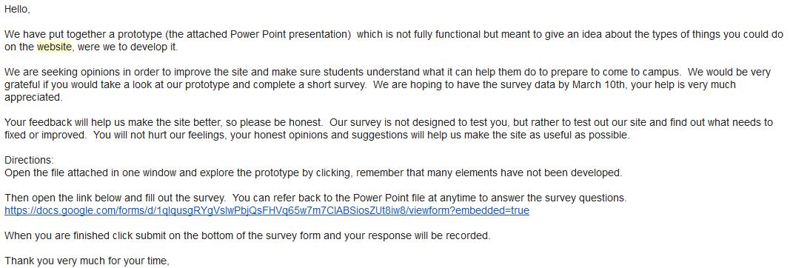

4.2 Survey questions
The survey can be found at the following link:
https://docs.google.com/forms/d/1qIqusgRYgVslwPbjQsFHVq65w7m7ClABSiosZUt8iw8/viewform?embedded=true

5 results
Themes and participant quotes are summarized in the following sections, grouped by topic. The entire collection of survey responses can be found at the following link:
Survey Results Spreadsheet

5.1 Perceived value for user
The following responses were obtained from the opening question in our survey. The users were answering the question, “What do you think this website can help you do?” The responses to this question validated our intended purpose. No issues surfaced for this question in terms of perceived value.
- “It will help me familiarize with the new reality, prepare as much as possible for living away from home (checklists, housing arrangement).”
- “Shows me out to get a visa. How to register for courses. Where to go for orientation. How to pay tuition. Advice on traveling to the U.S. in general. Important dates.”
- “It guides international students through everything they have to do before they actually arrive at the university/US. It is also a platform where one can discuss problems, especially with housing, with others who have been through the same situation.”
- “…information about two kinds of housing might be very helpful to them. One is for the undergraduate, who, per my knowledge, has to live on campus. And for a graduate …so the number 1 choice is off campus living, which demands a large amount of information about available apartment or townhouse. Then, the information of public transportation is the second important thing to me.”
- “Finding ways to get involved in school.”

5.2 Menu Link expectations
These questions generated actionable feedback, particularly with respect to the question about the link, “Learn about Mason”. The responses regarding the discussion board link were on-target with the team’s expectations. Below are several responses received from testers. The actionable feedback our team prioritized for revision is highlighted.
Learn about Mason link expectations:
- “I think at the moment when the international student will plan the trip s/he might not connect George Mason University and Mason. I didn't see the full name of the university on the homepage, it was confusing for a second if this website has a direct affiliation with GMU. I would expect see a list of my options (e.g. student job opportunities, gyms, housing, food arrangements, events, transportation, scholarship) then I would expect to have an option to explore each topic in details. I would expect to see a search tab so I can search with the key words for things I am interested in. Peer ratings and comments for options suggested would be nice. (like in TripAdvisor) where other students can add comments and recommendations (what you need to use the public transportation (cash, card, etc.) Those details are important when you are in unfamiliar context.”
- "’Learn about Mason’ may be better if you had a better welcoming statement, an image for the Quest, call it "Quest: Your Online Orientation to George Mason." Can you provide an approximate time for the quest (i.e. each of the 5 quests take approx. 5 mins)? Tell me there is a score and make that more visible when playing.”
- “I'd expect to learn about the academics and stats, e.g how many students are enrolled, what majors are offered, tuition and board.”
Discussion board link expectations:
- “On campus dining, gym information, student activities and job hunting information.”
- “These discussion boards will provide personal experiences.”
- “Could you have a FAQ section instead - with an option to post a new question not listed on the FAQ (that then links to the discussion board)?”
- “I hope that they have discussions in my language or, at least, with other people who ‘get’ me … from a cultural perspective.”

5.3 Clarity of wording and design
A few phases were identified as confusing and will be revised. Further, the discussion board example post was identified as important information but in the wrong location, so the checklist will be moved to the Resources menu link from the home page.
- “… ‘mix and mingle’ is a conversational phrase that is not taught in the core of standard English, it is likely that international students will not know the phrase.”
- “I know the site is only partially functional, but on the discussion boards page, the hot spot in on "Introduce Yourself" but it leads to the checklist.”

5.4 Quest Game
The majority of testers responded that they did not understand the point system for the Quest online scavenger hunt. Further, two of the testers responded that it was childish and another remarked that it was too time consuming. One tester provided positive feedback on the game aspect but remarked that the point system was unclear and that she worried it would take too long.

Was the point system a motivator for you to complete the game?
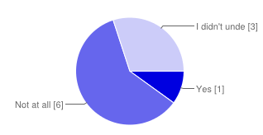
Was the feedback in the answer section in the Quest appropriate and in sufficient level of detail?
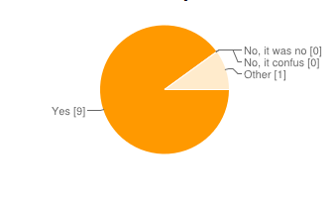
Responses regarding Quest:
- “I would abandon the game, going into scenario will just take my time. I need to find relevant information quickly, I need to answer an immediate question I have.”
- “… ‘QUEST’ was concerned how long this quest would take to get me the orientation information”
- “The Quest made me feel like a little child. It's too obvious that it's meant to teach/how me something.”
- “The quest/game. I found it more than unnecessary.”
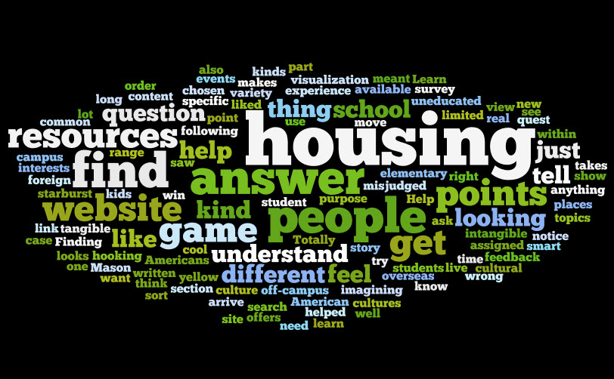
The results for the question “what is the purpose of the Quest game?” parsed into a word cloud demonstrates a clear understanding that the game was designed to help them find resources they might be looking for or need. Other words that stand out are: points, understand, answer, and different. These all suggest that the game, as it was designed, would have helped our users achieve what we were hoping to do. In contrast, the user quotes stated that Quest took too long, was unnecessary, and made them feel childish. It is possible our rapidly designed prototype did not include enough features to let the users fully experience its design and how it might help them. Never the less, responding to the specific negative comments about the game, the team decided to abandon Quest and redesign those features as a more efficiently navigated information hub.

5.5 recommendations
Many of the recommendations were related to the Quest game or dealt with navigation problems with the power point presentation. Both of these issues will be resolved in the revised prototype.
- “Top priority would be making the checklist more user friendly, savable offline, and more prominent on the site.”
- “… put as much (helpful) resources into the website as you can.”

6 Implications for design

6.1 Prototype revisions
The following changes were made to the prototype to bring our website more in-line with user expectations.
- A search feature was to pages to allow users to find relevant information more quickly
- The new student checklist was made more prominent by moving it to the Resources link on the home page
  - It was not possible to make it savable offline in the prototype, but it will be suggested to the client in the final report.
- References to Mason were changed to George Mason University
- The link “Learn about Mason” became “Life at George Mason University”
- The Quest online scavenger hunt was replaced with an information hub
  - Each topic delivers a short scenario and top tips with relevant links
  - Change reflects user requests to find information quickly
  - New design is more self-directed and requires fewer clicks to find information
  - Abandons the game aspect and point system, which users found confusing

New Home Page
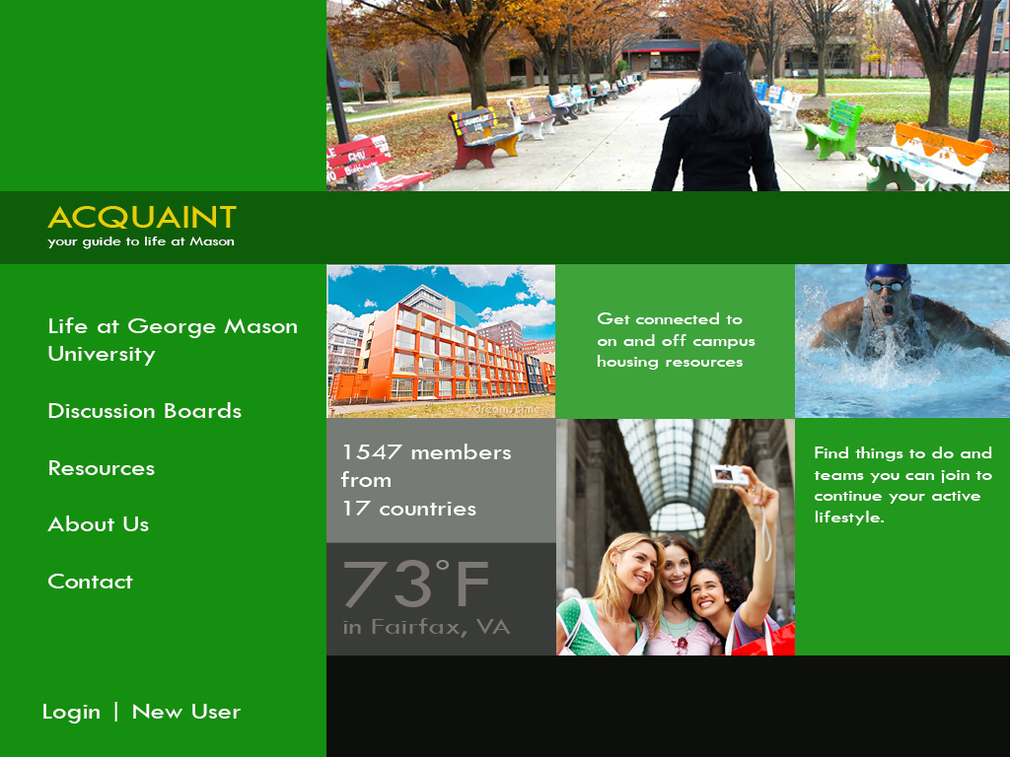

Resources with new student checklist less than three clicks from the homepage, search feature.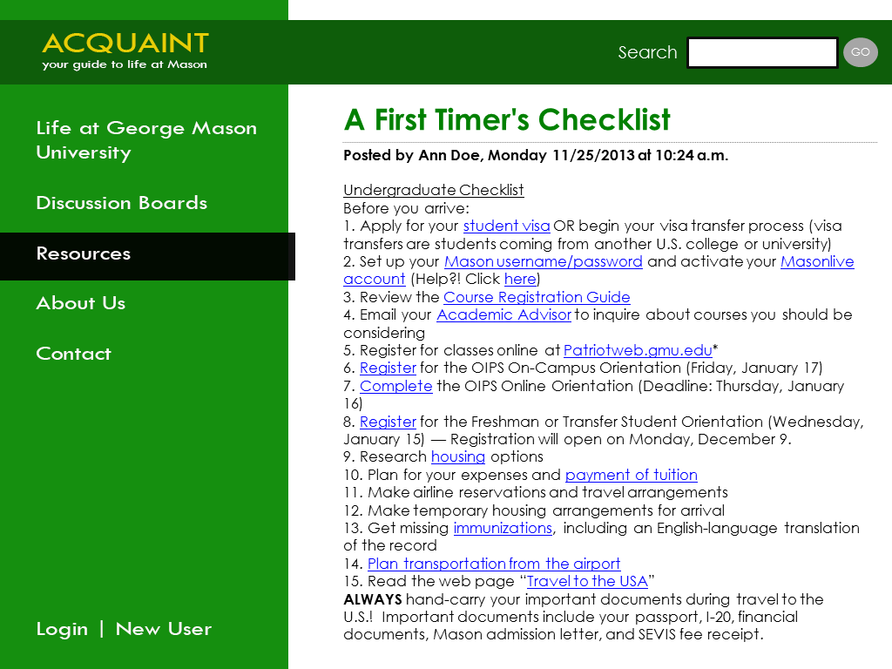
Learn about Mason / Quest  Life at George Mason University hub
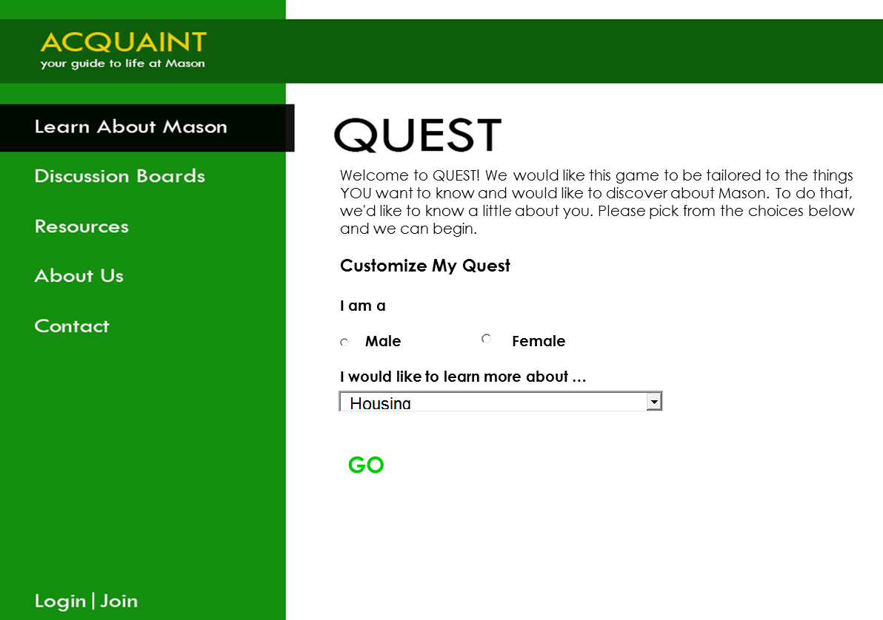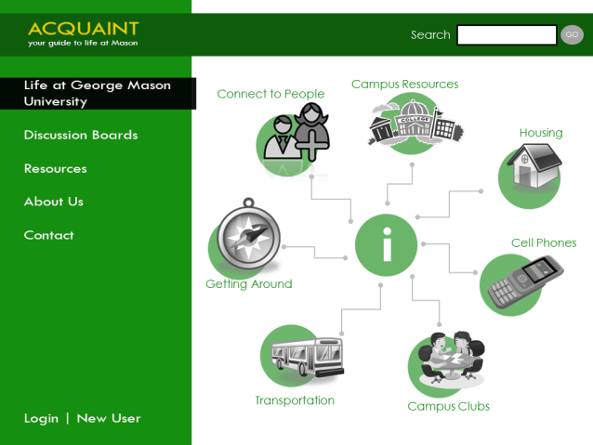
Quest scenario Topical tips with links
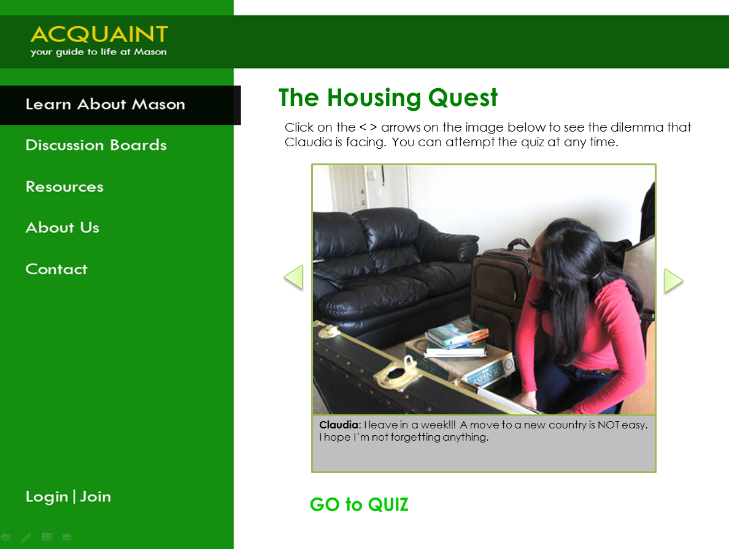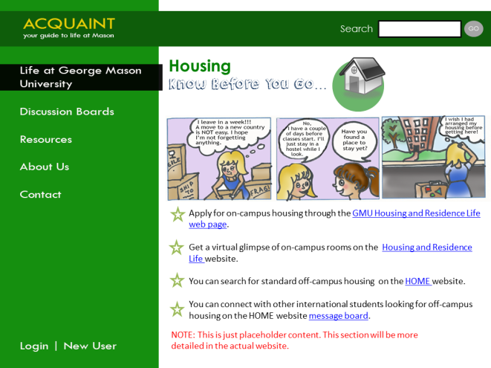

6.2 Implications for Round 2
Round 2 will consist of scripted tasks performed remotely by the many of the same testers used for Round 1; additional testers will also be recruited for a fresh perspective. The users will be asked several questions related to transportation, as this feature is the most built-out of our prototype. Data will be collected for time on-task, as well as click paths, and number of clicks to complete the task. This method of user experience research was laid out in our original plan, but gains validity as the best choice in light of our Round 1 data from users requesting a more efficient path to the information. The data collected will hopefully highlight any navigational issues of confusing aspects of our site.

