Africa Through Western Eyes: Imperial to Modern
Africa 1300-present day
By: Amanda Branch, Amanda Nicoll,
James Farley, LJ Kosar, and Frances Lester
What is cartography?
- “The art and science of making maps”
-James S. Aber – Professor of Geology Emporia State University, PH.D in Gelology.
What is a map?
- “A map is a graphic representation or scale model of spatial concepts.” – James S. Aber

History
- 15th and 16th centuries were a time of expansion and trade for economic opportunities.
- Map making shifted from an intuitive to practical for professional use rather than the guesswork.
- Greek & Roman philosophy heavily influenced map-making up to the 16th century.
- Ptolemy’s belief and influenced Casper Vople.
- Vople’s “Terrestrial globe with Armillary Sphere” was a globe encircled by a sphere that distinguished seasonal changes and orbits of heavenly bodies.
- Venetian Sailing directions in the 15th century employed the zodiac and cultic hand signs as a means of navigation.
Geographic Information Systems
- “GIS is a collection of computer hardware, software, and geographic data for capturing, managing, analyzing, and displaying all forms of geographically referenced information.” –GIS.com

Works Cited
Aber, James S. "Brief History of Maps and Cartography." Academicemporia.Edu. 2004. Emporia State University. 20 Feb. 2008 <http://academic.emporia.edu/aberjame/map/h_map/h_map.htm>.
Aber, James S. "James S. Aber Biography." Academicemporia.Com. Oct. 2007. Emporia State University. 24 Feb. 2008 http://www.emporia.edu/earthsci/aberjame.htm
Abu-Lughod, Janet L., “Before European Hegemony,” in the Atlantic World in the Age of Empire, Thomas Benjamin et al., eds., Boston: Houghton Mifflin, 2000 (second edition), pp. 13-18
Al-Siddiq, Abu Bakr, “The African Travels of Abu Bakr Al-Siddiq,” in Africa Remembered: Narratives by West Africans from the Era of the Slave Trade, Philip Curtin, ed., Long Grove, IL: Westland Press, 1997, pp.156-163
Cesaire, Aime, “Discourse on Colonialism,” in African Philosophy an Anthropology, Emmanual Chukwudi Eze, ed., Hoboken, NJ: Wiley, 1998, pp.222-227
"The History of Maps." 1 World Globes. 25 Feb. 2008 <http://www.1worldglobes.com/History/historyofmaps.htm>.
"The Story of Africa." BBC.co.uk. BBC. 18 Feb. 2008 <http://www.bbc.co.uk/worldservice/africa/features/storyofafrica/10chapter3.shtml>.
"The Story of Africa." Bbc.Co.Uk. BBC. 18 Feb. 2008 <http://www.bbc.co.uk/worldservice/africa/features/storyofafrica/10generic3.shtml>.
Tignor, Robert and Jeremy Adelman et al., Worlds Together, Worlds Apart, New York: W. W. Norton, 2002.
What is GIS?" GIS.Com. 4 Apr. 2007. ESRI. 27 Feb. 2008 http://www.gis.com/whatisgis/index.html
-"World Atlas History." 1 World Globes. 25 Feb. 2008 <http://www.1worldglobes.com/History/worldatlashistory.htm>.
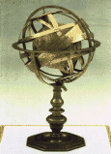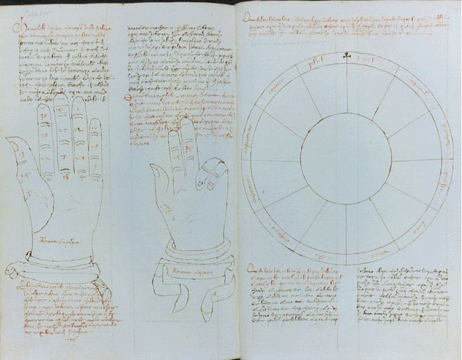
http://www.1worldglobes.com/History/historyofmaps.htm http://www.1worldglobes.com/History/historyofmaps.htm
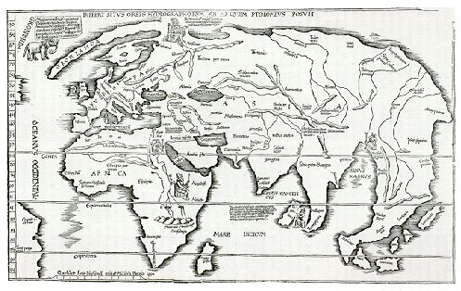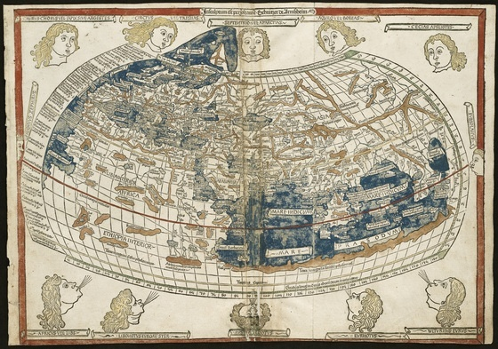
http://www.antiquemaps.co.uk/graphics/plate5.jpg http://maps.bpl.org/pub/05/01/05_01_000200.MEDIUM.

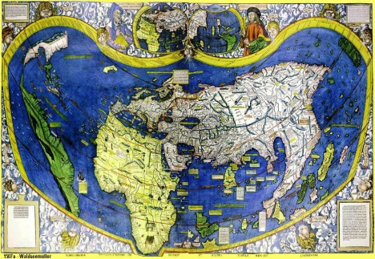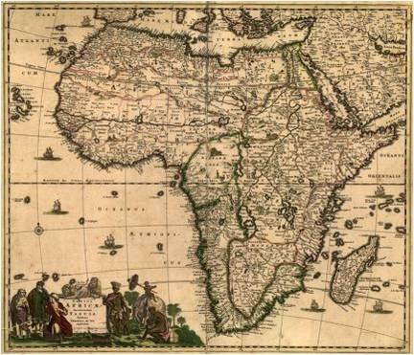
http://www.brazilbrazil.com/m/map1507a.jpg http://lcweb2.loc.gov/cgi-bin/query/D?gmd:36:./temp/~ammem_yuzj::
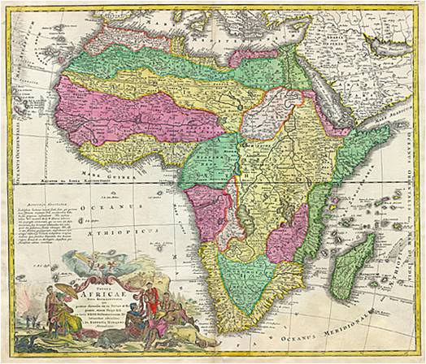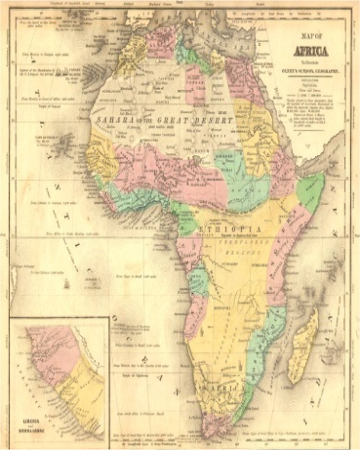
http://lcweb2.loc.gov/cgi-bin/query/D?gmd:34:./temp/~ammem_yuzj:: http://lcweb2.loc.gov/cgi-bin/query/D?gmd:36:./temp/~ammem_yuzj::

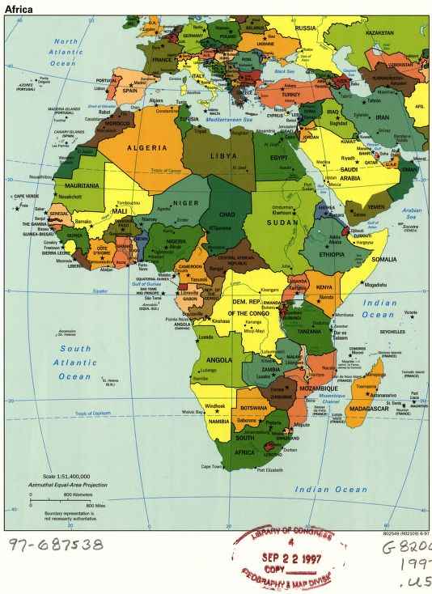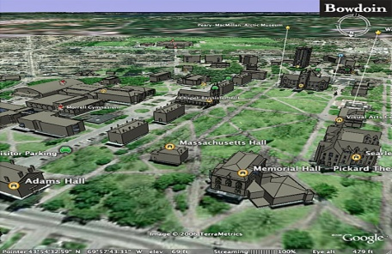
http://www.africa.upenn.edu/CIA_Maps/Africa_19850.gif http://www.bowdoin.edu/about/campus/maps/earth/images/bowdoin-google- earth-models.jpg

