The Honorable Governor Charlie Crist
State of Florida
PL-05 The Capitol
Tallahassee, FL 32399-0001
Dear Governor Crist,
I urgently recommend that you make it a point to address and enact policy concerning the regulation of pollution in the form of a state-wide pollution tax in order to benefit society and business as a whole in the long run.
It is my view that pollution remains regulated while efficient forms of energy be further developed and manufactured in order to improve the benefit of society as a whole. As more and more businesses spring up, the environment appreciation becomes devalued.
The State of Florida is home to wildlife which cannot be found anywhere else in the world. Manatees serve as a prime example of wildlife conservation and economic advantage through tourist attraction. By not regulating pollution, companies are left to do as they please. If further measures are not taken, public and wildlife health will be lost as a whole.
I propose that large businesses in the energy and industry sectors be taxed based on the amount of output of pollution they give off. Taxing these firms will force them to be more efficient in their means of production.
Each company must consider its production factors of land, labor, and capital. A firm has make crucial decisions as to the location of production, the number employees it hires, and the amount of machinery necessary to produce a desirable level of production. All of these factors combined with the taxatation process lead to smarter and more efficient means of production.
The benefits of taxing pollution are endless. Taxing companies for their output not only enables the government to have funds for environmental clean-up programs, promotion of air quality, consumer pollution awareness and grants for efficiently producing companies.
It is important to note that more taxation is seen as the degrading stigma that takes more money out of the common pocket. The belief that taxation is harmful is both unfounded and false in the case of taxing firms. In the short-run, the firm may loose out periodically, but the gains that the business gets from producing a more efficient product allow it to simultaneously gain more revenue and decrease the effect it has society’s environment in the long run. In many cases, excessive overproduction is eliminated.
The taxation gained by the state from the firms should then be used for public works for health and environmental cleanup to benefit society. In short, it should cost firms just as much as the society and environment they affect with the pollutant byproduct of their output. As a representative of the people, I am assured that you will take this issue of implementing an effective a state-wide tax for pollution into serious consideration. Thank you for your time.

Sincerely,
James Farley
PMB#21999
James J. Farley
4450 Rivanna Lane
Fairfax, VA 22030-4441

Resources

Taxation of Firms
http://www.environmentalleader.com/2007/11/06/bloomberg-proposes-pollution-tax/
http://www.environmentalleader.com/2007/10/25/ny-plan-caps-power-plant-emissions-auctions-pollution-credits/

Environmentally Friendly Firm Initiatives
http://www.environmentalleader.com/2007/11/19/bayer-to-spend-146-billion-on-green-initiatives/

Regulation of Pollution

http://www.enviroliteracy.org/article.php/278.html
http://ec.europa.eu/environment/climat/kyoto.htm
http://www.cityofgainesville.org/recycles/busi/env_impact.shtml

Manatees as a source of tourist income

http://www.sciencedirect.com/science?_ob=ArticleURL&_udi=B6VDY-4D636YJ-1&_user=650615&_coverDate=09%2F01%2F2004&_rdoc=1&_fmt=&_orig=search&_sort=d&view=c&_acct=C000035118&_version=1&_urlVersion=0&_userid=650615&md5=9b5c43170f68d1a8f0c7426e8e386d42

Externalities
http://www.economist.com/research/economics/alphabetic.cfm?term=euro
http://www.infoplease.com/ce6/sci/A0856527.html
http://www.infoplease.com/ce6/sci/A0839553.html

Air Pollutants
http://www.epa.gov/air/airpollutants.html
Regulations and Production
http://www.epa.gov/air/oarregul.html
Climate Change
http://www.epa.gov/climatechange
Effects of Pollution on Ozone Layer
http://www.epa.gov/ozone/strathome.html
Consumer Pollution
http://www.iht.com/articles/2007/02/22/news/poll.php

Graphs and Charts
*Chart showing that the U.S. Industrial Sector gives off more C02 emissions than either the Residential or Commercial sector, thus showing that Industry should be taxed more than any other sector
Data table taken from: http://www.bts.gov/publications/national_transportation_statistics/#appendix_c

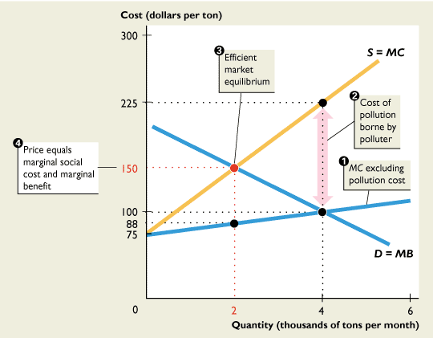
http://wps.aw.com/wps/media/objects/2896/2965631/ppt/ch09slecture.ppt#567,26,9.1

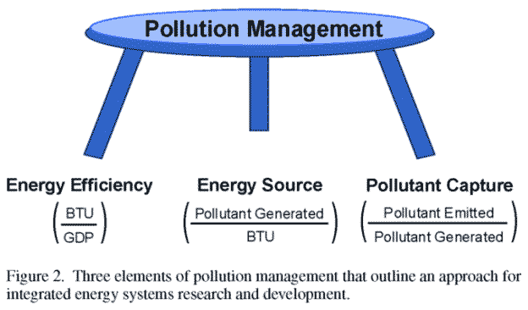
http://www.giss.nasa.gov/meetings/pollution2002/summaryd.html

Bibliography
"Air Pollutants." US EPA- Air and Radiation. 02 May 2007. US EPA. 29 Nov 2007 <http://www.epa.gov/air/airpollutants.html>.
Bade, Robin&Parkin, Michael. "Chapter 9- Externalities." Foundations of Microeconomics- Third Edition. 1995-2008. 18 Nov 2007 <http://wps.aw.com/wps/media/objects/2896/2965631/ppt/ch09slecture.ppt#607,1,Slide 1>.

“Bayer to Spend $1.46 billion On Green Initiatives. ” Environmental Leader. 19 Nov 2007. Green Business and Corporate Sustainability News. 29 Nov 2007. <http://www.environmentalleader.com/2007/11/19/bayer-to-spend-146-billion-on-green-initiatives/>
"Bloomberg Proposes Pollution Tax." Environmental Leader. 06 Nov 2007. Green Business and Corporate Sustainability News. 29 Nov 2007 <http://www.environmentalleader.com/2007/11/06/bloomberg-proposes-pollution-tax/>.
Bortin, Meg. "Poll Finds Strong Support in Europe and U.S. for Polluter Taxes." Health and Science. 23 Feb 2007. International Herald Tribune. 29 Nov 2007 <http://www.iht.com/articles/2007/02/22/news/poll.php#end_main>.
"Climate Change." US EPA- Climate Change. 19 Nov 2007. US EPA. 29 Nov 2007 <http://www.epa.gov/climatechange/>.
"Economics A-Z." The Economist. 2007. 18 Nov 2007 <http://www.economist.com/research/economics/alphabetic.cfm?term=euro>.
"Environmental Impact of Recycling." The City of Gainesville Official Website. 2006. The City of Gainesville . 29 Nov 2007 <http://www.cityofgainesville.org/recycles/busi/env_impact.shtml>.
"Ecological Economics: The Florida Manatee and eco-tourism: Toward a Safe Minimum Standard." Science Direct. 25 Mar 2004. Science Direct. 29 Nov 2007 <http://www.sciencedirect.com/science?_ob=ArticleURL&_udi=B6VDY-4D636YJ-1&_user=650615&_coverDate=09%2F01%2F2004&_rdoc=1&_fmt=&_orig=search&_sort=d&view=c&_acct=C000035118&_version=1&_urlVersion=0&_userid=650615&md5=9b5c43170f68d1a8f0c7426e8e386d42>.
"Effects of Pollution on Ozone Layer." US EPA- Ozone Layer Depletion. 27 Nov 2007. US EPA. 29 Nov 2007 <http://www.epa.gov/ozone/strathome.html>.

"Kyoto Protocol." The Environmental Literacy Council. 16 May 2007. The Environmental Literacy Council. 29 Nov 2007 <http://www.enviroliteracy.org/article.php/278.html>.

"National Transportation Statistics." RITA- Bureau of Transportation Statistics. 2007. U.S. Department of Transportation- Research and Innovative Technology Administration. 29 Nov 2007 <http://www.bts.gov/publications/national_transportation_statistics/#appendix_c>.
"NASA GISS: Air Pollution as a Climate Forcing- Summary D." Air Pollution as a Climate Forcing: A Workshop. 2007. NASA. 29 Nov 2007 <http://www.giss.nasa.gov/meetings/pollution2002/summaryd.html>.

“NY Plan Caps Power Plant Emissions, Auctions Pollution Credits. ” Environmental Leader. 25 Oct 2007. Green Business and Corporate Sustainability News. 29 Nov 2007. <http://www.environmentalleader.com/2007/10/25/ny-plan-caps-power-plant-emissions-auctions-pollution-credits/>
"Pollution Allowance." Infoplease.com. 2007. Infoplease.com. 29 Nov 2007 <http://www.infoplease.com/ce6/sci/A0839553.html>.
"Regulations and Statues." US EPA- Air and Radiation. 05 Mar 2007. US EPA. 29 Nov 2007 <http://www.epa.gov/air/oarregul.html>.
"Solutions to Air Pollution." Infoplease.com. 2007. Infoplease.com. 29 Nov 2007 <http://www.infoplease.com/ce6/sci/A0856527.html>.

"The Kyoto Protocol- A Brief Summary." Environment- Climate Change. 2007. The European Union. 29 Nov 2007 <http://ec.europa.eu/environment/climat/kyoto.htm>.

