Faye Huie

Project 4

Testing structural models

1.) Use the Anderson & Gerbing two step approach to test this model. Begin by testing the measurement model via a saturated structural model.

Saturated Structural Model: Confirmatory Factor Analysis 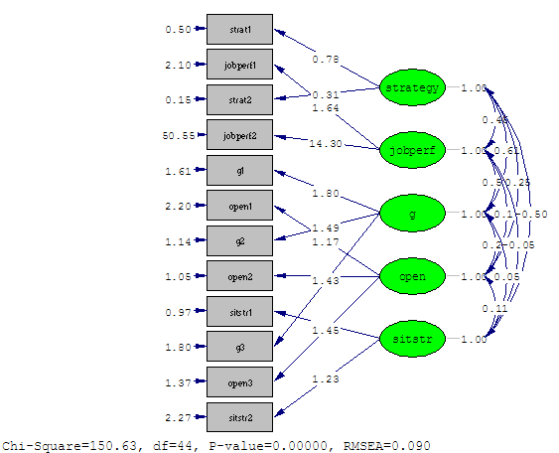

Is fit excellent?

Fit indices:

1) Chi square: 168.60

2) RMSEA: .09

3) NFI: 0.90

4) CFI: 0.92

5) GFI: 0.92

No, the fit is not excellent. Although most of the indices are close to reaching the benchmarks and are relatively acceptable, the fit indices are not indicative of excellent fit. This is troubling because this is the saturated structural model, where all the paths are included. From here, the fit will only get worse when we start removing paths.

No, you say? Correct you are! Now look at the modification indices, particularly the standardized expected change values.

Modification indices: standardized expected change values:

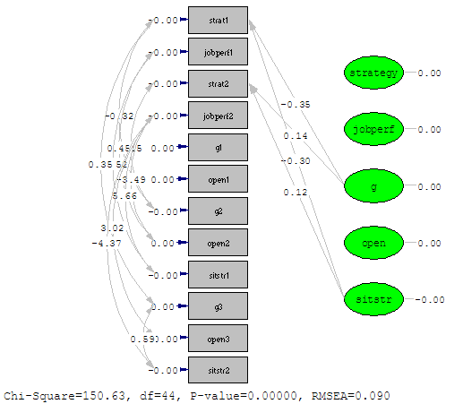

Which items seem to be creating the problem?

From the modification indices, we can see that the items from the strategy development factor are correlating with both general mental ability and situational strength factors.

Suppose that, on the basis of these data, you decided to modify the first Strategy indicator and collect more data. Suppose that the correlation matrix were identical to the original except that the correlation between Strat1 and the two Sitstr variables were -.19 and -.18 respectively.

Now rerun the measurement model.

Modified Saturated Structural Model:

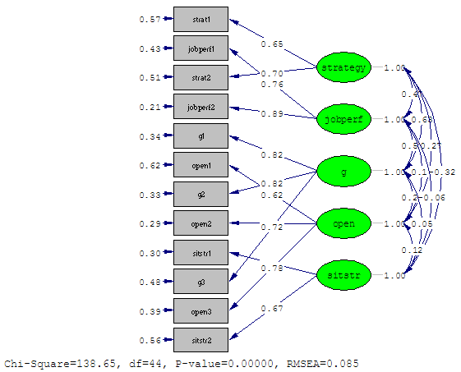

Better?

Yes.

Fit indices: from previous model

1) Chi square: 168.60

2) RMSEA: .09

3) NFI: 0.90

4) CFI: 0.92

5) GFI: 0.92

Fit indices from modified model:

1) Chi square: 138.65

2) RMSEA: .085

3) NFI: 0.90

4) CFI: 0.93

5) GFI: 0.93

Write two paragraphs explaining what you did and why you did it. In other words, write the relevant portion of the Method section (or whichever section you would put this in).

In order to test the hypothesized structural model, a confirmatory factor analysis was first run to examine the soundness of the measurement model. The variables general mental ability, openness to experience, situational strength, strategy development, and job performance were entered into a confirmatory factor analysis. The results overall suggested that the fit was not strong enough to continue on with the structural tests. Specifically, since the fit of a confirmatory factor analysis is as good as the fit can get, the removal of certain paths in the structural model would result in poorer fit. Therefore, the modification indices were examined to identify items that were causing the poor fit.

The modification indices showed that the two items that were indicative of strategy development were crossloading with the general mental ability factor as well as the situational strength factor. Although there are some theoretical reasons for why strategy development may be related to general mental ability and situational strength, they should still be relatively independent measures. Additionally, since the strategy development latent variable was only determined by two observed variables, we were unable to drop any of the items. An examination of the correlations between the observed variables shows that the two situational strength variables were correlating -.38 and -.29 with the first strategy development indicator and -.19 and -.10 with the second strategy development indicator. The differences between the first and second set of correlations seem to be rather high. Therefore, we decided to collect additional data to see if any significant changes occur in terms of the correlations. Indeed, this was the case. The correlations after collecting more data became -.19 and -.18 between the first strategy development variable and the two situational strength variables—which is more similar to the -.19 and -.10 correlations between the second strategy development and situational strength variables.

2.) Once you have settled on a measurement model, test the hypothesized structural model.

Hypothesized structural model:

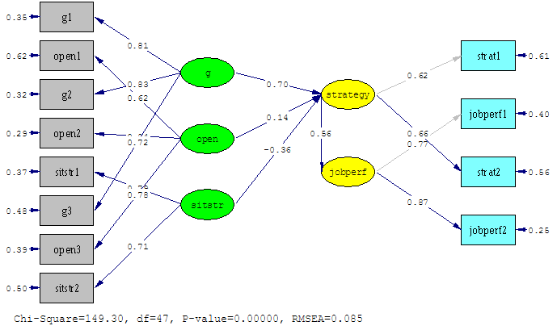

Then, compare it to the saturated structural model.

|  |  |  |  |
| --- | --- | --- | --- |
|  | Hypothesized/  Theoretical Model | Saturated Structural Model | Difference |
| Chi Square | 149.30 | 138.65 | 10.65* |
| Df | 47 | 44 | 3 |

Write a couple of paragraphs interpreting these tests.

The chi square test shows that the saturated structural model is significantly different from the theoretical model. Although this is not what we hoped for, it is not surprising, given the number of paths that we are restricting in the theoretical model and the model fit statistics in the saturated structural model. Specifically, this suggests that the measurement model that was tested earlier no longer holds true in the theoretical model. Following Anderson and Gerbin’s suggestions, we would eventually need to present an unconstrained model as the alternative. Or we can look at the modification indices in the theoretical model to see if there are any paths that makes theoretical sense to free up.

3.) Examine the modification indices for the theoretical model.

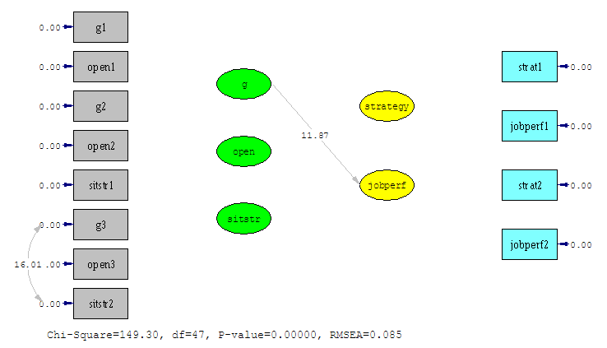

Choose the modification that is most justifiable/ beneficial and perform that modification (there is one that stands out).

The path between general mental ability and job performance should be freed up. Although freeing up the path between the errors of the third mental ability item with the second situational strength item would improve fit more so than freeing up the path between general mental ability and job performance, it is not as theoretically justifiable as the path between general mental ability and job performance.

Unconstrained model: With the path between general mental ability and strategy freed up

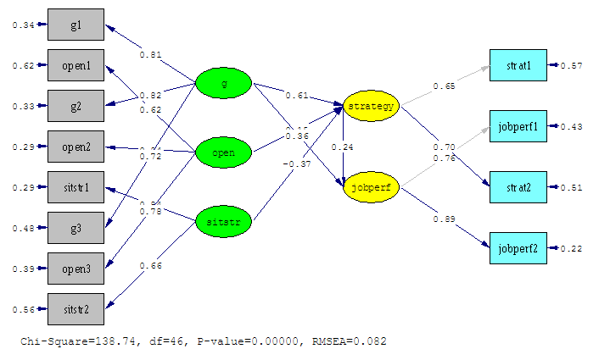

Comment on the difference between this model and the original model as well as the difference between this model and the saturated model. Include the justification for the change.

|  |  |  |  |  |  |
| --- | --- | --- | --- | --- | --- |
|  | Hypothesized/  Theoretical Model | Saturated Structural Model | Unconstrained Model | Differences | |
| T – U | U - S |
| Chi Square | 149.30 | 138.65 | 138.74 | 11.56** | .09: NS |
| Df | 47 | 44 | 46 | 1 | 2 |

The sequential chi square difference tests show that although there is a statistically significant difference between the theoretical and unconstrained models, there is no difference between the unconstrained and saturated model. These results are not what we would have hoped because we want the theoretical model to be just as good as the unconstrained model. However, the results also suggest that we may need to respecify our model and use the unconstrained model as an alternative to align the structural model with the saturated measurement model.

This change is justified because it makes sense that the more mental ability a person has, the higher his/her job performance will be. However, there is no theoretical reason to believe that the errors of observed variables should correlate.

4.) Choose one or two components of the revised model that don’t need to be there (again, there are 2-3 that stand out), remove them, and rerun the model. I removed the path between situational strength and strategy development as well as openness to experience and strategy development.

Constrained Model

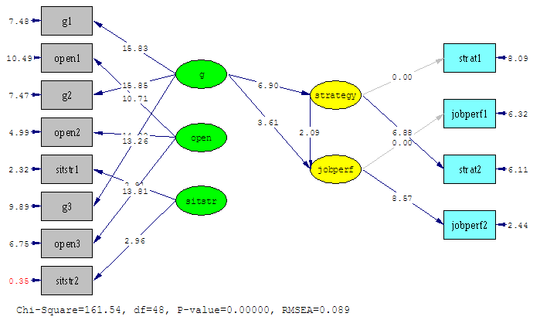

Then compare it to the hypothesized and null models. Offer commentary. Include justification for the change.

Null Model:

Ran the following syntax to set correlations between latent and observed variables to 0:

jobperf1 jobperf2 = jobperf

strat1 strat2 = strategy

g1 g2 g3 = g

open1 open2 open3 = open

sitstr1 sitstr2 = sitstr

set the correlation between strat1 - sitstr2 to 0

set the correlation between strategy - sitstr to 0

The null model was so bad and misspecified that LISREL would not even run the model diagram.

|  |  |  |  |  |  |
| --- | --- | --- | --- | --- | --- |
|  | Null Model | Constrained Model | Hypothesized/  Theoretical Model | Differences | |
| C – T | N – C |
| Chi Square | 407.41 | 161.54 | 149.30 | 12.24** | 245.87** |
| Df | 93 | 48 | 47 | 1 | 45 |

The sequential chi square difference tests show that the theoretical model is significantly different from the constrained model. This is a positive sign because we want evidence to suggest that the paths that were included in the theoretical model are important and that the remove of the paths in the theoretical model would result in worse fit. In this case, the removal of the paths between situational strength and openness to experience to strategy development resulted in a poorer model as indicated by the significant increase in the chi square value. Additionally, the null model is significantly different from the constrained model, which is also a good sign because we hypothesized that there are relationships in the data itself. If the null model was not significantly different from the constrained model, it would indicate that there are no significant relationships to examine within the data.

Overall, the results suggest that although there is evidence to conclude that relationships exist between the different latent variables, the data suggest that the hypothesized theoretical model should be respecified to include general mental ability affects on job performance. Doing so takes into account both the structural and measurement model. Ultimately, the results show that strategy development partially mediates the relationship between general mental ability and job performance (unconstrained model) as opposed to a full mediation (theoretical model).