Analysis of the heterocompound (S)-2-METHYL-1-[(4-METHYL-5-ISOQUINOLINE)SULFONYL]- HOMOPIPERAZINE with its protein Transferase

This is a report on the analysis of the heterocompound (S)-2-METHYL-1-[(4-METHYL-5-ISOQUINOLINE)SULFONYL]- HOMOPIPERAZINE (HET: H52) which is complexed with the protein Transferase (PDB: 1Q8U). The protein transfers phosphate groups to amino acids and the heterocompound acts as an inhibitor to this reaction. This protein is found in all biological cells.

Part III
First I did a calculation of the total steric energies of the heterocompound when complexed with the protein and when energy minimized in the gas phase. These two values are shown and compared in table 1. There are pictures of both shown below in figure 1 and 2. Following that is a comprehensive discussion on each individual steric energy calculations between the two forms on the heterocompound.

Table 1.

Figure 1. On the Left is the hetero compound (S)-2-METHYL-1-[(4-METHYL-5-ISOQUINOLINE)SULFONYL]- HOMOPIPERAZINE when complexed with its protein

Figure 2. On the Right is the hetero compound (S)-2-METHYL-1-[(4-METHYL-5-ISOQUINOLINE)SULFONYL]- HOMOPIPERAZINE when the energy is globally minimized in the gas phase

There is no doubt that there is a difference in steric energy between the hetero compound when it complexed with the protein and when it is energy-minimized in the gas phase. The two total steric hindrances were 79.763 kcal/mole and 25.773 kcal/mol. There is much less steric energy in the 2nd hetero compound versus the compound complexed in the protein. This is to be expected because the protein may have a number of different amino acid groups that can change the interior environment of the protein where much of the hetero compound is located.

The first steric energy described is stretch. The stretch refers to the stretching apart of the bond lengths and the compressing of the bond lengths towards each other. The stretch energy for the complexed hetero compound is 13.0525 and the stretch energy for the minimized compound is 2.3389. There is obviously a difference in energy here. Since the minimized compound has more room to move around it can position its atoms at further distances from each other so that atoms won’t have to try and stretch as much to be next to each other.

The next steric energy calculated is bend. The bend energy refers to the bending of atom angels towards and away from each other. The bend energy for the complexed hetero compound is 40.4574 and the stretch energy for the minimized compound is 9.8829. This steric energy is probably the most significant. This energy is kind of like the stretch except that these are on two atoms that are not directly adjacent with each other. So if they two atoms have more room to move around like in the gas phase then there is less chance of the atoms having to bend to get away from one another.

The next steric energy calculated is stretch-bend. The stretch-bend is basically a combination of both the individual stretch and bend energies. These are basically when there is an atom that bends due to steric hindrance there is also sometimes a stretch involved as well if the atoms repel each other significantly. This is usually between three or more atoms. The stretch-bend energy for the complexed hetero compound is 1.5828 and the stretch energy for the minimized compound is 0.4952. As you can see this energy is not really significant anyways.

The next steric energy calculated is the torsion. The torsion energy is based on the different conformations of the carbons in either the staggered or eclipsed conformations. Eclipsed conformations have larger steric energies than the staggered conformation because of the atoms bumping into each other when eclipsed. In the staggered conformation they sit next to each other and are more stable. The torsion energy for the complexed hetero compound is -1.5914 and the stretch energy for the minimized compound is -2.8709. These numbers are even negative which I do not really understand but they must not be very important to the steric energies since it is so low.

The next steric energy calculated is the Non-1,4 VDW. This stands for Non-1,4 Van der Waals energy. This energy basically takes into effect every atom that is more than two atoms apart and how they interact with each other. The Non-1,4 VDW energy for the complexed hetero compound is 4.5153 and the stretch energy for the minimized compound is -1.1604. This steric energy is not very significant because the energies both conformations are pretty low. This can be expected since after you get four atoms apart there isn’t going to be much steric hindrance between the atoms.

The next steric energy calculated is the 1,4 VDW. This stands for the 1,4 Van der Walls energy. This energy is basically taking into account all atoms that are two atoms apart. So it’s taking into account the first and fourth atoms. The 1,4 VDW energy for the complexed hetero compound is 20.9445 and the stretch energy for the minimized compound is 16.5464. This is one of the more important energies as you can see by the large steric energy it produces. This can be expected since most atoms that are 2 atoms apart from each other tend to interact in many ways.

The last steric energy calculated is the dipole/dipole. The dipole/dipole is basically the measurement of the partial negative and positive charges on particular atoms when interacting with one another. For example I have Oxygen and Sulfur atoms which tend to be electronegative and there for may cause steric energies to increase if they are somehow attracted or repelling from one another. The dipole/dipole energy for the complexed hetero compound is 0.8018 and the stretch energy for the minimized compound is 0.5406. This steric energy is obviously not contributing that much and is probably because the very electronegative atoms are pretty far apart and not directly in close contact with one another.

The steric energies that seems to have contributed the most to the total steric energy are the stretch, bend, and 1,4 VDW. These had the greatest values in both conformations of the hetero compound and also made up the majority of the total steric energies. Even though the energies in the minimized energy conformation was much less than that of the complexed hetero compound it still made up a large portion of the end figures.

Part V
Here I have a number of pictures of the protein in DSVisualizer. It shows a number of different interactions between the heterocompound and the protein residues as well as the primary structure along with a ligplot and wireplot.

This is the wireplot (Figure 3.) for (S)-2-METHYL-1-[(4-METHYL-5-ISOQUINOLINE)SULFONYL]- HOMOPIPERAZINE. This shows the beta pleated sheets in the protein as well as the alpha helixes. It also shows where there is interaction with the heterocompound. This is signified with the red dots and the red rectangles refer to the catalytic residues.

Figure 3.

This is the ligplot (Figure 4) for (S)-2-METHYL-1-[(4-METHYL-5-ISOQUINOLINE)SULFONYL]- HOMOPIPERAZINE. This is basically the heterocompound with it’s interaction with the amino acid residues. The green dotted line represents a hydrogen bond and the red eyelash looking things are different interactions between the amino acid residues and the heterocompound.

Figure 4.

The hetero compound (Figure 5.) (S)-2-METHYL-1-[(4-METHYL-5-ISOQUINOLINE)SULFONYL]-HOMOPIPERAZINE (ball & stick) with Protein. This is the protein show in ribbon form with the beta pleated sheets and alpha helixes all in grey. The heterocompound is in ball and stick and has its atoms color coded within the protein.

Figure 5.
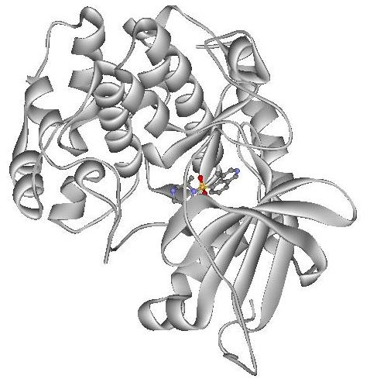

The Heterocompound (Figure 6.) (S)-2-METHYL-1-[(4-METHYL-5-ISOQUINOLINE)SULFONYL]- HOMOPIPERAZINE (ball & stick) with interacting amino acid residues. This is basically like the last picture except the amino acid residues are shown in yellow interacting with the heterocompound.

Figure 6.
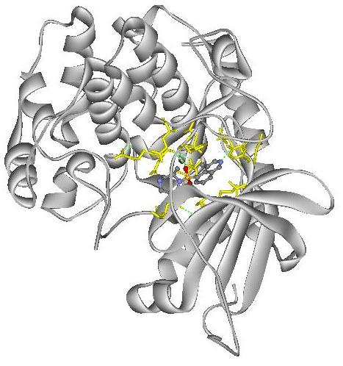

The heterocompound (Figure 7.) (S)-2-METHYL-1-[(4-METHYL-5-ISOQUINOLINE)SULFONYL]- HOMOPIPERAZINE (ball & stick) with interactions between the amino acids. This is a picture of just the amino acid residues that are interacting with the heterocompound. The hydrogen bonds are the green dotted lines.

Figure 7.
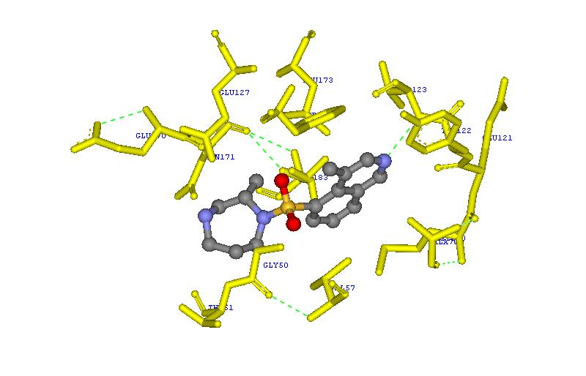

The heterocompound (Figure 8.) (S)-2-METHYL-1-[(4-METHYL-5-ISOQUINOLINE)SULFONYL]- HOMOPIPERAZINE in it’s final rendering with everything. This is the final rendering with the protein and the amino acid residues and even the labels for each amino acid with its three letter code and the number amino it is in the protein sequence in blue.

Figure 8.
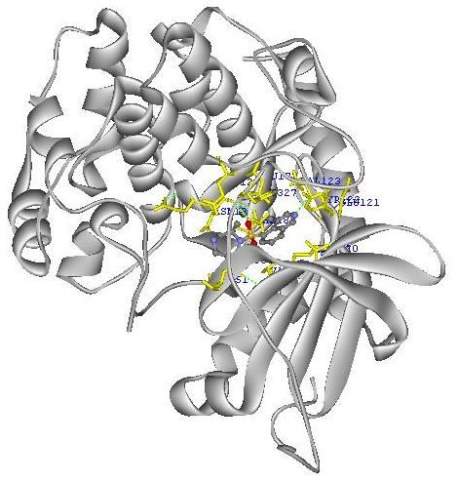

Part VI
Here in Table 2 I have explained all the different interactions between individual amino acid residues and the heterocompound when complexed together.

Table 2.
Amino acid residue | Hetero compound atoms | Nature of interaction
Gly 50 | ? | It should be hydrophobic interaction but the only thing near it is the highly electronegative oxygen atom.
Thr 51 | ? | There should be hydrophobic interactions with the methyl group and hydrogen bonding with the OH group but the residues are facing away from the heterocompound
Val 57 | Aromatic ring | Hydrophobic interaction with the aromatic ring in the heterocompound
Ala 70 | Aromatic ring | Hydrophobic interaction with the aromatic ring in the heterocompound
Met 120 | Aromatic ring | Hydrophobic interaction with the aromatic ring in the heterocompound
Glu121 | ? | The residue is facing in the opposite direction of the heterocompound
Tyr 122 | Aromatic ring | Hydrophobic interaction with the aromatic ring in the heterocompound
Val 123 | Nitrogen in aromatic ring | It is hydrogen bonded to the nitrogen in aromatic ring on the heterocompound.
Glu 127 | Oxygen | May be interaction with the electronegative oxygen but it’s a little far away
Glu 170 | ? | The residue is facing in the opposite direction of the heterocompound
Asn 171 | ? | It is a very polar residue but the only thing near it is a hydrophobic ring and possibly a nitrogen atom
Leu 173 | Aromatic ring | This is a really nonpolar residue and is interacting with either or both aromatic rings
Thr 183 | Aromatic ring | The methyl group is probably interacting with the aromatic ring while the OH group is hydrogen bonded to another amino acid residue
Phe 327 | CH3 group on ring | Hydrophobic interaction with the methyl group on the aromatic ring

Bibliography

The protein data base is where I downloaded the protein file.
H.M. Berman, J. Westbrook, Z. Feng, G. Gilliland, T.N. Bhat, H. Weissig, I.N. Shindyalov, P.E. Bourne: The Protein Data Bank. Nucleic Acids Research, 28 pp. 235-242 (2000).

The protein was first taken from the journal article
Breitenlechner, C., Gassel, M., Hidaka, H., Kinzel,V., Huber,R., Engh,R.A., Bossemeyer,D. PROTEIN KINASE A IN COMPLEX WITH RHO-KINASE-INHIBITORS Y-27632, FASUDIL AND H-1152P: STRUCTURAL BASIS OF SELECTIVITY STRUCTURE v11 pp.1595-1607 , 2003

The Wireplot and Ligplot were taken from
C.Breitenlechner, M.Gassel, H.Hidaka, V.Kinzel, R.Huber, R.A.Engh, D.Bossemeyer. (2003). Protein kinase A in complex with Rho-kinase inhibitors Y-27632, Fasudil, and H-1152P: structural basis of selectivity. Structure, 11, 1595-1607. [PubMed id: 14656443]

The hetero compound was taken from
A. Yamaguchi, K. Iida, N. Matsui, S. Tomoda, K. Yura, M. Go: Het-PDB Navi. : A database for protein-small molecule interactions. J. Biochem (Tokyo), 135, pp.79-84 (2004)

