
Middle Earth

Middle Earth
An online newspaper by and for middle school students

Type of activity structure: Electronic Publishing

Educational Purpose of Project -- learning goals:
- The student will interview, write and edit journalistic articles in differing styles (news, feature, sports, and editorial).
- The student will share and gain information regarding the programs, personality, infrastructure, and human interest aspects of middle schools near and far.
- The student will have a clear purpose to write for publication.
- The student will gain insight into similarities and differences between middle schools around the country (world). Students can then apply information they read to issues in their own school.

Project Organizer: Cynthia Donehoo
cdonehoo@gmu.edu

Curricular Areas addressed by project:
- Language Arts: writing, editing
- Technology: working with electronic publishing software and web based submissions
- Communications: interviewing, information gathering, objective writing

Approximate grade levels: 6-8

Description/summary of the plan:
Middle school students often have lessons that ask them to write a news article. Often this is used as a practice summarization strategy for Language Arts that require students to recognize the 5 W’s. Other times, students are asked to write editorials to practice their persuasive writing. Some middle schools have courses built into their curriculum that teach specifically journalistic writing and concepts.

Some middle schools have newspapers that are printed. Some have electronic versions, and some have both. This project would be a clearinghouse for publication of articles that originate in any of the above situations, in a Language Arts/Journalism class, or from another middle school curriculum source. (For example, a social studies teacher may assign students to write a feature article on the experiences of a relative or acquaintance that was alive during WWII.)

Teachers would register and have log on privileges to upload their student work to the Middle Earth website. This is to give oversight into the content that is uploaded. Students would be responsible for the writing, editing, and page design. Students would use whatever desktop publishing software they have available and would also be responsible for headlines, bylines, and photos/captions if available. The file would then be converted into a PDF and posted on the website. There will be directions on the website for submission guidelines. Articles would stay on the website for a pre-determined time length and then be deleted by the site administrator. The administrator reserves the right to keep articles up longer if desired and also to delete articles at any time.

The site would have information for submission pertaining to both the design and technical requirements. There would be a Frequently Asked Question section for repeated inquiries as well as a forum that allows participants to post a question of a specific nature. The forum questions can then be answered by the administrator, or one of the educator/student participants.
See Website Plan diagram below.

Plan for managing project:
Directions for joining project:
In the Introduction of the project on the home page, teachers will be directed to the Educator page where they will be able to register for submission privileges. This page will also give educators guidelines of appropriate content and encourage them to be the only ones who post. If they give their log-on and password to someone else, they will still be held responsible for the content posted under their name.

Timeline for project:
This site is ongoing. Educators should post articles that have at least some shelf life and interest for a couple weeks. As articles continue to be submitted, older ones will be archived in chronological order according to their submission date.

Procedures for participation:
Once an educator is registered, he/she can then choose work to post on the web newspaper following stated design and technology guidelines. Articles must be edited for correct grammar and facts. Articles should be designed in an electronic publishing software program. If one is not available, the site will contain instructions on how to design in Microsoft Word in order to make headlines, bylines and columns of text. If the site designer is able to create it, there could even be a template where educators simply copy and paste their text and/or photo elements and then compose a headline.
Educators are responsible for knowing if students have permission to have their name/image published on the web with any liability resting with the registered teacher and school system.

Description of student work that the project will generate:
Website will contain news articles, feature articles, sports articles, editorials, and photos created by middle school students. Educators will be given guidelines for submission of articles. Articles should appeal to a wide audience of middle school students. For example, don’t simply submit an article about how your football team won Friday night. Try to look for more universal themes.

Description of project end/project results:
This project is ongoing. Articles will be posted for a time and then rotated out for new articles to appear. Older articles will be archived.
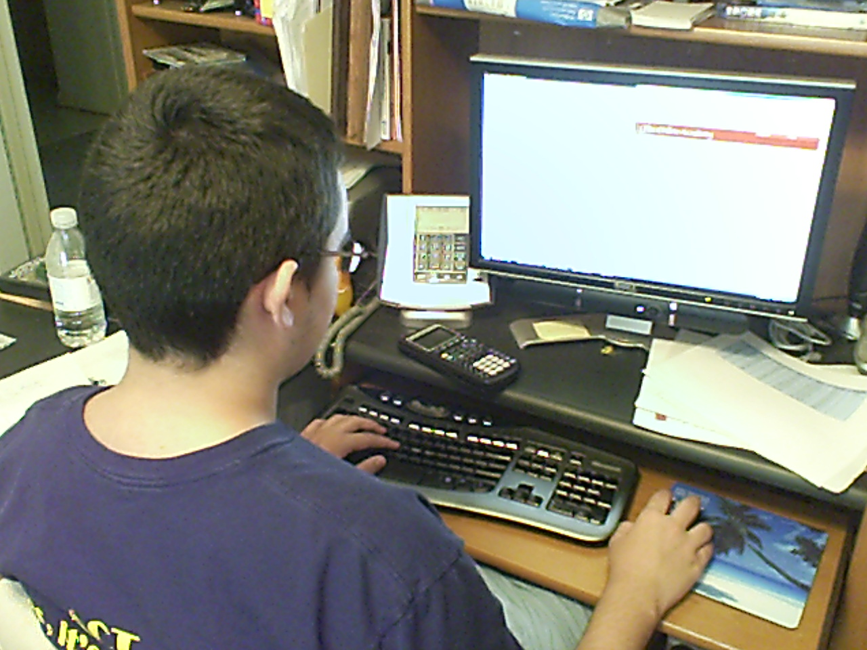
Website Plan
Middle Earth

Archive:

Articles that have been published on the site and now are listed chronologically according to date of publication on site.
Middle school online newspaper debuts
Middle Earth, an online newspaper for middle school students is also made by middle school students. Offered online, the newspaper allows students to write articles and editorials about their school and then upload them to the website.
Students who have submitted articles to the online site say they are excited to see their work published.
“It gives me a sense that my writing in class really means something,” said Sid Student, an 8th grader at George Mason Middle School. “I really feel I am participating in the community of professional learning when I participate in something like this.”
One of the participating teachers, Emilia Educator of Norton/Sprague Academy, said she was especially thrilled with the situated learning that was part of the website.
“It’s like they are learning what they live and living what they learn,” said Educator.
The designer of the newspaper web site, Cynthia Donehoo, said the site is a place for students to feel the work they do in class is really worth something. She also
wants students to learn from one another as they read what is going on in each other’s schools.
“I want students to know that the issues they face in their school are not isolated to them alone. They can see how other middle schoolers are solving problems or cele-
brating spirit days. As such they are learning to collaborate which is a excellent skill.”
Currently over 200 schools from 38 different states and 3 countries contribute to Middle Earth online newspaper. Donehoo hopes to see that number grow to all 50 states and many more countries.
By Suzie Student
Hathaway Middle School
Sam Student works on an editorial regarding dress code.
Photo by: Sarah Student
Example of Newspaper Page
Home Page

Introduction

Summary

Link to Middle Earth electronic newspaper

Log in for educators
Forum:

Place that teachers and students can post questions/comments about articles they read.
Design resources

Format guidelines for article submission

Tech guidelines for article submission

FAQ for page design

Educator Page

Information about site and how to participate

Registration for log-in

Middle Earth electronic Newspaper page(s):

News articles
Feature articles
Sports articles
Editorials
As content grows, this page would be subdivided into a page for each category

