Computer-Based Graphics Tools
Definitions, Benefits, and Limitations of Graphics Programs
 Print Graphics: Programs that allow users to create banners, posters, signs, certificates, simple letterheads, and greeting cards.

:images are created by formulas and they can be enlarged, reduced, or moved-impossible to erase part of an object

:composed of pixels, users can free-form their objects as opposed to being constricted with a formula, have to cover or erase objects

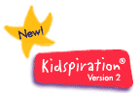Idea Processors: help brainstorm thoughts and diagram information, good for graphic organizers

Animation: allows the user to simulate motion by displaying a sequence of images in rapid succession

Common Tools Found in Graphics Programs

Shared Functions across most graphics programs:
- Text tool, line tool, shape tools, free-hand tools, eye-dropper, paintbrush, magic wand, pencil, spray can & eraser

 File Formats

Proprietary Formats
Examples: PICT & PCX

Benefits and Limitations:
You can’t work with these in another computer system but they are created to accomplish specific tasks on their computer platform.
Web-Based Formats
Benefits and Limitations of .jpg:
Reduces the file size through compression, are higher quality, and the format used for web graphics.
Benefits and Limitations of .gif:
Transfers bitmapped graphics through telecommunications.

Tools for Obtaining Graphics
Defining Importing and Exporting:
Importing ~ bringing an image into a document
Exporting ~ taken from a file and saved separately

Benefits and Limitations of –

Clip Art: saves time, royalty free, offers many images BUT stifles creativity and often have to modify idea to fit the art

Web-Based Graphics: save time, availability BUT copyrighted

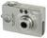 Digital Cameras: put pictures in digital format, manipulate, get exact image you want BUT availability and permission could be an issue

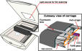 Scanners: capture image, put into bitmapped format and manipulate BUT need specific hardware

Composition

Definition: kinds of decisions the artist makes concerning placement of objects on the drawing surface

Associated Concepts: alternatives to the center of the paper for placing the main subject, strategies for placing the secondary center of interest, understanding foreground-midground-background, tricks for creating effects

Basic Rules:
- Place the subject into one of four quadrants
- Use the ¼ - ¾ ratio
- Divide into thirds and put subject on one of the lines

 Perspective

Definition: ability to create illusion of depth in three dimensions on a two dimensional surface

Associated Concepts: use geometry to determine perspective

Eight Techniques:
- Foreshortening – create illusion that one edge is closer
- Shading – adding darkness to a surface to add depth to an image
- Surface – drawing objects lower on the paper to make them appear closer
- Size – objects drawn larger look closer
- Contour lines – lines connecting two points on a surface
- Overlapping – objects in front of others make the front objects look closer
- Density – darker images appear closer than lighter images
- Shadows – cast off the object from the shaded side

 The Basic Elements of Graphics

Definition: adding visual and kinesthetic representations of reality to linguistic and print representations

Associated Concepts:
- Support students’ efforts to create and alter images and can serve as a unique medium for artistic expression
- Different artistic medium

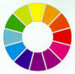 Color and Texture

Definition: representation of an emotional response in shades of warm & cool

Associated Concepts:
- Colors are selected from a palette-you don’t have to mix them
- You can use color to provide texture

Rules to Know about Color Use:
- Colors are either warm or cool – using both creates contrast
- Each color has a complementary color
- An object’s shadow is created in its complementary color

The Language of Visual Representation
Techniques and Tools

Five Purposes of Graphic Representation

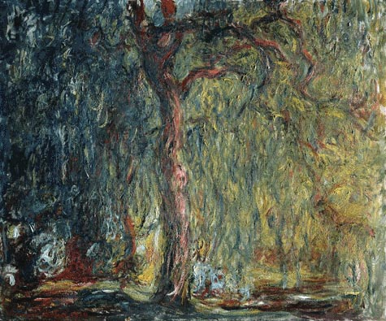
This is an example of a __decorative______ graphic because . . .

One instructional idea for using __ decorative__ graphics to support learning is to add visual appeal to student work and develop a sense of pride and professionalism.

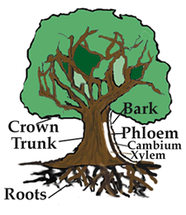
This is an example of a __representational__ graphic because it visually explains a concept .

One instructional idea for using representational _ graphics to support learning is to use the image to summarize central ideas.

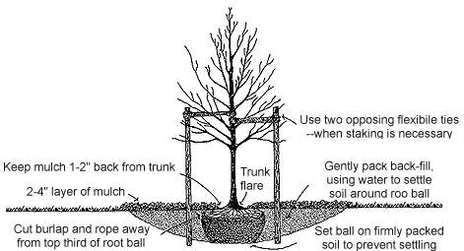
Note: It would be a good idea to look at this is 200% in order to read the words.

This is an example of a _organizational_ graphic because it focuses on one aspect of information.

One instructional idea for using organizational _ graphics to support learning is to use concept mapping.

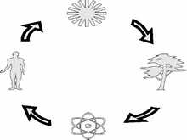
This is an example of a _explanational_ graphic because it’s a visual outline of this process.

One instructional idea for using _ explanational_ graphics to support learning is demonstrating how a bill becomes a law.

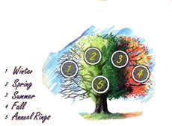
This is an example of a __transformational_ graphic because it illustrates a changing process.

One instructional idea for using _ transformational_ graphics to support learning is to illustrate moon phases.

