Web version available at http://mason.gmu.edu/~ameyer3/hist615f02/halttunen.html
Karen Halttunen. Confidence Men and Painted Women: A Study of Middle-Class Culture in America, 1830-1870. New Haven: Yale University Press, 1982. Pp.262; 14 illus.

Introduction
Karen Halttunen's Confidence Men and Painted Women: A Study of Middle-class Culture in America, 1830-1870, suggests a different set of questions to ask in our quest to understand middle-class culture. Her questions move us beyond the observation of American sentimental culture as hypocritical so that we may gain an understanding of why nineteenth century Americans found hypocrisy in society so problematic, how, according to advice manuals of the time, they proposed to solve the problem of hypocrisy, and what effect the failure of their solution had on society.
The work provides an interesting perspective on a driving force of nineteenth century culture; it explains the conditions which make the confidence man—a figure that had existed a century earlier without much notice by society—a figure of such preoccupation and fear. The conditions, reactions, and outcomes are placed into a context which show the impact of a grand historical meta-narrative on everyday aspects of life such as fashion, etiquette, and social ritual.

Overview
A brief overview of the structure of the meta-narrative in Halttunen's discussion will help orient us as we move through Confidence Men and Painted Women. Two strands feed into sentimental culture's preoccupation with hypocrisy. One strand derives from a national identity crisis generated by the rise of large urban centers, in which people could no longer know others in the community as well as people in small towns could know the members of their community. There was a need for a “code” to distinguish who these strangers were. The other strand has its origins in the eighteenth century republican ideology, which considered virtue as a necessary requisite for the preservation of the American republican experiment. The confidence man embodied the hypocrisy and corrupting influences that might lead young Americans away from the virtues necessary for the success of the American nation.
The preoccupation with hypocrisy lead to the formation of social forms and rituals intended to allow members of the middle-class to distinguish who in their community was sincere. The social forms and rituals were then followed as custom rather than an expression of sincerity, which heightened the preoccupation with hypocrisy, and lead to development of new social forms and rituals. Eventually this cycle broke when the preoccupation with sincerity faded away and only the empty social forms and rituals remained.
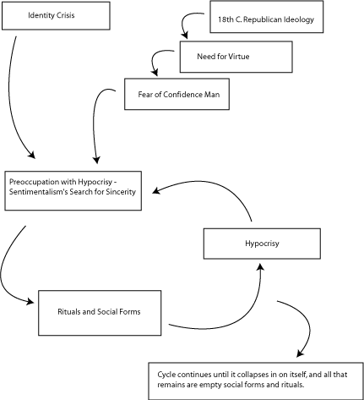
Social Conditions
Halttunen begins laying the context for her argument by describing the confidence man and painted women that figure in Benjamin Franklin's Autobiography; the confidence man was not a new figure that appeared in nineteenth century culture. However, social reaction to the confidence man in the nineteenth century was marked by an anxiety about the potential threat he posed to members of society.
A number of individuals wrote advice manuals, intended primarily for the young men who left the small towns in which they grew up to go to the big city. These advice manuals provide an insight into the identity crisis in America as society was in the process of transforming from a rural society with a relatively fixed social structure to an urban society with a fluid, liminal quality. The national identity and the individual identity were both in question. Those advice writers who felt that there had been a golden era in social relations from which society had declined, warned of the threat of such a decline to the American republican experiment.
As a mechanism for protection from confidence men—those who pretended to be what they were not in an effort to advance themselves at the expense of others—middle-class society felt a need to create means of distinguishing confidence men from the rest of society.
In an interesting contradiction, while they were busy defending themselves from the deceptions perpetrated by confidence men, many of these middle-class Americans were immersed in their own deceptions, geared toward their advancement in society.

Reactions
One reaction to the social conditions was the development of two separate codes of conduct, one to survive out in the world of strangers, in which opacity of character was required to avoid being at a disadvantage in the midst of confidence men, and another for interacting with family and trusted friends, in which transparency of character was highly prized as a mark of sincerity. (p. 54-55) With this dual code of conduct, women acted as the arbiters of sentimental conduct, and the parlor became the central focus of its practice.
Individuals strove to demonstrate an internal moral character through outer manifest signs; codes of dress, behavior, and social ritual ensured the sentimental culture a uniform understanding of these signs. These codes changed in response to a need to re-establish sincerity that arose once it became ambiguous whether they were practiced out of sentiment or convention.
Outcomes
The inherent contradiction embodied in sentimental culture led to the vicious cycle of preoccupation over hypocrisy, codified behavior, and de facto hypocrisy. By the 1850s the unsustainable cycle collapsed, and the concern about sincerity that characterized sentimental culture melted away, leaving empty social forms and customs behind, which were then accepted by society as “a theatrical performance of gentility.” (p. 196)
Another outcome of the elaborate codes set out in various types of advice manuals was “an unconscious strategy for middle-class Americans to distinguish themselves as a class while still denying the class structure of their society.” (p.195)

Commentary
Confidence Men and Painted Women provides us with a way to make sense of the sentimental culture of the nineteenth century, as well as the resulting consequences. Halttunen includes detailed, rich descriptions of the culture in her study, leading us to a better understanding of the period. Going a step beyond, Halttunen explicitly links the social history to a broadly-framed meta-narrative of traditional history, demonstrating that it is possible to integrate the two successfully.
Perhaps due to the many threads that Halttunen weaves together, the work can be somewhat confusing, at least until the reader looks closer to see the interplay of small and large patterns.
As an example of confusion on the way to understanding, read my initial attempt to write a review in traditional paper form. I eventually became so frustrated in my attempts to make sense out of the paper that I gave up, and started over with this web-based review. While much has been left out of this discussion, it can, I hope, serve as a roadmap for understanding the work.
--Allison Meyer

