IT 101-001
Homework #4 Due October 25

- Calculate the size of a 35 minute movie in terms of gigabytes with 128x128 pixels per frame, 9 bits per pixel shown at a frame rate of 48 frames per second
a. 494 GB
b. 1.73 GB
c. 30 GB

2. If the frequency of the pure tone is 10 kHz, what is its period:
a. 10 sec
b. 0.0001 sec
c. 0.2 sec
d. 0.001 sec

3. The value of standard sampling frequency used to digitize speech for digital telephony is:

- 4 kHz
- 8 kHz
- 3000 Hz

4. The standard sampling rate of an analog audio signal in preparation for audio CD is 44,100 Hz (or 44,100 samples per second). What is the highest theoretical frequency in Hz of the recorded analog audio signal?

- 10 kHz
- 22,050 Hz
- 4410 Hz

5. On the slide number 12, lecture 8, plot of the spectrum shows that the last important frequency component occurs around 4,100 Hz..
If we will use 5 kHz to sample the signal, how do we call the distortion effect?

- multiplexing
- aliasing
- oversampling

6. If we would like to quantize the signal below, by using 4 bits, how big will be each quantization level (interval)?
a. 1 V
b. 0.25V
c. 4 V

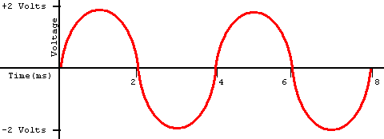

7. Second generation of cellular phone systems, GSM used the following type of multiplexing many telephone conversations:

- TDMA
- FDMA
- WCDMA
- All of the above

8. Base stations are connected to the MTSO:
a. True
b. False

9. Which of the following is a frequency band in radio spectrum:
a. HF
b. VHF
c. LF
d. All of the above

10. MEO satellites complete one revolution around the earth in 24 hours:
a. True
b. False

