IT 101-001
Homework #3

1. How much storage is needed (in kilo bytes (KB)) for a black and white photo with 128x128 pixels if the photo has
64 gray levels?

a.128 KB
b.12 KB

2. How many rows of pixels are needed to form a line so that a human viewer can distinguish the presence of the line?
a. 4
b. 2
c. 1

3. What do the following acronyms stand for MPEG:

a. Mega Pixel Expanded Graphics
b. Motion Pictures Experts Group

4. Assign a code table for events A, B, C, D, E, and F for the following Huffman code tree:

.7 .3

.2 .1

p(Event A) = .4 p(Event B) = .3 p(Event C) = .1 p(Event D) = .1 p(Event E) = .05 p(Event F) = .05

a. A 11 B 10 C 110 D 111 E 010 F 111
b. A 00 B 01 C 100 D101 E 110 F 111

5. Spatial resolution is related to the number of pixels in an image:

a. True
b. False

6. Brightness resolution is related to the number of bits for each shade of gray:

a. True
b. False

7. How much storage (in B) is needed to store a color image with 128x128 pixels, if 16 shades are
needed to represent each: red, green and blue?

a. 24,576 B
b. 2.4 B

8. How long will it take (in minutes) to transmit the image from question 7over a 56 kbit/sec modem?

a. 0.058 minutes
b. 3.5 min

9. What is an equivalent to RGB color system?

a. Hue, luminance and saturation
b. Chrominance and hue

10. For the plot below determine the value of the period, frequency and amplitude

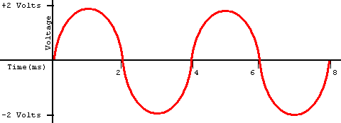

a. 4 msec, 500 Hz, 4 V
b.4 msec, 250 Hz, 2 V

