CHEMISTRY 315

IR, MS, UV SPECTROSCOPY

PROBLEM SET

All Sections

CHEMISTRY 315
IR, MS, UV SPECTROSCOPY PROBLEM SET

Consult the Lab Manual, the textbooks by Solomons and by Pavia, et al., and the following discussion to help you with the analyses.
In the Lab Manual section, Spectroscopy I, there is a section titled "Using On-line Databases to Help Solve Organic Chemistry Spectroscopy Problems". You should review it so you can use on-line sources to help you analyze some of the problem spectra and as a source for literature spectra. The GMU Organic Chemistry web page (http://mason.gmu.edu/~sslayden/Lab/index.html) has links to the databases. You really will find this material easier to master if you take the logical approach outlined in the manual and in Pavia.
If you are unfamiliar with a compound's name, look it up on-line, or in the textbook, Merck, CRC, or Aldrich catalog. The Lab Manual has a list of reference sources in the section "Finding and Citing Information for the Laboratory".

Part I: Answer the questions in the space provided on the page.

1. a) For each of the compounds below, first write a structural formula and then indicate which of them is likely to absorb in the UV region. Briefly explain your reasoning.

A. cyclohexanol

B. 2,4-hexadienal

C. 2-methyl-5-vinylpyridine

b) An unknown oxygen-containing compound is suspected of being an alcohol, a ketone, or a carboxylic acid. Its IR spectrum shows both a broad strong peak at 3100-3400 cm⁻¹ and a sharp strong peak at 1700 cm⁻¹. What kind of compound is it? Explain what you would see in the spectra of the two compounds that you did not choose that allows you to differentiate these three classes of compounds.
c) Specific compounds are named in the boxes below and the functional group part of the name is in boldface. For each boldface functional group, draw an expanded structural formula.

Indicate the approximate wavenumbers of the IR absorption peaks that could be used to distinguish between the members of each of the pairs of compounds in a row. Mention at least one distinguishing absorption peak for each compound in the pair that is absent in the spectrum of the other compound (except for the compound in the lower right box).

Example:

acetonitrile and methylamine

–C≡N –NH₂ (primary amine)

Nitriles have a CN triple bond stretch at ~2250 cm⁻¹; sharp
Primary amines have an NH stretch around 3500-3300 cm⁻¹ that appears as two bands (the CN single bond stretch at 1350-1000 cm⁻¹ is weak and difficult to distinguish).

A. | 1-propanol | methyl ethyl ether
B. | 1-pentyne | 1,3-pentadiene
C. | pentanal | 2-pentanone

2. Shown on the next page are the IR spectra of the four isomeric butyl chlorides. The spectra are clearly different, as are their structures. Focus on two of the absorption regions in the spectra: ~1380 cm⁻¹ and ~525 cm⁻¹. Notice the variability in intensity and appearance of the peaks in those two regions for the isomers. Mark these regions on the spectra on the next page.

a) For the two IR spectra below, specify in the white space on the spectra, whether they contain an n-butyl, sec-butyl, isobutyl, or tert-butyl group. Circle the peaks that justify your choices using the spectra on the next page for comparison. Remember to compare the two important absorption regions specified above.

b) Which of these two spectra is of an aromatic compound? Mark the peaks that justify your choice. Put all your answers on this page.

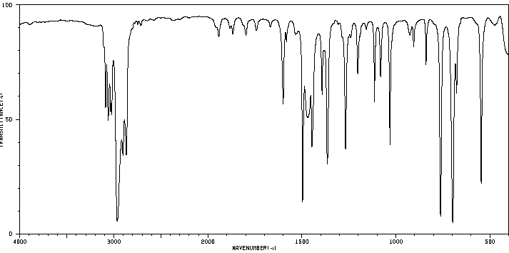
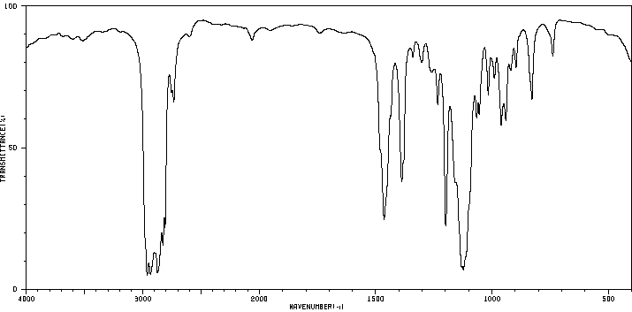
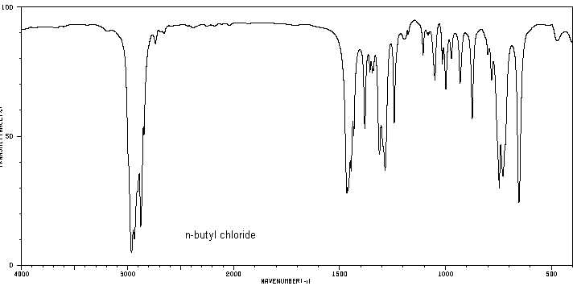
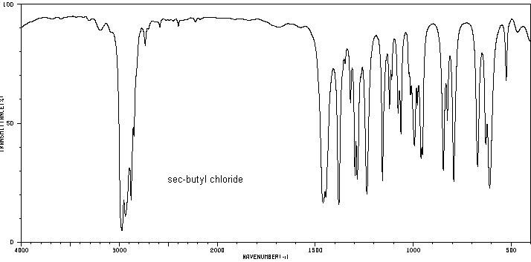
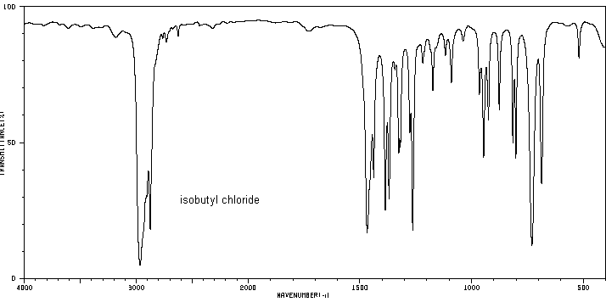
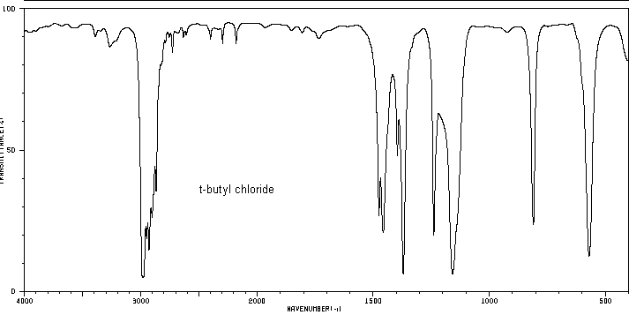
3. Go to the NIST web site (http://webbook.nist.gov/chemistry/) and find the mass spectrum for 2-bromobutane.

To print the mass spectrum, scroll down and click on “View image of digitized spectrum (can be printed in landscape orientation)”.
Change the page orientation to “Landscape” in the File | Print…| Properties window. If you get an error message, reload the page and try to print again.

Calculate the molecular weight of 2-bromobutane to guide you where to look for the highest mass peaks. Remember, the mass spectrum itself will show only the integral mass, not the molecular weight, which is an average of all the atomic isotopes present in the sample.

Before you leave the website, make sure you write on the printed copy the mass numbers of the peaks of highest M/z (they may be very small) and several other peaks. It is easier to see them on the monitor screen than on a black and white printout.

a) On the printed spectrum of 2-bromobutane, indicate the two isotopic molecular ion peaks and their M/z ratios (refer back to the discussion in the lab manual on MS).

b) On the printed spectrum of 2-bromobutane, indicate the M/z for the peak of greatest intensity. What fragmentation of the 2-bromobutane accounts for its presence? Draw the structure of the charged fragment.

Attach the printouts to your other answers from Part I.

Part II: Each Combined Spectra Problem on the following pages contains some combination of this information: IR spectrum, mass spectrum or molecular ion peak, major UV peak, element % mass. On each spectrum, neatly label the major absorption peaks with the structural fragment that causes the absorption. On the answer sheet that follows each problem, fill in the requested information so that you assemble all the structural information that can be obtained from the spectra. Then, using this information, propose the structure and identity of the compound. A logical analysis of the data to support the identification should be written in the "Combined Analysis" section. You can confirm the identity from literature or on-line sources. A completed example is given.

Example Spectra Problem – The spectra here have been marked to indicate major absorptions. Other answers are entered on the next page.

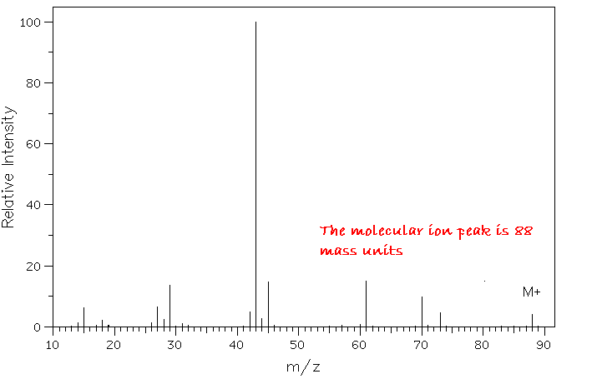

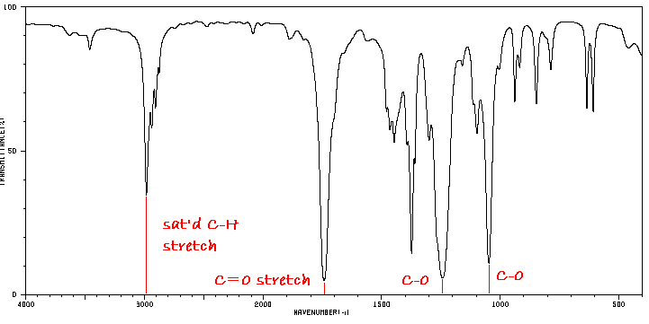

Answer to Example Problem
Mass Spectrum Analysis:
The integral molecular weight of the unknown is 88. Because this is an even number, the compound has either no nitrogen atoms or an even number of N atoms. The highest m/z peaks do not show evidence of the presence of atoms such as Cl or Br (which would have two peaks in 75:25 and 50:50 ratios, respectively).

Elemental Analysis:
None was given.

UV-visible Analysis:
No information was given.

IR Analysis:
The absorption at 3000 cm^{–1} (and not to the left) shows only aliphatic (saturated) C–H groups. The carbonyl, C=O, absorbs strongly at 1740 cm^{–1}. The two intense peaks between 1000-1300 cm^{–1} indicate the carbonyl belongs to the ester group. The C=O absorption is within the range for an ester group.

Combined Analysis:

The IR shows the only functional group present is an ester. There is no aromaticity or other unsaturation in the molecule (except for the C=O). The ester group accounts for 44 amu of the 88 integral mass. The remaining mass (88-44= 44) belongs to one or more hydrocarbon groups. The basic structure must be R–(CO₂)–R' where R could be a hydrogen bonded to the C of the ester (but R' cannot be H, since the functional group would be a carboxylic acid, not an ester).

Since the hydrocarbon group(s) must be saturated, there must be 3 carbons (36 amu) and 8 hydrogens (8 amu) = 44 amu. The molecular formula is thus C₃H₈O₂. If R=H, then R'= isopropyl or n-propyl. The two remaining possibilities are for R and R' to be methyl and ethyl (or vice versa). [Note: A more detailed analysis of the fingerprint region would show this is not either of the propyl formates. A more detailed analysis of the fragmentation in the mass spectrum would also eliminate these.]

Entering the molecular formula into the search page of an on-line spectroscopy database, and comparing the known spectra with the unknown's spectra matches only one of the possibilities.

Unknown Identity: Synonym:
Thus, the unknown is identified as ethyl acetate acetic acid, ethyl ester

Molecular Formula: Structure:
C₃H₈O₂ 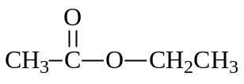

1.
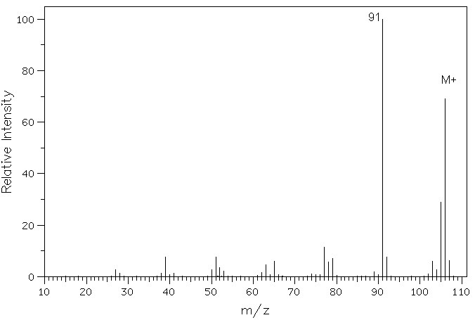

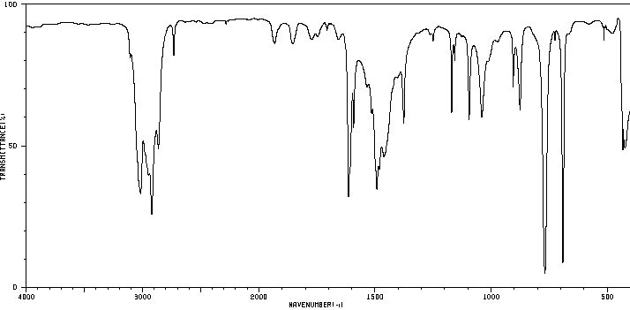
Answer to Problem 1
Mass Spectrum Analysis:

Elemental Analysis:

UV-visible Analysis:

IR Analysis:

Combined Analysis:

Unknown Identity: Synonym:

Molecular Formula: Structure:

2. UV: λ_{max} 205 nm, log e = 2.2 %C 49.3; %H 9.7

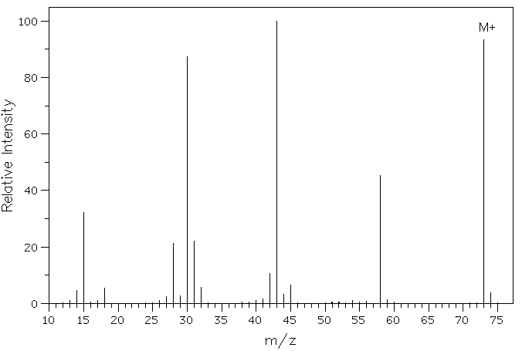

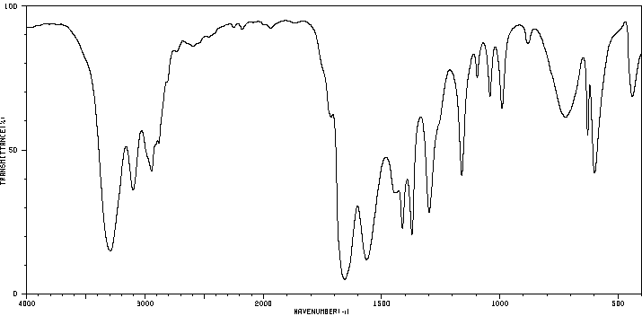
Answer to Problem 2
Mass Spectrum Analysis:

Elemental Analysis:

UV-visible Analysis:

IR Analysis:

Combined Analysis:

Unknown Identity: Synonym:

Molecular Formula: Structure:
3. UV: λ_{max} 280 nm, log e = 1.3

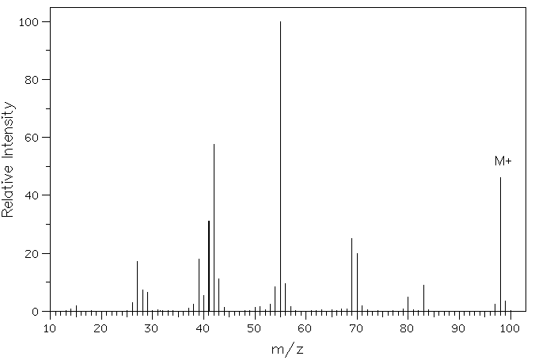

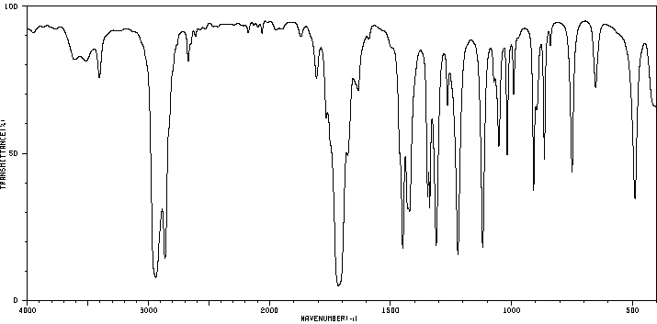
Answer to Problem 3
Mass Spectrum Analysis:

Elemental Analysis:

UV-visible Analysis:

IR Analysis:

Combined Analysis:

Unknown Identity: Synonym:

Molecular Formula: Structure:

4. UV: λ_{max} 217 nm, log e = 3.8 %C 84.8; %H 7.1

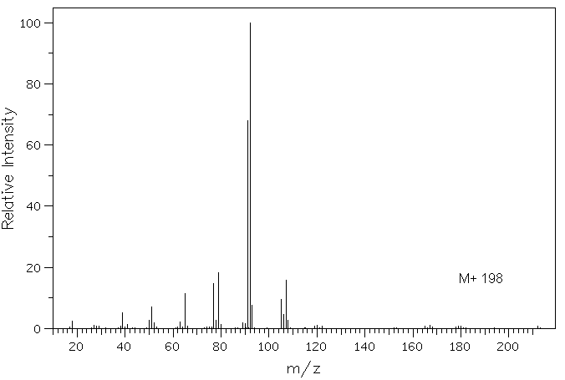

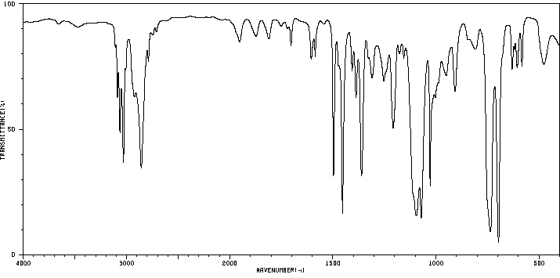

Answer to Problem 4
Mass Spectrum Analysis:

Elemental Analysis:

UV-visible Analysis:

IR Analysis:

Combined Analysis:

Unknown Identity: Synonym:

Molecular Formula: Structure:

5. UV: λ_{max} 208 nm, log e = 1.5 %C 33.2; %H 4.6

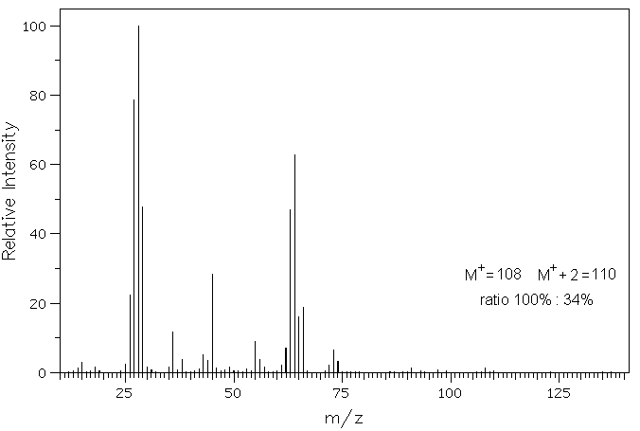

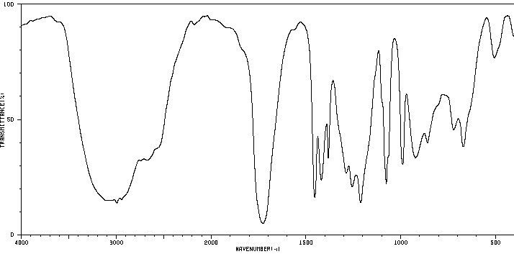

Answer to Problem 5
Mass Spectrum Analysis:

Elemental Analysis:

UV-visible Analysis:

IR Analysis:

Combined Analysis:

Unknown Identity: Synonym:

Molecular Formula: Structure:

