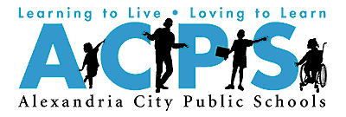
Examples of Helpful Technology
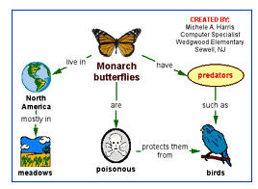
Kidspiration & Inspiration help students organize ideas and make them easier to remember.
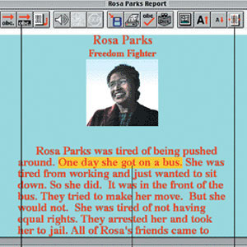

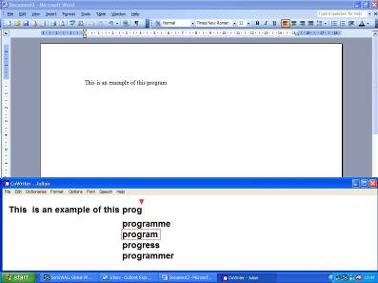

Co:Writer helps students spell words they know but are unable to spell.
Write:Outloud reads what students write. When they hear the words, they can make better corrections.
For Questions or Concerns about Assistive Technology
Speak with your child’s:
- Speech Therapist
- Occupational Therapist
- Case manager
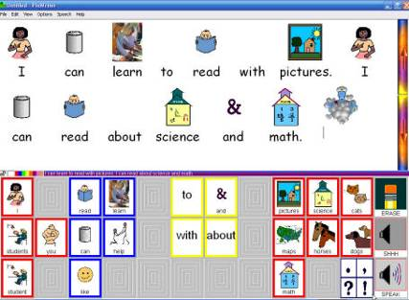
Or contact the
ACAT Team
Division of Student Services
2000 N. Beauregard Street
Suite 203
Alexandria, VA 22311

ACAT Team Office is located at George Washington Middle School Room D-107
Susan Kenney
acat@acps.k12.va.us
Phone: (703) 706-4500 ext. 2627

Division of Student Services
Augmentative Communication & Assistive Technology ACAT Team
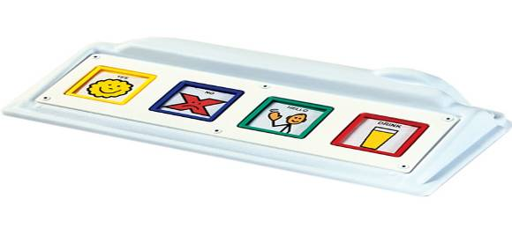
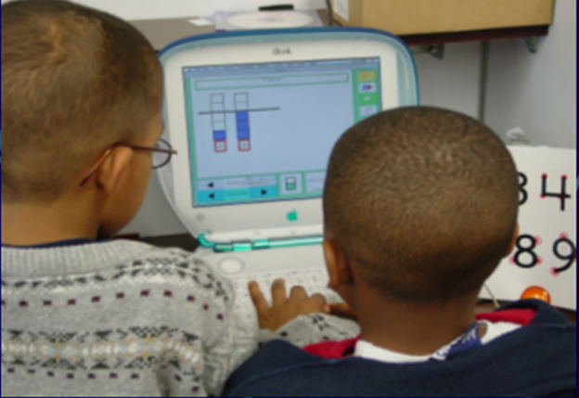
Information for Parents
Assistive Technology

A device, product, and/or service required for a person with a disability to do a task that would otherwise not be possible

Assistive Technology Device
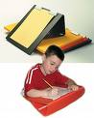
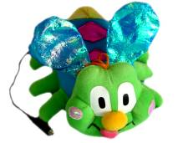
“Any item, piece of equipment or product system, whether acquired commercially off the shelf, modified, or customized, that is used to increase, maintain, or improve functional capabilities of individuals with a disability” (Tech Act, 1998) -- may be as simple as a pencil grip, or as complicated as an adaptive computer system.

Assistive Technology Service
Any service that directly helps a child with a disability in choosing, getting, or using an assistive technology device
Assistive Technology Services Include:
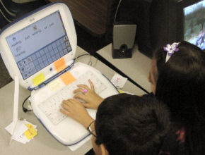
- Working with a student’s team to generate solutions
- Screening to determine the needs of a student with a disability
- Identifying appropriate assistive technology devices
- Maintaining assistive devices in good working order
- Training students to use required technology
- Training the family of a student and professionals who work with a student with a disability

  - Conducts needs assessments
  - Makes suggestions which may help students write, speak, listen, read, and study in school
  - Finds assistive technology that students with disabilities need to reach educational goals
  - Trains students, teachers, staff, parents
Refer for an
Assistive Technology Screening*
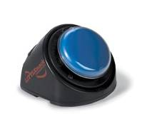
When the needs of a student with a disability have not been met with current strategies and accommodations
When the speech/language skills of a student with a disability are not developed enough to be able to let others know his/her needs and ideas
When a student’s disability makes it difficult to use regular school tools and materials
* A student with a current IEP or 504 Plan whose disability appears to prevent successful participation in classroom learning activities is a candidate for Assistive Technology.

