
ACAT
Team Assistive Technology Process
__________________
Case Manager Roles and Responsibilities:
- Schedule planning meeting to identify student needs
- Invite ACAT Team member
- Identify and implement a trial of building resources including existing technologies
- Collect data
- Meet to review data collected – after designated time
- Complete ACAT Referral Packet Forms - if needed
- Continue with data collection
ACAT:
- Conduct student observation and screening
- Recommend solutions
- Select and install equipment
- Develop Implementation Plan
- Conduct student/teacher training and collect data
- Monitor student progress
  - Conducts needs assessment
  - Recommends interventions which may assist students in educational settings with physical access, written production, and/or spoken language
  - Aids in determining, developing, and/or securing, the assistive technology devices and services required for special education students to achieve educational goals
  - Educates and trains students, teachers, staff, parents
ACAT Team
Division of Student Services
2000 N. Beauregard Street
Suite 203
Alexandria, VA 22311

ACAT Team Office is located at George Washington Middle School Room D-107
Susan Kenney
acat@acps.k12.va.us
Phone: (703) 706-4500 ext. 2627
7/30/26

Division of Student Services
Augmentative Communication & Assistive Technology ACAT Team
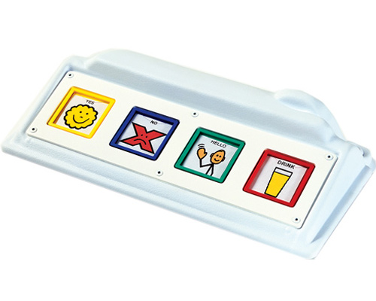
Information for Teachers
Assistive Technology

Refers to any device, product, and/or service required for a person with a disability to accomplish a task that would otherwise not be possible.

Assistive Technology Device


“Any item, piece of equipment or product system, whether acquired commercially ‘off the shelf,’ modified, or customized, that is used to increase, maintain, or improve functional capabilities of individuals with a disability” ** It may be as simple as a pencil grip, or as complex as an adaptive computer system.

Assistive Technology Service

“Any service that directly assists a” child “with a disability in the selection, acquisition, or use of an Assistive Technology device.” ** ** (Tech Act, 1998)
Assistive Technology Services Include:
- Collaborating with a planning team including therapists to generate solutions
- Screening to determine the needs of a student with a disability
- Planning/Facilitating the acquisition of assistive technology devices

- Selecting, designing, fitting, adapting, applying, maintaining, repairing or facilitating replacement of assistive technology devices
- Integrating assistive technology services with existing interventions and/or services
- Training or technical assistance for a student (family) with a disability
- Training or technical assistance for professionals or other individuals who provide services to a student with a disability
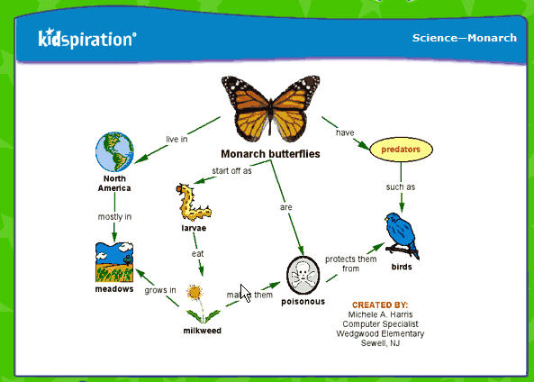
Refer for an Assistive Technology Screening *

When the needs of a student with a disability have not been met with modifications and/or building resources (for example: low tech solutions, free online resources, ReadPlease, Word accessibility options, Co:Writer, Start to Finish Books, Write:Outloud, Kurzweil Kidspiration/Inspiration, Draft:Builder,)
When the speech/language skills of a student with a disability are insufficient to meet his/her communication needs
When a physical disability is impeding the educational potential of a student with a disability
When conventional learning materials and equipment cannot meet the needs of a student with a disability
* A student with a current IEP or 504 Plan whose disability appears to prevent successful participation in classroom learning activities is a candidate for Assistive Technology.

