Hw 2 : 2.6(b), 2.11 (f), 2.12 (b), 2.15 (c), 2.17 (a) (3rd ed)

Hw 2: 3.9(b), 3.12(f), 3.13(b), 3.16(c), 3.17 (a) (2nd ed)

Hw 3: 2.10, 2.14(d) ,  2.23(b), 2.24(c), 2.33, 2.37 (a), 2.38 (b)  (3rd ed)

Hw 3: 3.11, 3.15 (d), 3.4 (b), 3.5 (c), 3.19, 3.25(a), 3.26(b) (2nd ed)

3.4 b (2nd ed)

2.23 b (3rd ed)

Roots are -5 and -5

Steady part is 3

There are 2 exponential terms for the transient part

3.5 c (2nd ed)

2.24 c (3rd ed)

Complex roots with positive real part. UNSTABLE

3.9 b (2nd ed)

2.6 b (3rd ed)



3.11

a)

x(0+)= 5/3

x(infty)=0

b) x(0+)= 0

x(infty)=0

3.12 f



3.13 b



3.15d

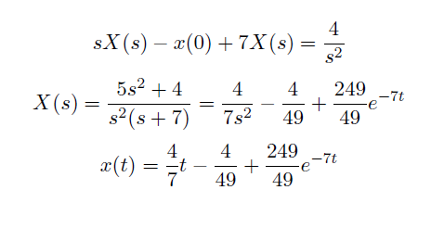

3.16 c



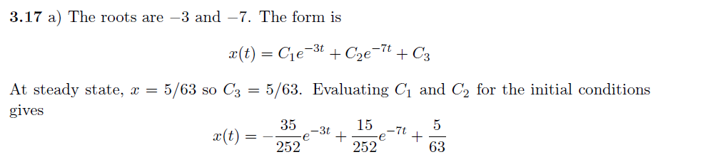

3.19



3.25 (a)





x(0+) is not equal to x(0)

3.25 (c)

x(0+) = x(0) = 2

.

Initial Value Th not valid for x(0+)

3.26 b



x(0+) =25/7

.

Initial Value Th not valid for x(0+)