Astronomy 112 Laboratory Manual Table of Contents

Solar System Walk 3
Walk the Solar System Answer Sheet 6
Pre-lab for Farquhar Globe 8
Modeling the sky with the Farquhar Globe 10
Farquhar Globe Answer Sheet 14
Retrograde Motion pre-lab exercise. 19
Exploring retrograde motion with Starry Night 22
Retrograde motion answer sheet 24
Kepler’s Laws pre-lab exercise 26
Methods of science and Kepler’s laws of planetary motion 28
Answer sheet for Methods of Science and Kepler’s Laws 35
Moons of Jupiter Pre-Lab Exercise: 38
The Revolution of the Moons of Jupiter 39
Jupiter’s Moons Answer sheet 44
Investigation of the motion of a celestial object pre-lab 47
Investigation of the Motion of a Celestial Object 49
Investigation of the Motion of Celestial Object Answer sheet 53
Exploring the nature of light 56
Nature of Light answer sheet 63
Infrared Radiation Pre-lab 66
Investigation of Infrared Radiation 67
Investigation of Infrared answer sheet: 71
Geological processes Pre-lab exercise 72
Geological processes: volcanism, wind erosion, water erosion, tectonics and cratering 73
Group member rating form 78
Geology of Mars Pre-lab exercise 79
Group member rating form 88
MATHEMATICS TOOL KIT 89
INTRODUCTION: 90
EXPONENTS and SCIENTIFIC NOTATION 90
LOGARITHMS 92
Working with logs 93
Converting logs to numbers 93
RATIOS 95
UNITS OF MEASURE 96
GRAPHING 98
PROBLEM SOLVING TECHNIQUES 98
Error Calculations: 99
Introduction to Celestial Coordinate systems 100
Latitude and longitude: 100
Right ascension and declination: 100
Altitude and azimuth: 101
Graphing with Excel 102

Solar System Walk

Learning Goals: Students will develop a scale model of the solar system in order to practice with scaling and ratios, review scientific notation and units of measure and angular size. By laying out the scale model students will get a sense of the relative sizes and distances for the planets in the solar system.

Materials: small metric rulers, balloons collection of small objects, peppercorns, coins, small round pebbles of a variety of sizes, marbles, salt or sugar grains, note cards, wooden stakes or skewers, transparent tape, digital camera or cell phone camera, table of planetary data.

Tools for learning:
See the math guide for help with scientific notation, ratios, and simple algebra.

Introduction: You have seen scale models of one kind or another. Model airplanes and cars, floor plans for buildings, and maps are examples. An intriguing model in astronomy is a scaled model of the solar system to give people a feel for the relative size and distances of the planets.

In today’s lab you will scale the distances from the Sun to the planets so that the whole scale model will fit in a space you chose on campus. Once you know the length of the path where you plan to put your model, you will need to develop a scaling factor. Since the maximum space you have to work with will also be the distance between the Sun and Neptune, use those two distances to make a ratio which will then be the scaling factor for all the other distances and diameters.

Be sure to check that you are using the same units in the ratio above when you develop the scaling factor. Since a very long stride is approximately a meter, it is best to convert units to meters. You may use a calculator or a spread sheet to do your calculations. On your answer sheet record sample calculations for the distance and diameter of Earth in your model so that your instructor can check to see that you are doing the math correctly.

An excellent resource for getting an estimate of distances on campus is at the following website http://wikimapia.org/. While you are deciding about a place to set up your model, think about whether the place you have selected will have a clear line of sight from the Sun to Neptune and points in between. Once you select a place and a scaling factor, record your choice and your reasons for the choice on the answer sheet.
The table of planetary data gives diameter of each of the planets and their distance from the Sun. Use that data to complete the data table on the answer sheet. You will need to scale the distance from the Sun for each planet in order to know where to put the marker for the planet on your scale model.

Once the distances are determined, you will also need to scale the diameter of each planet to find a suitable object to represent it in your scale model.

Keep track of the process you go through as you do the scaling exercise, including any “missteps”. For example you may discover your scaling factor is incorrect and will have to choose a new factor. Perhaps your model won’t fit in the designated area after all. Again, recalculate and document what you have done. It is important as well to record what decisions you have made and why you made them. One of the goals of this class is for you to learn to evaluate your results and analyze your own thought processes as you practice doing science investigations.

When your table is complete, have your instructor check it, then chose the objects you want to represent the Sun and planets, attach them to index cards and attach the cards to the small stakes to place in the ground.

You will need to know how to determine where to place the objects. One possibility - measure the length of a long step for someone in your group and have that person pace out the distances. Perfect accuracy is not necessary; the goal here is to get a sense of relative size, so the most important thing is consistency.

Take the stakes with the planet cards and go to your selected site. Pace off the appropriate distances and put a stake where it will not damage plantings or structures. Note carefully where you put each of the solar system objects.

If you have a camera phone take picture at points along the walk.

When you reach each planet look back at your Sun and use a ruler or another object held at arm’s length to measure the apparent angular diameter of the Sun at that distance. Record these measurements as well.

When you have completed the walk go back and pick up the objects and return them to the lab. Please remove the objects and sticks from the cards and put them back neatly for others to use.

Conclusion: What does this exercise teach you about the sizes and distances of planets? What was the most surprising thing you noticed as you set up the planets? If you were creating a permanent feature on campus what would you do differently? Do you think that a permanent feature is a good idea? Why or why not?

Material to be turned in at the end of the Lab:

Group:
- Walk the solar system answer sheet
- Completed table of diameters and distances.

Individual:

- Thinking skills survey answer sheet.
- Answer to Conclusion question

Walk the Solar System Answer Sheet

Group members ___________________________________________________________________________________________________________________________________________________________________________________________________________________________________________________________________________________________________________________________

On a separate piece of paper record notes about the process – what worked, what didn’t, what did you have to repeat or correct? What was difficult or confusing? How did you sort it all out?

Location for model:

Reasons for your choice:

Explain how you determined the dimensions of the site where you to placed your model.

Show how you determined the scaling factor and show a sample calculationsfor the distance of Earth from the Sun and the Earth’s diameter here.

Scaling factor ____________________________________________

Object | Diameter in kilometers | Distance from the Sun in kilometers | Scaled diameter | Scaled distance from Sun | Scaled distance from preceding object | Position of object in model (give a landmark or where you placed the marker) | Apparent size of Sun from this position (in cm)
Sun
Mercury
Venus
Earth
Moon
Mars
Jupiter
Saturn
Uranus
Neptune

Approximately where would Pluto be in your model?

Conclusion: What does this exercise teach you about the sizes and distances of planets? What was the most surprising thing you noticed as you set up the planets? If you were creating a permanent feature on campus what would you do differently? Do you think that a permanent feature is a good idea? Why or why not?

Pre-lab for Farquhar Globe

Before the celestial sphere lab you need to be familiar with the various coordinate systems that may be used to help find objects in the night sky as well as other terms that are used in the lab. Look up the following words and turn them in at the start of class. You can consult your book and reliable web sites as well as the Celestial coordinates help in this module. Bring the completed answer sheet to class with you for the Farquhar Globe lab.

altitude

azimuth

ecliptic

latitude

longitude

right ascension

declination

stellar magnitude

horizon

sunset

sunrise

Modeling the sky with the Farquhar Globe

Learning Goals: Learn to use a model to visualize motions in the sky and understand relative apparent positions of Sun and stars. Evaluate the usefulness of the model.

Equipment: Farquhar globes

Learning tools: Introduction to Celestial Coordinate systems

Pre-lab Exercise: Pre-lab for the Farquhar Globe

Introduction:
The Farquhar Globe is a model with an Earth globe at the center, a surrounding clear globe representing the stars, and a small yellow ball on a movable arm to represent the sun. It is a three dimensional geocentric model with the Earth at the center and stars of varying distance from the Earth projected onto the surrounding plastic celestial sphere. The Farquhar Globe is a model that allows you to rotate the Earth, holding the Sun and stars still, or to hold the Earth still and move the Sun and globe of stars around it.

Ancient astronomers developed the geocentric model to explain the apparent motion of the Sun, moon, planets and stars in the sky. For the most part this picture of the solar system worked very well. If the Earth is at the center of a giant sphere with stars fixed on the outer part with Sun, Moon and planets moving on the inner part of the sphere, the motion of the sphere can be used to predict the relative position of stars and other objects. We cannot tell from just looking how far away individual stars are, nor can we tell that they are different distances relative to each other, so having visible stars displayed as if they are all the same distance from Earth corresponds to what we perceive.

Until the development of the atomic clock in the late 1960’s, monitoring the positions of the stars on the celestial sphere was the most accurate means of timekeeping. The positions of the stars, Sun and other objects on the celestial sphere were important in navigation and the U.S. Naval Observatory still provides information about the motion of celestial bodies for the Navy as well as the general public. (http://www.usno.navy.mil/mission.shtml.

Although the classroom model you are using today cannot provide precise measurements, it will help you visualize what the sky looks like from a particular location and how the constellations and position of the Sun with respect to the horizon change during the year.

Some definitions:

Ecliptic: The ecliptic, the path the Sun appears to follow through the stars over the course of a year, is marked on the clear plastic celestial sphere with dates so that the Sun can be positioned for a particular time of the year.

Horizon ring: Some of the globes in the lab have a metal ring circling the celestial sphere, parallel to the table top. This is the horizon ring, showing the apparent dividing line between sky and earth from the point of view of the location at the part of the globe currently facing the ceiling.

Meridian ring: the meridian ring is perpendicular to the horizon ring and marks where celestial objects will be highest in the sky as the sky appears to rotate overhead. The Sun, for example, reaches the meridian at its highest point for the day at local noon.

Motion of the globes: The central Earth globe is mounted on a rod that is attached to a knob at the bottom of the globe. You can move the Earth globe by turning the knob to simulate the rotation of the Earth. The rod goes through the axis of rotation of earth. The rod goes through the north and south celestial poles. Be careful to turn the Earth knob clockwise only since turning it in the opposite direction might disassemble the globe.

From the point of view of what we on Earth observe about the motion of the Sun and stars, rotating the Earth while holding the outer globe of stars still is equivalent to rotating the stars and Sun in the opposite direction while holding the Earth still. It should be apparent that, with only a few exceptions, before precision instruments the two models are equally good at predicting motion and position.

Your Observations:
Begin by examining the model in detail. List features that are marked and named on each of the following parts of the model as outlined on the answer sheet. It may be helpful to include sketches of various parts of the sphere as well.

Some things to look for in the model:
Earth globe
Celestial globe
Horizon ring
Meridian ring
Base of globe

Note that the constellations are displayed as they are seen from Earth. You need to look through the globe and past the Earth to the stars on the far side of the clear outer sphere to see the constellations as we do from Earth, not “backwards”. The inner globe is the Earth with lines of latitude and longitude marked. A small yellow ball on a long curved rod represents the Sun, not to scale of course. The path the ball takes as you turn the knob attached to the rod holding it is called the ecliptic.

You should have noticed a variety of types of labeling on the spheres, rings and base of the model. Three different coordinate systems are important to know to understand positions on the globes and in the real night sky. On your answer sheet record which coordinate systems are used on which part of the globe.

Practice with the sphere:

To get practice using the celestial sphere model, answer the questions on the answer sheet for this lab. As you work think about what the model is able to show as well as what it cannot show.

Setting the Globe for a Specific Geographic Location and Time:
To set the globe for a particular place, that place must be “up”; a line dropped from the ceiling through the globe to the table top would go through the location.
To set the model for a time you must locate the sun on the proper date along the ecliptic, then rotate the celestial sphere and Sun together to get the proper time (for example, if the Sun is aligned with the meridian it is noon, if it is just below the horizon ring it is sunset, etc.)

Example: To set the globe for “noon” at Washington, D.C.

Latitude: 39º N Longitude: 77º W

Rotate the celestial globe and the Earth globe until our location is "on top" (i.e. Washington, D.C. should face the ceiling.) Degrees are marked on the meridian ring. The mark indicating 39º should be positioned at the zenith.

Note: No matter where you are on the surface of the Earth, you can consider yourself as being "on top;" the point directly overhead will be the zenith.

The directions North, South, East and West are indicated on the base (i.e. the stand) of the celestial sphere.

Position the Sun at today’s date.

Set the globe for 12:00 noon by holding the Earth-knob fixed and rotating the sky until the Sun is on your meridian.

Before proceeding, have your instructor check that your globe is set correctly. Once you are sure it is correct you may begin answering questions on the answer sheet.
Go to the Farquhar Globe answer sheet and complete it as a group. Then answer the following conclusion question to turn in individually.

Conclusion: Evaluate the model you have been using today. What parts of reality does it model successfully? What are possible uses for a model like the Farquhar globe? In what ways is it inadequate?

Turn in:

Group:
- Observations and sketches of Farquhar Globe model
- Farquhar Globe answer sheet
Individual:
- Pre-lab exercise sheet
- Conclusion question

Farquhar Globe Answer Sheet

Observations: Write down your observations of the celestial sphere in this space. At a minimum take a careful look at the parts of the globe listed and include sketches with labels. You may use another sheet of paper if necessary.

Earth globe, Celestial globe, Horizon ring, Meridian ring, Base of globe

Where on the globe do you find the following markings?

Right ascension

Declination

Latitude

Longitude

Altitude

Azimuth

Practice with sphere:
Stars on the sphere are represented by small circles of various sizes. The larger the circle, the brighter the star.

What is the name of the brightest star in the constellation of Cygnus?

What is the name of the brightest star in the constellation of Lyra?

Complete the table below.

Star Name | Constellation Name | R.A. | Dec.
Arcturus
Sirius
Altair
Pollux
Procyon
Rigel

Set the Globe for Washington D.C. for today’s date at noon:

Which constellation is closest to the zenith at noon?

What is the Sun's altitude at noon?

What direction would you face in order to see the Sun at noon?

Rotate the celestial sphere and Sun while holding the Earth knob still to find how many hours after noon sunset occurs. (Give your answer to the nearest ½ hour)

What is the Sun's altitude now (i.e. at sunset)?

What direction would you face to watch sunset today?

At what longitude is it now noon?

List two stars and that are just rising at sunset today.

Star name | Constellation | Right Ascension | Declination | Altitude | Azimuth

Now rotate the sky to 3 hours past sunset and record the altitudes and azimuths of the stars you listed above? Have the right ascension and declination changed?

Star name | Constellation | Right Ascension | Declination | Altitude | Azimuth

What constellation is closest to being at the zenith at midnight on today’s date?

Exercise 1

It is noon on the 20th of May. You and a group of friends are sailing around the world. On this particular day you decide just for fun to use a sextant to measure the altitude of the Sun and compare it to your known location. The Sun is to the south and you measure its altitude to be 75  What is your latitude? Explain how you figured this out.

Exercise 2:

You are on the same sailboat as in Exercise 1, but it is now July 5th and it is late at night. You have just been through a storm and all of your maps except a very good star chart have been washed overboard. You have no power and your GPS unit no longer works. However, being brilliant and resourceful and having taken astronomy at GMU, you realize that all is not lost! You look for the bright star Vega in the constellation of Lyra and find that it is at your zenith. A chronometer (i.e. an accurate clock) on board indicates that it is noon in Greenwich, England.

A.) What body of water are you in?

B.) What are your latitude and longitude?

Exercise 3:
Make sure the globe is set for today’s date and Washington, D.C. at noon. Make a prediction for December 1st of this year. Where will the Sun be at noon on that day, higher or lower in the sky? When will it set compared to the setting time for today? One way of measuring the height of the Sun in the sky is to use a vertical pole and measure the length of the shadow at noon. Describe how you would expect the shadow to change if you were to measure it every few days between now and Dec. 1st. Explain your reasoning using the globe.

Retrograde Motion pre-lab exercise.

Read the following material and answer the questions at the end of the reading.

Planets whose orbits lie outside the orbit of the Earth are called superior planets. These include the three naked-eye planets of Mars, Jupiter, and Saturn, and the two telescopic planets of Uranus, and Neptune.

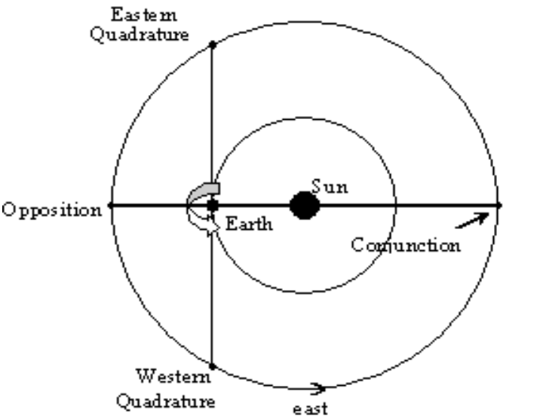
Figure 6.1: The Four Planetary Configurations of a Superior Planet

When a superior planet is on the opposite side of the Earth with respect to the Sun, it is said to be in opposition. At that time, the planet is also as close to the Earth as it will come, and as bright in the night sky as it will appear, until the time of the next opposition approaches. When a planet is in opposition it is visible throughout the night because it rises at sunset.

From Kepler’s Third Law we know that a superior planet moves more slowly around its orbit than the Earth, so as time passes after opposition the Earth moves away on an “inner track” leaving the superior planet behind. As a result, the planet appears to move from opposition to eastern quadrature, the point that is 90º east of the Sun with respect to the Earth-Sun line, an imaginary line joining the Earth to the Sun. At eastern quadrature the planet will rise at noon and will appear as an “evening star” in the night sky.

As the Earth and the superior planet continue around their orbits, the superior planet will appear to get closer and closer to the Sun. In actuality it is still just moving around its orbit at about the same distance from the Sun as it was at opposition, but to us from our perspective on Earth, it appears much nearer the Sun as time goes on after it reaches eastern quadrature.

When the planet appears to rise and set with the Sun, and perhaps is invisible behind it from our point of view, it has reached conjunction and is at its farthest point from Earth. It is aligned with the Earth and the Sun, as it was in opposition, but now it will be positioned on the other side of the Sun from Earth. Here the planet will rise and set in “conjunction” with the Sun.

After conjunction a superior planet passes through to western quadrature, a point in its orbit that is 90º west of the Earth-Sun line. When the planet is in this configuration, it will rise at midnight and will appear in the sky as a “morning star.” Finally, the superior planet will return to opposition, its cycle of configurations complete.

The planets orbit the Sun in a counterclockwise direction, as viewed from a point above the solar system. Why is it that a superior planet will proceed to eastern quadrature, and not western quadrature, following opposition?

Retrograde Motion
As the orbital velocity of the Earth is greater than that of a superior planet, the Earth will overtake and pass a superior planet at some point during their respective orbits. This will occur as the planet's configuration is changing from western quadrature through opposition to eastern quadrature. (From eastern quadrature through conjunction to western quadrature, the planet exhibits its normal eastward motion relative to the background stars.) During this period of passing, the superior planet will appear to temporarily interrupt its normal eastward motion, known as direct motion, and move westward. This counter-motion is known as retrograde motion, during which time the superior planet will appear to trace either a closed loop or a figure-S against the background stars. The planet will appear to slow as the period of retrograde is coming to a close. It will then resume its usual eastward path in the sky.

It may help to think about an example from everyday experience. Picture yourself riding in a car. You are about to overtake a slower-moving vehicle and you can observe this car relative to the distant horizon ahead of you. At first the other car appears to be moving forward relative to the horizon, but as you begin to pass, the car appears to slow to a stop. As you pass this car it then appears to be moving backward, despite the fact that it is moving forward.. Once you are well past the car, it again appears to be moving forward, relative to the horizon behind you.

The motion from when the planet appears to slow, then stop its motion Eastward with respect to the background stars, begins to move Westward instead, until it reverses yet again and moves in the “normal” Eastward direction is called retrograde motion.

Retrograde motion Pre-lab questions to turn in:

The planets orbit the Sun in a counterclockwise direction, as viewed from a point above the solar system. Why is it that a superior planet will proceed to eastern quadrature, and not western quadrature, following opposition?

What time of day or night would you have to look to see Saturn when it is in opposition?

When would Mars appear to be largest in the sky, near conjunction or near opposition?

Would you expect opposition for a superior planet to occur every year, more than once a year, less than once a year? Explain.

Exploring retrograde motion with Starry Night

Learning Goals: Students will practice making predictions then checking the predictions against a model and actual observations. Students will use planetarium software to explore retrograde motion and how it is explained in the heliocentric model of the solar system

Materials: Starry Night professional on student computers, printer

Tools for Learning: Starry Night Notes.

Pre-lab activity: Retrograde motion pre-lab exercise

Introduction: One of the most difficult things to explain with a geocentric model of the solar system is retrograde motion of Mars, Jupiter and Saturn, something that can be seen by any careful observer, even without a telescope. While retrograde motion alone did not lead to acceptance of the heliocentric model, the explanation of the motion becomes much simpler. From the readings in your textbook you know that the Copernican heliocentric model form the base for current understanding of motion in the solar system. The Copernican system was modified by Kepler, and the physical reasons behind it were supplied by Newton. Even a model accepted in its main outlines is modified as new information must be taken into account. A good model explains more than one thing. While both the heliocentric and geocentric models had a way of explaining retrograde motion, the heliocentric model is much simpler and, in the long run, more accurate for prediction motion. However, because a model is simpler and powerful doesn’t mean it is easy to visualize or understand.

Today’s lab should give you a clearer picture of what retrograde motion looks like, and how to predict it. Because the planetarium software can “speed up time” and enable you to see over the space of hours or less what happens in the sky over months or years, you should be able to look at retrograde motion for Mars and ate least one other planet during today’s lab.

From your pre-lab reading, think about the conditions necessary for retrograde motion, then make a prediction about how often retrograde motion of Mars should be seen.
Answer the following questions on your answer sheet.

Q. 1 Make predictions based on the following two questions and explain what data you used to make them.

How far apparent are successive retrograde periods for Mars? (approximately)
When will the next date of opposition for Mars occur?

Your Obserations:

Part 1: Use the Starry Night program to look for Mars during the month of September 2008. Record the date, the time, the right ascention and declination of Mars, and how it appears to be changing position from day to day. Print out a star chart for September and mark the position of Mars on the chart. Then continue marking the position as you make observations over the month. Is Mars in direct or retrograde motion? Does it appear to change direction during this time period?

Part 2: With a new star chart repeat the investigation for December 2007.

Q.2 How would you modify the predictions in Question 1 based on what you have seen using Starry Night?

Continuing investigation:

Develop a procedure for using Starry Night to find the next opposition of Mars and carry through the investigation, completing the questions on the answer sheet.

Turn in:
Individual:
- Retrograde Motion pre-lab
- Retrograde Motion answer sheet
- Star charts with Mars’ position marked for August and September
- Print-outs documenting your observation, and annotated to show start and end dates fir retrorgrade motion
- Print-out documenting retrograde motion of a second planet and annotated just as you did for Mars.
Group:
No group assignment today

Retrograde motion answer sheet

Q. 1 How much time passes between successive retrograde periods for Mars will be? Explain.

When will the next date of opposition for Mars occur? Explain.

Preliminary observations:

Observation Part 1: Record what you saw for the motion of Mars during September 2008 on the September star chart. Mark the path of Mars as you saw it for September.

Observation Part 2: Record what you saw for the motion of Mars during December 2007 on the December star chart. Mark the path of Mars as you saw it for December 2007.

Q.2 How will you modify the predictions in Question 1 based on what you have seen using Starry Night?

Frequency of retrograde periods of Mars

Date of next opposition

Continue your investigation:

Plan your procedure: How will you go about finding the next time that Mars will begin in retrograde motion, and the next date that Mars will be in opposition using the Starry Night software?

Documentation: Once you have found out how long Mars is in retrograde and the next date of opposition using Starry Night, document your work to turn in. You should have a print-out showing retrograde motion, and you should annotate it to show where retrograde began and ended and the probable date of opposition.

Real life application: Describe the procedure (including any needed tools) that you would follow in order to “see” Mars exhibiting retrograde motion.

Further investigation: Do a similar investigation for one of the other planets. Predict how frequently you expect to see retrograde motion, then look for it and if you find it, document it and note the dates and when the motion began and ended.

Conclusion: Why would dates of opposition matter to astronomers today?

Kepler’s Laws pre-lab exercise

Write definitions in your own words for the terms listed at the end of this writeup.
A good place to begin understanding ellipses is at this Windows to the Universe website. http://www.windows.ucar.edu/tour/link=/physical_science/physics/mechanics/orbit/ellipse.html
A simple outline of properties of ellipses is here
http://www.mathopenref.com/ellipse.html
Another source and simulator for motion of the planets
http://astro.unl.edu/naap/pos/pos_background1.html
http://astro.unl.edu/naap/pos/animations/ellipsedemo.swf

An ellipse can be crudely described as a “squashed circle.” As such, it has a long axis, called the major axis, which divides the ellipse into two equal parts. Perpendicular to the major axis is the short axis, called the minor axis, which also divides the ellipse into two equal, but different, parts. The major and minor axes cross at the center of the ellipse. Symmetric on either side of the center and lying along the major axis are two points called the foci (singular: focus). According to Kepler’s first law, the Sun is located at one focus. The other focus is empty. The position of closest approach to the Sun made by a planet in its orbit is known as perihelion, while the most distant position is known as aphelion. Perihelion and aphelion are located at opposite ends of the major axis.

The imaginary line joining the planet and the Sun is the radius vector. The angle measured between the radius vector to the perihelion point and the radius vector to the planet is the true anomaly. We measure the position of a planet using both a distance, the radius vector, and an angle, the true anomaly. The average distance of a planet from the Sun is the sum of the perihelion distance and the aphelion distance, divided by two. However, the sum of these two distances is just the length of the major axis. We divide by two to obtain the semi-major axis, denoted by the letter a. The semi-major axis of an ellipse is analogous in concept to the radius of a circle, and as such it characterizes the size of the ellipse.

Unlike circles, which can differ in size but not in shape, ellipses can differ in both size and shape. The shape of an ellipse is characterized by its eccentricity, denoted by the letter e. This is a value that essentially tells us how “squashed” the ellipse is. The eccentricity is defined mathematically as the ratio of the distance of a focus from the center of the ellipse to the length of the semi-major axis. For instance, if both foci coincide with the center of the ellipse, that ratio is equal to zero, and the ellipse is just a circle, a special case of an ellipse described by e = 0. On the other hand, if the foci recede from the center, then the ellipse becomes more elongated and the eccentricity approaches, but never equals, a value of 1.
- ellipse

- eccentricity

- major axis

- focus of an ellipse

- aphelion

- perihelion

- radius vector

8. true anomaly

9. sidereal period

Methods of science and Kepler’s laws of planetary motion

Learning Goals: Students will learn to make data-based observations and structure them in order to build and test a hypothesis. Students will use a spread sheet to practice ways to present data in graphs or charts. Students will explore graphical representations of Kepler’s three laws and compare them to planetary data.

Materials: Planetary data chart, spreadsheet program

Tools for Learning: Guide to graphing with Excel

Pre-Lab Exercise: Kepler’s Laws definition worksheet

Introduction:

All science begins with making observations, then finding patterns or order within them. Some ordering schemes are more useful than others. For example, it might be useful to organize animals by whether or not they have hooves, but it might not be particularly useful to organize them by color of their eyes.
In astronomy some of the big organizational patterns might include separating out objects that produce their own light and those that reflect it. Or it might be worthwhile to sort out objects that orbit the Sun, are spherical, and have cleared their own orbits, (the current definition of a planet), from those that don’t meet those criteria.
A useful pattern should lead to questions about why certain classes of objects have certain characteristics. Not every question will lead to a testable scientific hypothesis, but some will. A difference between a question and a scientific hypothesis is that a hypothesis has an element of prediction that makes it testable. It could be stated in an "if…then," format.
Just looking at a table of data can lead to “why” questions. Going back to the solar system walk you might ask why the inner planets are close together but the outer ones are much more widely spaced, or why the inner three planets are small in diameter compared to the other planets.
In today’s two part lab you will begin by looking at some basic data about the planets in order to find patterns you think are interesting, or patterns that raise questions. Once you find something that intrigues you, you will create a graph or chart that may help make the pattern more obvious. You might also be able to see a mathematical relationship between different elements in the table.

Part I: Hypothesis building exercise:

Open the spreadsheet titled “Planetary data.” You will find a table with some facts about the planets and their motion. The table is arranged in order of increasing distance from the Sun. It is, of course, possible to arrange it differently, perhaps by mass or density of the planets, or by period of their orbits, or any of the other columns. You may arrange the table as you like as you hunt for interesting regularities, or striking irregularities.

- Do you see patterns in the data, perhaps something about the planets that increases regularly or decreases regularly with distance from the Sun? List patterns that you notice on the answer sheet, you should find quite a few.

- At least one of these patterns should lead you to ask “why”? Record questions on your answer sheet then select one to explore.

A graph is not an “answer”, but it may give you insight into how things in nature relate to each other. A simple example might be to graph number of birds versus number of cats in your neighborhood. When number of birds seems to decrease as number of cats increases it might be significant and might lead you to a statement such as “Bird populations in a neighborhood decrease in inverse proportion to the cat population.” Of course there may be other important factors you have not taken into account, and the apparent link may be coincidental, so you would then need to find a way to test this statement.

- Construct a graph that will present the relationship you are interested in (the one your question in Q.2 concerns and prepare a graph to get a visual representation of the data. Consult the Guide to Graphing with Excel if you are uncertain about how to use the program.

- Once you have a graph that shows something “interesting”, label it, give it a title, and save it on its own worksheet.

Now turn to the question of why. Can you think of a reason why your graph should show what it seems to show? You should try to state what you have observed in the form of a “testable hypothesis”, something that you could make a prediction with and then check to see if the prediction matches what really seems to happen.

In our bird/cat example, we might say “if the number of birds decreases in inverse proportion to the number of cats increases, then if we double the number of cats in the neighborhood we ought to find half as many birds.” You could then compare neighborhoods with varying populations of cats to see if the prediction about birds holds true.

Your instructor can help you with the phrasing of the hypothesis. At this point you might want to revise your graph, or perhaps even change the original question.

- Type your original question and hypothesis on the graph and print out a copy to turn in at the end of the lab period.

Part II Kepler’s Laws of Planetary Motion

In the next part of this lab you will explore Kepler’s laws of planetary motion. To move from hypothesis to law means that the original hypothesis has been tested time and again and found to hold in all circumstances to date. Laws seem to be foundational, and we would expect them to hold in general, though it is always possible that in some circumstance not yet tested they will be found not to be valid. This week you will explore the laws of planetary motion, then next week you will test them on a system of planet and moons and also see how, in combination with Newton’s laws, they become useful for prediction more than just motion.

Chances are good that some of you discovered a relationship between the distance of a planet from the Sun and the time it takes to orbit the Sun. If so you are well on the way to uncovering Kepler’s third law on your own!

Kepler’s Laws of Planetary Motion:

- Kepler’s First Law of Planetary Motion states that the orbit of a planet about the Sun is an ellipse with the Sun at one focus.
- Kepler’s Second Law of Planetary Motion states that a line joining a planet and the Sun, called the radius vector, sweeps out equal areas in equal intervals of time.
- Kepler’s Third Law of Planetary Motion states that the square of a planet's sidereal period is directly proportional to the cube of the semi-major axis of the orbit. This is represented by the formula

Here, P is the orbital period of a planet, in years and a is the average distance from the planet to the Sun, in astronomical units (AU).

Kepler developed his three laws to describe the motion of the planets in our solar system. However, they also apply to any two celestial objects, such as two stars or two galaxies, locked in mutual orbit about one another.

From a practical point of view, what do Kepler’s Laws tell us about the motion of the planets in the solar system? We will explore this question by using a computer program that simulates the Keplerian motion of two fictitious planets around the Sun.

Spreadsheet Simulator
Open the Excel spreadsheet simulator entitled planetaryMotion6. The simulator contains three spreadsheets—Title, Instructions, and Input—and six graphs—Orbit, Radius Vector, X-Component of Radius Vector, Radius Vector versus True Anomaly, Orbital Velocity, and Orbital Velocity versus True Anomaly.

You will be exploring how speed of the planet, length of time to complete one orbit and angle swept out by an imaginary line joining the planet to the Sun vary as the average radius of the orbit and the eccentricity of the orbital path change.

You can change the semi-major axis, a, for each of the two planets and the eccentricity, e, (amount ellipse is “squashed”) on the input sheet. Note that the maximum and minimum values for a and e are given in parentheses. Other variables can also be changed, these have to do with how the planets’ orbits are tilted with relationship to each other and the angle at which we are viewing the orbits. For today’s lab these would be left as originally set in the simulation

Input Quantities
Planet 1: | Semi-Major Axis (0.1 to 2.0 AU) = a = | 1.00000
 | Eccentricity (0.0 to 0.9) = e = | 0.00000
Planet 2: | Semi-Major Axis (0.1 to 2.0 AU) = a = | 1.50000
 | Eccentricity (0.0 to 0.9) = e = | 0.00000
Values to change on the input sheet.

Exploring Kepler’s Third Law
Kepler’s third law describes a simple mathematical relationship between the semi-major axis, or the size, of a planetary orbit and its sidereal period, which is the time it takes for a planet to complete one orbit around the Sun. Mathematically, this relationship can be written as P² = a³, or P = a^{3/2}. For Planet 1, the default value of a is 1.0 AU, so P is equal to 1 year. For Planet 2, the default value of a is 1.5 AU, so P is equal to 1.83 years.

The second quantity calculated for each planet in the table below is the angle that the radius vector sweeps out in 1 year, known as the mean annual motion. For Planet 1, the mean annual motion, N, is just 360 degrees/year, while for Planet 2, N is approximately 196 degrees/ year. (The mean annual motion describes how many degrees of its orbit a planet completes in the period of one Earth year. An N-value of 360º indicates one full orbit.)

Calculated Quantities
Planet 1: | Sidereal Period (years) = P = | 1.00000
 | Mean Annual Motion (degrees/yr) = N = | 360.00000
Planet 2: | Sidereal Period (years) = P = | 1.83712
 | Mean Annual Motion (degrees/yr) = N = | 195.95918
Calculated Quantities

As an exercise, you will change the values of the semi-major axis and the eccentricity of the two fictional planets and answer the following questions on the answer sheet.

- For Planet 1, let a = 1.20 AU. For Planet 2, let a = 1.35 AU. What are the new values of P and N?

- As the value of the semi-major axis increased, did the sidereal period increase or decrease? Did the mean annual motion increase or decrease?

- For Planet 2, change the value of e, try several different values. How did the shape of the orbit change? (Switch to the Orbit sheet to see graphs of the orbits). When you changed e, did the sidereal period change?

Exploring Kepler’s First and Second Laws
Reset the values of a for Planet 1 (let a = 1.0) and for Planet 2 (let a = 1.5). Set e = 0 for both planets. The program calculates the orbit for each planet by dividing the sidereal period into 40 equal time intervals. Since the sidereal period is different for the Planet 1 and Planet 2, the amount of time represented by each time step is also different.

However, for each planet the mean angle swept out by an imaginary line between the planet and the Sun (the mean anomaly) is 9º for each time step. This is because the sidereal period is the length of time for the planet to move through 360.

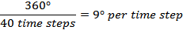

Look at the Orbit sheet and notice that, because the eccentricities of both planets have been set equal to 0, the data points are equally spaced around circular orbits with the Sun at the center. The spacing between consecutive data points represents equal intervals of time. This time between data points will not change with changes in eccentricity. For e = 0 the calculated time steps amount to 9-degree intervals between the data points. Do you think this is always true regardless of the eccentricity of the orbit?

Answer the following questions on your answer sheet.

- As you increase the eccentricity for Planets 1 and 2, does the Sun stay at the center of the orbits? Describe how the shape of the figure changes as you change e. (With a value of e = 0.8, note that the shape of the orbits near perihelion are distorted and no longer elliptical. You are seeing the effects of the limited accuracy of only 40 time steps. Had we used 72 time steps, for example, the distortion would be almost imperceptible.)

- As you change the eccentricity for the planets record what happens to the spacing of the time steps.

- Change the eccentricity for Planet 1 while observing the table of values below on the input sheet. In particular, what happens to the Time step and True Anomaly columns? Does each time step still represent 9 degrees?

- Given your answers to questions 5 and 6, where does a planet spend more time in its orbital motion, near aphelion or perihelion? Explain.

- Look at the graph labeled Orbital Velocity. Why do the time periods covered by the two graphs differ?

- Which of the two planets has the greatest orbital velocity? As you increase its distance from the Sun what happens to the orbital velocity of Planet 2?

- Start with e for both planets set at 0, then increase e for both. Does orbital velocity vary with time? At what point in its orbit does a planet move the fastest? At what point does it move the slowest?

Conclusion: Look at the planetary data sheet one last time and consider the eccentricity of the orbits of the real planets. Describe how the most and least eccentric of the planets orbits appear on the simulation.

Turn in to your instructor:

Group:
- Answer sheet for Part I.
- Graph with question and hypothesis from Part I.
Individual:
- Pre-lab definitions
- Answer sheet for part II.

Answer sheet for Methods of Science and Kepler’s Laws

Part 1 (Group)

- Do you see patterns in the data, perhaps something about the planets that increases regularly or decreases regularly with distance from the Sun? List patterns that you notice.

- At least one of these patterns should lead you to ask “why”? Record your questions and mark the one who have selected to explore.

- Construct a graph that will present the relationship you are interested in (the one your question in Q.2 concerns and prepare a graph to get a visual representation of the data. Consult the Guide to Graphing with Excel if you are uncertain about how to use the program.

- Once you have a graph that shows something “interesting”, label it, give it a title, and save it on its own worksheet.

- Type your original question and hypothesis on the graph and print out a copy to turn in at the end of the lab period.

Part II: (Individual)
- For Planet 1, let a = 1.20 AU. For Planet 2, let a = 1.35 AU. What are the new values of P and N?
P (planet 1) =______________ N (planet 1)
P (planet 2) =______________ N (planet 2)

- As the value of the semi-major axis was increased, the sidereal period (increased, decreased)? The mean annual motion (increased decreased)?

- For Planet 2, change the value of e, try several different values. How did the shape of the orbit change? (Switch to the Orbit sheet to see graphs of the orbits). When you changed e, did the sidereal period change?

- As you increase the eccentricity for Planets 1 and 2, does the Sun stay at the center of the orbits? Describe how the shape of the figure changes as you change e. (With a value of e = 0.8, note that the shape of the orbits near perihelion are distorted and no longer elliptical. You are seeing the effects of the limited accuracy of only 40 time steps. Had we used 72 time steps, for example, the distortion would be almost imperceptible.)

- As you change the eccentricity for the planets record what happens to the spacing of the time steps.

- Change the eccentricity for Planet 1 while observing the table of values below on the input sheet. In particular, what happens to the Time step and True Anomaly columns? Does each time step still represent 9 degrees?

- Given your answers to questions 5 and 6, where does a planet spend more time in its orbital motion, near aphelion or perihelion? Explain.

- Look at the graph labeled Orbital Velocity. Why do the time periods covered by the two graphs differ?

- Which of the two planets has the greatest orbital velocity? As you increase its distance from the Sun what happens to the orbital velocity of Planet 2?

- Start with e for both planets set at 0, then increase e for both. Does orbital velocity vary with time? At what point in its orbit does a planet move the fastest? At what point does it move the slowest?

Conclusion: Look at the planetary data sheet one last time and consider the eccentricity of the orbits of the real planets. Describe how the most and least eccentric of the planets orbits appear on the simulation.

Moons of Jupiter Pre-Lab Exercise:

In your text book read about the Galilean Moons of Jupiter and answer the following questions:

1. When were the moons discovered?

2. Name the 4 Galilean moons beginning with the innermost moon of Jupiter

3. Describe what you would expect to see if you looked at Jupiter and its moons with a telescope. You can add a sketch to help illustrate. How would the position of the moons in relation to Jupiter appear to change over time?

The Revolution of the Moons of Jupiter

Learning Goals: Examine Kepler’s Laws for moons orbiting a planet. Understand how combining Newton’s laws of motion with Kepler’s Laws can allow us to measure mass of a solar system body.

Materials: CLEA Lab, Revolution of the Moons of Jupiter.

Tools for learning: Graphing with a spreadsheet

Pre-lab exercise: Galilean Moons of Jupiter

Introduction: The invention of the telescope at the beginning of the 17th century made it possible for us to observe objects not visible to the naked eye. Using a telescope, Galileo discovered the four largest of Jupiter’s moons orbiting around the planet, and made exhaustive studies of the Jovian system. This system was considered to be especially important because it is a somewhat miniature version of the solar system, and so could be studied in order to better understand how the solar system works.

For the lab today, keep in mind that once Newton had come up with a physical reason behind Kepler’s Laws, the gravitational attraction between two bodies, the combination had predictive value regarding distance and period for planets orbiting the Sun or satellites orbiting a planet. In addition the modified form of Kepler’s 3rd Law could also be used to calculate mass of a planet very simply, by measuring the time for a moon to make a complete orbit and the average distance of the moon from the planet’s center.

Procedure
Open the CLEA lab, Moons of Jupiter, following your instructors directions. The images show Jupiter and its moons over time as they appear from a vantage point on earth. Follow the instructions for operating the program and set the date and time, as well as the time interval between images. Spend a little time getting familiar with the program. Click forward in the images to see what happens over the course of a few hours to the position of the moons. Imagine that you are looking at the real moons through a telescope.

- On your answer sheet write what you observed as you watched the moons over a few hours. Discuss speed, relative position, apparent motion etc.

- Plan your investigation. To get a reasonably smooth plot of the path of the moon you selected would you need to record the moon’s position monthly, daily, hourly, or at some other time interval?

- How long do you think it takes each of the moons to make a complete orbit of Jupiter?

- We can’t see the orbit of the moons from above, so how can we know the radii of the orbits?

Your investigation:

Think about what to record, how frequently to observe and how to collect your data. Think ahead to how you might display the data in a graph. What will you need to collect and what will make your life easier when you analyze the data?

Construct a graph in Excel using the data you recorded. (One technical note, the distance readings marked E in the simulation should be recorded with a negative sign in a spread sheet, the ones marked W are positive.) Decide what you will put on each axis of an xy scatter graph. Think about what you want the graph to show and how it relates to what you are trying to find out.

Figure out how to measure period and the radius of the moon’s orbit. If you have more than one period, decide if you want to average the periods or not. Annotate the graphs showing exactly where and how you measured the period and the radius of the orbit for each moon. If you used averages, explain that you did, and tell why. Follow the checklist for graphs on your answer sheet and make sure each graph is correctly labeled and annotated before you turn it in. A sample graph is at the end of this write up.

Once your graph is annotated and you have the values for a and P, you can go on to calculate the mass of Jupiter using Newton’s version of Kepler’s third law.

Newton’s form of Kepler’s third law:

Newton’s form of Kepler’s third law is written:

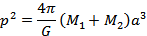

where the period, p, is in seconds,
the radius of the semi-major axis, a, is in meters,
the masses, M₁ and M₂ are in kg, and the universal constant of gravitation,
G, is

By using the units below and making the assumption that the moon’s mass is much less than the mass of the planet, the more general form of Kepler’s third law can be written in a much simpler way as:

where M_{Jupiter} is the mass of Jupiter, in units of solar masses,
a is the radius of the moon’s orbit, in AU,
and P is the period of the moon’s orbit, in years.

You can use the CLEA program to record the apparent distance of the moon from Jupiter in Jupiter radii. You will need to convert that distance to AU using the following relationship:

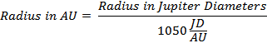

- On your answer sheet show your calculation of the radius of the orbit for Io in AU.

In addition to figuring out the radius of the orbit of a moon you will also need to measure the time it takes for a moon to complete one orbit of the planet. You will need to figure out how to convert days into years for this part of the calculation.

- On your answer sheer show your calculation of the period of the orbit for Io.

- On your answer sheet show your calculation of the Mass of Jupiter using Io’s radius and period.

Estimating error:

It is always important to see if your results are in line with other measurements. In this case you can use % error to compare your result for the mass of Jupiter to published results. Look up the mass in your textbook, then compare as follows.

- On your answer sheet calculate % error to compare your values for the mass of Jupiter to published results.

Conclusion: How might you carry this investigation further? Can you point to some assumptions you made that might not be quite true? What are other factors you should take into account?

Turn in:
Group:
Answer sheet
Graphs for each moon with annotations
Sample calculation
Individual:
Pre-lab answer sheet
Conclusion question

Example Graph

Orbital Motion of Jupiter’s Moon Io
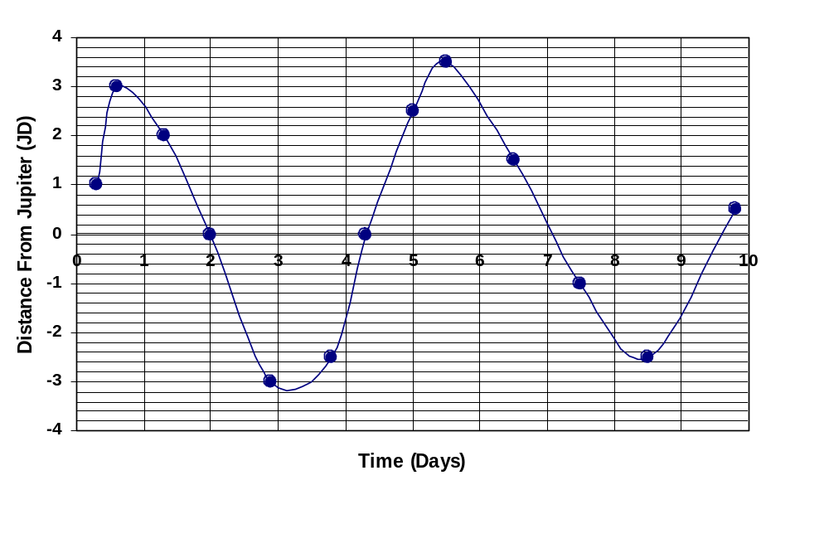
Period – days moon takes for complete revolution.
Farthest point the moon has gotten from Jupiter in this series of observations.

Figure 4.2 – Sample graph from data. The period is from one peak to the next. The average radius is the farthest point the moon reaches from Jupiter.

Checklist for graphs:

Graph is all on one page (use print preview)
Graph has titles
Axes correctly labeled
Maximum distance marked and labeled on graph
Period marked and labeled
Explanation in words of how period was calculated

Jupiter’s Moons Answer sheet

- Record your observations as you watched the moons over a few hours. Discuss speed, relative position, apparent motion etc.

- Plan your investigation. To get a reasonably smooth plot of the path of the moon you selected would you need to record the moon’s position monthly, daily, hourly, or at some other time interval?

- How long do you think it takes each of the moons to make a complete orbit of Jupiter?

- We can’t see the orbit of the moons from above, so how can we know the radii of the orbits?

- Sample calculation of the radius of the orbit for Io in AU.

- Sample calculation of the period of the orbit for Io.

- Sample calculation of the Mass of Jupiter using Io’s radius and period.

- On your answer sheet calculate % error to compare your values for the mass of Jupiter to published results.

Investigation of the motion of a celestial object pre-lab

For your individual science investigation you are going to plan an investigation of the motion of a solar system body, the Moon, Sun, or a planet. For those who are new to observing the sky either Moon or Sun will be easiest. For those who are familiar with major constellations and are reasonably sure they can identify the planets, this may be a more interesting option.

It isn’t hard to find examples of how ancient civilizations monitored the motion of Sun and Moon. For example, Casa Grande in Arizona is a structure built by the Hohokum people in the 1300s and abandoned around 1450 A.D. One interesting feature are the small openings in the walls that align with important astronomical events, solstice or equinox for example. The Hohokum people were a farming people and managed their water supply with a series of canals. It was probably important for them to have markers for changes of seasons. 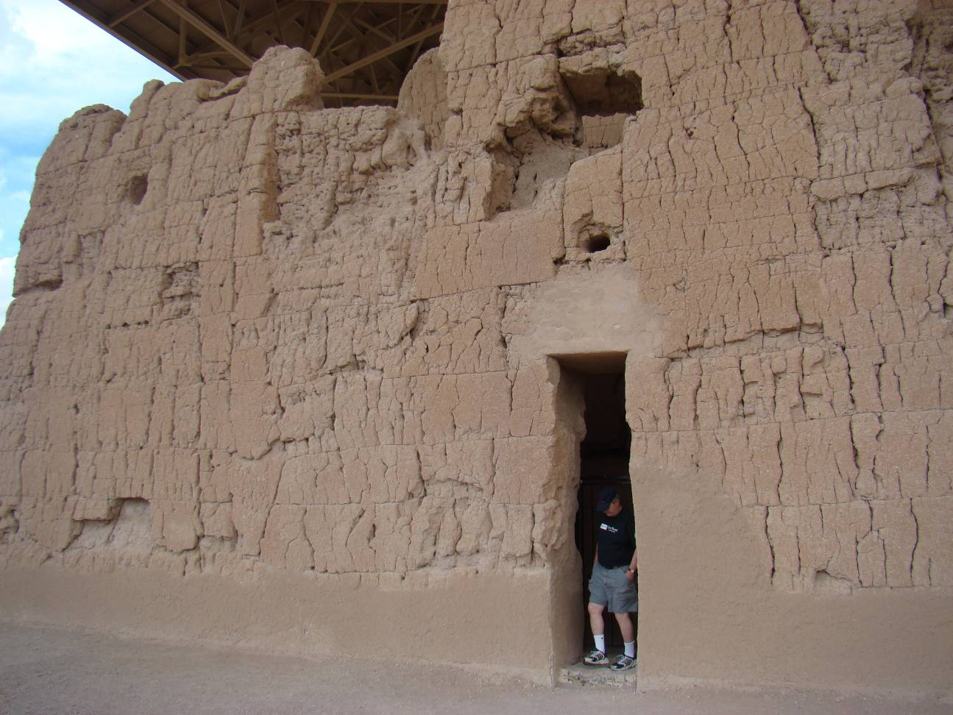
Note square opening on the left – it appears to be a marker for sunset at the summer solstice. Other openings in the building match other significant positions of the Sun and Moon.
Casa Grande July 2008 Ericson

While you do not need to put a slit in a building or construct something like Stonehenge to carry out your investigation, the idea that at a certain time of day at a certain time of the year the Sun or Moon will line up with some physical object as viewed from a given location is good to keep in mind as you observe the object you have chosen over a month or so and predict where it will be in the sky on a given day.

Turn in your responses to the following pre-lab questions to your instructor.
- Solar system object whose motion you will investigate

- Go outside at a convenient time to observe the solar system object you have chosen and find a good place to see it. Never look directly at the Sun, if you have chosen it as your object you might measure where it is by measuring a shadow’s length and direction, or perhaps by noting where the Sun rises or sets with respect to a marker on your horizon from a certain position. Record what you observed.

- Place you will use to observe the object

- Time and days of week that you plan to observe

- Current position of object at selected time (approximate position, use reference points, “from my driveway looking West at 9 P.M. I see_______ just above the house directly across the street.” Or something along these lines. You will design more quantitative ways to measure during the lab.)

Investigation of the Motion of a Celestial Object

Learning Goals: Students will plan an investigation of the motion of a solar system object. They will develop a question, design a process for making observations, and begin to think about how they will present the results of the investigation to the class during a poster session. Students will help set evaluation criteria for their projects.

Materials: Sample poster papers, Sample rubrics

Learning Tools: Guide to poster presentations

Introduction:
One of the reasons to take a general education science course is to help you understand how science works, in part so you can more effectively evaluate science claims, but also because the process of thinking that goes into doing a scientific investigation is a good model for evaluating claims in other areas. Since one of the best ways to learn something is to try it, an important part of this lab is to plan and carry out an investigation.

Today you will outline the plan for a straightforward investigation of motion of the Moon, Sun, or a planet. The goal is not to discover something new and earth-shaking, but rather to move from observations, through constructing a model (not a physical model in this case, but a graph or diagram), to making a prediction and testing it against reality. Because it is highly likely that the prediction will not exactly match what you really see, you will be able to go back and suggest ways you might improve the prediction just as a scientist might do when preliminary results suggest that the original hypothesis needs to be modified.

At the end of the semester you will present your investigation with a simple poster paper to give your classmates a “snapshot” of what you have done. In today’s lab you will make a preliminary layout for the poster.

Procedure:

You should have already selected the object you want to observe, Moon, Sun, or a planet. You should also have a rough idea of where you would look for the object at the time and place you have selected in the pre-lab activity.

- Record object, time and place where you plan to observe.

Now you need to do some research. In the lab today look for sources that will help you figure out how the object you have selected will change position during the next month. Sun, Moon and planets all change right ascension, declination, altitude and azimuth over time, you need to figure out where the object is now and how much change you think will occur between now and prediction day.

- Make notes as you search the web, check times, dates, etc. with Starry Night, or web resources and refer to your book. This background information will go into you poster presentation, so take careful notes, including information that you will need to correctly reference your sources.

When you have a good background understanding of how the position of your object will change over the next month or so, make a prediction about the position of the object at the time and exact location where you will observe. For example, if you have decided to observe the moon from a specific position on the top level of Sandy Creek parking deck, describe exactly what you expect the moon to line up at the viewing time you have selected on a day during the week of November 13th. If you will be observing the Sun you might predict the length and orientation of the shadow of a particular vertical pole on campus at noon on the day you have chosen. Be sure to include directions (N,S.E.W) in your prediction.

- Write your detailed prediction including date, time, place of observation, direction and what you expect to see, length and direction of shadow, phase of moon, etc.

You will also need to make observations between now and the date of the prediction. You will have an opportunity to modify the prediction after you have done a series of observations, so set up a schedule and follow it carefully. Because in real life you will have cloudy days and nights, or times when other obligations prevent you from observing, you should schedule at least three observations a week for the next three weeks.
You will also need to think about how best to take measurements. Remember never to look directly at the Sun if you have chosen it as your object. It is best instead to think about the shadow cast by some object as a measure of where the sun is in the sky.
For measurements of objects relative to the horizon, remember the altitude, azimuth measurements from the Farquhar globe lab and also the method of using an object such as the width of your hand to determine distance above the horizon. To get more accuracy think about using a ruler held at arm’s length to measure distance above the horizon. A compass would be useful for azimuth measurements, although you can also estimate it. Remember, to go around the horizon from north to east, south, west and back to north makes a complete circle, 360 degrees. You can figure out approximate East and West from where the Sun rises and sets. Come up with a method that will quantify your measurements and record it.

- Schedule of observations and method for taking measurements

An important part of science is presenting your results to others. In this case you will present a poster paper to the class at the end of the semester. Posters usually include graphs and charts as a short and informative way to present data. At this point, consider what you are going to record and what kind of graph might display it well. Make a spreadsheet with the values you plan to record. You should have at least one observation to enter already. Based on your research so far put in some “dummy” values similar to those you would expect to get in the next week or so. Use these values to design a graph that represents the data. When you collect actual data you will need to replace the “dummy” values, and you may want to modify the graph design at that point as well, but this will be a starting point.

- Include your sample spreadsheet and graphs with the answer sheet.

You will need to think how to display your information so the viewer of your poster can understand what you did in a short amount of time. Lay out a rough outline of the poster at this point. It should include a title, your research question or prediction, a small amount of background information, your charts and graphs, results, conclusion, possible future modifications, and a visual element, a sketch or photo, that will help the viewer to quickly see what you have done.

- Draft a rough outline of what you would include on a poster that is about 22” by 28” (the standard, cheap poster board from an office supply store or bookstore, NOT standup science fair boards, and not foam). You can tape or glue text boxes, graphs and other items onto the board, so lay out the elements you need.

Group component:
It is important for you to know how your project will be evaluated. A valuable resource for both instructor and student is a grading rubric that outlines the major points the instructor will look for and the weight that will be given to them. Your instructor will design a grading rubric taking some of the best of your suggestions into account and will post it for you to use as you work on your investigation.

- With your group design a grading rubric for the poster paper and presentation using the form that follows. Consider what elements should be present and how they should be judged. For example, you might look at overall poster design, poster content, completeness of the investigation, and the one minute oral summary and rate using a 3 point scale.

Turn in:
Individual:
- Answer sheet
- Sample spreadsheet and graphs

Group:
- Grading rubric

Investigation of the Motion of Celestial Object Answer sheet

- Record object, time and place where you plan to observe.

- Make notes as you search the web, check times, dates, etc. with Starry Night, or web resources and refer to your book. This background information will go into you poster presentation, so take careful notes, including information that you will need to correctly reference your sources. Attach a copy of your notes to the answer sheet.

- Write your detailed prediction including date, time, place of observation, direction and what you expect to see, length and direction of shadow, phase of moon, etc.

- Schedule of observations and method for taking measurements.

- Include your sample spreadsheet and graphs with the answer sheet.
- Outline of what you would include on a poster

Sample rubric form
Add your own items and add to or delete items in sample.

 | Excellent | Adequate | Inadequate
Title | Describes investigation well  Memorable | Describes investigation | Missing or not descriptive
Overall design | Eye-catching  Clearly and logically arranged  All elements add value (relate to investigation) | Neatly arranged  Clear | Jumbled  Hard to read  sloppy
Visuals (photos and graphs)
Oral presentation
Investigation question
Conclusion

Properties of Light pre-lab

Define the following

focal point

focal length

curvature

diverging

converging

concave

convex

There is some information that may help here

http://www.physicsclassroom.com/Class/refrn/U14L5a.html

After you find the definitions go to

http://www.school-for-champions.com/science/experiments/simopticslens.htm
or
http://physics.bu.edu/~duffy/java/Opticsa1.html

1. Set up a concave mirror and a beam of light. Sketch what happens to the light rays as they come toward the mirror and are reflected back. What happens to the focal point as the curvature of the mirror is increased?

2. Try a convex mirror. Sketch what happens to the light rays as they come toward the mirror and are reflected back. Where is the focal point for this mirror? Do light rays pass through the focal point? What happens to the focal point as the curvature of the mirror is increased?

3. Examine the simulation for a concave lens. Sketch what happens to the light rays as they come toward the lens and pass through. What happens to the focal point as the curvature of the lens is increased?

4. Examine the simulation for a convex lens. Sketch what happens to the light rays as they come toward the lens and are reflected back. What happens to the focal point as the curvature of the lens is increased?
5. Replace the beam of light with an object (an arrow, you can change its height by clicking on it and “stretching” it with the mouse.) For each of the cases above describe what the image looks like and where it forms. “Virtual” images are indicated with dotted light rays in the simulation

Turn in your sketches and definitions at the start of lab. Your quiz will cover material you have studied in the simulation as well as definitions.

Exploring the nature of light

Learning Goals: Investigate the properties of light, mirrors and lenses to understand path light takes from distant objects, and the principles of reflection and refraction.

Materials: optical benches, optical kits with sources, lenses, mirrors, filters, parallel ray lens, ray table, holders, screen, slit plates, small rulers, long white paper.

Pre-lab activity or question: On-line exploration of lenses and mirrors

Introduction:

Visible light is a term that refers to the part of the electro-magnetic spectrum that humans sense with their eyes. Though this is only a tiny part of the radiation that is given off by stars (and in reality all objects in the universe), it is the part that we can most easily understand since we are equipped to distinguish among wavelengths in that range. Humans have varying ability to see in color, really to sort out different wavelengths of light reflected by objects around us. In this lab we will examine light in the visible range, but remember that what you learn about visible light also applies to other wavelengths that our eyes don’t sense. We will use the term “light” loosely to mean light visible to human eyes.

This is an opportunity for you to investigate light and how it travels through air and glass and how it reflects and refracts at the interface between glass and air. Consider as you work how this relates to telescopes and astronomy.

You will do your investigations using an optical bench where you can place a light source and various lenses, mirrors and filters. The light source is a black box that plugs into the wall containing a small bulb with a glowing filament.

- Describe the bench and its components on the answer sheet

In this lab you will make observations of what light does. You have probably learned that light travels in straight lines.

- What is meant by straight in terms of the path of light?

Set up the light source, and the ray table with the white screen on the side away from the light source. Arrange the components on the optical bench so that you can see light falling on the table and screen.

- Describe the path the light appears to take from the source to the screen.

Put a slit plate on a holder, place it in front of the light source and again observe and draw.

- What path does light seem to take through the slits? Are the rays straight? Are they parallel?

- Move the slit plate back and forth, use the knob on the light box to turn the bulb slightly side to side, move the ray table and explain what you see in each case.

Once you have a sense of how light travels through the slit plate, use the following procedure to systematically work through how the light behaves when you put lenses and mirrors in the path of a light ray.

Ray Optics Experiment

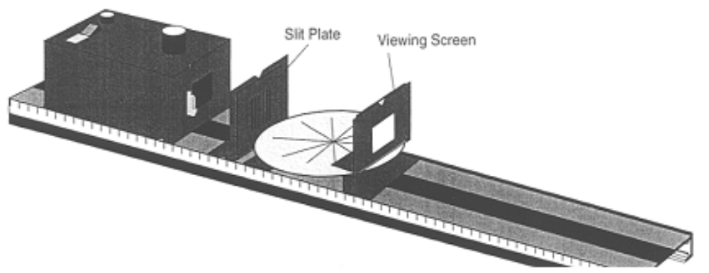

Set up the equipment as shown above .

Observe the light rays on the Ray Table.
- How do the width and distinctness (i.e. sharpness) of each ray vary with its distance from the Slit Plate? (Do not move the Slit Plate and Component Holder to answer this question.)

Set aside the Viewing Screen and Component Holder for the next step.

Lower your head until you can look along one of the rays of light on the Ray Table.
- Where does the light originate? What path did it take in going from its point of origin to your eye? Try this for several rays.

Replace the Viewing Screen and its Holder on the Optical Bench. Rotate the Slit Plate 90º to the left or the right. Rotate it slowly on its Component Holder, as if you were turning a knob, until the slits are horizontal. The Slit Plate should remain flush with the Component Holder and the position of the Holder should not be changed. Observe the slit images on the Viewing Screen.

- How did the width and the distinctness of the slit images change as the angle (i.e. the orientation) of the Slit Plate is changed from vertical to horizontal?

- Explain your why you see changes when you rotate the slit plate. Think about light traveling in straight lines and remember how the light bulb and its filament are lined up with the slit plate. Draw a diagram illustrating how the width of a single slit image depends on the orientation of the Light Bulb filament with respect to the Slit Plate.

Ray Tracing:

You can use the fact that light propagates in a straight line to measure the distance between the Light Bulb filament and the center of the Ray Table. The rays that appear on the Ray Table originate from the Light Bulb filament of the Light Source. Since light travels in a straight line, you need only extend the rays backward to locate the position of the filament.

The vertical edge of this notch indicates the position of the filament.
Filament
Folded paper on ray table with center of table marked.
Slit Plate

Top view of ray tracing set up

Get a piece of blank white paper from your instructor and fold it in half. Place the paper on the Ray Table, with the fold adjacent to the Slit Plate as shown above Make a reference mark on the paper at the position of the center of the Ray Table. Using a pencil and the straightedge provided, trace the rays onto the paper. Make sure that the Ray Table is not too far from the light source.

Remove and unfold the paper. Use your pencil and the Straightedge to extend each of the rays back to a common point of intersection. Label the position of the filament and the center of the Ray Table on your diagram.

Measure the distance between your reference mark and the point of intersection of the rays. Label this distance M₁.

Use the metric scale on the side of the Optical Bench to measure the distance between the filament and the center of the Ray Table directly. Label this distance M₂.

- Are the distances you measured, M₁ and M_{2,} the same or different? What did you expect? Should the measurements be the same or not?

One of the concepts that this experiment illustrates is that light rays can be traced to their (apparent) origin. This concept will prove most useful in the following investigations of light interacting with mirrors and lenses.

Refection from a mirrored surface

The most important thing to keep in mind for this section is the law of reflection - the angle of the incident (i.e. incoming) ray is equal to the angle of the reflected ray. In other words, if you draw a line perpendicular to a surface, an incoming ray of light makes an angle with the perpendicular line and will be reflected from the surface at the same angle.

That means that you can trace a ray to a surface and figure out where it will end up after reflection, or if you chose a point on the reflected image you can trace a ray from that point back to its source.
Perpendicular line
Light ray
Mirror
Angle incoming ray makes with perpendicular line
Angle outgoing ray makes with perpendicular line

The ray tracing technique can be used to locate the image formed by the reflection of light rays from any mirrored surface. Think of the object to be reflected as a collection of point sources of light. For a given point source, light rays diverging from it are reflected from the surface of the mirror according to the Law of Reflection. If the reflected rays intersect at a point, then a real image is formed at that point. That point is the focal point. However, if the reflected rays diverge (i.e. spread out), then a virtual image will be formed behind the plane of the mirror. The position of this image can be found by extending the reflected rays back behind the surface of the mirror. The virtual image will appear to be located at the point where the extended rays cross.

In this experiment you will use the Ray Table to examine the properties of image formation from a mirrored cylindrical surface. The properties you will observe have important analogs in image formation from concave mirrors that are found in some optical (i.e. reflecting) telescopes.

Determining Focal Length of a Cylindrical mirror

We want to simulate light coming from a distant source in this part of the lab. Because the source is a long way away, the rays coming to us will be parallel or at least close to parallel. Fasten the parallel ray lens on a holder, with the slit plate in front of it. Adjust the distances so that the rays falling on the ray table are parallel. Put the concave surface of the Mirror on the table as shown below and arrange so that all the incident rays are reflected from the concave surface of the Mirror.

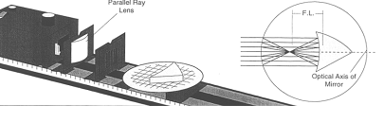
Setup for Cylindrical Mirror Experiment

- Measure the distance between the middle of the surface of the mirror and the point where the reflected light rays appear to converge. This is the focal length of the mirror. F.L._{mirror} = ____________________

- Which type of telescope uses a mirror to gather light from celestial objects? If this mirror were used as the main mirror for such a telescope where would the image form?

Cylindrical Lenses

In this part of the lab we will replace the mirror with a cylindrical lens. Instead of reflecting, most of the light will now go through the glass of the lens.

The important principle at work here is the law of refraction. Light changes direction when it passes from air to a denser medium such as glass, and changes direction again when it goes from glass (or water) to air.

- Can you think of a case where you have observed light refraction? Think about cases where light passes through water for example. Refraction happens whenever light moves between areas of different density. Give an example on the answer sheet.

Replace the mirror with the Cylindrical Lens on the Ray Table so that all of the incident rays hit the flat surface of the lens.

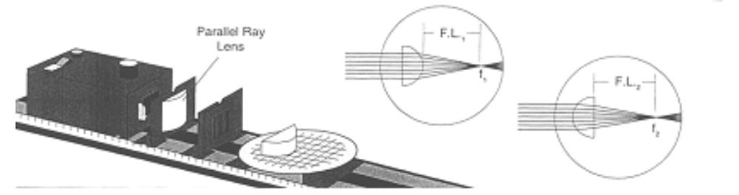

Setup for Cylindrical Lens Experiment

- What happens to the light now? Change the position of the lens on the table as show in the illustration and compare the focal length. Is it the same for both orientations of the lens?
- Sketch the path of the light from before it gets to the lens, through the lens and after it exits. Can you see how it changes direction?

Measure the focal lengths for the lens in both orientations on the ray table.

- F.L.₁ (when flat side of lens faces light source, measure from center of curved side to the focal point ___________________

- F.L.₂ (Curved side of lens faces light source, measure from center of flat side to focal point ____________________

Position the slit plate directly on the front of the light source and remove the holder and the parallel ray lens. Leave the lens on the ray table. Can you position the lens and ray table so that the rays are parallel after they pass through the lens. Make a prediction about how far from the source this should happen.

- Your predictions about where the lens should be positioned to get parallel rays from the source.

Set up the equipment and move the ray table back and forth until you get parallel rays for each orientation of the lens.

- How far from the source was the lens when you were able to get parallel rays? Does this match your prediction?
- How do you think the parallel ray lens works?
- What type of telescope uses a lens to gather light?
- List some of the differences between telescopes using mirrors and telescopes using lenses.

Conclusion question: You have examined how light appears to travel in straight lines…then how can you explain the behavior of light in a fiber where it appears to curve as the fiber bends?

Turn in:
Group:
- Answer sheet
Individual:
- Pre-lab
- Conclusion question

Nature of Light answer sheet (Group)

- Describe the bench and its components, sketch major parts.

- What is meant by straight in terms of the path of light?

- Describe the path the light appears to take from the source to the screen.

- What path does light seem to take through the slits? Are the rays straight? Are they parallel? Explain with words and/or diagram.

- Move the slit plate closer to the light source then farther away. Then use the knob on the light box to turn the bulb slightly side to side, move the ray table and explain what you see in each case. Remember to vary one thing at a time to get an idea of what is happening.

- How do the width and distinctness (i.e. sharpness) of each ray vary with its distance from the Slit Plate? (Do not move the Slit Plate and Component Holder to answer this question.)

- Where does the light originate? What path did it take in going from its point of origin to your eye? Try this for several rays.

- How did the width and the distinctness of the slit images change as the angle (i.e. the orientation) of the Slit Plate is changed from vertical to horizontal?

- Explain why you see changes when you rotate the slit plate. Think about light traveling in straight lines and remember how the light bulb and its filament are lined up with the slit plate.

- Are the distances you measured, M₁ and M_{2,} the same or different? What did you expect? Should the measurements be the same or not?

- Measure the distance between the middle of the surface of the mirror and the point where the reflected light rays appear to converge. This is the focal length of the mirror. F.L._{mirror} = ____________________

- Which type of telescope uses a mirror to gather light from celestial objects? If this mirror were used as the main mirror for such a telescope where would the image form?

- Can you think of a case where you have observed light refraction? Give an example.

- What happens to the light when you replace the mirror with the cylindrical lens?

- Sketch the path of the light from before it gets to the lens, through the lens and after it exits. Can you see how it changes direction?

- F.L.₁ (when flat side of lens faces light source, measure from center of curved side to the focal point ___________________

- F.L.₂ (Curved side of lens faces light source, measure from center of flat side to focal point ____________________

- Your predictions about where the lens should be positioned to get parallel rays from the source.

- How far from the source was the lens when you were able to get parallel rays? Does this match your prediction?

- How do you think the parallel ray lens that you used earlier in the investigation works?

- What type of telescope uses a lens to gather light?

- List some of the differences between telescopes using mirrors and telescopes using lenses.

Conclusion question (Individual): You have examined how light appears to travel in straight lines…then how can you explain the behavior of light in a fiber where it appears to curve as the fiber bends?

Infrared Radiation Pre-lab

Visit one of the below sites to get a picture of where infrared radiation fits into the electromagnetic spectrum:

http://www.lbl.gov/MicroWorlds/ALSTool/EMSpec/EMSpec2.html
http://imagine.gsfc.nasa.gov/docs/science/know_l1/emspectrum.html

Use the sites below to explore uses of infrared radiation in planetary astronomy:

http://www.spitzer.caltech.edu/Media/releases/ssc2005-09/release.shtml
http://antwrp.gsfc.nasa.gov/apod/ap060215.html
http://antwrp.gsfc.nasa.gov/apod/ap050423.html

- What is your body temperature in degrees C?

- What is comfortable “room temperature?”

- If your eyes were sensitive to infrared radiation, what do you think would appear brighter, your hand or a pencil on your desk? Why?

- List two ways viewing in the infrared region of the electromagnetic spectrum might be useful in planetary astronomy.

Investigation of Infrared Radiation

Learning Goals: Design and carry out an investigation using an infrared sensor to explore the ways various surfaces transmit infrared “light.” Write a hypothesis that can be tested with the lab equipment, carry out the test, then modify the hypothesis as a result of the investigation, suggest a test for the modified hypothesis and carry it out.

Materials: Infrared sensor, Leslie’s cube apparatus, multimeter, coated Styrofoam sheets, small glass sheets

Tools for Learning: Guides to graphing with Excel

Pre-lab exercise: Infrared Radiation

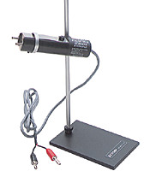
Introduction:
Today you will investigate thermal radiation from different kinds of surfaces. Thermal radiation is part of the electromagnetic spectrum, not visible to the human eye, though human sense of touch gives us a rough estimate of infrared radiation (heat). Think for example about touching the outside of a coffee cup to see if it is still warm. Something that feels warm is radiating more infrared that something that feels cool.

Thermal radiation sensor. In this lab we use a much more sensitive gauge of the kind of infrared radiation given off by a simple box heated by a light bulb. The sensor produces a voltage that is proportional to the intensity of the radiation that falls on it. This sensor used in this lab is best for measuring radiation in the infrared from about .5 to 40 micrometers. It is sensitive to changes in temperature from about -65 to 85 degrees C.
Thermal radiation sensor

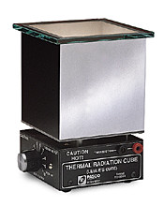
Leslie’s Cube. You will use Leslie’s cube to investigate how much heat is emitted from variously coated sides of an otherwise uniform box. Take a few minutes to examine the cube before you plug it in.
Leslie's Cube

The connectors on the outside of the cube are used to measure resistance of a metal piece inside the cube. The resistance of the metal decreases as the temperature increases, making resistance an indirect measure of the temperature inside the box. By comparing the reading of resistance on a multimeter to the chart marked on the outside of the cube, you can keep track of the temperature inside the box.

Mulitmeter. The multimeter on your desk can measure voltages, currents, and resistances. You will need to use it for voltage when it is connected to the radiation sensor and for resistance when it is connected to Leslie’s Cube. Since you only have one multimeter you will have to switch the as you change from measuring resistance to measuring voltage. You will also need to switch scales. When you begin taking readings, use the least sensitive scale available, then move slowly down until you reach a scale where you can make a measurement. Ask you instructor for assistance if you are unfamiliar with this kind of meter.

Procedure:

This lab is intended to be a real investigation for you. There is no answer sheet today, instead each group will turn in a short report. Keep careful notes as you work and turn in a copy of the notes along with a 1 – 2 page write-up of the lab. At the end of the instructions you will find a checklist of what to include in your report, be sure to refer to it as you work so you don’t have to repeat any part of the experiment because of poor record keeping.

Predictions:

Before you begin, make some predictions. If you heat the cube from inside by turning on the bulb the cube itself will heat up, that is will radiate in the infrared. Do you expect to find more radiation from one side than the others, or will they all be the same amount? Predict too whether the radiation you measure will increase linearly as the cube gets hotter, or perhaps exponentially, or with some other relationship. This prediction can be the basis for your first testable hypothesis.

Safety Notes:
- The surfaces and even the knob on the top of the cube get hot, be careful to put the apparatus in the center of the desk so you don’t risk bumping it by accident.

- Keep cords out of the way, toward the back of the desk if possible so that you don’t risk getting a foot or hand tangled in them and pulling the cube off the desk.

- If you are uncertain about how to set up the apparatus, ask your instruction BEFORE plugging anything in.

Set up: After examining the cube plug it in and turn the dial on the front to five. It will take a while for the temperature to stabilize. Plug the colored leads into the cube, then into the multimeter and set the scale to ohms (Ω). Adjust the scale to get a reading near the center of the range. You should see the resistance decreasing as the bulb heats up. You will have to wait until the resistance is fairly constant before taking measurements. Since this may take 10 or 15 minutes, use the time while you are waiting to structure your question and hypothesis and to plan how you will conduct the investigation. You should also take a few minutes to practice with the sensor as outlined below.

Practice with sensor:

Connect the sensor to the millivoltmeter using the black and red plugs on the sensor to plug into the black and red terminals on the meter and turn the dial to read in volts (marked with large red “V”) The dial marked 200m should give you readings for various objects in the room.

With your partner investigate differences in thermal radiation for objects around the room. Take notes as you go, comparing what you measure to possible reasons for the measurement.

Preliminary investigation:

Use the multimeter’s resistance setting to check the temperature of the cube. If it seems to be changing fairly slowly, record the resistance and the temperature (using the chart on the cube.)

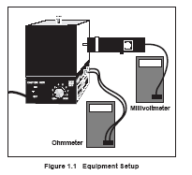
You will need to switch these leads as you change from measuring voltage to measuring resistance with the multimeter.

Warning: The Cube gets quite hot, even the knob on the top will be hot after the bulb reaches its maximum temperature. Turn the bulb off and let it cool for several minutes before trying to move it.

Unplug the cube’s leads to the multimeter from the cube, change to the voltage scale and plug the sensor’s leads into the meter. Take the readings that will be used to test your prediction.

Investigation of Infrared answer sheet (Group):

You will not fill out an answer sheet today, rather you will document your investigation in a paper (probably two or at the most 3 pages including graphs and data tables). Some suggestions for the report are below.

In your write up include the items below and any drawings or sketches that will help the reader understand what you have found.

Your final report should not be a chronological outline of every step, but should clearly tell what you thought you would find, how you went about checking, and whether or not reality matched your prediction. You should be clear enough about how you did it so that someone else could do it just as you did and check to see if they get the same results.

- A description of the equipment used and how you used it.
- Your initial predictions
- The hypothesis you decided to test
- The test procedure you devised
- Your results (think about how to display them in a table and graph)
- Comparison of your results to the prediction
- Modification of hypothesis
- Test procedure for the modified hypothesis

You should allow about 45 minutes (more or less) to write up your results

Geological processes Pre-lab exercise

Your instructor will assign you to become an “expert” on one of the geological processes. You should read the textbook and take notes about the process, the energy source that drives it, how the process works, and how it might appear. These details are important and will help you understand what you are becoming expert about.

You should also locate at least three images on the internet, or in a book other than the text that illustrates the process. Bring your notes and the images to class for the first session. Submit a copy of your notes and images to your instructor for pre-lab assessment.

In addition your quiz may include the terms below. Define them in your own words and bring the definitions with you to lab.

Words that all students should be able to define for Geology lab.

impact crater

ejecta blanket

volcanic caldera

lava Flow

canyon, chasm

layered rock

fault

scarp

dune

gully

dendritic

Geological processes: volcanism, wind erosion, water erosion, tectonics and cratering

Learning Goals: Understand how a particular process works on Earth in order to look for evidence of similar processes elsewhere in the solar system. Be able to function as an “expert” in the lab on geologic processes of Mars. Learn to observe and evaluate group processes.

Pre-lab: Geological processes

Introduction:

The surface of the Earth is continually changing as geological processes work to transform it. A research direction for astronomers involves investigating the way such processes would look on other solar system bodies to better understand how the solar system formed. Finding evidence of water erosion on Mars leads to questions about whether Mars currently has water in liquid form and if, at some point, conditions on Mars were favorable for life. In turn, understanding the processes that have shaped other planets may help us better understand the earth, and predict how it will change with time.

One major area of interest is the question about whether or not life has evolved elsewhere in the solar system. Life itself is a prime reason the surface of Earth looks as it does. Life processes have changed Earth’s atmosphere and shaped its surface. Plants cover much of the solid surface of the Earth. They interact chemically with the soil in which they grow and when they die, form a layer of decaying organic material. Biological processes continually erode rock even deep below Earth’s surface. It is hard to find a place on Earth without fingerprints of living organisms. It would be exciting to find geological evidence for life on a solar system body other than Earth, but in order for scientists to spot such activity they need to understand processes on Earth to better identify life and its signs on other planets.

In today’s lab you will form small groups to consider various geological processes and how they look on Earth. It will be especially useful to try to identify the processes on aerial photography since with few exceptions that is how we see the surfaces of other solar system bodies.

Next week each of you will be an “expert” in a different group to look at imagery from Mars in order to identify what processes similar to Earth processes and to try to order them in time. The processes you will consider are erosion from wind and water, cratering from meteorites that strike the surface, movement of large blocks of the surface due to forces interior forces (tectonics), and volcanic processes.

While you will not become instant experts on geology over the course of two labs, you should develop some sense of what the different processes might look like, and you will be able to look for evidence of these processes in imagery from Mars. As you begin this series of labs, keep looking for questions you can ask of the data. The kinds of questions to think about in particular are “how did this form”, “when did it form in relation to other features”, and “is the process still active, and how could we tell?”

Procedure:
You will meet with your assigned group and share the pre-lab research you have done. As a group work to make understand the process better and make a short presentation on your topic. Next week’s lab will require each group member to give the presentation to a new group that will contain representatives of some of the “expert” groups from today. Each of you in the group will be responsible for teaching a new group of three or four about your topic. Because this new group will be looking at an image from Mars and analyzing it for evidence of each of the geological processes you are studying, it is vital that each member of today’s group understand the process and be able to give the short presentation. You should make a power point presentation and a set of notes and make sure each member has a copy by the end of the lab period. Turn in one copy of the presentation and notes to your instructor at the end of today’s class period.

Sites to visit:
Use Google earth to get a satellite view of various surface features on Earth to get started. Other suggestions for places to visit are included with each process. Remember that today you need only study the process your instructor assigned to your group.

These sites have leads to helpful material as you begin. http://www.lpi.usra.edu/education/resources/processes/ http://www.lpi.usra.edu/education/explore/shaping_the_planets/

A good site for finding some earth images of various features from space is here:
http://eol.jsc.nasa.gov/sseop/EFS/land.htm

Volcanism:
You might take a look at Mauna Loa, Mt. Saint Helens, and some of the volcanic buttes near Idaho Falls, Idaho. Craters of the Moon National park near Arco, Idaho has lava flows that should be interesting as well, but any place where lava has flowed fairly recently should be a good example. As usual, the problem on Earth is that life processes quickly obscure the geology in most areas, making it difficult to see exactly what the bare bones process would look like.

Look for shapes and patterns that several areas have in common. What kinds of symmetries, or lack of symmetry do you see? You are looking at a three dimensional object in just two dimensions, do you get any sense of height from the images? If so, what clues did you use? Be sure to record the scale of the image. How big is it from side to side in several directions? Sketch and label surface features you see and include their measurements.

Wind erosion:
Examples of dunes in the Sahara and Gobi deserts are a good place to start. Great Sand dunes National monument should also have coverage, and you can look at the Great Sandy Desert of Australia as well. Areas without much vegetation will be most useful for you. Can you determine anything about dunes or ripples in the surface? Which way do you think the wind was blowing to create the pattern? Here is a good place to start as you examine wind erosion. http://www.weru.ksu.edu/new_weru/multimedia/multimedia.html

Cratering:
We don’t have a lot of large, uneroded craters on Earth, wind, water and life have modified most so that they are often difficult to distinguish. An excellent starting point however is Barringer Crater in Winslow, Arizona. Wolfe Creek Meteorite Crater in Australia is another example. This website allows you to zoom in on images. http://geology.com/meteor-impact-craters.shtml

Look for shapes and patterns that several areas have in common. What kinds of symmetries, or lack of symmetry do you see? You are looking at a three dimensional object in just two dimensions, do you get any sense of height from the images? If so, what clues did you use? Be sure to record the scale of the image. How big is it from side to side in several directions? Sketch and label surface features you see and include their measurements.

Water erosion:
Any place where water has once run should give you examples of water erosion, but it may be most useful to try to find places with very little vegetation. Canyons in desert areas would be useful, and it might also be interesting to look at glaciers and their erosion patterns in spring.

While there is no evidence of liquid water currently on the surface of Mars (and the low atmospheric pressure there causes water to go directly from ice to vapor if it is found at all), there are many signs that water probably once did flow on the surface of Mars. Some landforms there are very similar to those found on Earth that are caused by water or ice.

This website gives an overview of some types of soil erosion due to water that are of concern on earth.
http://topsoil.nserl.purdue.edu/nserlweb/weppmain/overview/intro.html

Look for shapes and patterns that several areas have in common. What kinds of symmetries, or lack of symmetry do you see? You are looking at a three dimensional object in just two dimensions, do you get any sense of height from the images? If so, what clues did you use? Be sure to record the scale of the image. How big is it from side to side in several directions? Sketch and label surface features you see and include their measurements.

Tectonics:
Large scale motion of large sections of Earth’s crust is responsible for mountain ranges, deep trenches, and at least some volcanism of Earth’s surface.

Because in plate tectonics heat from the interior of the earth causes convection currents that move large “plates, containing both continent and sea floors, which separate and collide with each other, geologists map plate edges by looking at patterns of earthquakes and volcanoes.

You can find current earthquake activity here:
http://earthquake.usgs.gov/eqcenter/recenteqsww/
For volcanos go to:
http://volcano.wr.usgs.gov/activity/

Look for shapes and patterns that several areas have in common. What kinds of symmetries, or lack of symmetry do you see? You are looking at a three dimensional object in just two dimensions, do you get any sense of height from the images? If so, what clues did you use? Be sure to record the scale of the image. How big is it from side to side in several directions? Sketch and label surface features you see and include their measurements.

Group process assessment:
Because a common problem in groups is unequal work load, you will be asked to assess your group today and how it functioned. Each person will be responsible for knowing the material from your work today, but it is also important that each person contribute. You will fill out the following form to rate your group. The instructor will assign points to individuals based on the ratings by the group.

Turn in:
Group:
- Power point slides and notes (save a copy per person to use next week)

Individual:
- Group process rating form

Group member rating form

Please rate each group member using the following scale. Any rating of 1 must be explained.

Excellent performance = 3
Average performance = 2
Inadequate performance = 1

.
Group member name
Showed up on time ready to work
Contributed to final product in a significant way
Listened to others and took their contributions seriously
Was able to lead when necessary

Stayed on task
Overall assessment

Explanation of scores below 1 for any of the boxes above.

Additional comments.

Geology of Mars Pre-lab exercise

In order to analyze actual pictures of Mars you will need to know some of the basic principles of geology, the principle of superposition, the principle of cross-cutting relationships, and the principle of horizontal bedding. An excellent overview of these principles and some applications to Mars, are given at the following site.

http://marsed.asu.edu/pages/pdfs/MappingStudentGuidev200.pdf

Define these principles on your own words, then do the activity described below for your geology speciality.

1. Principle of superposition

2. Principle of cross-cutting relationships

3. Principle of horizontal bedding

Go to your “specialty” and following the instructions for practicing identifying the process on Mars.

Water erosion:
Read the text and print out the pictures at the following web address (color is not necessary)

http://www.lpi.usra.edu/education/MarsMillennium/rivers_adv.pdf

Travel the paths you see where water might have flowed on both photos. Indicate with an arrow which direction you think water flowed on each of the photos.

Describe similarities and differences in the two photos.

Cratering:

Read the text and print out the pictures at the following web address (color is not necessary)

http://www.lpi.usra.edu/education/MarsMillennium/craters_adv.pdf

Outline the crater(s) on each of the photos and identify characteristics you see. Describe similarities and differences in the two photos.

Volcanism:
Read the information at the sites below and compare the summits of the two craters. Print out the pictures (color not necessary) and out line and label basic features on both volcanoes. What differences and similarities do you see?

http://www.lpi.usra.edu/publications/slidesets/hawaiivolcanoes/slidespages/slide_36.html
http://www.lpi.usra.edu/publications/slidesets/hawaiivolcanoes/slidespages/slide_38.html

Wind Erosion:

Read the material here for background on wind streaks
http://www.siliconspaceships.com/WindStreaks.html

Print the picture from the site below and outline wind streaks you see there. Draw and arrow to show which way the wind was blowing when the streaks formed.

http://msip.asu.edu/support_files/6_SyrtisMajor/VIS/Syrtis%20Major.jpg

Here is a pictures of dunes on Earth, read the material and print out the picture, outline the dunes and “streets” between them
http://earth.jsc.nasa.gov/EarthObservatory/ErgOriental_Algeria.htm

Tectonics:

Read the information at the site below http://www.windows.ucar.edu/tour/link=/mars/interior/Mars_history_overview.html&edu=high

Print the picture of Mars from this site and trace the edges of the canyon, Valles Marinaris http://apod.nasa.gov/apod/ap020827.html
Do the same for the Google Earth image of the Grand Canyon.
Compare the sizes of the two. Describe differences and similarities you see in the two images. You can also locate the Grand Canyon on Google Earth and Valles Marinaris on Google Mars. Do you think the same process formed both? Explain.
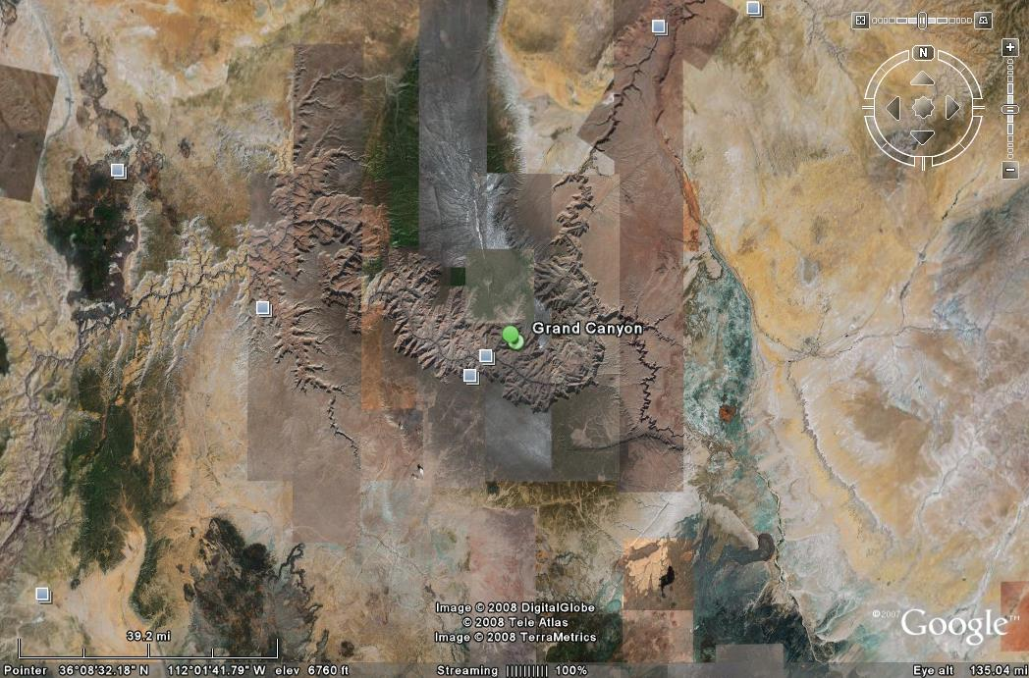

Geology of Mars

Goal: Students will practice sharing “expert” knowledge with members of new research group in order to build a group to evaluate the geological processes likely on a selected region of Mars.

Pre-lab: Geology of Mars

Introduction:
You have joined a group of researchers preparing to analyzing imagery from several areas of Mars that are being considered as potential landing sites for scientific mission.

When your group forms you should spend a few minutes introducing yourselves, then move into short presentations of each of your specialties (as developed in last week’s lab).

It is important that you begin to work as a team. In order to practice using your skills to analyze images from Mars go to:

http://clickworkers.arc.nasa.gov/hirise

Read the summary of what Clickworkers for HiRise is all about and summarize. This is an actual working site, the images you analyze will be entered in a database for future use, you are making a contribution!

- Analyze 5 pictures at a minimum, working as a group on each one. (Don’t try to shortcut this part, it is important that all members work together.) Print out one of the images that you find interesting.
- Annotate the images telling what geological features you found and why they are interesting. Suggest a science question for each image.

Your Project:

Now you should be ready to go on and investigate some of NASA’s proposed landing sites for the Mars Science Laboratory. Thirty-six sites made the “finals”, look at these sites and decide if the processes your group is interested in were once active there.

The site below has images of the 36 sites that were possibilities for the Mars Science laboratory.
http://themis.asu.edu/landingsites/

- List 3 or 4 of the 36 sites at http://themis.asu.edu/landingsites/ that you think would be interesting from the point of view of the geology specialties you have each learned about. (These may include the 7 final sites selected by NASA by they don’t need to, you may have reasons for choosing others from the 36.
- For each of the sites, give evidence that the process or processes your group is interested have occurred there at some time..
- Print out an imagine of the site that is your first choice of the ones you have considered..
- Label the image with the exact coordinates and identify it on a map of Mars.

The sites in the table below are the seven that have been chosen by NASA out of the 36 as finalists for the MSL mission.

MSL Landing Sites – Final 7

MSL LANDING SITES
NAME | LOCATION | ELEVATION | TARGET
Nili Fossae Trough | 21.00ºN, 74.45ºE | -608 m | Noachian Phyllosilicates
Holden Crater Fan | 26.37ºS, 325.10ºE | -1940 m | Fluvial Layers, Phyllosilicates
Mawrth Vallis  Site 1  Site 2  Site 3  Site 4 | 24.65ºN, 340.09ºE  24.01N, 341.03ºE  23.19ºN, 342.41ºE  24.86ºN, 339.42ºE | -3093 m  -2246 m  -2187 m  -3359 m | Noachian Layered Phyllosilicates
Eberswalde Crater | 23.86°S, 326.73°E | -1450 m | Delta
Miyamoto | 3.34ºS, 352.26ºE | -1807 m | Phyllosilicates, Sulfates?
S Meridiani | 3.05ºS, 354.61ºE | -1589 m | Sulfates, Phyllosilicates
Gale Crater | 4.49ºS, 137.42ºE | -4451 m | Layered Sulfates, Phyllosilicates,

Table from http://marsoweb.nas.nasa.gov/landingsites/index.html MSL Landing Sites - Final 7 v. 7; 07/08/08

Read the selection criteria that were used to sort out seven sites here:
http://marsoweb.nas.nasa.gov/landingsites/msl2009/memoranda/sites_jul08/MSL%20Landing%20Sites%20-%20Final%207%20v.7.doc

- Your criteria may differ, and your selection from the 36 possibilities may not be on NASA’s short list. Whether it is or not, list reasons why you think this site would be ideal for NASA to chose for a science mission.
- Draft a letter to NASA explaining which site you recommend they choose for the MSL mission, and giving reasons from the point of view of your science specialties. Why do you find this an interesting and potentially scientifically useful place to set up a laboratory?

TURN IN:
Group:
  - A labeled HiRise image
  - Your notes on 3 or 4 top sites for the MSL mission, including location of sites and evidence for the processes you are interested in.
  - A printed image of your selected site
  - Map of Mars with your chosen site marked
  - Your list of reasons for selecting this site
  - Letter to NASA
Individual:
Rating form for group process

Group member rating form

Please rate each group member using the following scale. Any rating of 1 must be explained.

Excellent performance = 3
Average performance = 2
Inadequate performance = 1

.
Group member name
Showed up on time ready to work
Contributed to final product in a significant way
Listened to others and took their contributions seriously
Was able to lead when necessary

Stayed on task
Overall assessment

Explanation of scores below 1 for any of the boxes above.

Additional comments.

MATHEMATICS TOOL KIT

INTRODUCTION: 90
EXPONENTS and SCIENTIFIC NOTATION 90
LOGARITHMS 92
RATIOS 95
UNITS OF MEASURE 96
GRAPHING 98
PROBLEM SOLVING TECHNIQUES 98

INTRODUCTION:

It is often easier to explore science concepts and relationships with a combination of mathematics and words than with words alone. Some important math tools are presented in the following sections. Your instructor can give you get help with them if you have forgotten them from your high school algebra course. You may need to refer to this section during astronomy 111 and 112 so be sure you are clear about the concepts presented here.

If your algebra is rusty there are many good places to go for help. You can consult a text, and instructor, or one of the on-line help sites such as:
http://www.algebrahelp.com/lessons/
http://www.purplemath.com/modules/index.htm http://www.mathleague.com/help/algebra/algebra.htm

EXPONENTS and SCIENTIFIC NOTATION
Exponents are an economical way of writing the repeated multiplication of a factor:
a a a = a³

Here we represent repeated multiplication by using a power (i.e. an exponent) of 3, which indicates that you need to use “a” as a factor three times. For example, if a = 2, the above equation above would give an answer of 8; i.e. a³ = 8. The exponent (power) simply indicates the number of times a factor is repeated.

Look at the problem below:

a² a⁵

Let’s write the problem in expanded form:

(a a) · (a · a · a · a · a) = a · a · a · a · a · a · a = a⁷

Notice that a⁷ simply equals a² ⁺ ⁵.

Notice that the exponent in the answer is simply the sum of the exponents of a.

Thus, to manipulate multiplication of values raised to a power, you simply add the exponents. However, this applies only if the value (i.e. the factor) is the same!

Example: a² · b⁵ does NOT equal ab⁷!

How would you handle division of exponents? (Hint: Multiplication and division are opposite operations. When you multiply values raised to a power, you add the exponents.)
a⁵ = a · a · a · a · a = a · a = a²

a³ a · a · a 1

Notice that a² simply equals a^{5 – 3}.

Notice that the exponent in the answer is simply the difference between the exponents of a.

Thus, to manipulate division of values raised to a power, you simply subtract the exponents. Again, this applies only if the value (i.e. the factor) is the same!

Example: a⁵ ÷ b³ does NOT equal ab²!
Having now introduced power rules we can discuss scientific notation, which is the form of expressing a value most often used in the sciences. In this notation a value is expressed as a number greater than or equal to 1 and less than 10, multiplied by a power of 10.

For example, the value 450 expressed in scientific notation:

450 = 4.5 × 100 = 4.5 × 10 × 10 = 4.5 × 10²

You may see this represented on your calculator as 4.5 E2. Here the E stands for exponent and the number raised to that power is always assumed to be 10.

What happens when the value is less than 1?
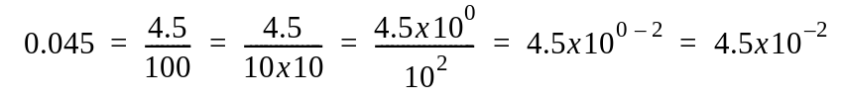

In general, a negative power of 10 indicates a value less than 1.

Now that you can write values in scientific notation, how do you combine values that are expressed in this form?

For addition, the exponents must be identical if we are to add the values preceding them.
(Why is this true?) Think about the values as expressed in standard notation first.

450 + 25 =
We know the answer is 475, but we can get this same value using scientific notation:

(4.5 × 10²) + (2.5 × 10¹) =

Since the powers must be identical we have to change the expression of one of the numbers:

Express 450 as 45 × 10¹

We substitute this expression of the number into the problem:

(45 × 10¹) + (2.5 × 10¹)

You can now factor out the power of 10 by using the distributive law of multiplication over addition:

(45 + 2.5) × 10¹ = 47.5 × 10¹ = 47.5 × 10 = 475

For multiplication, follow the rules for exponential notation as previously discussed:

(450)(1000) =

Express each value in scientific notation:
(4.5 × 10²)(1 × 10³) =
Separately group the numbers and the powers of ten:

(4.5 × 1)(10² × 10³) = 4.5 × 10⁵

In general, multiplication and division problems involving exponents can be simplified. Instead of entering powers of 10 into your calculator, just combine (i.e. add or subtract) the exponents as previously discussed for multiplication and division and then proceed as before.

LOGARITHMS

Scienctific notation makes it easier to work with large numbers. Logarithms make it easier to work with scientific notation. A logarithm (log for short) using the fact that you can represent a number using a base (for scientific notation the base is 10 though other bases are possible) and an exponent to make calculations simpler.

For a simple example, think about how you would write 100 and 1000 in scientific notation.

100 = 10²
1000 = 10³

But how would you write 500 for example? Another way to put it is to ask what power of 10 gives you 500. Since 500 is between 100 and 1000, the answer must be between 10² and 10³. It would be tempting to guess that the exponent needed is 2.5, but it turns out to be approximately 2.7. So 500 can be written in base 10 as 10^{2.7}.

What do you think the necessary exponent would be to represent 200 in base 10 notation? You can use the log function on your calculator or on a spreadsheet program to find the answer using the expression =log(200,10). (The spreadsheet uses base 10 as a default so you can also type =log(200)).

In case you haven’t guessed, log of a number is just the exponent needed to raise a base of 10 to the number. To “take the log” of a number is just to find out what exponent 10 needs to have to make it equivalent to the number.

Working with logs

Once you have taken the log of the number you can using it in calcuations. Remember the rules of multiplying and dividing numbers with the same base. To multiply 10² times 10³ remember that you keep the base but add the exponents. So to multiply numbers that are in log form, just add the logs together. Similarly division of numbers is equivalent to subtraction of their logs. If you want to raise a number to a power, you multiply its log by the power to which you are raising it. You can do this easily on the calculator.

Converting logs to numbers

Once you have completed the mathematical calculations using logs it is simple to get the original number again. Just raise 10 to the desired power. For example, if the result of you math in log form is 2.3, raise 10 to the 2.3 power and get 199.5262. Not exactly 200, but if you are working with very large distances in astronomy for example, the errors caused by rounding are usually not significant. You can convert a log back to the number it represents using a spreadsheet by typing =10^2.3 (or whatever log you are working with), on the spreadsheet.

A example of the importance of logs in simplifying equations is when we think about stellar distances. The following equation relates a star’s apparent magnitude, how bright it appears to us, and its actual magnitude, how bright it would be if we were seeing it from 10 parsecs (a distance measure in astronomy) away to the actual distance of the star.

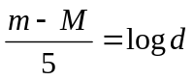

You will see this equation more in astronomy 113 and 114, don’t worry if the concepts are not yet clear.

Try an example. A star has an apparent magnitude (m) of 13 and an actual magnitude of 2. Using the formula, calculate the distance (it will come out in parsecs using the formula) the star is from us.

Substituting the values given we get

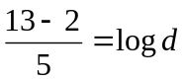
or

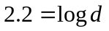

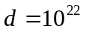

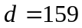 parsecs

Working the other way around we can figure out the absolute magnitude (M) of a star when we know its apparent magnitude and distance away of the star. If m is 20 and d is 1200 parsecs, what is the absolute magnitude M?

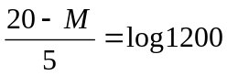
So
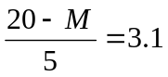

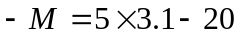

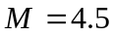

RATIOS
Understanding astronomical sizes and distances can be difficult as they are often so large that they go beyond our everyday comprehension. One way to appreciate the sizes of planets/moons/stars is to construct ratios between these celestial bodies so that sizes can be examined in relation to one other. The question could be asked, “How many times larger/smaller is one object than another?” To answer this question requires that we set up a ratio between the two objects. Let’s try to use ratios to find out about the relative sizes of some of the celestial bodies in our solar system.

A ratio is the quotient of two numbers. The numbers should usually be expressed in the same units of measure. In this example all the radii are measured in km (kilometers), so there is no need to change units.

If we want to compare the Sun’s radius to the Earth’s radius, we need to put the Sun’s radius in the numerator and the Earth’s radius in the denominator, as shown below. The quotient will be the number of Earth radii that equals the radius of the Sun.

If the radius of the object under consideration is larger than the Earth’s radius, the resulting ratio will be greater than one. This ratio will describe how many times greater the object’s radius is than the Earth’s radius. If the radius of the object under consideration is smaller than the Earth’s radius, the resulting ratio will be less than one. This ratio will describe how many times smaller the object’s radius is than the Earth’s radius. These ratios provide a quantitative means of examining the relative sizes of various celestial objects.

UNITS OF MEASURE

Without units, numbers are simply…numbers! By attaching a unit to a number it becomes a quantity. Units are needed to complete the story of the calculations you made. Were you looking for a velocity, a distance, a time? What does the number represent? Without units you are doing simple mathematical calculations; by attaching a unit, you are making calculations involving velocity, distance, and time, to name just a few quantities. Keep in mind, throughout this lab and this course, that units are important. Not only do they indicate to someone reviewing your work the different quantities that were measured, but, if you pay attention to them as you take your measurements and do your calculations, they also will indicate the algebraic steps you need to follow in order to solve a problem.

Combining quantities with addition and subtraction: You can only combine (i.e. add/subtract) two quantities that have the same units.
Example: John walked 1 mile and then walked an additional 3 kilometers. You cannot add these quantities and say that John walked 4 miles-kilometers. In order to do this addition either 1 mile must be converted to an equivalent number of kilometers or 3 kilometers must be converted to an equivalent number of miles.

Multiplying and dividing quantities: You can multiply/divide any two quantities, regardless of units; however, just as numbers multiply/divide, so do the units!

Example: John walked 3 kilometers in 20 minutes. If we want to determine the speed at which he walked, we need to look at the following equation:
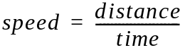
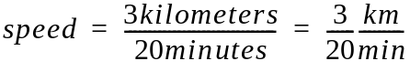

We had to divide both the values and the units.

Converting Units: Units also cancel out like the factors of numbers in multiplication/division problems.

Example: John cycled for 30 minutes at a speed of 15 miles/hour. How far did he cycle?

Notice that this problem involves two different units of time: minutes and hours. We cannot cancel out different units, only identical ones. Thus, we must convert one quantity to the other in order to solve the problem. When converting we want to change the units without changing the value of the number. To do this we will multiply by the value 1 expressed in the appropriate form, since multiplication by 1 does not change the value of a number.

In order to convert 30 minutes into an equivalent number of hours, we will use the following conversion factor, which is a fractional equivalent of 1:

1 hour/60 minutes

Conversion factors are ratios, equal to 1, in which the numerator and the denominator contain different quantities.

You may ask, “How can this help?”

Well, we know that 60 minutes = 1 hour, so let’s try converting the quantity of 30 minutes:

We can see that the minutes cancel out, leaving us with units of hours, which is exactly what we wanted. The conversion factor (1 hour/60 minutes) = 1, because one hour equals 60 minutes. Thus, we have not changed the value of the 30 minutes, but simply converted it to another unit of measure (i.e. to an equivalent quantity).

Now, to solve the initial problem:

John cycled for 30 minutes = 0.5 hours at a speed of 15 miles/hour. How far did he cycle?

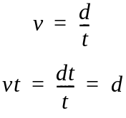
Thus, he cycled a distance d = (15 miles/hour) x (0.5 hour) = 7.5 miles. Notice that we used unit cancellation in both parts of this problem. You will use this technique often in the lab exercises.

Note: It is important that all the ratios under consideration have the same quantity in the denominator—in this case the radius of the Earth—so that comparisons of the different ratios can be made.

GRAPHING

The ability to read and interpret graphs is part of scientific and quantitative reasoning. This is essential to understand how science, a well defined process, is accomplished. In this laboratory exercise, and many of the following exercises in the reminder of the semester, you will be asked to plot or graph certain data. You will then need to extract information from the graphs. This requires you to understand the basic nature of the Cartesian plane, namely the xy-axes of a graph. Please keep in mind that proper units are always necessary, so always label your data, label your graphs, and note the units you are using in your calculations.

There are many different types of curves that can result from the graphing of data. Some graphing will entail the plotting of data which is linear, that is, the result will be a straight line. Each point on a line can be defined by two values, an x-value and a y-value. Each line can have a positive or a negative slope, that is, the line will either slant upward or downward as it moves to the right. This means that y will either be a positive or a negative multiple of x plus a constant offset. For example:

y = c₁x + c₂

Here c₁ and c₂ are constants. If c₁ = m and c₂ = b, the equation then becomes the standard slope-intercept formula of a line:

y = mx + b

Here m is the slope of the line and b is the y-intercept or the point where the line crosses the y-axis.
Please remember that a line can have a slope of zero, meaning it is horizontal, or no slope, meaning it is vertical.

You will encounter plots that are not linear. In such a case you will have to graph the values of x and y so that the shape of the resulting curve can be determined. Nonlinear equations, associated with non-linear plots, are more difficult to solve.

A convenient way to graph quantities to show the relationship between them is to use a spread sheet program. We will use a spread sheet it nearly every lab so it is important to practice with them if you have forgotten how to construct and use this powerful program.

PROBLEM SOLVING TECHNIQUES
In astronomy we must ‘use’ mathematics to ‘answer’ a question. Therefore, you must know how to formulate the question into mathematical equations in order to find the solution.

Outline of Steps to Solve Mathematical Questions:
1.) State the question clearly.
2.) Make an educated guess at an answer. This will allow you to check whether your solution makes sense.
3.) Collect the facts presented or needed to solve the problem.
4.) Formulate equations using these facts.
5.) Solve the mathematical problem (i.e. the equations) to answer the question.
6.) Check your solution with your prediction. Ask yourself if it makes sense.

Error Calculations:

Knowing how much error is in your measurements is important in science. There are many ways of doing error calculations. For our purposes in Astronomy 112 and 114 we usually use a simple comparison of the result obtained in lab to known values from published sources. The percent error of a final result is the difference between the value you found by experiment and the published value divided by the published value to get a decimal amount, then multipled by 100 to get percent error.

Your value – published value X 100
Published value

This is usually an absolute value.

Introduction to Celestial Coordinate systems

For our study of the solar system it is necessary to understand three different sets of coordinate systems. Each has a different purpose, but they are similar in that each uses a pair of coordinates to establish position. You should be able to visualize all three and know where each one is used to understand position and motion in the solar system.

Check your textbook first as you try to sort out the coordinate systems used in the Farquhar Globe lab. Your text probably has an online guide as well that may be useful. In addition, here are some websites you can visit for diagrams to supplement the basic outline of the systems in this guide.

http://www.astroleague.org/al/astrnote/astnot11.html
http://library.thinkquest.org/29033/begin/coordinate.htm

Latitude and longitude:

The first coordinate system is the system we use to uniquely define a position on Earth. Lines of latitude are measured from the equator to the poles with the equator being at 0 degrees latitude, the North Pole at 90 degrees N and the South Pole at 90 degrees S. Longitude is measured from the line that goes from the North Pole to the South Pole and runs through Greenwich England. Starting with 0 degrees at Greenwich, longitude is measured either East or West to 180 degrees. A given latitude and longitude uniquely determine a position on the surface of the Earth. If you didn’t note the longitude and latitude marks on the Earth sphere, look for them now and make a sketch.

Right ascension and declination:

The celestial sphere has a similar system of measurement. If you imagine Earth’s equator extending until it touches the celestial sphere, this celestial equator is at 0 degrees of declination. Declination is marked in horizontal circles that get smaller until they reach the poles at + 90 degrees for the North Pole and – 90 degrees for the South Pole.

The vertical measuring lines are called lines of right ascension. Since the stars appear to make a complete circuit of the Earth in about 24 hours, right ascension is divided into 24 major divisions. The 0 of right ascension is at the vernal equinox, the point where the Sun crosses the horizon in March, as it moves from the southern to the northern hemisphere. The 24 units of right ascension are broken down into minutes and seconds.

Because R.A. and dec are the same for anyone observing a particular star, or position of a planet at a given time, they are used to point telescopes at an object whose R.A. and dec. are known. R.A. and declination change over a short period of time for planets, moons, asteroids and comets, but star’s positions change much more slowly and can be considered to have fixed values for R.A. and dec for our purposes.

Altitude and azimuth:

Since right ascension and declination are not marked on the sky itself, it is often useful to use a third measuring system which depends on where the observer is on Earth. If you were standing in the quad and wanted to point out a particular star to a friend you might use a form of altitude and azimuth to locate it. You could begin by estimating altitude, how far above the horizon the object is. Your book outlines some ways to estimate this, for example, the width of your hand held at arm’s length is about 10 degrees. The horizon is at 0 degrees, the zenith, the point in the sky directly overhead, is at 90 degrees so the object will be somewhere between 0 and 90 degrees in altitude.

The second direction you could give your friend is azimuth, which is measured from 0 to 360 degrees along the horizon. Face north and you are looking at azimuth 0 degrees. Turn one quarter of the way to your right, facing east and you are looking at 90 degrees azimuth. Facing south is 180, and West is at 270. Again you can estimate the approximate number of degrees from North to locate the object in terms of azimuth.

Graphing with Excel

It is helpful if you are familiar with the program before using it is class. Some websites that may help are listed below. Be aware though that the lab version is the newest one and the buttons and general look are different. All the same features are included, but some take a little looking for if you are using it for the first time. Your instructor can help guide you through the process of making a graph, and you will find that many students have quite a lot of experience with using the program for graphing.

Some useful websites to practice with at home.

This one is from Clemson University’s physics laboratory
http://phoenix.phys.clemson.edu/tutorials/excel/graph.html

And this one has a tutorial that may be useful. The LabWrite program is also one to remember if you are ever asked to write a formal lab report.

http://www.ncsu.edu/labwrite/res/gt/gt-menu.html

This one from Chemisty professor Dr. Thomas R. Burkholder is also very simple and straightforward.

http://www.chemistry.ccsu.edu/burkholder/chem121/graphing_in_excel.htm

