Karyn Sykes
Professor Kristin Scott
Final Discovery
12/8/08

Looking Back
There are four major waves of British immigration (Powell 37). The first major wave was between 1620 and 1650 when about 21,000 people from England immigrated to the United States in search of religious freedom (Climent 18, 30). They had a specific ideology, and when the Church of England refused to reform, they decided to revolt and create a new colony in America where they could practice their beliefs freely (Climent 18). The reaction of these immigrants is similar to the reaction of the Communists in China. The Communists did not agree with the government so they decided to revolt and overtake the government. The Communists wanted to practice their ideology freely. On the other hand, the reaction of the immigrants was not violent like the reaction of the Communists. The second wave was during the 1750s when about 45,000 people from southern England came to America (Powell 37). Most were Royalists and indentured servants (Powell 37). Since the colonies were still under the rule of England, the King gave land in America to the Royalists who were his supporters (Climent 33). The third wave was between 1790 and 1820, when about 23,000 people came to America (Powell 37). Most of the people who came to America during this time were looking for a better life (Powell 37). The fourth and final wave was between 1830 and 1850 (Climent 51). During this time, about 250,000 people came to America (Powell 37). Many came because of the economic struggles in England and were looking to America as a way to improve their lives (Powell 37). The table and graph below help explain this information.

British Immigration
Date | # of Immigrants | Origin | Settlement
1620-1650 | 21,000 | England | Massachusetts
1750s | 45,000 | Southern England | Virginia
1790-1820 | 23,000 | Wales and the Midlands | Delaware
1830-1850 | 250,000 | England and Ireland | Along the Appalachians
(Powell 37)
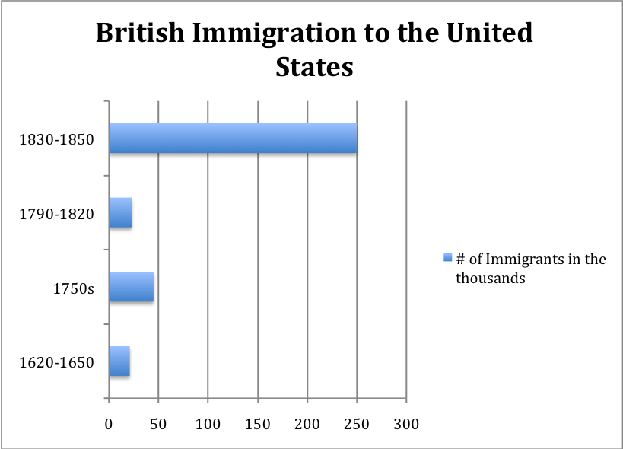
(Powell 37).
Between 1790 and 1820, many of the immigrants traveled to America in search of a better life but were met with laws that invoked fear, and this wave of immigration is closest to the immigration of Henry and Conrad Bolton.
Between 1790 and 1820, 23,000 Immigrants entered the United States from England (Powell 37). They came to America during the time of British Imperialism (Ward 44). During this time, England was controlling places such as India to help England become wealthier and more capitalistic (Ward 46). England wanted to force its ideas of capitalism on the smaller countries, and by using the resources and revenue from those countries, England hoped to help its own country prosper and finance wars (Ward 47). The British Imperialism is similar to the European imperialism of Africa that we studied in class (Azevedo 78). Azevedo states that during the European imperialism “the capitalists needed precious raw material to feed their factories and machinery as well as new opportunities to invest surplus capital” (78). The Europeans used the resources in Africa instead of their own to help profit the European countries (Azevedo 78). England did the exact same thing to the smaller countries that it conquered.
The Immigrants who came to America during this time were mostly Quakers (Powell 37). They were in search of a better life in America (Climent 52). The British were involved in several wars, and the economic conditions were bad even with the resources and wealth they acquired from other countries (Climent 52). Many people began protesting, and the economic conditions worsened (Climent 52). The Quakers left England hoping to escape the economic conditions and the oppression from the government (Climent 52). When they arrived in America, they were met with persecution from the Puritans (E.E.C 6). The Puritans would kill any Quaker that acted “disorderly” and who did not follow their laws (E.E.C 6). The Quakers then decided to move into the Delaware Valley where they would be free from the Puritans and could do as they pleased (Climent 52.) Below is a timeline of some of the major events during that time period along with the sources I used to find the information.

Timeline of British Events
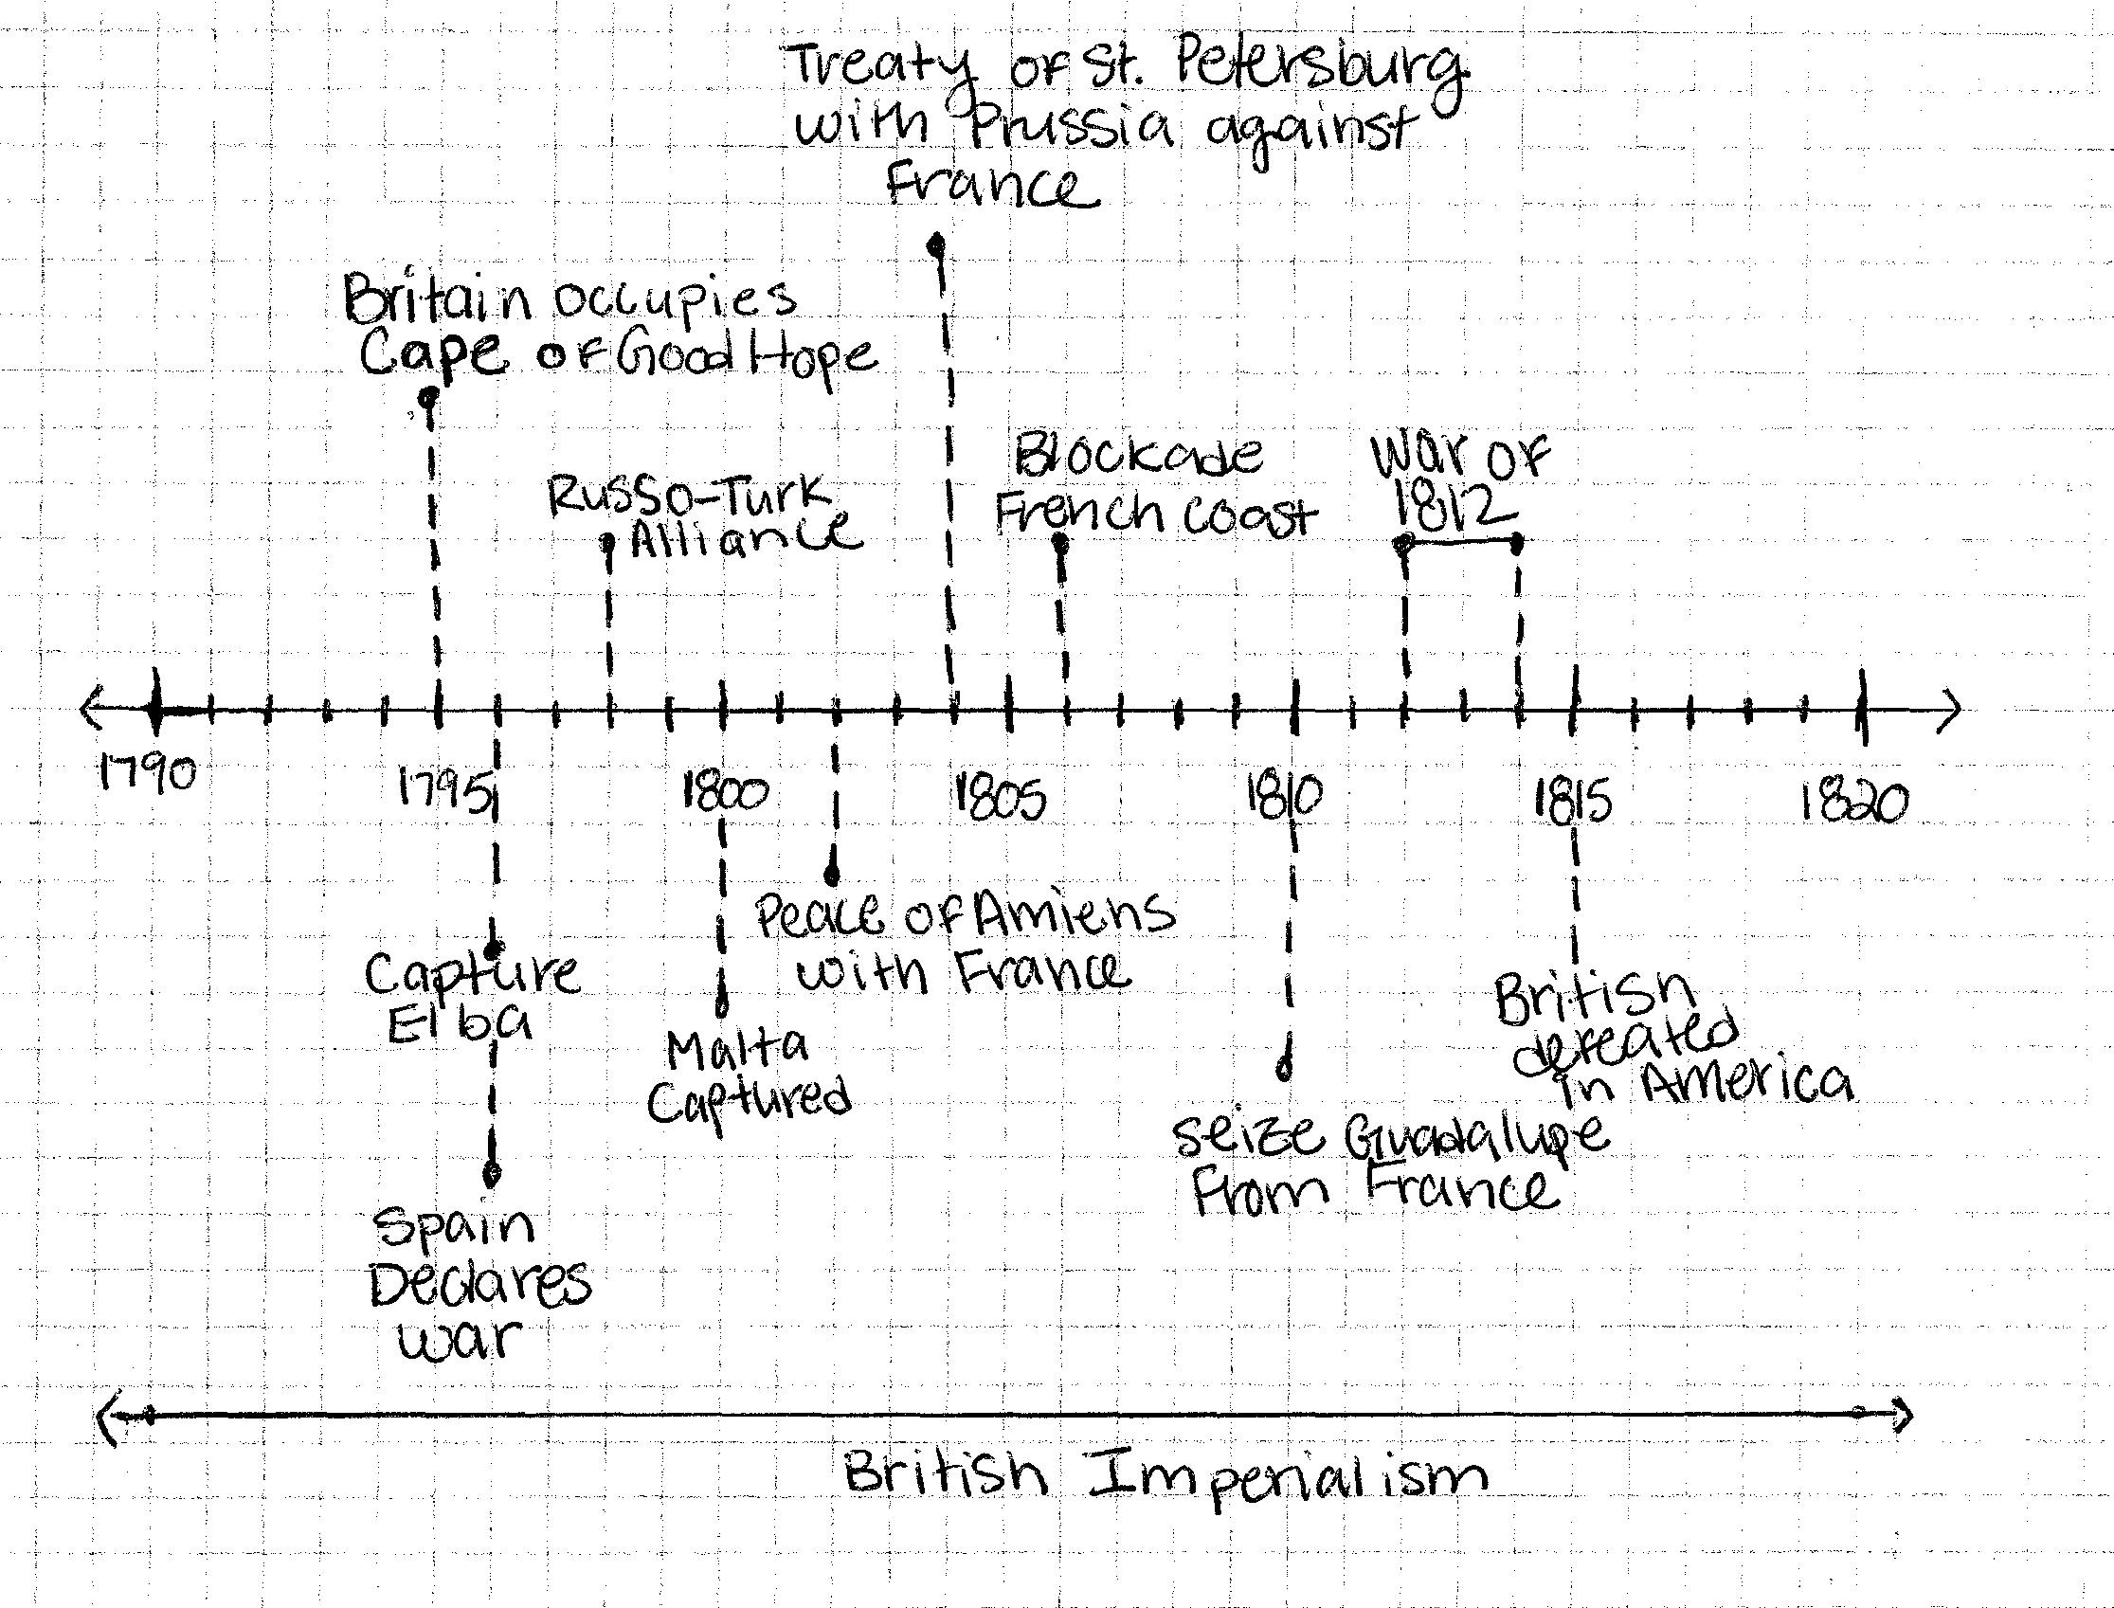

Works Cited for the Timeline

Grun, Bernard. The Timetables of History. New York: Simon and Schuster/
Touchstone, 1991.
Ward, J. R. “The Industrial Revolution and British Imperialism 1750-1850.” The
Economic History Review, New Series. Vol. 47 No. 1 (1994):pp 44-65. JSTOR, http://mutex.gmu.edu:2112/stable/2598220?&Search=yes&term=1790-1820&term=british&term=imperialism&list=hide&searchUri=%2Faction%2FdoBasicSearch%3FQuery%3Dbritish%2Bimperialism%2B1790-1820%26x%3D0%26y%3D0%26wc%3Don&item=1&ttl=75&returnArticleService=showArticle>

Soon after the immigrants arrived, Congress passed the Alien and Sedition Acts (Transcript). These laws made it legal for the President to deport any alien he judged as “dangerous to the peace and safety of the United States,” or an alien he believed was involved in “treasonable or secret machinations against the government” (Transcript). These laws also made it legal for the President to imprison alien males over the age of fourteen during a war against the country the aliens came from (Transcript). Finally, the Alien and Sedition Acts made it a crime to talk or write anything against the government of the United States (Transcript). The government passed the Alien and Sedition Acts to keep immigrants from turning against the United States, but these laws caused many problems for new immigrants.
The Alien and Sedition Acts were passed during a period when the United States was about to go to war with the French (The Formation). With the colonization of the Americas, many groups who were previously separated came into contact with each other and began fighting over the land (Pratt 6). They all wanted complete control over the colonies (Pratt 4). In 1798, the United States had only been a nation for about ten years, and both France and England continued to fight for potential control of the Americas (Grussendorf 126). The United States was “caught in the middle” of the conflict, and finally, the government decided to sign a treaty with the British (Grussendorf 126). The French became angry and began attacking American ships (Grussendorf 126). Many of the immigrants coming to America during that time were either French or British (A Daily). The government feared that these aliens would side with the French if they were to go to war with them (The Formation). Therefore, the government passed the Alien and Sedition Acts to give the President power to deport or imprison any alien who was against the government (Transcript).
The Alien and Sedition Acts caused problems for new immigrants (Grussendorf 127). Many of the immigrants during that time were looking for relief from the war between England and France (A Daily). When they arrived in America, they were met with the threat of being sent back (Transcript). They were constantly on their guard making sure they did not say anything against the government that would send them back to their homeland (Transcript). Many immigrants were sent away or imprisoned (Hakim 43). Immigrants lived with the constant fear that they would be sent back to their homeland (Transcript).
In the same way, the Alien and Sedition Acts made it harder for immigrants to become citizens (A Daily). The naturalization laws became more strict and defined (A Daily). For example, the residency requirement in order to attain citizenship was raised from five years to fourteen years (The Formation). Also, an alien must live in the state or territory he or she intends to stay in for five years (Dyer). In other words, the alien had to live in one place for five years (Dyer). Finally, an alien must declare his or her intention of becoming a citizen five years in advance (Dyer). This meant that an immigrant who had just arrived in America had to first let the government know that he or she wanted citizenship (Dyer). Then, he or she had to wait five years until they could begin to count the fourteen years of residency required for citizenship (Dyer). Therefore, not only did immigrants have to live in fear of being deported, but they also had to wait a long time before they could become citizens.
The Alien and Sedition Acts were passed to keep immigrants from siding with the French, but the laws filled the immigrants with fear and made it harder for them to become citizens (Transcript). With the passing of these laws, the United States received its second lowest number of immigrants from England (Powell 37). The immigrants who decided to come to America were trying to escape the war and economic problems that they faced in England (Climent 52). When they arrived in America, they were met with hostility and threats of being sent back (Transcript). The Alien and Sedition Acts were enforced until spring of 1801, and they were never again passed into law by Congress (Hakim 45).
Henry and Conrad Bolton came to America from London, England sometime between 1770 and 1775 (Bolton 19). This is about 15 to 20 years before the major wave of immigration we just talked about. Henry and His brother Conrad were at the Port of London looking at the harbor when a person on one of the ships convinced them to come aboard to look at the harbor from there (Bolton 19). The boys agreed and stepped onto the boat (Bolton 19). As they were looking at the harbor, the ship began to leave, and they could not return (Bolton 19). The name of the ship they boarded was Culvert (Bolton 20). Below is a copy of the passenger list from the Culvert listing both Henry and Conrad as passengers.
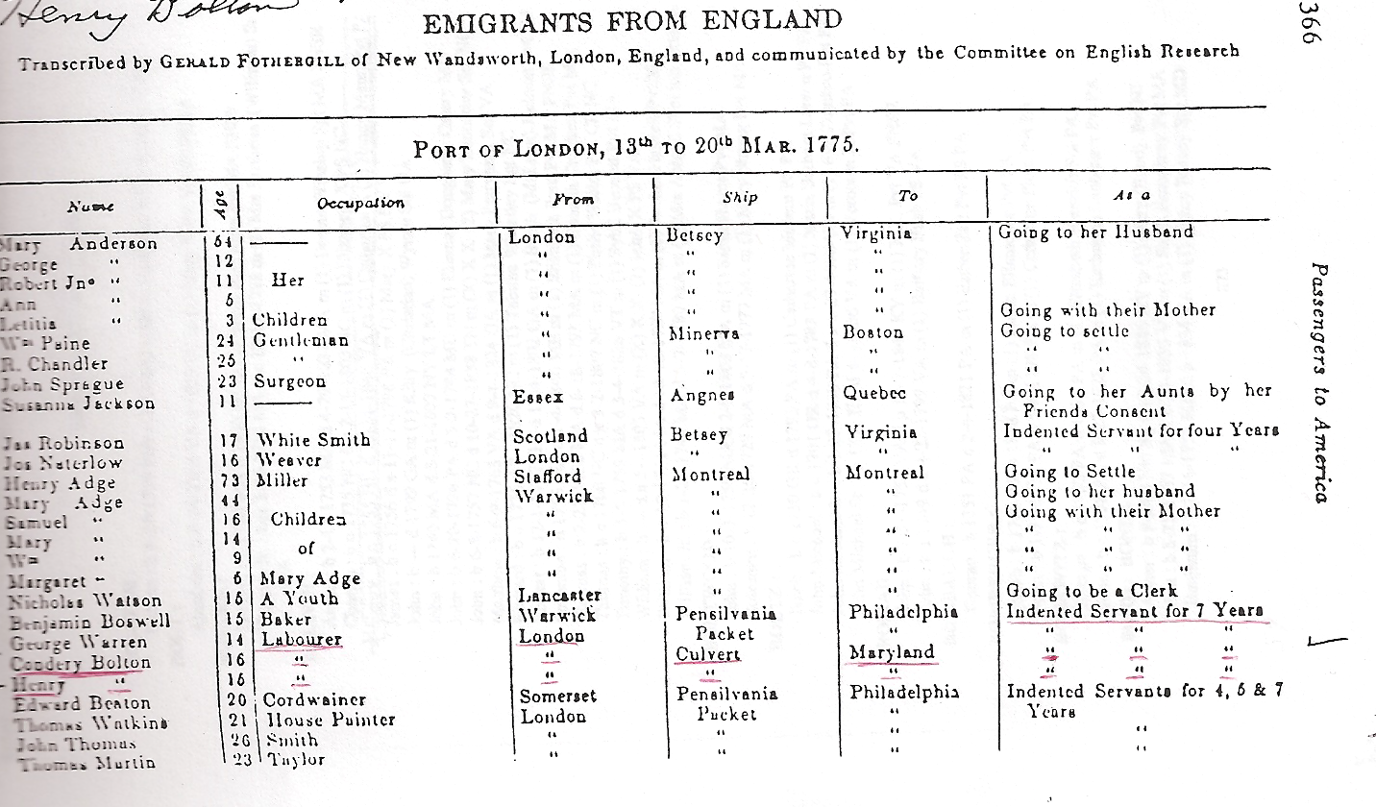
(Bolton 1).
Henry and Conrad arrived in Maryland mid March in 1775 (Bolton 20). They became the indentured servants of Mr. Moore in Hagerstown, Maryland (Bolton 19). Eventually, Henry joined George Washington’s army and fought in the Battle of Brandywine (Bolton 19). After the war, Henry married Catherine Chapman, and they had six children before she died in 1798 (Bolton4). A year later, Henry married Nancy Mann, and they had 14 children (Bolton 4). Below is a picture of Henry and Nancy’s son Joseph at a family reunion (Bolton 23).
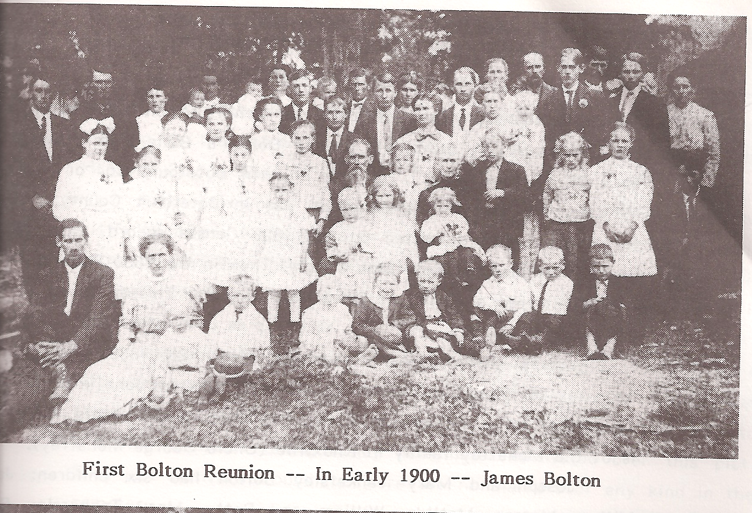
(Bolton 23).
Between 1790 and 1820, many of the immigrants traveled to America in search of a better life but were met with laws that invoked fear, and this wave of immigration is closest to the immigration of Henry and Conrad Bolton. The Quakers were trying to get away from the war and economic crisis in England (Climent 52). They hoped that they would find peace and prosperity in America, but they were met with the Alien and Sedition Acts that made it harder for them to become citizens and could return them to their homeland upon arrival into the country (Transcript). On the other hand, Henry and Conrad were forced to come to America (Bolton 19). They were not trying to escape war or financial problems (Bolton 19). They accidentally got stuck on a ship, and it changed the course of their lives forever (Bolton 19). Both the Quakers and the Bolton brothers were faced with many choices (Bolton 19). They could decide to stay, or they could choose to leave. In the end, Henry and Conrad decided to stay even with all the hardships they would face including a war (Bolton 19). Their choice to stay affected the lives of the many generations that followed them, and the Bolton family continues to live out their story in America today.

Works Cited
"A Daily Lesson in History :June 25, 1798--The Alien Act ...
Passed.. " Boston Daily Globe (1872-1922) [Boston, Mass.] 25 Jun 1901,10. ProQuest Historical Newspapers Boston Globe (1872 - 1925). ProQuest. George Mason Library, Fairfax, Virginia. 21 Nov. 2008 <http://mutex.gmu.edu:2233/>
Azevedo, Mario. Introduction. ”European Exploration and Conquest of Africa.” The
Reader. Ed. Mario Azevedo. Durham: Carolina Academic Press, 2005. Pg 67-79.
Bolton, Wint. Bolton Family History. 1985.
Climent, James ed. Encyclopedia of American Immigration Volume 1. New York:
Sharpe Reference, 2001.

Dyer, Brainerd . "Today in History. " L.A. Times (1886-
Current File) [Los Angeles, Calif.] 18 Jun 1958,B4. ProQuest Historical Newspapers Los Angeles Times (1881 - 1986). ProQuest. George Mason Library, Fairfax, Virginia. 21 Nov. 2008 <http://mutex.gmu.edu:2233/>
E.E.C.. "The Puritans and Quakers. " New York Times (1857-Current file)
[New York, N.Y.] 8 May 1899,6-6. ProQuest Historical Newspapers The New York Times (1851 - 2005). ProQuest. George Mason Library, Fairfax, VA. 14 Nov. 2008 <http://mutex.gmu.edu:2233/>
Grun, Bernard. The Timetables of History. New York: Simon and Schuster/
Touchstone, 1991.
Grussendorf, Kurt A. America Land I Love. Florida: A Beka Book, 1994.
Hakim, Joy. The New Nation.” New York: Oxford University Press, 1993.
Powell, John. Encyclopedia of North American Immigration. New York: Facts-on-File,
2005.
Pratt, Mary L. “Introduction: Criticism in the Contact Zone.” The Reader. New York:
Routeledge Publishing Inc, 1994.
“The Formation of Political Parties: The Alien and Sedition Acts.” Archives. National
Archives and Records Administration. 11/21/08 <http://www.archives.gov/exhibits/treasures_of_congress/page_5.html#>
“Transcript of Alien and Sedition Acts (1798).” Our documents. National Archives.
11/21/08 <http://www.ourdocuments.gov/doc.php?doc=16&page=transcript>
Ward, J. R. “The Industrial Revolution and British Imperialism 1750-1850.”
Economic History Review, New Series. Vol. 47 No. 1 (1994):pp 44-65. JSTOR, <http://mutex.gmu.edu:2112/stable/2598220?&Search=yes&term=1790-1820&term=british&term=imperialism&list=hide&searchUri=%2Faction%2FdoBasicSearch%3FQuery%3Dbritish%2Bimperialism%2B1790-1820%26x%3D0%26y%3D0%26wc%3Don&item=1&ttl=75&returnArticleService=showArticle>

