Discovery- Support Document – Fareeha Khan Seminar C 2

Senator Linda Todd Puller
P.O. Box 73
Mount Vernon, Virginia 22121

Dear Senator “Toddy” Puller-
From research I found out that is her commonly used nickname. Using this at the start of the letter may make her feel more comfortable.

I encourage you to use your position as senator of my district, the 36th District of Virginia, to actively promote use of alternative fuels to lead to a society less dependant on oil and gas.

Global warming is a problem often overlooked in politics but as there has been a rise in interest on the topic in recent years, so has come the opportune time to create a strong movement towards conservation.

Creating a bill on fuel conservation would be similar to your work already done on energy conservation. Helping alternative fuels become dominant over oil would be groundbreaking and could become an example for other states to follow. Also your work done to clean up the Chesapeake Bay shows how aware you are of our environment’s current state. By continuing to clean it up and save our planet you will gain more supporters who see consistency in your efforts.
She put efforts into cleaning up and preventing pollution from contaminating the Chesapeake Bay. This shows that she is already interested in saving the environment.

By making alternative fuels more available to the public and promoting the use of these over oil and gas we can avoid such disasters as loss of important species of animals and plants to the ecosystem, increased natural disasters such as hurricanes, and health problems that are created from over pollution.
http://www.cem.msu.edu/~cem181h/projects/98/global/gw&everydaylife.html
Using alternative fuels creates more jobs, is better for the environment, and helps engine last longer.
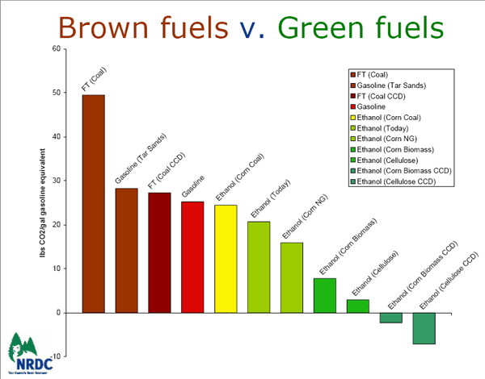

The most effective way to gain momentum on this issue would be to make public transportation more accessible. By creating more stops around the area and perhaps including tax benefits from using public means rather than personal automobiles will propel forward the movement for more efficient use of resources.
http://www.cem.msu.edu/~cem181h/projects/98/global/gw&everydaylife.html

Another way to go about encouraging conservation would be to enforce an act that would require all automobiles to run on alternative fuels. For example promoting use of bio-ethanol fuel in cars would be a fruitful idea. It is an incredibly safe alternative fuel and is non-toxic as well as it lubricates the engine, making it last longer. This would not only conserve oil and gas, but also it would provide jobs and promote business of the alternative fuel companies, which would enhance the economy. Especially because of the constantly rising gas prices, this would be favorable to most citizens. This would be similar to a bill that has recently been introduced in California, Assembly Bill 236. In this bill, the law would be enacted in 2009, giving people time to assess and adjust to the new situation.
http://209.85.165.104/search?q=cache:F1Sm755XfYEJ:www.legis.state.wi.us/2005/data/AB-236.pdf+assembly+bill+236&hl=en&ct=clnk&cd=1&gl=us&client=safari
This bill promises that by 2009 all cars would be converted into cars using alternative fuels. This would ensure a move towards conserving our resources.

My mother works at a hospital and has seen the devastating effects that poor air quality from traffic pollution has had on citizens’ health. Not taking action would result only in an increased number of diseases from breathing in such toxic air. When one takes the time to investigate just what them and their families have been breathing in, they’re flabbergasted and disgusted. The EPA has estimated that 5 to 20% of the populations are susceptible to sickness from air pollution It’s time to clean up this air.
http://64.233.169.104/search?q=cache:4T0Y4ABG7lwJ:www.nwf.org/globalwarming/pdfs/Virginia.pdf+effects+of+global+warming+on+northern+virginia&hl=en&ct=clnk&cd=6&gl=us&client=safari

Fareeha Khan

