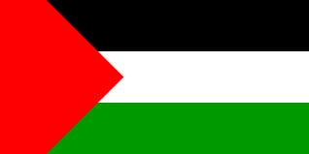

**Celebrating Cultural Diversity**

1. What country (or countries) did your family/ancestors originate?

My family came from America and Palestine.

1. List 3 things that make you special and unique.

**The three things that make me special and unique are: 1) I am very tall; 2) I like babysitting little kids; 3) I love cats!**

1. What are some traditions that you have in your family?

One of the traditions we have in my culture is that we celebrate Eid. It’s kind of like Christmas, we get together with family and friends, eat lots of yummy food, and open gifts!

1. Describe some of your favorite foods from your country that you like?

**One of my favorite foods that we all love to eat is grape leaves with rice inside. It is so yummy! We always ask my grandmother to make them since she is a really good cook. Another food that we love to eat is falafel. We like our falafel in a sandwich. On some nights, we go and order falafel sandwiches.**

