[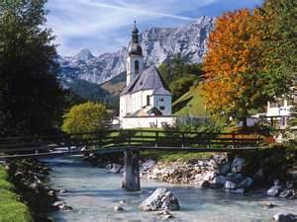](http://wallpapers5.com/images/wallpapers/33460554/Photography/Autumn-in-Ramsau-Bavaria-Germany.jpg) Celebrating Cultural Diversity

1. 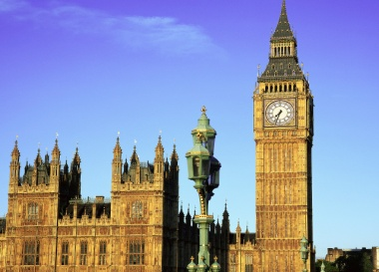What country or countries did your family/ancestors originate?

* My family originated from Germany (my mom’s side of the family) and England (my dad’s side of the family).

1. List three things that make you special and unique.

* I’ve been out of the country and I love to travel.
* I have a ten pound, white, fluffy dog named Milo.
* I play piano and love to listen to music.

1. [](http://0.tqn.com/d/culinaryarts/1/I/m/A/-/-/omelet200.jpg)What are some traditions that you have in your family?

* One tradition in my family is to have breakfast (my dad’s awesome omelets) for dinner on Christmas Eve. Another tradition is that we open one present on Christmas Eve.

4) Describe some of your favorite foods from your country?

[](http://dir.coolclips.com/Celebrations/Christmas/Christmas_Trees/christmas_tree_and_a_present_CoolClips_vc086188.jpg)[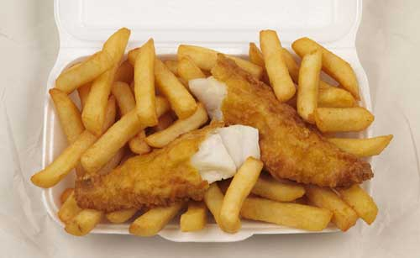](http://1.bp.blogspot.com/-TwwyskCzneY/TZRTUvLAzfI/AAAAAAAAAAs/IgQ4wVPOpPQ/s1600/fish_and_chips.jpg)I love German sausages (Germany)! They are very tasty and mostly big! I also like fish and chips (England)! Did you know that “chips” in England are actually fries?