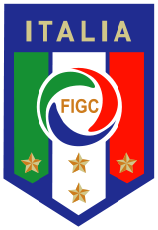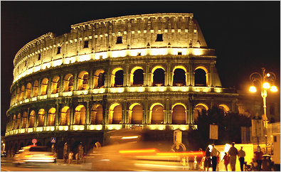

Celebrating Cultural Diversity

1. What country (or countries) did your family/ancestors originate?

My family originated from Italy.

1. List 3 things that make you special and unique.

I am unique because:1) I am good at art; 2) I love basketball; 3) I live with two monsters (my brothers).

1. What are some of traditions that you have in your family?

The traditions that make me unique are is my family is going to New York on thanksgiving. Another is on our birthdays we all get all the time we want with Sandy (our dog)--my brother made that rule up.

1. Describe some of your favorite foods from country that you like?

One of my favorite foods from Italy is Covatels .This a kind of noodle that’s made with a wooden crank .My family always makes them together.



