



Mr. Tony Arko, Managing Broker—United Real Estate. Corporate background: 600 offices across the U.S. and internationally. Top 25 Franchise by the Wall Street Journal and among Entrepreneur Magazine’s Franchise 500®. Mr. Arko has been a top producer and sales leader for the company for over 2 years.

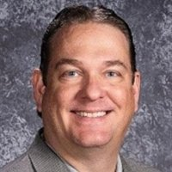

Mr. David Stephenson—Teacher, LCPS. Mr. Stephenson will bring is 16 years of sales and technology experience to the table. He is currently CEO of two companies, M2 Birdsitters and Focal Point Solutions.

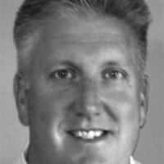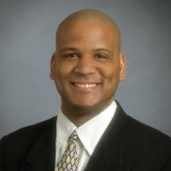

Mrs. Kristen Badgely—Managing Director, Albertini Group. Harvard business school graduate with over 20 years of business experience. Currently oversees business development activities and has sales in excess of $10 million.

Mr. Brian Mahoney, Compuware, Senior VP, Software Solutions Group. Mr. Mahoney is a top revenue producer for his division. Currently handles government and commercial accounts in the Washington, DC area.

Mr. Brian Allen, Mortgage Advisor, Fulton Group.P, Software Solutions Group. Mr. Allen is the highest performing mortgage advisor in the company of over 100 mortage advisors. He was also a stand out basketball player at Penn State.