Letterhead Design Project

Objective: Using Word, create a Letterhead design and type in a “Thank You” letter.

Background:
Congratulations! You’ve been promoted to the new Marketing Director for “Company X” (insert your company name here). You have been asked by the Chairman of the Board, Mr. Stephenson, to design a new letterhead for the corporation. Don’t know what letterhead is? Letterhead is the formal design that a business uses when writing correspondence to customers and other companies. You will need both a company name and a logo/graphic/clip art. The Chairman wants you to be professional, school appropriate and creative!

Letterhead Design:
The letterhead that you use for your business will affect the image that others form about your company. It is sometimes the first opportunity that you have to present your company to someone. It is important that the design you create for your letterhead reflects the image you want conveyed. Your letterhead will not only provide the others with your name and address, it will also create an image about the quality of your products or services. Image is important in business. Proof read everything!

Using Word, (Start, Programs, Productivity) open up a new document. Using the Ribbon UI, go to the “Insert” tab and select insert text box. Insert a textbox on your document. From there, be creative! Use different fonts to put in the requirements listed below. You will have to add a piece of clip art or graphic to the left of the letterhead. Please resize if you need to and make it look professional. An example has been included as a guide for you.

The second part of the project will be required to type the “Thank You” letter on the next page using the spacing requirements given. Type the letter exactly as it is written.

Part One—Letterhead requirements:
Your letterhead design must include (do not use your real address, phone or email):
- Your company name (also think about what product or service you would like to sell)
- A correctly formatted address (123 Anywhere St.)
- A City, State, Zip Code (Ashburn, VA 20147)
- A phone number (703-555-1212)
- An email and website (email: david@yourcompany.com; web: www.yourcompany.com).
- Graphic of your choice/design (You can use Image Blender, Paint, www, or an existing Clip Art to complete your project). Again, be creative!
- Type in the “Thank You” letter as it appears. Spell check and proof read your document for errors.
- Practice setting up envelop address. Highlight the address for Janet Lynn. Go to “Mailings” tab. Select “Envelopes.” Click on the Envelops tab and paste Ms. Lynn’s address on the Delivery Address. Make sure you type your company’s address in the Return Address field. DO NOT PRINT. Have Mr. Stephenson look this over along with your letter.
- Have Mr. Stephenson review your work PRIOR to saving.
- Save the file as “Last Name_Letterhead.doc” to your keyboarding folder. Next, copy it to Mr. Stephenson’s Global Folder, in the appropriate Block for grading.

Part Two—“Thank You” Letter:
Using Word and your new letterhead, please type in the following letter in “Block Style.” This means everything is left justified (#1). DO NOT USE THE TAB KEY TO INDENT THE PARAGRAPHS. Follow the spacing as noted in the text. DS=Double Space, QS=Quadruple Space. Using the Ribbon UI, go to the “Home” tab, select Times New Roman, 12-point font (#2). Check your page settings. Go to the “Paragraph” arrow, set the spacings to “single.” Be sure the line Spacings for “Before” and “After” are set to zero (#3).

No typographical or spacing errors will be accepted. Please proof read and follow directions!

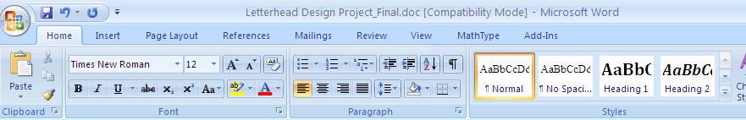

#2

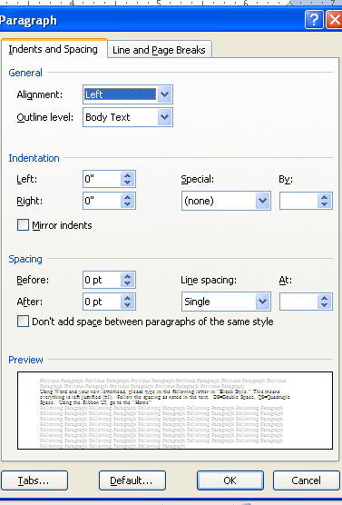
#3


M2 Bird Sitters….For the Birds!!!!
David Stephenson
P.O. BOX 307, ASHBURN, VA 20147

PHONE: 703-222-0288 WEB: www,m2birdsitters.com
EMAIL: david@m2birdsitters.com

Today’s Date spelled out(QS)

#1

Janet Lynn
HR Director
The Learning Academy
1234 Anywhere Street
Ashburn, VA 20147(DS)

Dear Ms. Lynn: (DS)

I wanted to say "Thank You" for taking the time out of your busy schedule to talk to me about working with The Learning Academy. I appreciate your time and consideration in interviewing our company to handle your needs. (DS)

After speaking with you and the group, I do feel that our company would be perfect for this position, offering quick turnaround and creativity that would be ideal for “TLA” to be successful in today’s competitive world. (DS)

In addition to our track record for performance, our organization will bring the skills necessary to get the job done on time and within budget. (DS)

I am very interested in working with you and look forward to hearing from you once the final decisions are made regarding this teaming arrangement. (DS)

Please feel free to contact me at anytime if further information is needed. My cell phone number is (555) 111-1111. (DS)

Sincerely, (QS)

David Stephenson (Type your name here)
Marketing Director
M2 Bird Sitters (Type your company name here)

