Hot Dog Stand Project

Objective: Using Excel, create a spreadsheet that details the cost and revenue for a week at “Dave’s Famous Dogs” hot-dog stand.

Background:
Promotion #4: You’re the new Financial Manager for “Dave’s Famous Dogs.” The hot dog stand has not been profitable and the Chairman of the Board, Mr. Stephenson, has asked you to create a spreadsheet to help analyze the costs and revenue for the stand. You will also have to answer questions regarding the stands profitability or loss. Lastly, you will have to create a graph that charts the progress. NO CALCULATORS OR PAPER ARE TO BE USED ON THIS PROJECT!!!

Part One—Download the excel spreadsheet:
You will be using Excel. To download the file, go to “My Computer”, go to Mr. Stephenson’s Folder on the Global drive. Copy the xls spreadsheet, HotDogStand.xls, to your keyboarding folder. Open the file and save it as “Lastname_HotDogStand.xls.” The spreadsheet has been formatted for you. Please fill out your name date block

Part Two—Data: hours, money, costs:
Here is where you will enter the data. Under the “Days of the Week” column, please fill in the five day week starting with Monday. The “Number of Hours Worked:” Monday, 8 hours; Tuesday-Thursday, 9 hours each day; Friday, 10 hours. The “Number of Hot Dogs Sold:” Monday, 22; Tuesday, 30; Wednesday, 21; Thursday, 22; Friday, 25. The price charged per hot dog is $1.50. The supply costs (i.e. hot dogs, buns, condiments, etc.) for the week: Monday, $6.00; Tuesday, $12.00; Wednesday, $45.00; Thursday, $8.00; Friday, $6.00. You are now ready to enter the formulas.

Part Three—Formula creation and samples:
You must now enter the formulas to calculate the money taken in and what the cost are. To enter a formula, highlight the cell, then type. Use the formulas below as a guide to help you enter them in the spreadsheet. Here is a list of the formulas needed for this project.
Day of the Week | Number of Hours Worked | Number of Hot Dogs Sold | Price Per Hot Dog | Total Money Taken In | Supply Cost | Net Revenue
 |  |  |  | =C6*D6 |  | =E6-F6
 |  |  |  | =C7*D6 |  | =E7-F7
 |  |  |  | =C8*D6 |  | =E8-F8
 |  |  |  | =C9*D6 |  | =E9-F9
 |  |  |  | =C10*D6 |  | =E10-F10
TOTAL | =SUM(B6:B10) | =SUM(C6:C10) |  | =SUM(E6:E10) | =SUM(F6:F10) | =SUM(G6:G10)

Part Four—Create an Exploded, 3-D Pie Chart:
This part is tricky. Please follow directions. Highlight all of the cells (using the mouse, anchor the cells—see the picture below).
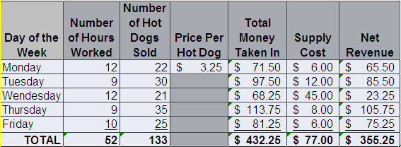

Go to the Ribbon UI, select “Insert (#1)”, then go to the “Pie Chart (#2).” Selected “Exploded Pie Chartt 3-D.” Change the chart title to “Hot Dog Stand Project(#3).” This part is trick: You now must add data labels. Click in the pie so the anchors appear. Right click on your mouse and go to “Add Data Labels.” They will appear on your pie chart as numbers and dollar values. We will change them to percents. Highlight the individual data pieces by clicking on the values. See chart below. Click on “Format Data Labels.” Check the “Percentage” radio button and the “Outside End.” Move your chart to the bottom of the spreadsheet. You are now ready to answer the questions.
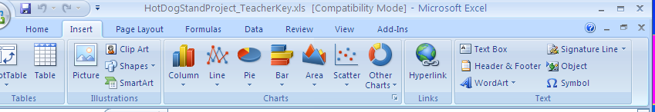

#2
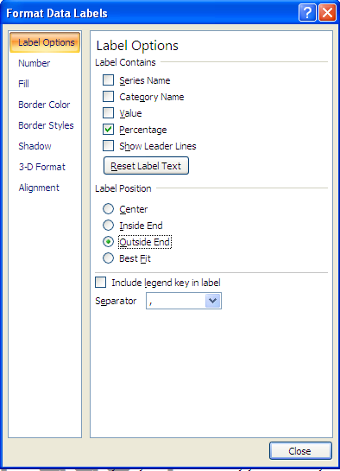

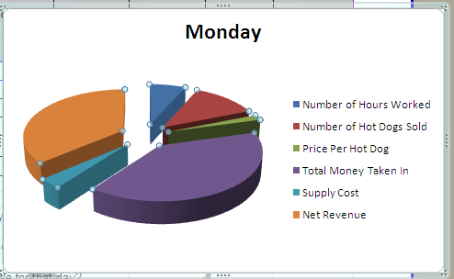

#1

#4

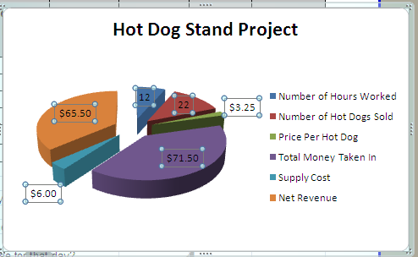

#3

You are now ready to answer the questions on the spreadsheet. See the example below for the questions. Please type them into the space below the question. Once you are done, please ask Mr. Stephenson to check your work before you save your project. You will have to change the price and you will see all of the cells updated, including the pie chart. Once you have done so, please save the project as “Lastname_HotDogStand.xls” to your keyboarding folder. Next, copy it to Mr. Stephenson’s Global Folder, in the appropriate Block Inbox for grading.

Name:
Date:
Block:
Day of the Week | Number of Hours Worked | Number of Hot Dogs Sold | Price Per Hot Dog | Total Money Taken In | Supply Cost | Net Revenue
TOTAL
1) What is the "Net Revenue" at the end of the week?
2) What day did you loose money?
3) How much money did you lose for that day?
4) Change the price per hotdog to $2.15. How much money did you make for the day you lost money?
5) What are the totals for each column?
6) Change the hours worked on Monday and Wednesday to 12. What is the total "Number of Hours?"
7) Change the number of hotdogs sold on Thursday to 35. What is your "Net Revenue?"
8) Increase the price per hot dog to $3.25. How much is the "Total Money Taken In" column?

