Celebrating Cultural Diversity Project

Background:
Mr. Stephenson has just hired you as the as the new Cultural Diversity Coordinator. Cultural Diversity is the coexistence of numerous distinct ethnic, racial, religious, or cultural groups within one social unit, organization, or population. Within our classroom, there are many different cultures, backgrounds, interests and traditions.

You will be in charge of celebrating that diversity for all new hires of the DRS Consulting Company. The Chairman of the Board wants you to set the example and be the first one to produce a word document that celebrates culture, diversity and student uniqueness. The Chairman wants you to be professional, school appropriate and creative! Make it personal.

Using Word (Start, Programs, Productivity OR double click on the blue W. Key in and answer the following questions in complete sentences. You may use several sentences to answer the questions:

- What country (or countries) did your family/ancestors come from?
- List three things that make you special and unique.
- What are some traditions that you have in your family?
- Describe some of your favorite foods from your country. (Note: If you have never had any of the foods from your country, answer by describing some of your favorite foods)

Please be sure to type in your name, date, block on the page. Type in “Celebrating Cultural Diversity” in 16 point, Times New Roman font and center. See the example. The questions and answers can be in any font that you would like, as long as there are at least 4 types.

Images:
Find 4 images and place them on the letter. You may use the Internet or bring in images from home. Your parents can also email me the images. See the example on the next page. To insert and images, go to the Menu bar, find Insert, scroll down to the “Picture” menu. Locate the file(s) of your choice and place on the letter.

Celebrating Cultural Diversity Project requirements:
Your project must include:
- At least 4 images/pictures of your choice that relate to your cultural background. You may get images from the web or bring them from home.
- On the upper left of the letter, please key in your name, date, and block.
- Please proofread and check for typographical errors.
- Each of the answers must have a different font.
- Have Mr. Stephenson look over the document PRIOR to copying to the global drive for grading.
- Must adhere to the C-RAP and DEAPR design concepts as covered in class.

No typographical or spacing errors will be accepted. Please proof read and follow directions!
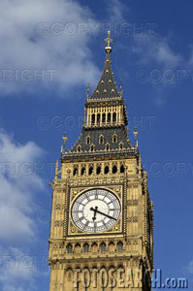
Name: David Stephenson
Date: September 24, 2012

Block: 5B

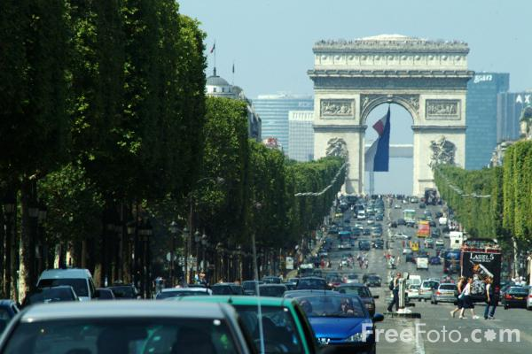

Celebrating Cultural Diversity

1) What country (or countries) did your family/ancestors originate?

My family emigrated from France and England.

2) List 3 things that make you special and unique?

The three things that make me special and unique are: 1) My sense of humor; 2) My compassion for animals; 3) I love parrots!

3) What are some traditions that you have in your family?

One of the traditions that we celebrate is opening one gift on Christmas Eve. Another tradition that we have is we always eat pork and sauerkraut on New Years day. It is supposed to bring you luck for the year.

4) Describe some of your favorite foods from your country that you like?
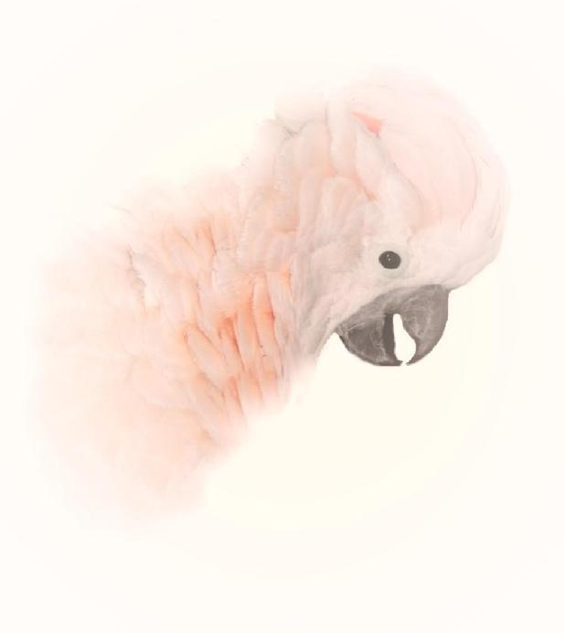

I love so many of the foods from France and England but my favorite one is Bangers and Mash. It is a funny name for sausages (bangers) and mashed potatoes (mash). It has gravy on the potatoes and it is very tasty.

