Book Review Project

Objective: Using the enclosed Proof Reader Marks Sheet, retype an error free book review using Word.

Background:
Mr. Stephenson has just promoted you to be the Chief Editor for Newsmonth Magazine. Colin Barker has just quit and it is your job to proofread, edit and change the book review that he submitted for the publication. A copy of the article is on the following pages, as is the list of proofreader marks and what they mean. The Chairman of the Board needs you to make the corrections and resubmit the article to meet the afternoon printing deadline. Please be thorough.

Using Word (Start, Programs, Productivity), start a New Blank Document. In the review, you will see instructions on how to format the book review. Using the Ribbon UI set up the measurements as follows:

PLEASE FOLLOW THE DIRECTIONS CLOSELY OR YOUR PROJECT WILL NOT BE ACCEPTED:

1) Margins (on the Ribbon UI, go to “Page Layout”, Margins, then Custom Margins. Then set: Top/Bottom=0.3”, Left/Right=0.4,” font will be Courier New, Size 12. The entire document will be double-spaced (See Instructions below). To format the document to double space, on the Ribbon UI, go to “Page Layout” tab. Select “Paragraph” arrow, go to Spacings, find where it says “line spacing” and select double space. Be sure the “Spacings” on the Before and After are set to 0 pt. This project will be on one page.

2)Other Changes as follows: (1) Replace the underlines with italics; (2) Use your name in the byline (where it says Colin Barker); (3) Proof read and fix any errors that remain; (4) Correctly format the reference.

3) Note: There are 3 hidden errors in the document. Find them (hint: Use the “Spelling and Grammar” tool in Word)!

You are now ready to begin keying in the text and making the corrections. Use proofreader marks and make the changes required. Take your time.

Book Review requirements:
Your book review must have:

- Proper formatting and spacing. This project will be on 1 page.
- No typographical errors.
- Please proofread and check to be sure ALL corrections have been made.
- Have Mr. Stephenson review your work prior to saving.
- Save the file as “Last Name_BookReview.html” to your keyboarding folder so it can be published via the web. Next, copy it to Mr. Stephenson’s Global Folder, in the appropriate Block for grading.

No typographical or spacing errors will be accepted. Please proof read and follow directions!

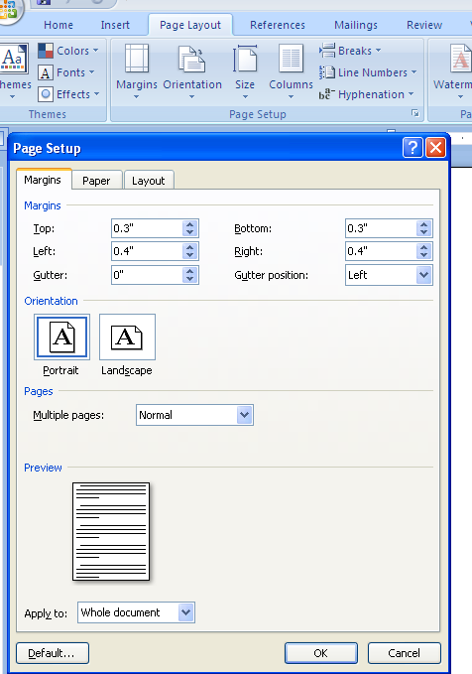
Page Layout Tab

Margin Set ups

Paragraph Set up

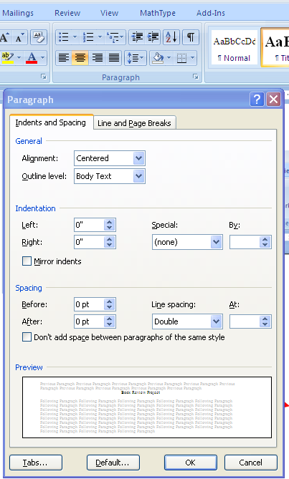

Double Space Settings

