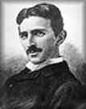

The brilliant inventor and electrical engineer Nikola Tesla developed the alternating-current (AC) power system that provides electricity for homes and buildings. Nikola Tesla was granted more than 100 United States patents. Many of his discoveries led to electronic developments for which other scientists were honored.

Nikola Tesla was born in Smiljan, Croatia, then part of Austria-Hungary, on July 9, 1856. He was often sick during his boyhood, but he was a bright student with a photographic memory. Against his father's wishes he chose a career in electrical engineering. After his graduation from the University of Prague in 1880, Tesla worked as a telephone engineer in Budapest, Hungary. By 1882 he had devised an AC power system to replace the weak direct-current (DC) generators and motors then in use.

What is your major?

What are you interests?

http://www.b-link.co.uk/ckn/inventors/nikola_tesla.htm

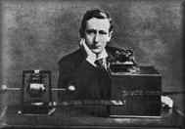

Guglielmo Marconi was born in Italy in 1874 to a rather wealthy Italian father and Irish mother. While there, he read an article that grabbed his attention.
The article suggested the possibility of using radio waves to communicate without wires. The year was 1894, and the most modern way to send a message was over telegraph wires. (Heinrich Hertz, for whom the units hertz and megahertz are named, had discovered and first produced radio waves in 1888.)

Guglielmo Marconi jumped right on the problem and in 1899, sent a signal 9 miles across the Bristol Channel and 31 miles across the English Channel to France. By 1901 Guglielmo Marconi was able to transmit across the Atlantic ocean opening the door to a rapidly developing wireless industry.
What articles have you read?
What problems are you willing to solve?

http://www.b-link.co.uk/ckn/inventors/guglielmo_marconi.htm

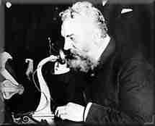
Alexander Graham Bell never set out to invent the telephone. Initially, he wanted to develop a multiple telegraph. Only later did he realize that a far greater prize lay at the end of the road.
In telegraphy, a current is interrupted in the pattern known as Morse Code. Bell hoped to convey several messages simultaneously, each at a different pitch. However, he could not see a way to make-and-break the current at the precise pitch required. "How," he wondered, "could pitch be conveyed along a wire?"

What ideas have you pondered?

What would you like to invent?

http://www.b-link.co.uk/ckn/inventors/alexander_graham_bell.htm

