Ece101 hw6 Due March 27

(Hw.5 was the in-class encryption project. Students that did not attend this class and did not submit full report, will not get a credit for HW.5)

1. Identify the type of modulation used:

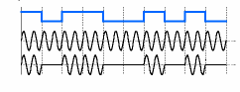

2. Can the data with R=56 kbps/sec and M=2 be transmitted over the telephone channel with the bandwidth 3.3 kHz,
signal power 2 W and noise power 2 mW?

3. IP address is 00110101000101100000111100000110. By grouping 8 bits, give the equivalent dotted decimal representation

4. Expand the following acronyms:
a) WAN-
b) NIC-

5. The Ethernet LAN uses which of the following logical topologies? Select one:
a) Ring
b) Bus
c) Branching tree
d) All of the above

